VICTORIAN CIVIL AND ADMINISTRATIVE TRIBUNAL
planning and environment LIST | vcat reference No. P325/2022  Permit Application no. PA2-0971
CATCHWORDS
Green Wedge A Zone; Design and Development Overlay Schedule 11 (Casey Foothills); Primary and secondary school; site selection; site cut.

Applicant | Pared Victoria Ltd trading as Lysterfield Lake College

Responsible Authority | Casey City Council
Respondent | Green Wedges Guardian Alliance Inc.
Referral AuthoritIES | CFA
 | Head, Transport for Victoria
SUBJECT LAND | 19-23 Horswood Road  NARRE WARREN NORTH VIC 3804
HEARING TYPE | Hearing
DATE OF HEARING | 29, 30 & 31 August 2022
DATE OF ORDER | 4 October 2022
CITATION | Pared Victoria Ltd trading as Lysterfield Lake College v Casey CC [2022] VCAT 1136

Order

No permit granted
- In application P325/2022 the decision of the responsible authority is affirmed.
- In planning permit application PA2-0971 no permit is granted.

Michael Nelthorpe
Member

Appearances
For Pared Victoria Ltd trading as Lysterfield Lake College | Mr Barnaby Chessell, barrister instructed by  HWL Ebsworth Lawyers. He called the following witnesses:  Mr David Barnes, town planner of Hansen Partnership;  Mr Mark Potter, bushfire risk assessor of Fire Risk Consultants;  Mr Leigh Furness, traffic engineer of the Traffix Group; and  Ms Leanne Dowey, landscape architect of Hansen Partnership.
For Casey City Council | Mr Nick Crawford, solicitor. He called the following witnesses:  Mr John Glossop, town planner of Glossop Town Planning; and  Mr JP Maina, traffic engineer of Impact Traffic Engineering.
For Green Wedges Guardian Alliance Inc. | Ms Karen Cavanagh and Ms Kate Rousseaux.

Information
Description of proposal | A faith-based school of 239 students and 22 staff developed over two stages.
Nature of proceeding | Application under section 77 of the Planning and Environment Act 1987 – to review the refusal to grant a permit.
Planning scheme | Casey Planning Scheme
Zone and overlays | Green Wedge A Zone Schedule 4 (‘GWAZ4’)  Significant Landscape Overlay Schedule 1 (Casey Foothills) (‘SLO1’)  Bushfire Management Overlay (‘BMO’)
Permit requirements | Clause 35.05-1: to use land for a Primary School and for a Secondary School;  Clause 35.05-5: to construct a building or construct or carry out works for a use that requires a permit;  Clause 42.01-2: to construct a building or construct or carry out works; and  Clause 44.06-2: to construct a building or construct or carry out works associated with an Education Centre.
Relevant scheme policies and provisions | Clauses 11, 12, 14, 19, 21.03, 21.04, 21.08, 21.14, 22.08, 35.05, 42.01, 44.06, 51.02, 52.06, 52.34, 53.02, 53.19, 65 & 71.02.
Land description | This rectangular 8 hectare site is at the end of Horswood Road on the south side of that street. Lysterfield Lake Park abuts its western boundary, and the Montague Orchard and fruit processing complex is opposite to the north. An equestrian complex is to the site’s east.  The site is on the north-east side of a hill and falls 25m from west to east at its highest point.
Tribunal inspection | 28 August and 22 September 2022.

Reasons

What is this proceeding about?
- A small, independent Catholic organisation (‘the College’) proposes to establish a primary and secondary school on grazing land in the Casey Foothills. It says that the site is affordable and close to the College’s sister school, and it sees synergies with the neighbouring Lysterfield Lake Park and Montague orchard and fruit processing complex.
- Casey City Council (‘the Council’) refused to grant a permit. It says that the site is unsuitable because it is remote from established residential areas, has no association with the purpose of the Zone, and is inconsistent with planning policy for non-urban areas. It says that the school’s buildings and playing fields are incompatible with the area’s scenic landscape values and that its traffic impacts create uncertain and potentially unacceptable outcomes.
- The College seeks a review of this decision.
- The Green Wedges Guardian Alliance Inc. (‘GWGA’) supports the Council’s decision. Separately, it questions the appropriateness of a school in this location due to the risk of bushfire.
- The relevant referral authorities do not oppose the grant of a permit subject to conditions.

What are the key issues?
- Based on the submissions and evidence, I consider that the key issues are:
- Is this a suitable site for a school?
- Are the anticipated traffic impacts acceptable?
- Is the risk from bushfire managed appropriately?

Summary of findings
- A school can be an appropriate land use in a Green Wedge A Zone subject to site selection. This school is too large for its site and that the site’s topography cannot accommodate the proposed earthworks without compromising the landscape values of the Zone and the Significant Landscape Overlay.
- I must strike a balance between the two competing community benefits:
- the benefit that the school would bring; and
- the benefit of being consistent with the planning policy framework and associated provisions.
- With regard to the proposed school on this particular site, I find that the benefit of being consistent with the planning policy framework and associated provisions outweighs the benefit that the school would bring.

The site and surrounds
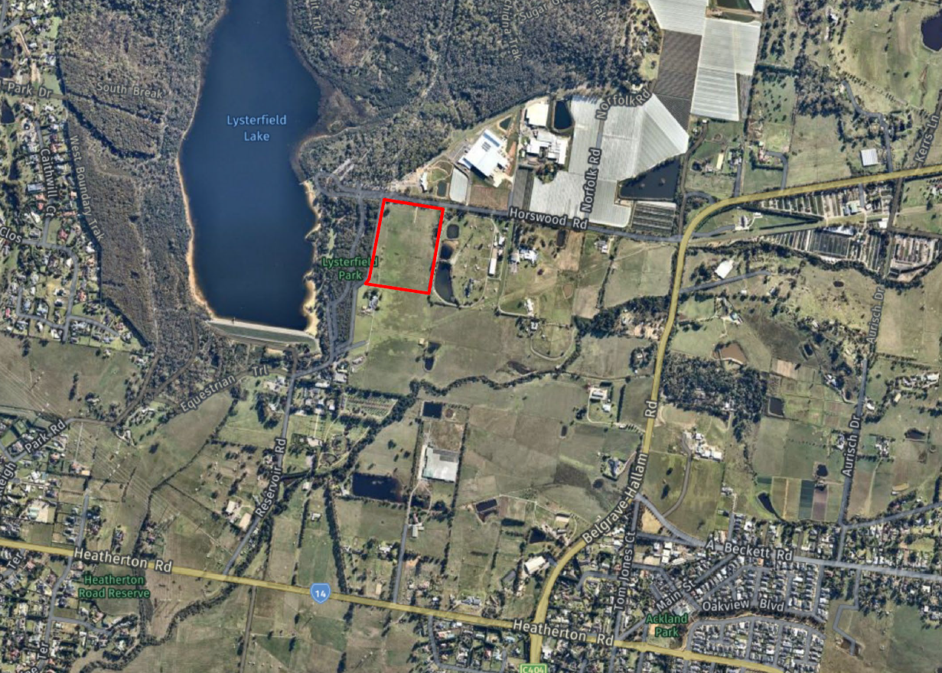

Figure 1: The site is in the red box.
- The site is a vacant 8-hectare grazing property at the end of Horswood Road. Horswood Road is a two kilometre long sealed, two-lane road that joins Belgrave-Hallam Road. Belgrave-Hallam Road is a rural arterial road serving this part of the Casey foothills.
- The site is on an east-facing hillside and falls 25m along the rear boundary and 20m diagonally from the south-west to the north-east. It contains two native trees (Tasmanian Blue Gums), with one worth retaining.
- Lysterfield Lake Park abuts the site’s western boundary. It is a regionally significant bushland conservation and recreation reserve that is part of the Churchill National Park.
- An 8-hectare equestrian complex is to the east. It on the south-west side of the adjacent ridgeline and has a series of dams in the valley next to the site. It contains over a dozen agistment paddocks and several stables, along with a trail around its perimeter. The dwelling is in the site’s south-east section.
- A rural-residential property is to the south of the site. The dwelling is on the property’s highest point and the remainder of the site is cleared. It gains access from a road to the south.
- Montague Orchard is on the opposite side of Horswood Road. It is a substantial complex of orchards and fruit processing facilities. It has recently expanded and now includes a visitor centre with a new fruit processing plant, restaurant, produce store and associated parking.
- Horswood Road has a two-way traffic volume of up to 1,200 vehicles per weekday, which is typical of a local road. It carries over 2,900 vehicles on each weekend day, with Lysterfield Lake Park and Montague orchard and fruit processing complex being the primary traffic generators.
- In a broader context, the area containing the site is outside the edge of metropolitan Melbourne. The established suburbs of Narre Warren, Endeavour Hills and Lysterfield are to the south and west, while the urban growth corridor that extends to Pakenham is to the south-east.

The Proposal
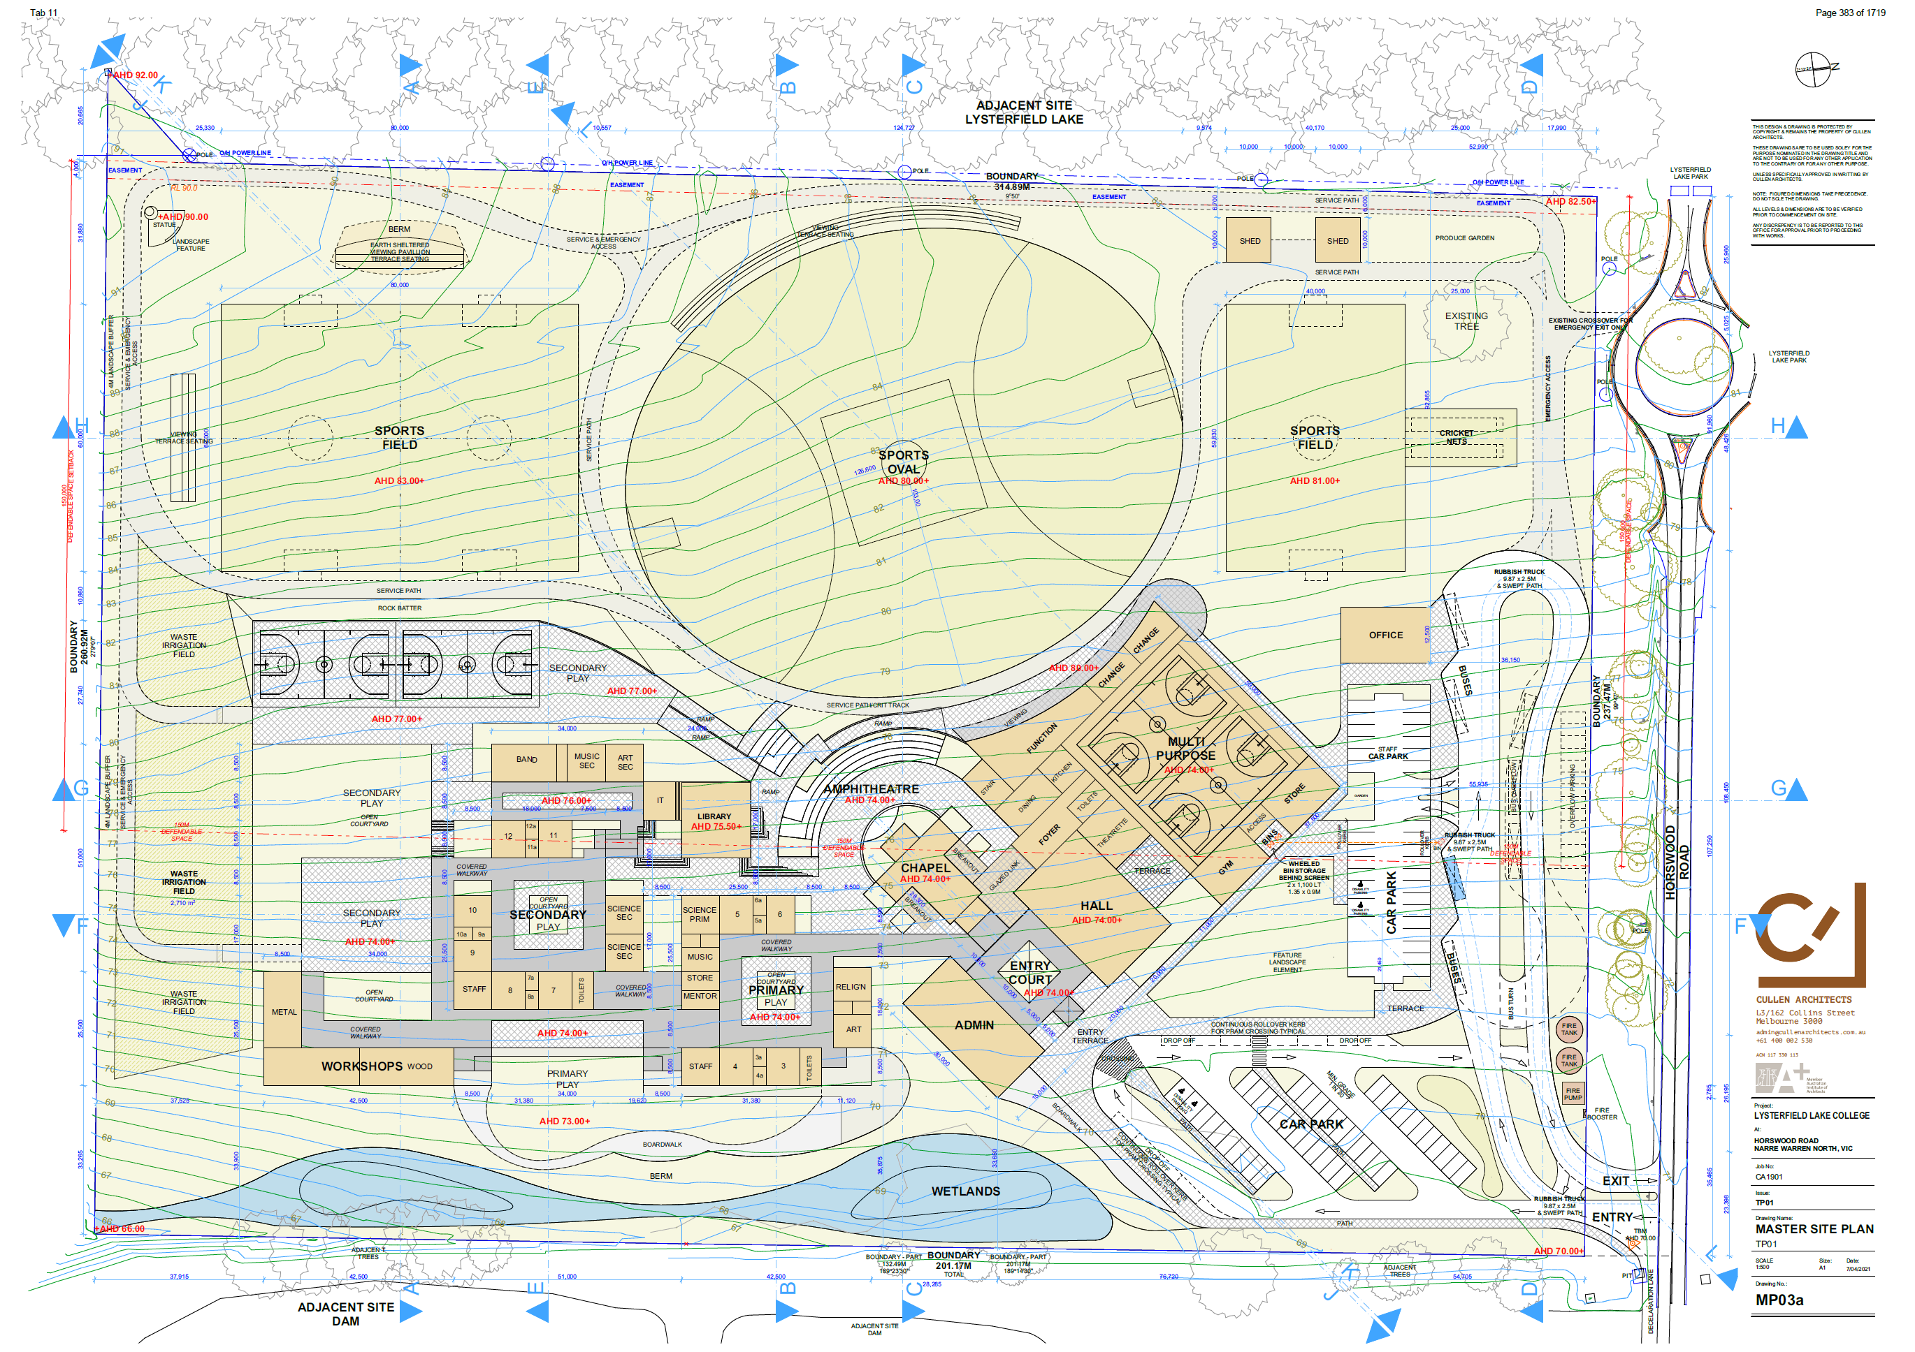

Figure 2: The school’s Master Plan with contours.
- It is proposed to establish a school that provides primary and secondary school education to boys between Year 3 and Year 12. Its maximum numbers are 239 students and 22 on-site staff. The school will adopt the PARED education philosophy which has 150 schools worldwide. It teaches the Catholic faith and believes that parents are the primary educators of their children. It includes one-on-one mentoring of students by staff and has a focus on outdoor education.
- The school campus is proposed to be developed in two stages. The primary school classrooms, administration building, chapel, hall, sports oval, sports field, most of the car park and all the bus parking would be constructed in Stage 1. The secondary school classrooms, a multi-purpose room and a further sports field would be constructed in Stage 2.
- In Stage 1, students would be bussed from the sister campus on Belgrave-Hallam Road. In Stage 2, parents would drive all students to the school. The Department of Transport requires the school to signalise the intersection of Belgrave-Hallam and Horswood Roads prior to the commencement of Stage 2’s operation, i.e., when parents start driving their children to the school. The school accepts this requirement.
- The buildings and works would be sited on terraces down the slope. The sports oval requires up to 6m of cut while the south-western sports field requires 7m of cut. The levelled areas required for the administration and multi-purpose buildings, the hall, and the chapel require a similar degree of cut, while the secondary school rooms break this cut into two terraces. The following images show examples of the terracing of the site.
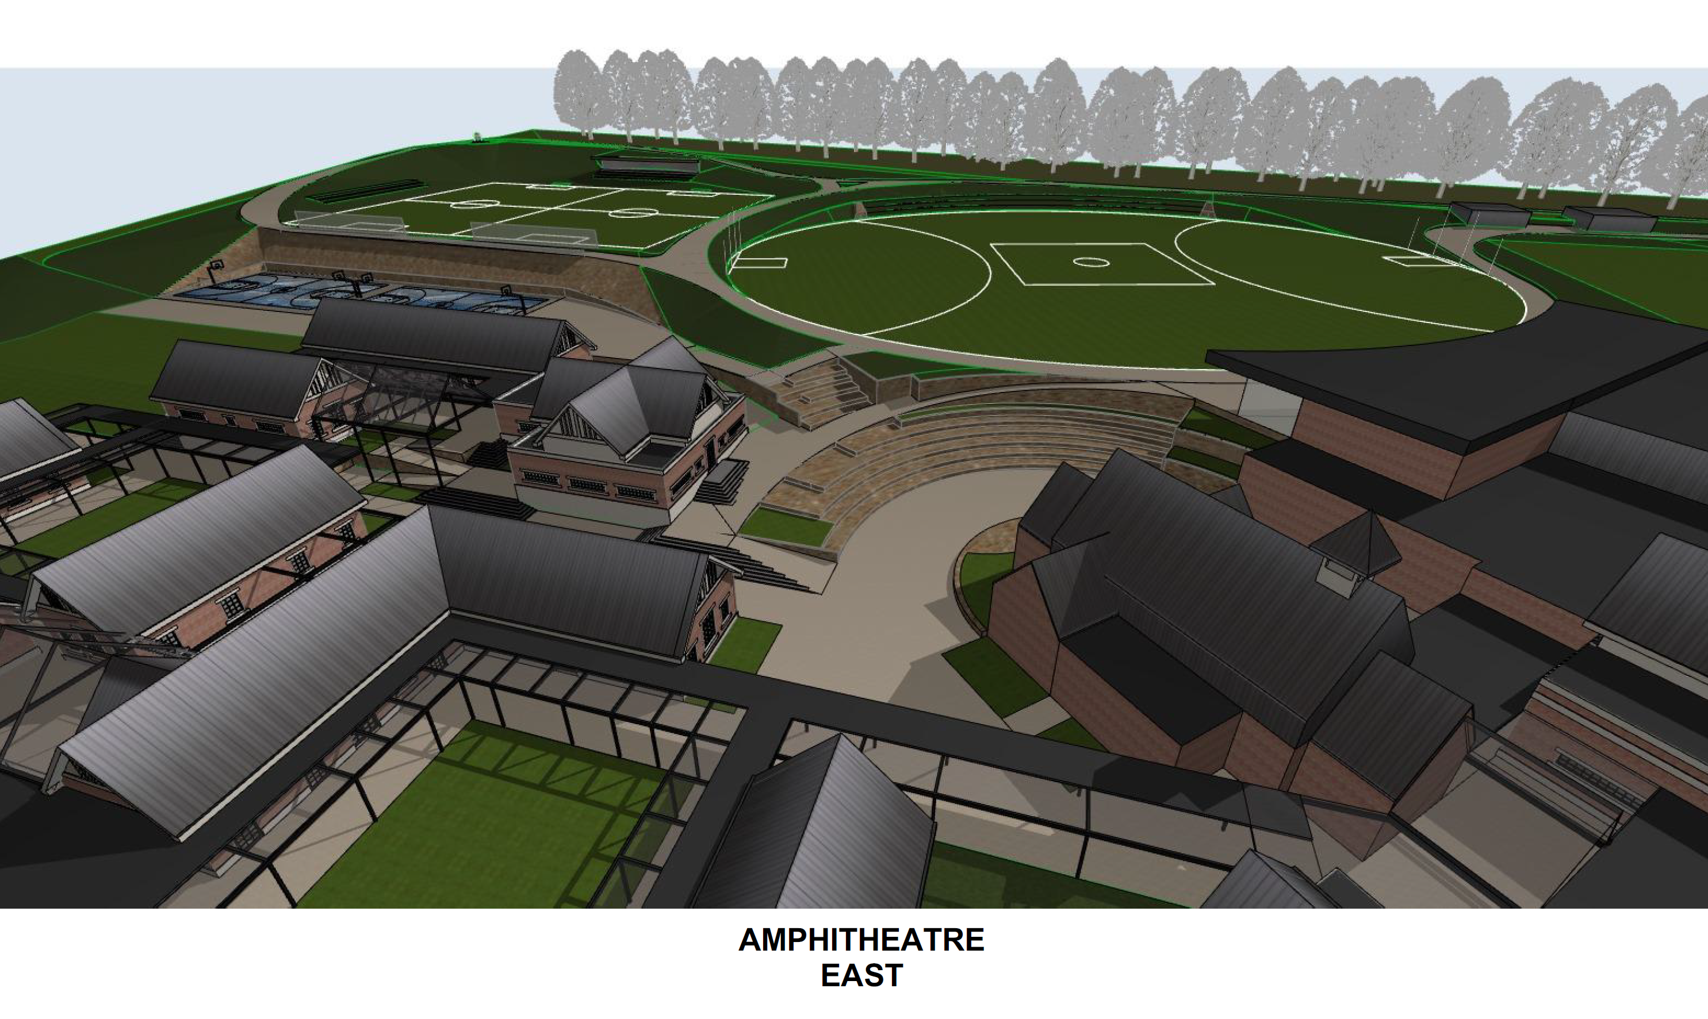

Figure 3: Image prepared by the project architect
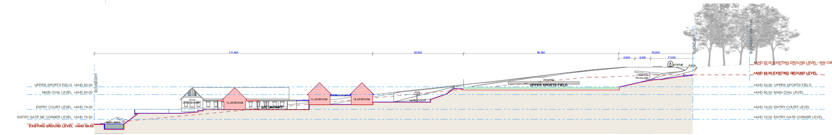Figure 4: Longitudinal section prepared by the project architect

Is this a suitable site for a school?

What does the Council and its planning witness say?
- The Council says that the site is unsuitable because of its remote location, its lack of association with the purpose of the Zone, and its inconsistency with planning policy for non-urban areas.
- It stresses that it does not oppose all schools in the Green Wedge A Zone, and it highlights several nearby schools that it has supported. It says that the distinguishing features of these schools is that they are on the main road (Belgrave-Hallam Road) and/or have an affinity with the Zone’s purpose. It also takes issue with the extent of earthworks required to terrace the buildings and works down the site.
- It relies on Mr Glossop’s evidence. He concludes that:
Schools can be appropriate land uses in a Green Wedge A Zone, subject to site selection.
This is principally a matter of strategic appropriateness as to whether the Review Site represents an appropriate location for a school of this scale. I consider that strategically, the development of the Review Site in the manner proposed is not supported by planning policy principally due to the Review Site’s more isolated location, the scale of the school proposed and the apparent lack of any meaningful connection to the green wedge.
I am generally comfortable with the buildings proposed from a design response perspective but note that the extent of buildings and works proposed and the extent of earthworks required to provide for level surfaces contributes to my concerns regarding scale and their appropriateness…
I consider matters of bushfire safety to have been addressed through the Bushfire Management Plan prepared and the CFA’s subsequent referral response.
- Expanding on the question of strategic appropriateness in his Statement of Evidence, he considers that the school’s location is relatively isolated in the context of State and local planning policy.
- He notes that State planning policy encourages schools to locate where access by public transport, walking and cycling is maximised, but that the provisions of the Green Wedge A Zone anticipate that these criteria may not be met.
- Regarding local policy, he sees its overall direction as being to protect Green Wedge land from urban growth pressures. He says that it does this by:
- discouraging ‘urban-type’ uses in Green Wedge areas unless they operate in conjunction with agricultural uses on the land, and
- encouraging uses without an agricultural connection to locate close to urban or township areas.
- Regarding the scale of the school, he opines that the planning policy framework suggests that this school is not small enough to easily fit in this relatively isolated Green Wedge context. He suggests that it would be acceptable up to Year 5 (161 students) but beyond this, it becomes more of an urban scale given its isolation from urban services and facilities.
- Regarding the apparent lack of meaningful connection to the Green Wedge, he says that the planning policy framework suggests that there should be a link between the school and its surrounds in a Green Wedge setting. He accepts that the Applicant plans to partner with Parks Victoria and the Montague complex but views these partnerships as opportunistic rather than intrinsic to the site’s selection.
- Regarding the extent of buildings and earthworks, he notes that not much of the site will be left as ‘natural land’, and that considerable earthworks will be required to create the level surfaces of the playing fields and the terracing of the buildings. He believes that these earthworks contradict the objective of the Significant Landscape Overlay:
To encourage development that is in harmony with the hilly terrain and rural landscape of the Casey Foothills.
- He considers that this objective encourages buildings and works that sit lightly on the land and says that the extent of earthworks supports his concern over the school’s scale.
- He acknowledges the significant scale of the Montague Orchard complex but notes that they are in a different Zone with a different policy context. He also notes that they are on a large site, are connected to agriculture and that the larger buildings are well set back from Horswood Road.
- The Council and Mr Glossop rely on a recent State government discussion paper that suggests that schools and places of worship in the Green Wedge should be close to the Urban Growth Boundary to avoid compromising Green Wedge values.

What does the GWGA say?
- The GWGA says that the school is another inappropriate urban use in the Green Wedge. It says that such uses are properly restricted by the Planning Scheme’s provisions and that this school breeches many of those restrictions. It suggests that approving a school in this location would allow others to do the same. It also questions the appropriateness of locating a school in a site that is subject to the Bushfire Management Overlay.
- It also relies on the recent State government discussion paper referred to earlier.

What does the College and its planning and landscape witnesses say?
- The College emphasises the Planning Scheme’s support for independent schools in the Green Wedge A Zone. It says that the Zone was changed because the State government recognised that these schools struggled to find affordable sites inside the Urban Growth Boundary.
- It says that the site’s context suits a school. It says that Lysterfield Lake Park and the Montague complex bring significant traffic to Horswood Road, thus the school’s traffic would be absorbed in this context rather than change it. It says that the scale and intensity of the Montague complex assists in visually absorbing the school’s buildings and works in the landscape.
- It relies on Mr Barnes’ evidence, which reflects these submissions. Mr Barnes says that the school generally accords with planning policy. He says that the site is close to the Urban Growth Boundary given that this Green Wedge extends a great distance to the east.
- In strategic planning terms, and in the absence of a Green Wedge Management Plan, he views the section of the Green Wedge containing the review site as a precinct well suited to schools, places of worship and rural living as opposed to broadscale agriculture. This opinion is based on the current uses and the area’s proximity to the Urban Growth Boundary.
- He says that the objective of local policy prescribing main road locations is to protect the amenity of local areas. He sees this objective as less relevant to sites on Horswood Road given the current intensity of traffic on this road.
- He disputes Mr Glossop’s view that the school forms an ‘urban cluster’. He stresses that the school’s buildings occupy a very low percentage of the site (around 13%) and that most of the site is open land, i.e., the sports fields and oval and the wetlands and waste irrigation field.
- He and Ms Dowey say that the school’s buildings and works respond to the landscape values of the Casey Foothills. They say that the terracing of buildings and works down the slope is a direct response to these values and they both envisage the sports field and oval as green spaces that are compatible with green pasture that surrounds most of the rural living properties in the area.
- They have undertaken detailed visual assessments of the school’s impact on short-range, intermediate and long-range views. They both conclude that it will be visible in short-range views, i.e., from immediately outside the site but barely visible in intermediate and long-range views. They consider that the short-range visual impact is acceptable in the context of the Montague complex and that its impact on intermediate and long-range views is acceptable because it is barely discernible.

What are my findings?
- I support Mr Glossop’s opinion that a school can be an appropriate land use in a Green Wedge A Zone subject to site selection. This last phrase is central to my findings.
- While there are persuasive arguments why a school is acceptable in this location, I find that this school is too large for its site and that the site’s topography cannot accommodate the proposed earthworks without compromising the landscape values of the Zone and the Significant Landscape Overlay.

The use of the site for a school
- I find that this school would be acceptable if this site was flat or was significantly larger.
- This finding is based on the Zone’s nomination of schools as permissible uses in the Green Wedge A Zone. This carries great weight given that its purpose is to implement State policy seeking a diversity of primary and secondary schools. Allowing such schools in the Green Wedge A Zone is the means to achieve this end. In planning terms, the school is the community benefit.
- I do not support the GWGA’s high-level submissions that the school is an ‘urban use’ that should be inside the Urban Growth Boundary. The contention that schools are inappropriate urban incursions in the Green Wedges is not persuasive in a statutory context that specifically allows for schools. It is an argument for the strategic planning forum.
- I find that the Council’s submissions on the use of this site for a school rely too much on policies that either:
- have not kept pace with changes to the Green Wedge A Zone; or
- have not been applied to the site’s physical context.
- Regarding the first point, there was general agreement that State planning policy on Education facilities is not helpful due to its focus on urban areas. The Green Wedge A Zone’s support for schools in this non-urban zone negates the Council’s argument that the College should locate in the nominated education precinct in Berwick.
- I find that local policy on non-agricultural uses in Green Wedge areas places an undue emphasis on non-agricultural uses operating in conjunction with related agricultural activities. The ‘in conjunction’ test does not apply to schools in the Green Wedge A Zone thus the policy is not a good fit with the Zone’s provisions.
- Apart from that, the area’s physical characteristic of 8 hectare lots used for ‘lifestyle living’ does not favour policies that place high emphasis on agricultural uses.
- I find that the site’s location on a non-typical local road diffuses the direction that schools should be located on main roads rather than in remote areas. The intensity of activity at the Montague complex and at Lysterfield Lake Park make this road capable of absorbing a school despite its ‘remoteness’. As Mr Barnes’ says, the Performance standard associated with this policy seeks to protect nearby residents from unreasonable traffic impacts whereas the uses on Horswood Road allow the school’s traffic to be absorbed.
- These findings influence my view of Mr Glossop’s evidence. I am not persuaded that this school is in an isolated location given the existing activities on Horswood Road. I am more persuaded by the College’s advice that its catchment is in a reasonably large region to the south and east. The expectation is that students will be driven to the school, and this is anticipated by the Zone.
- Separately, I find that the apparent lack of any meaningful connection to the Green Wedge is a not fatal flaw. The State government’s support for schools in the Green Wedge A Zone turns on the objective of enhancing the diversity of primary and secondary education rather than on such schools having links to Green Wedge values. The lack of any ‘in conjunction’ test also frees schools from requiring the connection that Mr Glossop describes.

The earthworks required for the buildings and works
- Where I am persuaded by Mr Glossop, and what is ultimately fatal to this proposal, is the intensity of this school on this site. It is not a question of student numbers, as I could envisage a school with 239 students as being acceptable on a larger site. To this end, the College missed the point in emphasising the numbers when cross-examining Mr Glossop.
- What I find unacceptable is the intensive use of the site and the consequent earthworks needed to turn a sloping site into a conventionally laid-out school. As Mr Glossop observed:
- very little of this 8 hectare site would be left in its natural state;
- 6 to 7 metres of cut is required across most of the south-western section of the site to achieve level playing fields; and
- further cut, some of it extensive, would be required to create level pads for the school’s buildings.
- These outcomes are proposed in a planning framework that seeks to protect the existing landscape values. The Green Wedge A Zone, amongst other things, seeks:
To protect, conserve and enhance the biodiversity, natural resources, scenic landscapes and heritage values of the area; and
To protect, conserve and enhance the cultural heritage significance and the character of rural and scenic non-urban landscapes. (My emphasis)
- Local policy for the Casey Foothills states that:
The Casey Foothills area is important because its hilly terrain offers topographical and scenic relief to the otherwise low-lying built-up areas of Casey. Its visual qualities contribute to a positive image of the municipality as a desirable place to live…The area is protected for its long-term environmental and landscape qualities that ensure the special rural character is not compromised.
- Policy in this clause seeks to ensure the protection of these landscape qualities. It justifies the imposition of the Significant Landscape Overlay Schedule 1, which identifies the significance of the area as follows:
The hilly terrain of the Casey Foothills provides breathtaking views to and from the ridges and other vantage points. The terrain offers topographical and scenic relief from the low-lying built-up areas of Casey.
The rural nature, characterised by open pasture and hedge row plantings, as well as bush remnants, provide a green backdrop to the city that contributes to a positive image of the municipality as a desirable place to live.
- The environmental objectives to be achieved by the Overlay include:
To encourage development that is in harmony with the hilly terrain and rural landscape of the Casey Foothills.
- The decision guidelines to consider include:
Whether the development will be detrimental to the natural physical features and resources of the area;
Whether the development will require significant earthworks; and
Whether the development will be visible from public roads and other vantage points.
- I find that the extensive use of the site coupled with the significant modifications to the natural topography cannot be justified given these aspects of the Zone, the Significant Landscape Overlay and local planning policy.
- Almost all of the site will be re-worked to provide for school activities. Excavation for an oval that is 103m wide by 126m long is a significant change to the natural hillside. Adding sports fields with dimensions of 80m by 60m and 59.8m by 40m is also a significant change. Beyond that, the pad for the administration and multi-purpose buildings chapel, and hall is a further 80-90m by 50m cut at a lower level with a comparable area of cut surfaces for the secondary school rooms.
- I am not persuaded that these changes are consistent with the character of this ‘scenic non-urban landscape’ or ‘in harmony with the hilly terrain and rural landscape of the Casey Foothills’.
- Mr Barnes and Ms Dowey say that the oval and sports fields will form a green band across the highest point of the site and that the buildings will be less visible because they are on lower land.
- They also say that the changes to the topography are acceptable because:
- Immediate views of these works are limited and are in the context of the considerable buildings and works at the Montague Orchard;
- Mid-range views from Belgrave Hallam Road are limited to less than half of this hillside; and
- Long-range views (2km-4km) are insignificant given the distance and the dominance of the Montague Orchard.
- I am not persuaded that the sports fields will be a green band across the highest land on the site. The site layout provides little space for the earthworks to transition back to natural ground level (the batters). In evidence in chief, Ms Dowey advised that the batters would be at a ratio of 1 metre rise in height across 5m of distance (1:5) to allow for mowing, however most areas on the high side of the sports field and oval do not provide the 30-35m in distance for this to occur.
- The section diagrams show many areas, often next to the terraced seating, of batters of considerably less than 1:5. I am not persuaded that these areas can be maintained as lawn, as shown on the landscape master plan. I consider it is too likely that the batters will be exposed and will be visible in the landscape.
- Separately, I am not persuaded that the limited visibility of the site justifies the extent of earthworks. I accept that Montague Orchard has a considerable visual presence yet much of it is orchard covered with shade cloth on natural topography and the largest buildings are well set back from Horswood Road. I consider that the school’s landscape impact via the excavation on the site is greater than that of the Montague Orchard relative to the size of the two sites.
- I consider that views of the site from Belgrave-Hallam Road are important and that the considerable earthworks will be visible from outside 365-367 Belgrave-Hallam Road. This is a quite typical vista in the Casey Foothills, and I cannot justify the landscape impact of the earthworks given the policy framework and the purpose of the Significant Landscape Overlay. Allowing this impact could reasonably be interpreted as allowing comparable impacts in similar locations in the Casey Foothills and I do not believe that this is the intention of the controls.
- For completeness, I accept that the site and proposed works are insignificant in long-range views given the distance and the dominance of the Montague Orchard.

Are the anticipated traffic impacts acceptable?
- The Council raises concerns over access to 481 Belgrave-Hallam Road after the signalisation of the Horswood Road/Belgrave-Hallam Road intersection. It relies on Mr Maino’s evidence that future access and egress from this site could not safely occur without considerable works in the road reserve at the intersection.
- The College relies on the Department of Transport’s approval of Mr Furness’ Functional Layout Plan for this intersection, which shows the current access to 481 Belgrave-Hallam Road is retained.
- The Department of Transport’s support for Mr Furness’ Functional Layout Plan is highly persuasive. As such, I find it is acceptable.
- On other traffic related matters, both Mr Maino and Mr Furness consider that Horswood Road has the capacity to accommodate the anticipated traffic from the school, and that parking arrangements within the school’s boundaries properly manage the surge of vehicles at school drop-off and pick-up times. I agree with their opinions.
- On a separate matter, despite my question to Mr Glossop, the College’s submission that the installation of traffic lights at the College’s expense is an operational requirement rather than a community benefit under clause 71.02.

Is the risk from bushfire managed appropriately?
- The GWGA questioned the appropriateness of a school in this location due to the risk from bushfire. In response to questions, Mr Potter conveyed a considerable knowledge of the history of bushfire in the immediate vicinity, and a cautious yet pragmatic approach to the balance between land use and bushfire risk. I found him to be a very credible witness.
- On this basis, I consider that his peer review of the Bushfire Planning Report prepared by Euca Planning Pty Ltd is fundamentally sound.
- Given that the CFA does not object to the grant of a permit subject to conditions, including a Bushfire Management Plan requiring the closure of the school on days of elevated fire risk, I find that the risk from bushfire is appropriately managed.
- In saying this, I find that it is not appropriate to follow the Tribunal decision in Brumbys Road Investments Pty Ltd v Manningham City Council. A residential hotel was proposed in that proceeding, and the Tribunal’s concern related to the unstructured activities of future hotel guests. It said:
[119] The proposal is for a development to accommodate a use with patrons who may not be familiar with the land or the wider environs and the bushfire risk that the land is subject to. The proposal is primarily for a Residential hotel, where patrons are free to do as they please and are not under effective control of operators. We were not led to any material that would suggest otherwise. This differs from other scenarios where masses of people might be under the effective control of a premises operator, such as a school, for example.
[120] BRI also submits, in part through evidence, that patrons would expect to arrive by bus on occasions and so would not have immediate access to transport in the event of an emergency but would be highly mobile. Mr Francis’ opinion was that although this is the case, the construction level of the building would suffice as a place of refuge during a fire event.
[121] We are not persuaded that the proposal has adequately addressed the State policy that applies to the land in respect of bushfire risk. We are not satisfied that the development proposed which will allow the use of the land for this purpose, with such high numbers of patrons allowable, combined with the uncertainties that the use and transport options for patrons would raise, is acceptable in a moderate bushfire risk location.
- It is relevant that the Tribunal in that proceeding differentiated a residential hotel from a school ‘where masses of people might be under the effective control of a premises operator’. This is the case in the proceeding before me.

conclusion
- Ultimately, this proposal fails on its site selection. The earthworks required to build this school on this sloping site are contrary to the planning policies and controls that seek to preserve the hilly terrain of the Casey Foothills. The Council’s decision is affirmed, and no permit will issue.

Michael Nelthorpe
Member

The submissions and evidence of the parties, any supporting exhibits, and the statements of grounds filed; have all been considered in the determination of the proceeding. In accordance with the practice of the Tribunal, not all of this material will be cited or referred to in these reasons.
Preliminary Arboricultural Assessment by The Green Connection, dated 18 July 2019.
From p.19 of Mr Furness’ Evidence Statement.
At page 24 of his Evidence Statement.
At clause 19 and 35.05-6.
At clauses 21.02-4 and 22.08.
In evidence in chief, Mr Glossop said by example that ‘this school is not a Dookie Agricultural College’.
Department of Environment, Land, Water and Planning: Planning for Melbourne’s Green Wedges and Agricultural Land Consultation Paper May 2020.
At clause 19.02-2S.
At clause 22.08.
At clause 21.14-1.
At Section 10.2 of Mr Barnes’ evidence statement and at Section 4.1 of Ms Dowey’s evidence statement.
At Section 10.3 of Mr Barnes’ evidence statement and at Section 4.1 of Ms Dowey’s evidence statement.
At Section 10.4 of Mr Barnes’ evidence statement and at Section 4.1 of Ms Dowey’s evidence statement.
[2018] VCAT 449.

