VICTORIAN CIVIL AND ADMINISTRATIVE TRIBUNAL
planning and environment LIST | vcat reference No. P12005/2021  Permit Application no. P20/1177.01
CATCHWORDS
Section 82 Planning and Environment Act 1987, Mornington Peninsula Planning Scheme, Green Wedge Zone, Environmental Significance Overlay – Schedule 13, amendment to existing permit, dwelling location, impact of house location on wildlife corridor, impact of house location on agricultural productivity,

Applicants | D Samways & Others

Responsible Authority | Mornington Peninsula Shire Council
Respondent | J Stanton
Referral Authority | Country Fire Authority
SUBJECT LAND | 75 Hyslops Road  MAIN RIDGE VIC 3928
HEARING TYPE | Hearing
DATE OF HEARING | 1 and 2 September 2022
DATE OF original ORDER | 7 September 2022
date of corrected order | 19 December 2022
CITATION | Samways v Mornington Peninsula SC (Corrected) [2022] VCAT 1040

Order

Permit amended
- In application P12005/2021 the decision of the responsible authority is varied.
- Planning permit P20/1177.01 is amended and an amended permit is directed to be issued for the land at 75 Hyslops Road, Main Ridge. The permit is amended to amend conditions in the permit to accord with the conditions set out in Appendix A.

Alison Glynn
Member

Appearances
For D Samways and others | Louise Hicks, barrister on direct brief. She called the following witness:  - Malcolm Legg, ecologist.
For Mornington Peninsula Shire Council | Effie Tangalakis, town planner of Ask Planning Services.
For Country Fire Authority | No appearance.
For J Stanton | Paul Chiappi, barrister on brief from Elitlaw. He called the following witness:  - Alan Brennan, ecologist.

Information
Description of proposal | The proposal is to amend a planning permit by changing the location of a dwelling approved for the land.
Nature of proceeding | Application under section 82 of the Planning and Environment Act 1987 – to review the decision to amend a permit.
Planning scheme | Mornington Peninsula Planning Scheme
Zone and overlays | Green Wedge Zone – Schedule 2 (GWZ2)  Bushfire Management Overlay (BMO)  Erosion Management Overlay - Schedule 1 (EMO1)  Environmental Management Overlay – Schedule 13 (ESO13)  Environmental Management Overlay – Schedule 17 (ESO17)  Environmental Management Overlay – Schedule 28 (ESO28)  Significant Landscape Overlay – Schedule 1 (SLO1)  Vegetation Protection Overlay – Schedule 1 (VPO1)
Permit requirements | Construction of a dwelling in GWZ2 and BMO.  Buildings and works in ESO13.
Relevant scheme policies and provisions | Clauses 02, 11, 12, 13.02, 14.01, 15.01, 35.04, 42.01, 44.06 and 65.
Land description | The review site forms a 20.3 Ha rural property to the east of Hyslops Road. It is irregular in shape and has part of its eastern, rear boundary abutting ‘Greens Bush’ which is part of the Mornington Peninsula National Park. The northern and part of the eastern rear boundaries abut rural properties at 35, 37 and 39 Hyslops Road. The review site is used to graze cattle and currently has no house on the land. There are three houses located across the adjoining properties at 35, 37 and 39 Hyslops Road.
Tribunal inspection | I inspected both 75 Hyslops Road and 35 – 37 Hyslops Road, unaccompanied, after the hearing on 5 September 2022. On my visit it was sunny so it was possible to see well across the properties and to the views out to the west and north-west.

Reasons

What is this proceeding about?
- In 2020 the Mornington Peninsula Shire Council (the council) issued a planning permit for a dwelling at 75 Hyslops Road, Main Ridge (the review site). The endorsed plans for this permit show the dwelling located just west of a treed area in which a shed will be used for calf rearing as part of Farm Management Plan (FMP) that forms part of the planning permit.
- John Stanton (the permit applicant) now wants to amend this planning permit, by changing the location of the house to further north-east on the site, so that it sits approximately 25 metres from the eastern, rear boundary, closer to where the site abuts 37 Hyslops Road and the ‘Greens Bush’ reserve. Figure 1 below shows in blue the already approved location of the house, with the proposed location shown in green. The dwellings on adjoining properties at 35 and 37 Hyslops Road are marked with blue and red pins respectively. There are also dwellings at 39 Hyslops Road, as well as other nearby lots, that I have not marked.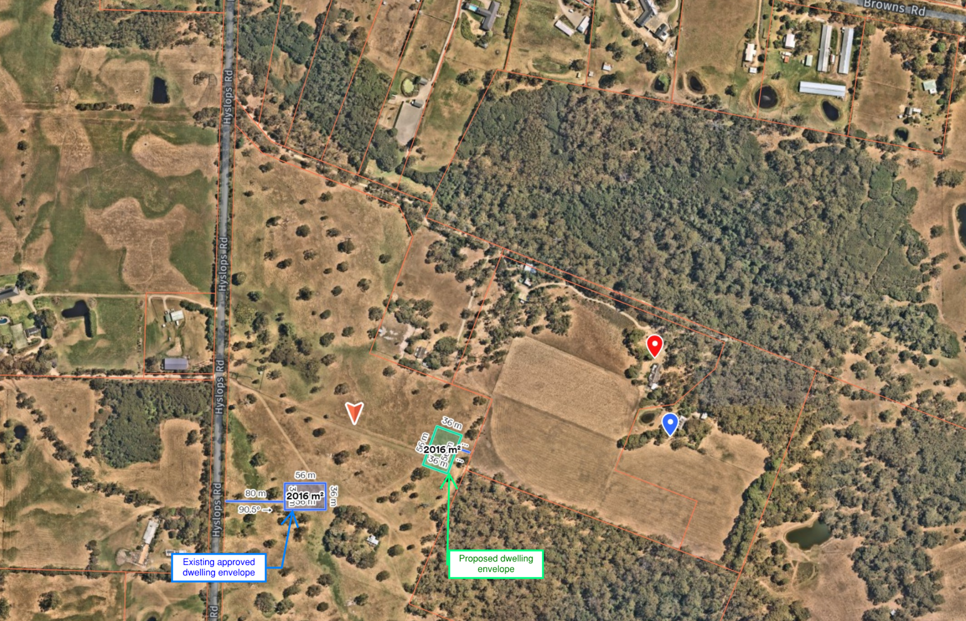
Figure 1 – Approximate location of existing (blue) and proposed (green) dwelling envelope on review site. The area shown is 2000sqm in which the house will be located. Blue pin marks dwelling at 35 Hyslops Road and red pin marks the dwelling at 37 Hyslops Road.
- The dwelling layout approved to fit within the existing and proposed 2000sqm envelope is single storey. Its general footprint is depicted in Figure 2 below.
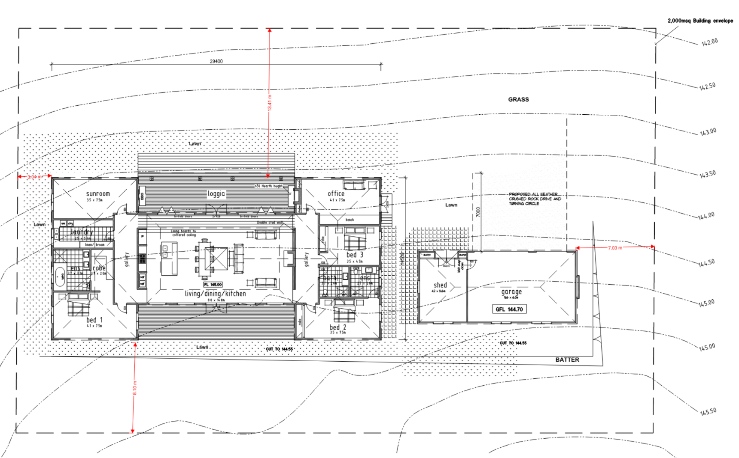
Figure 2 - Dwelling layout. The dashed rectangle marks the domestic building envelope
- Neighbours to the north-east of the review site (the review applicants), at 35 and 37 Hyslops Road oppose the new dwelling location. They say the proposed new location will have a significant impact on an established biolink that they say runs from north to south across the proposed dwelling location. They say that the native fauna that uses this biolink will avoid the house location and instead traverse their properties, leading to an adverse impact on the ability for them to conduct their agricultural activity, reducing the agricultural productivity of their land.
- The dwelling requires a planning permit in accordance with provisions of the GWZ2, ESO13 and the BMO provisions. A number of other overlays apply to part of the land, but do not trigger the need for a planning permit. The review before me is to consider if the amendment to the permit, that changes the location of the approved dwelling, is acceptable when tested against the permit requirements of the Mornington Peninsula Planning Scheme (the planning scheme).
- My reasons below set out my consideration of the relevant provisions of the planning scheme, having regard to the submissions and evidence put to me. In particular I have assessed the key issues put to me by the review applicants. This leads me to specifically consider:
- Is there a significant wildlife corridor that will be adversely affected by the amended dwelling location?
- Will the amended dwelling location lead to an unacceptable loss of usable agricultural land on the review applicants’ land?
- I have also considered other general provisions that may affect the approval of the amended dwelling location, including visual impact and amenity impact to neighbours.

Is there a significant wildlife corridor that will be adversely affected by the amended dwelling location?
- The GWZ2 triggers the need for a planning permit for a dwelling (and any amendment to it). This zone includes a purpose to protect and enhance the biodiversity of the area. ESO13, that also triggers a planning permit (and amendments to the permit) includes environmental objectives:
- To protect and conserve the environmental systems, bio diversity, native vegetation, habitat areas, land and soil stability, drainage patterns, and stream quality of this area.
- To promote the sustainable development of rural land and integrated land and catchment management, including the retention and enhancement of habitat corridors and wetlands.
- To ensure that subdivision and development density is compatible with maintaining the long term natural, agricultural and landscape values of this area.
- To promote siting and design of buildings and works that are responsive to the landscape character and vistas of this area, which includes the edge of the Selwyn Fault, and that maintains the scenic value of roads and recreation routes.
- To protect the landscape values of the area.
- Other overlays apply to the land, notably:
- The BMO that triggers a planning permit. The Country Fire Authority, as referral authority for this permit trigger do not oppose the permit and no issues before me impact on this consideration.
- The review applicants noted that while no permit is triggered under ESO28, it is relevant that this overlay includes objectives to protect bushland. My reading of the planning scheme maps is that ESO28 only applies to a thin area of the review site, abutting Hyslops Road, not the area of the approved or proposed dwelling location. ESO28 also applies to the Greens Bush area, and the Freemans Gully area north of the site.
- Both the GWZ2 and ESO13 require consideration to the Municipal Planning Statement (MPS) and the Planning Policy Framework (PPF) of the planning scheme when assessing the amendment to the permit. The review applicants particularly referred to clause 12.01-1S – Protection of Biodiversity, in the PPF. This clause has an objective to protect and enhance Victoria’s biodiversity. Policy in the clause then directs a need to consider any applicable biodiversity strategies.
- The review applicants then commented that there is a need to consider the Mornington Peninsula Biodiversity Conservation Plan and the Green Wedge Management Plan (GWMP), being adopted policies of the council. The review applicants submit these must be read together. There is no dispute between parties that these documents are of some relevance as both of the documents seek to protect and enhance habitat of native fauna. I agree, given the GWMP refers to the need to restore vegetation on private land to promote habitat links. Their relevance is also consistent with the policy objective to protect habitat areas. The GWMP then refers to a ‘Biolink’ project of the Mornington Peninsula Landcare network, at figure 9. The review applicants helpfully notated the location of the review site on this diagram, as I have copied at figure 3 below.
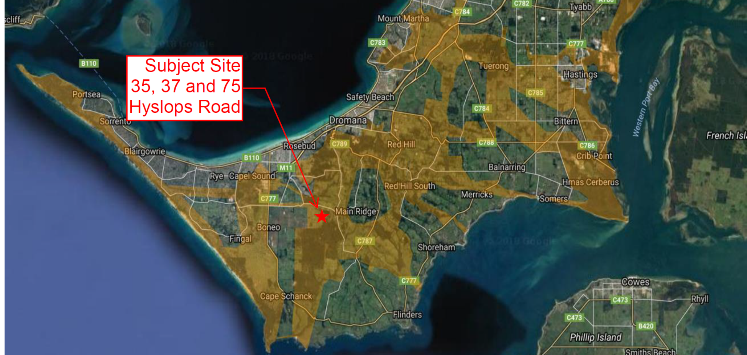
Figure 3 - extract of Figure 9 of GWMP showing Landcare Network Map of potential biolink linkages. Areas in brown are proposed biolinks
- The biolinks described in this figure are broad areas, traversing many private and public properties. The biolinks are not linked to any specific overlay provisions or have definitive boundaries. Despite the broad nature of these broad biolink areas, the review applicants rely on ecology evidence of Mr Legg that a very specific ‘critical connection point’ exists on the review site as part of the biolink network, that needs to be protected.
- Mr Legg is well experienced in monitoring fauna on the peninsula and in response to questions he also acknowledged he is secretary of South-West Mornington Peninsula Landcare group, referring to other work that he has been engaged with in other proceedings at the Tribunal, such as in Coffey v Mornington Peninsula SC. I note that in this other proceeding, referred to by Mr Legg, that he advocated on behalf of the South-West Mornington Peninsula Landcare group in its submission to support the Mornington Peninsula Landcare Network's approved biolink strategy to connect Greens Bush National Park, Arthur's Seat State Park, Peninsula Gardens Bushland Reserve and Tootgarook Wetlands through the creation and maintenance of vegetative corridors.
- Mr Legg’s evidence is that the proposed dwelling site is part of a critical connection point of this broad biolink by connecting Greens Bush, south of 35 and 37 Hyslops Road to Freemans Gully to the north of these two properties. His evidence is that fauna then traverses west from Freemans Gully across the north of the access to 35 – 39 Hyslops Road, that sits just north of 75 Hyslops Road. His evidence is that fauna then traverses Hyslops Road to loop around the south-west of a poultry farm to then connect to the Peninsula Gardens Bushland Reserve.
- Based on his experience and a site inspection, Mr Legg’s evidence is that there are two existing wildlife movement corridors between Freemans Gully and Greens Bush:
- One to the east of 35 Hyslops Road, referred to in the hearing as the eastern corridor, and;
- One that extends through 37 Hyslops Road into the review site, referred to at the hearing as the western corridor.
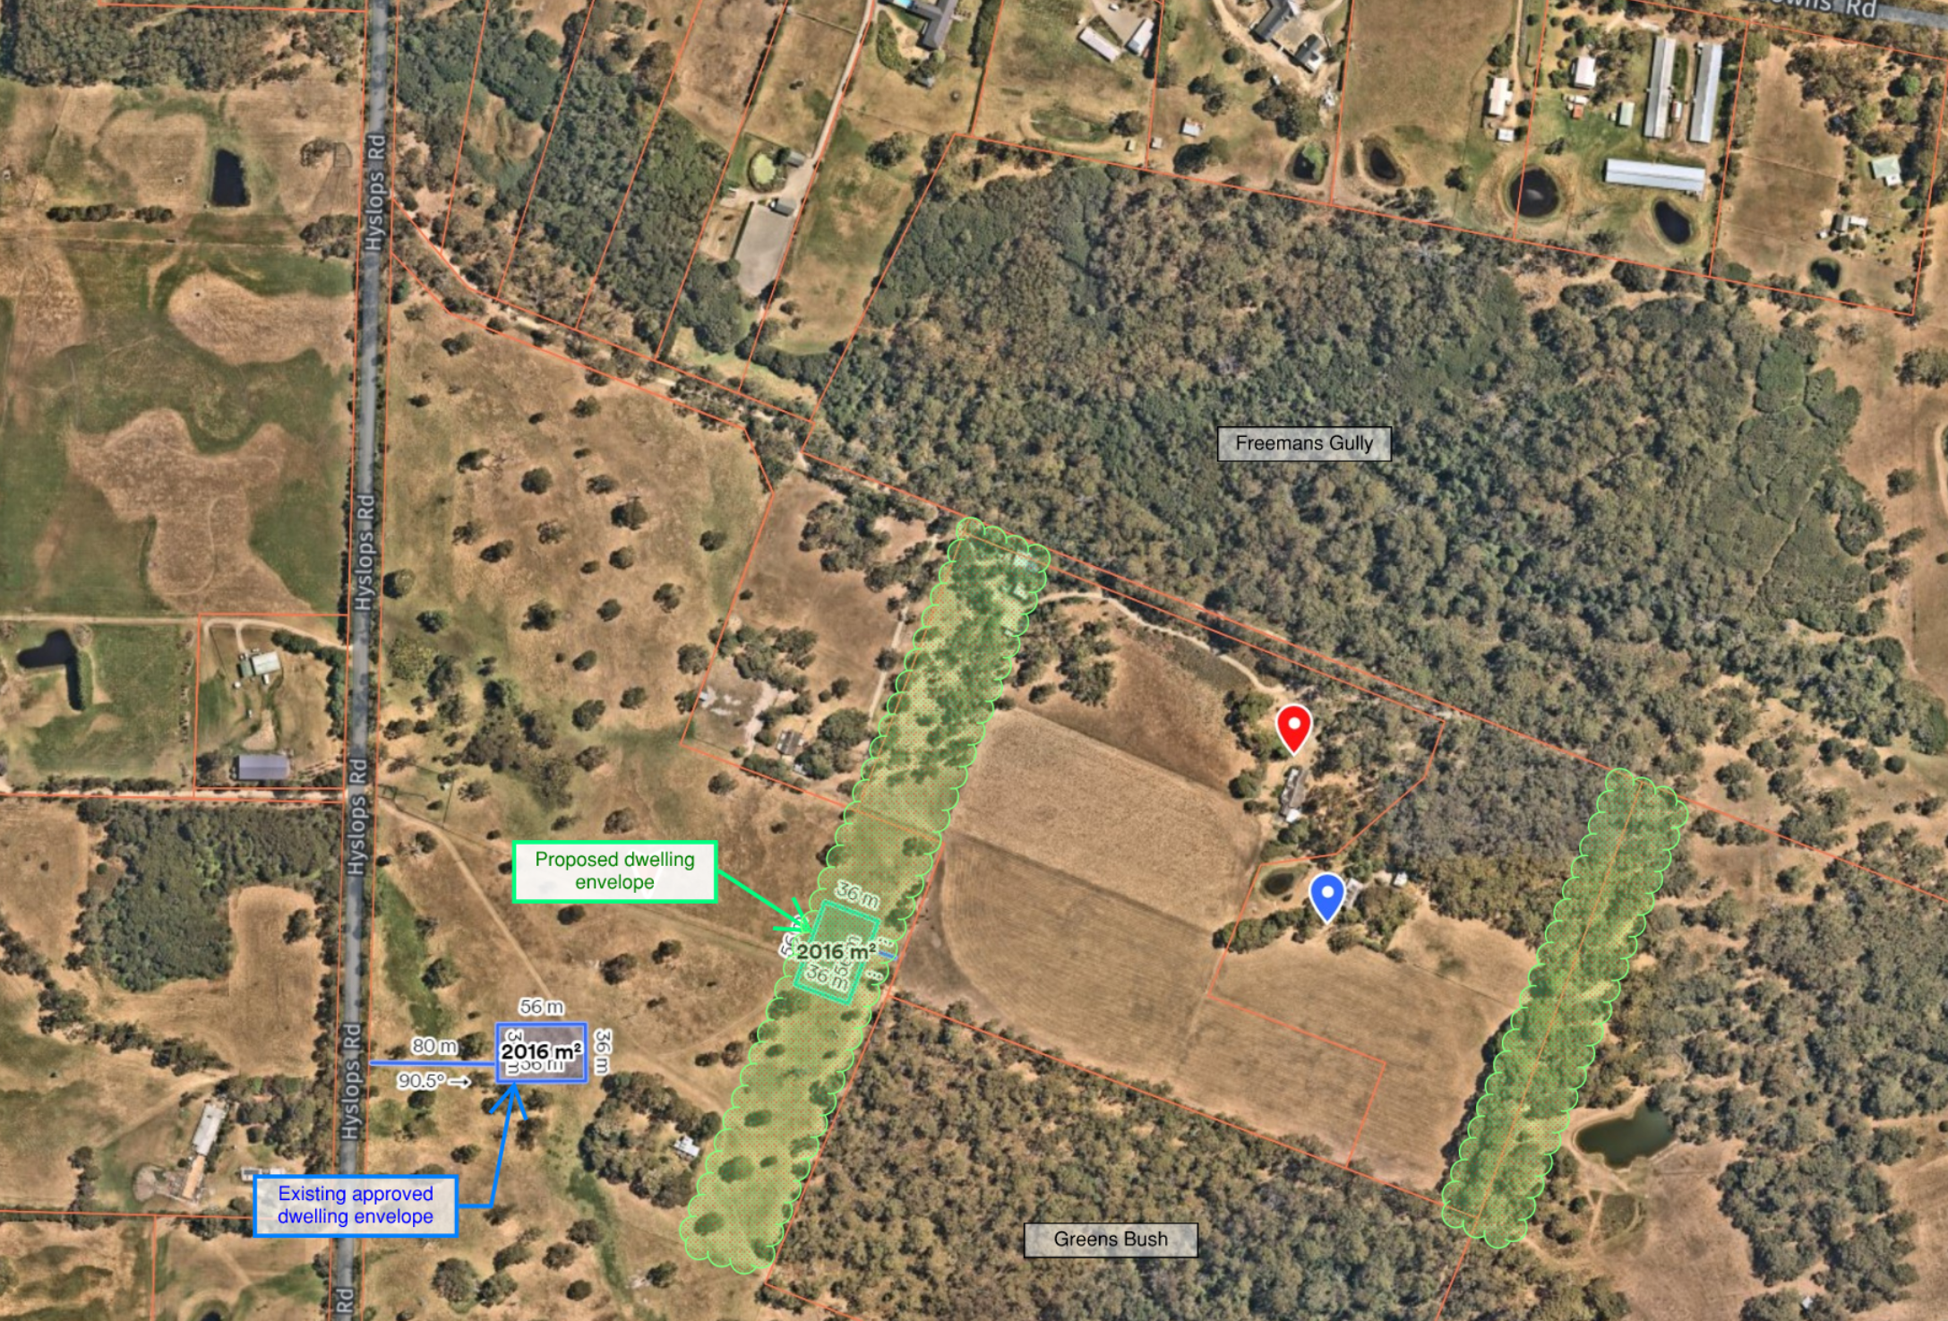
Figure 4 – East and west wildlife corridors referred to by Mr Legg marked in green on a current aerial image
- Mr Legg’s evidence, as expanded upon orally at the hearing, is that:
- The western corridor that traverses through the amended dwelling location will be adversely impacted forcing animals to travel diagonally across the open paddocks of 35 and 37 Hyslops Road that will ‘drastically affect both the carrying capacity (cattle) of number 35 and 37, and the crop yields of hay and silage currently grown.’
- The western link is the preferred route of wildlife ‘due to the quietness of the site and is the furthest away from existing houses and associated human activities.’ He makes this statement based on his observation of fauna and fauna markings on his inspection, and his understanding of the lived experience of the review applicants, as relayed to him by Ms Samways, in preparing his evidence.
- There is physical evidence on the site to indicate that animals currently traverse the western corridor, such as fur on wires where animals have created a gully under a fence.
- The eastern corridor may be used by animals traversing in a local area, but fauna travelling further north-west prefer to use the western link as it is shorter and more direct.
- Mr Legg also acknowledged in response to questions, that a contributing factor to his evidence about the location of what he says is a corridor in the west, derives from his briefing from the review applicants about their property. His written statement comments he understands from this briefing that the western corridor was achieved ‘with the informal co-operation of the neighbour to the east, and the previous owner of No. 75 to the west’ by ‘running an electric fence border’ in the location of the western corridor, in effect funnelling wildlife into this area. The electric fencing has since been removed as 35 and 37 Hyslops Road are currently destocked.
- The permit applicant called evidence of Mr Brennan that there was no physical evidence of a specific wildlife corridor by which fauna traverse the area. Rather his evidence relied on a more general understanding of fauna known in the area and the habitat environs they like to traverse. His evidence is that smaller animals will stay closer to more vegetated and covered areas, which are areas predominantly to the east of 35 Hyslops Road. This is consistent with Mr Legg’s nominated eastern corridor.
- Mr Brennan’s evidence is that larger animals, notably kangaroos, are more comfortable with traversing grassed areas so will take a multitude of potential options to use open areas to graze. This includes grazing across all of the paddocks surrounding Greens Bush and Freemans Gully. Mr Brennan also made observations on site, but his evidence is that this was to observe fauna and the habitat, not to rely on particular movements that he may have been seen on his visit.
- The review applicants submit that Mr Brennan provides no evidence that the eastern boundary is a better route noting that there is no indication that he considered the different soil type on the eastern boundary (being what they say is heavy clay). The review applicants also say the eastern area can be boggy due to a dam east of 35 Hyslops Road. They submit that the dampness deters animals. When questioned on this Mr Brennan’s response was that some animals prefer a damper location. His evidence is that the location of a dam is an advantage the eastern route has over the purported western route as it provides a localised habitat and water source for animals. There is no water source in the purported western corridor. I also note that the area east of 35 Hyslops Road is also on higher land, not a low point.
- I cannot rationalise from Mr Legg’s evidence that there is a western corridor, or that if there is, it is of such significance that the proposed dwelling cannot locate within it. It is not an area well vegetated with native plants, or identified in any policy document referred to in the planning scheme. If previous fencing had influenced animal movements, as Mr Legg was advised by his client, there is no meaningful evidence to suggest this continues or that it creates a designated corridor.
- Both ecologists were referred photos tabled by the review applicants that showing gullies under fences made by animals to suggest this demonstrated wildlife movement in the western area. Both experts concurred that these gaps in the fences may be providing access for wildlife. I saw these gaps on my inspection. I accept the evidence that they may be being used by wildlife, but I also observed them being used by two sheep traversing from 35 Hyslops Road to 75 Hyslops Road. In either event the gaps do not appear to have been created as a deliberate endeavour to direct wildlife as part of a corridor. Rather they appear to exist from opportunities taken by animals in general to move about the land. I therefore do not consider the use by animals of gaps under the fences is proof of a habitat corridor.
- Nor can I rationalise that observations of animals or animal markings in the area create a defined habitat corridor of such significance that it must remain devoid of any dwellings. This is noting that the area proposed for the amended house location is currently used as grazing land and the dwelling construction does not require the removal of any native vegetation. While I expect some native animals, notably kangaroos graze on the grassed area, this does not make a specific habitat corridor.
- My observations concur with aerial photography and photos tendered by parties that if there is a wildlife corridor, it is the area to the east of 35 Hyslops Road. This area has much greater undergrowth and general tree coverage. This eastern area is on higher land, so if it boggy it is possibly a drainage issue associated with the dam in this area, rather than being boggy as a natural depression, as no such low point exists in this location. This eastern area is also well away from any existing dwelling.
- In summary, I find I cannot rationalise that there is a definitive habitat corridor that will be adversely affected by the amended location of the dwelling at 75 Hyslops Road.
- My view on this is reinforced by the fact that the Department of Environment, Land Water and Planning (DELWP) did not object to the amended location of the dwelling, subject to conditions that are included in the amended permit proposed by the council. This includes a need to ensure that domestic and farm animals are contained within the property, so as to not roam onto the adjoining National Park, and also that no access tracks or entry points are allowed from the property to the park. The council’s proposed amended permit includes conditions to enact this. I note the review applicants also requested that a condition be put on the permit to prohibit the keeping of domestic dogs at the dwelling. I cannot rationalise a need for this for this permit condition given DELWP, as land manager of the adjoining National Park only requires fencing to be maintained.
- The proposed amended permit conditions proposed by the council require a domestic envelope to be established for the dwelling. This can assist in ensuring that any non-rural type activities are confined to a specific area. Mr Brennan’s evidence that the greatest disturbance of wildlife is likely to be during construction when noise may occur. His view is that a condition could be placed on the permit to limit construction activities to an area close to the house. I have added a condition to require construction activities to be restrained to the domestic envelope. The review applicants consider a more detailed construction management plan should be provided to restrict other matters, such as the hours of construction activity. I am satisfied that conventional State noise limit policies for construction can address this issue.
- Mr Brennan also acknowledged that intensive floodlighting may impact nocturnal animals and therefore a permit condition to restrict external lighting may be appropriate. I have included such a condition based on Mr Brennan’s oral evidence on this issue.
- With these conditions in place I am satisfied that the amended dwelling location will not unreasonably impact any wildlife that may use the general grazing area to traverse between the habitat areas of Greens Bush and Freemans Gully.

Will the amended dwelling location lead to an unaccepable loss of agricultural land?
- While Mr Legg’s written evidence is that having fauna traverse diagonally across 35 and 37 Hyslops Road, ‘will drastically affect both the carrying capacity of cattle and crop yields on these properties.’ In response to questions on this statement he acknowledged that he is not an agricultural expert. I remain unclear on what basis he makes his assertion that the amended dwelling location will ‘drastically affect’ the agricultural capacity of the adjoining land.
- Mr Brennan’s evidence is that, based on habitat, the most likely native animals to traverse the area where the dwelling is to be located are kangaroos. His evidence is that kangaroos most likely graze on much of the open grassed areas of the properties between Greens Bush and Freemans Gully. He also commented that kangaroos, as a species, become familiar with human activity and can often be observed grazing close to dwellings and human occupation of land (e.g. as can often be observed at regional golf courses).
- As farms located between public reserves, both 75 Hyslops Road and 35 – 37 Hyslops Road already need to manage native animals that may enter and impact farming activities. From Mr Brennan’s evidence I am not convinced that native animals that may currently traverse or graze in the area close to the amended location will substantially change their movement patterns. To any extent that these animals may change their grazing or movement patterns, there is nothing before to suggest that the change will result in a substantive increase or intensification of native animal use on 35 – 37 Hyslops Road, to the extent that it results in this agricultural land unusable or unsustainable.
- I find the review applicants’ arguments on this issue are not made out.

Are there any other issues?
- The review applicants statement of grounds lodged with their review application included statements that the proposed dwelling:
- will result in an unacceptable visual impact,
- will have an adverse impact on rural amenity, and
- fails to acceptably respond to the purposes of the Green Wedge zone and relevant overlays.
- From my inspection I was able to see poles on the review site nominating the proposed amended location of the house. While poles are not a house, the poles assisted in reading the location of the dwelling in the landscape context. From this I concur with comments of the council and the permit applicant that as a single storey house sitting part way up the ridge sitting closer to Greens Road to the east, the proposed amended location will not be in a highly exposed or visually prominent location.
- The proposed dwelling location does not impact on any existing native vegetation and it will read as a dwelling sitting in a location with a backdrop of other vegetation and the higher slope allowing it to read as a relatively low impact form in the overall landscape. It will not be prominent from any road. Nor was it put to me that it will be prominent from any public vantage point.
- The proposed location is more than 100 metres from any other dwelling ensuring that general amenity expectations for dwellings on rural properties can be maintained.
- From the material before me I find nothing to indicate that the amended dwelling location fails the relevant purposes and provisions of the GWZ2, ESO13, or BMO provisions that trigger the need for a permit.

Conclusion
- For the reasons given above, the decision of the responsible authority is varied. Permit P20/1177.01 is amended to amend permit conditions in accordance with the conditions set out in Appendix A.
- The conditions include an amended condition 1 and new conditions 11 to 19, inclusive. These are amendments as set out in the council’s notice of decision to amend the permit, other than from merging what the council proposed as conditions 1 and 1A. I have added in conditions 11 and 12 in response to the recommendations of Mr Brennan as I have discussed above.

Alison Glynn
Member

Appendix A – Amended Permit Conditions

Permit No: | P20/1177.01
Land: | 75 Hyslops Road  MAIN RIDGE VIC 3928

Conditions:

Amended plans
- Prior to the commencement of any buildings and works for the amended design approved under P20/1177.01, amended plans to the satisfaction of the Responsible Authority must be submitted to and approved by the Responsible Authority. When approved, the plans will be endorsed and will then form part of the permit. The plans must be drawn to scale with dimensions. The plans must be generally in accordance with the plans submitted with the application but modified to show:
  - Details as to the upgrade of the existing vehicle track to an all-weather track suitable for emergency vehicles. The details must include any required excavation or fill.
  - Details as to battering or retention of excavated or filled areas within the domestic building envelope.
  - Notations about the supply of potable water and electricity to the dwelling.
  - A notation about water supply and access for fire-fighting purposes.
  - The location of the turning area as described in the approved Bushfire Management Plan;
  - A nominated domestic envelope which must include the dwelling, parking, bushfire infrastructure, domestic gardens, and must not exceed 2,000sqm.

Layout not altered
- The layout of the land, the size and type of the buildings and works, including the materials of construction, on the endorsed plans must not be altered or modified without the written consent of the Responsible Authority.

External finishes
- Prior to the initial occupation of the dwelling external finishes must be completed to a professional standard to the satisfaction of the Responsible Authority.

Materials and colours
- The materials and colours of the exterior finish of the buildings must be in accordance with the Endorsed Plans unless with the further permission of the Responsible Authority.

Disturbed surfaces
- All disturbed surfaces on the land resulting from the development must be revegetated, battered and stabilised to the satisfaction of the Responsible Authority.

Vehicular access
- Prior to the occupation of the dwelling, the driveway must be constructed and thereafter maintained and drained to the satisfaction of the Responsible Authority.

Implementation of the Farm Management Plan
- Prior to the initial occupation of the dwelling, the landowner/occupier must demonstrate commencement of the endorsed Farm Management Plan to the satisfaction of the Responsible Authority. The endorsed Farm Management Plan must thereafter be implemented and maintained to the satisfaction of the Responsible Authority.

Environmental health
- All sewage and sullage wastewater from the proposed development must be discharged into an on-site septic tank system which is approved by the Environment Protection Authority, retains all waste within the boundaries of the land, and is installed in accordance with Council’s Wastewater Management Policy. This system must be maintained to the satisfaction of the Responsible Authority.
- The wastewater disposal field must be located no closer than 60m from any surface waters.

Permit expiry
- This permit will expire if either one of the following applies:
  - The development is not completed within four years of the date of this permit.
  - The use has not commenced within four and a half years of the date of this permit.
In accordance with Section 69 of the Planning and Environment Act 1987, an application may be submitted to the Responsible Authority for an extension of the periods referred to in this condition.

Fauna protection
- All construction activities associated with the establishment of the dwelling, other than for the establishment of vehicle access and services, must be confined to the nominated domestic envelope, to the satisfaction of the Responsible Authority.
- Any external lighting of the dwelling must be designed to minimise disturbance to nocturnal native animals, to the satisfaction of the Responsible Authority.

Country Fire Authority (CFA) conditions
- Before the development starts, the Bushfire Management Plan prepared by Nepean Planning Consultants, dated 01/07/2021, version 1, page 1 of 1 must be endorsed by the Responsible Authority. Once endorsed the plan must not be altered unless agreed to in writing by CFA and the Responsible Authority.
- The bushfire protection measures forming part of this permit or shown on the endorsed plans, including those relating to construction standards, defendable space, water supply and access, must be maintained to the satisfaction of the responsible authority on a continuing basis. This condition continues to have force and effect after the development authorised by this permit has been completed.
- At a minimum, a standard rural style post & wire fence capable of restraining domestic animals and livestock is to be constructed to the satisfaction of Parks Victoria on the boundary of the National Park.

Department of Environment, Land Water and Planning conditions
- No private entry points (gates) or informal access tracks are permitted into the National Park from the subject property.
- Domestic animals (dogs, cats or other) and all livestock are prohibited in the National Park and must be contained within and remain in the subject property at all times.
- Development and construction access/works cannot impact on, or any waste/debris or cut vegetation cannot be deposited into the National Park from the subject property.
- Pasture improvement and/or weed control practices on the subject property cannot impinge or have an effect on the native vegetation or fauna within the National Park.
- End of conditions -

The submissions and evidence of the parties, any supporting exhibits given at the hearing, and the statements of grounds filed; have all been considered in the determination of the proceeding. In accordance with the practice of the Tribunal, not all of this material will be cited or referred to in these reasons.
My emphasis added.
[2022] VCAT 463.
Paragraph 4 of Coffey v Mornington Peninsula SC.

