VICTORIAN CIVIL AND ADMINISTRATIVE TRIBUNAL

|  |  |
| --- | --- |
| planning and environment LIST | vcat reference No. P11245/2021  Permit Application no. PA21-0145 |
| CATCHWORDS | |
| Removal of restriction limiting development to a single dwelling and no subdivision as well as the specifying details regarding size and materials of dwelling; Whom should be given notice; Relevance and consideration of non-beneficiary objections; Relevance of other variations to restrictions including whether restriction has served its purpose; Neighbourhood character, amenity and traffic. | |

|  |  |
| --- | --- |
| **Applicant** | Mr T Willis |

|  |  |
| --- | --- |
| **Responsible Authority** | Casey City Council |
| **Respondent** | MJ Reddie Surveys Pty Ltd |

|  |  |
| --- | --- |
| SUBJECT LAND | 44 - 48 St Helens Crescent  NARRE WARREN VIC 3804 |
| HEARING TYPE | Hearing |
| DATE OF HEARING | 15 March 2022 |
| DATE OF ORDER | 10 June 2022 |
| CITATION | Willis v Casey CC [2022] VCAT 650 |

# Order

### No permit granted

1. In application P11245/2021 the decision of the responsible authority is set aside.
2. In planning permit application PA21-0145 no permit is granted.

|  |
| --- |
| Rachel Naylor  **Senior Member** |

# Appearances

|  |  |
| --- | --- |
| For applicant | Mr T Willis |
| For responsible authority | Ms B Gungabison, town planner |
| For respondent permit applicant | No appearance |

# Information

|  |  |
| --- | --- |
| Land description | The site has an area of 4,010sqm and is located on the north side of St Helens Crescent in a residential estate that has been in existence since at least the 1990s. It is not easily accessible with one access road connected to Belgrave-Hallam Road that is located about 1.5km away by road.  The estate comprises lots of generally about 2,000 sqm in area, but this site and the two properties either side of it are at the northern end of the estate and have areas of about 4,000sqm. The lots in this estate are also burdened by a covenant that restricts various matters including limiting development to a single dwelling, no subdivision as well as specifying details regarding the size and materials of any dwelling constructed. |
|  | |
|  | The land to the north of this residential estate forms part of another residential estate that also has larger lots of 4,000sqm or more. This includes Mr Willis’ property.  The site contains limited vegetation and one house that is located generally in the western half of the lot. |
|  | |
| Description of proposal | To remove the restrictive covenant to allow for future development in accordance with the General Residential Zone and Development Plan Overlay requirements. |
| Nature of proceeding | Application under section 82 of the *Planning and Environment Act 1987* – to review the decision to grant a permit. |
| Planning scheme | Casey Planning Scheme |
| Zone and overlays | General Residential Zone Schedule 1  Development Plan Overlay Schedule 2 |
| Permit requirements | Clause 52.02 To remove a restriction (restrictive covenant) |
| Non-participation of respondent permit applicant | The statement of grounds on behalf of the Respondent permit applicant was lodged by MJ Reddie Surveys Pty Ltd and the grounds relied upon in the statement are –  *Spear application S171498S to remove restrictive covenant W684846E on lot 53 PS412669P was lodged with Council and a notice of decision to grant the permit issued.*  *All steps were correctly taken under the planning scheme. My client will be attending the VCAT hearing*.  The Respondent had a representative at the Compulsory Conference for this proceeding[1], but no representative attended this merits hearing.  This was discussed with the Council and Mr Willis at the start of the merits hearing. The hearing proceeded as it is Mr Willis’ application to review the Council’s decision (regardless of the permit applicant’s participation), and the Council attended this merits hearing ready to support its decision. |

# Reasons[2]

### Overview

1. Mr Willis seeks a review of the decision by Casey City Council to grant a permit for the removal of the restrictive covenant from the land at 44-48 St Helens Crescent, Narre Warren North.
2. Mr Willis owns an adjoining property that abuts the majority of the northern (rear) boundary of this site. He is concerned that the covenant removal will result in additional development on the site that will be out of character with the large residential allotments and open, semi-rural surrounds, particularly in St Helens Crescent and Jaguar Close. He is also concerned about the loss of amenity in terms of noise and privacy, particularly as the common boundary fence is of post and wire construction and there is limited screening landscaping on either property.
3. The Council notes Mr Willis is not a beneficiary of the covenant as his property is located in a separate residential estate to this site. The Council considers the lack of objection by beneficiaries and the fact that area is fully serviced and could be developed in accordance with the relevant planning controls means the proposal is not considered to detrimentally affect the amenity of the area.
4. Having considered the legislation, the planning scheme, the material submitted to the Tribunal through the processing of this review application and the material submitted for and at this hearing, I have decided to set aside the Council’s decision. The reasons why I have reached this decision are explained below.

### The restrictive covenant

1. This covenant words that explain the restrictions is extracted and quoted in full below.



1. Of particular relevance to the concerns expressed by Mr Willis in this case the restriction limits development to a single dwelling, does not allow subdivision of lots and it specifies details regarding the construction of a dwelling including the size and materials of the dwelling.
2. Before turning to the merits of the proposal, I have made some findings about the documentation provided for this proceeding and the notice of the permit application.

### Material to be relied upon at the hearing

1. The Planning & Environment Division of VCAT has been undertaking hearings online for over two years now. The process to ensure fairness to all parties includes a standard order in initiating orders and orders following compulsory conferences that all submissions and materials to be relied upon at a hearing must be circulated to the Tribunal and the other parties five business days prior to the hearing.
2. In this case, this did not happen. Hence, my following observations and comments are provided as a timely reminder of the importance of following the Tribunal’s orders in order to provide a fair hearing to all involved, meaning both the parties and the Tribunal.
3. In this case, upon receipt of an email reminder from the Tribunal, Mr Willis re-filed his original letter of objection and two photographs. No correspondence was received from either the Council or the Respondent permit applicant. Hence, neither the Tribunal nor Mr Willis had any knowledge about what documentation other parties may seek to rely upon at the hearing. Time was spent at the start of the hearing confirming with the Council what documentation it would be relying upon, and whether that material was known to Mr Willis. Unremarkably, not all of the material was known to Mr Willis, such as the officer delegate report. Also, the Council referred to a full copy of the approved development plan, which was a document that had not been formerly provided during the processing of the review application and had not been seen by Mr Willis.
4. In regard to material such as a Council officer delegate report, there is no formal requirement[3] for this to be provided to an objector. Participants in a VCAT review process who are not technically experienced (e.g. a town planner or planning lawyer) do not know what they do not know. In other words, it should not be assumed that non-experienced participants in a VCAT planning proceeding will be familiar with the fact that a report assessing the merits of a permit application has been prepared by the Council, or that they are entitled to obtain a copy of this report. Similarly, they will not necessarily understand that there may be material filed with the Tribunal in response to the lodging of a VCAT application that may have formed part of the permit application (e.g. consultant reports and the Council delegate report, etc.). These circumstances assist to highlight why a response to the Tribunal’s standard orders about what material will be relied upon at the hearing is necessary. Certainly, it is not necessary to file material twice, but correspondence that outlines what material will be relied upon provides certainty and clarity for all involved, including the Tribunal member(s) hearing and determining the merits of the proceeding.

### Whom should be given notice of this planning application?

1. Whom should be given notice of this type of planning application (the removal of a restriction) has a level of complexity about it. Upon review of the *Planning and Environment Act 1987* (**P&E Act**) and the Development Plan Overlay, it appears that some of the notice the Council has given of this permit application and the recently determined permit application next door at 38-42 St Helens Crescent (a matter I will say more about later in these reasons) was not required.
2. Section 52 of the P&E Act specifies notice to be given of an application in particular ways, including specifically for a ‘registered restrictive covenant’.[4] The Council gave notice of this planning application pursuant to sections 52(1)(a), 52(1)(d), 52(1AA)(a), 52(1)(cb) and 52(1AA)(b).[5] During the hearing, I asked the Council about this extent of notice given there is a development plan approved under the Development Plan Overlay (**DPO**), which means the exemptions in clause 43.04-3 of the DPO are relevant:

If a development plan has been prepared to the satisfaction of the responsible authority, an application under any provision of this planning scheme is exempt from the notice requirements of section 52(1)(a), (b) and (d), the decision requirements of section 64(1), (2) and (3) and the review rights of section 82(1) of the Act.

1. The above exemption means no notice needs to be given to the owners and occupiers of lots adjoining the land, a municipal council who may be affected, a person to whom the planning scheme requires notice to be given, or any other persons the Council considers that the grant of the permit may cause material detriment to.
2. The particular notice requirements for applications to remove or vary a registered restrictive covenant that are not captured by the above exemption, are:
3. giving notice to the owners and occupiers of land benefiting from the registered restrictive covenant (s 52(1)(cb);
4. placing a sign on the land which is the subject of the application (s 52(1AA)(a); and
5. publishing a notice in a newspaper generally circulating in the area in which that land is situated (s 52(1AA)(b).
6. Mr Willis is an adjoining land owner who does not benefit from the restrictive registered covenant. Pursuant to the above notice requirements that are not exempt, he has the right to lodge an objection in response to the placing of a sign on site or publishing a notice in the newspaper. Hence, his objection is valid, and his concerns must be considered as relevant to the planning permission required.

### Overview of reasons for decision

1. The Council has given weight to the fact that there has been no objection by a beneficiary in making its decision to approve this proposal to remove the restriction.
2. The Council decision in this case is different to a decision made by the Council on 11 January 2022 on the property next door at 38-42 St Helens Crescent (that I was advised of during the hearing). The Council refused a variation to the restrictions relating to only one dwelling and no subdivision. The Council displayed this officer report during the hearing that explains a beneficiary did object, and the Council shared their concerns (see paragraph 37 of these reasons for further details).
3. If the Council considers the variation to the restrictions on the property next door may create detriment to be suffered by covenant beneficiaries, it is unclear how the Council does not consider the same situation applies on this site where the proposal is seeking more (as it seeks the total removal of restrictive covenant).
4. The consequence of this proposal could be a two lot subdivision (with a planning permit) and the construction of a dwelling (without a planning permit) or the construction of a second dwelling on a lot (with a planning permit). Another consequence of this proposal could be a new dwelling built that has a differing floor area and differing materials and finishes to those specified in the covenant. Whilst the subdivision of land contemplated by DPO2 sets a minimum lot size of 2,000 square metres, the relevant planning policies make it clear that this area of Narre Warren North is to remain a large lot/rural residential area described as ‘lifestyle living’. Hence, the fact that a permit can be granted for a two lot subdivision does not automatically mean that it would be pursuant to the existing physical and planning policy contexts.

### Relevant considerations

1. Relevant considerations for the removal of a restrictive covenant include:
2. Section 60(5) of the P&E Act:

The responsible authority must not grant a permit which allows the removal or variation of a restriction referred to in subsection (4) unless it is satisfied that —

(a) the owner of any land benefited by the restriction (other than an owner who, before or after the making of the application for the permit but not more than three months before its making, has consented in writing to the grant of the permit) will be unlikely to suffer any detriment of any kind (including any perceived detriment) as a consequence of the removal or variation of the restriction; and

(b) if that owner has objected to the grant of the permit, the objection is vexatious or not made in good faith.

1. Clause 52.02 that applies to easements, restrictions and reserves. The purpose of this particular provision is:

To enable the removal and variation of an easement or restrictions to enable a use or development that complies with the planning scheme after the interests of affected people are considered.

The associated decision guideline states that, in addition to the decision guidelines in clause 65, the interests of affected people must be considered.

1. Clause 65.01 general considerations for an application include (as potentially relevant to this proposal):

* The matters set out in section 60 of the Act.
* The Municipal Planning Strategy and the Planning Policy Framework.
* The purpose of the zone, overlay or other provision.
* Any matter required to be considered in the zone, overlay or other provision.
* The orderly planning of the area.
* The effect on the environment, human health and amenity of the area.

### Relevance and consideration of non-beneficiary objections

1. It appears the fact that there was one objector who benefited from the covenant was an influential consideration in the Council’s decision to refuse the permit application for the adjoining property at 38-42 St Helens Crescent. In addition, the Council officer delegate report for that permit application also determined that there would be detriment as a consequence of the proposed variation of covenant.
2. Section 60(5)(a) is not confined to the receipt of objections by beneficiaries of registered restrictive covenant. Any detriment of any kind in relation to any land with the benefit of the covenant must be considered, whether the owners of such land have objected or not.[6] Section 60(5) of the P&E Act requires the Council as the responsible authority and, upon review, the Tribunal (standing in the Council’s shoes) to be independently satisfied about the likelihood of detriment. This is not a matter that is dependent upon whether or not there are objections.

### Planning controls

1. This site is zoned General Residential (**GRZ**) and is affected by schedule 2 of the Development Plan Overlay - Intermediate Density Residential Areas (**DPO2**). The adjoining properties to the north in Jaguar Close are zoned Low Density Residential. This is illustrated in the extract from the Council officer report below.

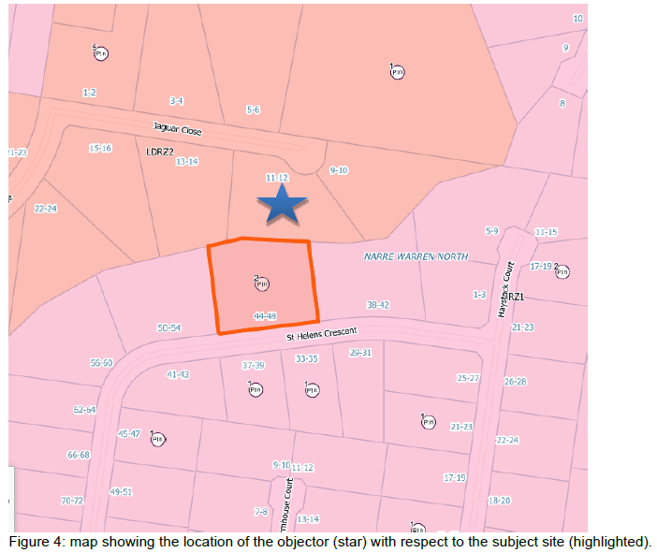

1. What this extract also illustrates is that the character of the area comprises lots gradually increasing in size. There are lots in the order of 2,000 square metres to the south of this site. This site and the two properties on either side then have an increased size of a minimum of 4,000 square metres. Then, the Jaguar Close properties are either around 4,000 square metres or greater in size.
2. Clause 2 of DPO2 contains the following requirement:

The following requirements should be met before a permit may be granted:

* A lot size for the subdivision that appropriately reflects the low density residential character envisaged in the development plan; or
* A minimum lot size of 2,000 square metres for all residential lots.

1. During the hearing, the Council provided a copy of the Cell K Development Plan approved on 24 March 2009 and updated on 11 December 2014. This development plan applies to both this site and its residential estate as well as the properties in Jaguar Close. Section 4 of the Development Plan explains the rationale for the allowable lot sizes:

The land contained in Cell ‘K’ is semi-rural in nature and includes a combination of low density residential properties and agricultural activities. Initially, it was proposed that Cell ‘K’ would be developed as a low density residential area with lots having a minimum area of 4,000 m2.

Council believes that the ‘hatched’ area shown on Plan No. 2 has potential to be developed to allow low density lots below the standard 4,000 m2. The ‘hatched’ area is considered to be suitable for lots with a minimum of 2,000 m2. The development of land into 2,000 m2 lots was facilitated by Amendment L103 to the Berwick Planning Scheme.

The provision of lots below 4,000 m2 within Cell ‘K’ will enable the land to be used more efficiently and will allow a wider variety of lot sizes. In turn, this proposal will facilitate development at a higher density which will ensure that the existing services are fully utilised. The development of this land to allow of [sic] 2,000 m2 will ensure the retention of the semi-rural environment within Cell ‘K’.

1. Page 11 of the Development Plan contains Plan 2 showing the hatched land with development potential for 2,000 square metres. The Council’s delegate report includes an extract of this plan with the location of this site identified. In the extract Jaguar Close I to the left of this identified site. It is not hatched and therefore does not have a development potential for 2,000 square metre sized lots. Hence, the approved development plan does not contemplate further subdivision of these properties.

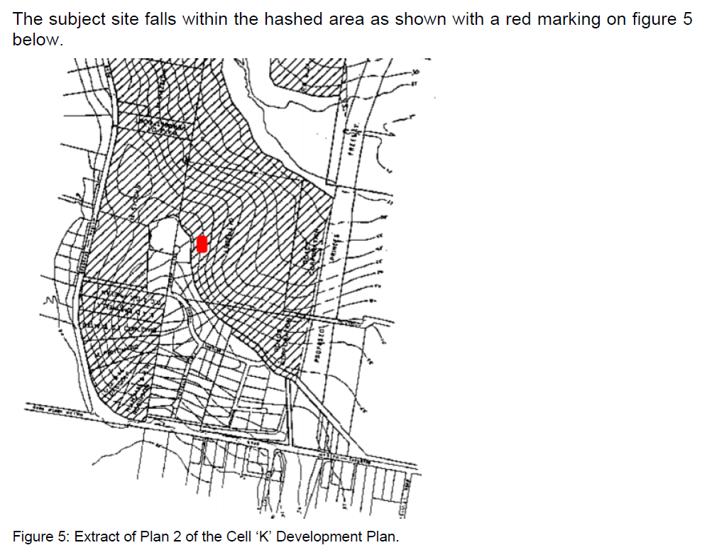

1. During the hearing, there was discussion about whether clause 43.04-2 of the DPO triggers permit requirements for land use, subdivision, construction of a building or construction or carrying out of works on this site as part of any future development. Despite the Council’s tentative view that the DPO may include permit triggers, after the hearing I have viewed the planning control in greater detail and consider that the DPO merely requires that there be a satisfactory development plan before a permit is granted under other provisions of the planning scheme for land use, subdivision or buildings and works. This means that any future planning permit requirements for this site are to be found in the GRZ. If the registered restrictive covenant was removed from this site, a planning permit would be required to subdivide the land. This would be exempt from notice requirements. The permit would need to be generally in accordance with the approved development plan and include any requirements specified in DPO2. Then, if this site was subdivided, no planning permission would be required for the construction of a dwelling (assuming that the lot for the dwelling is 2,000 square metres and therefore greater than 500 square metres in area).

### Relevance of other variations to restrictions including whether restriction has served its purpose

1. The purpose of the covenant needs to be identified in order to consider what detriment may be suffered as a consequence of its removal. The covenant places the following restrictions on this site and the other properties in the residential estate:

* One private dwelling with an area of not less than 223 square metres that has external walls of brick, stone, concrete and glass with cement sheet and timber infill panels not exceeding 25% of total external wall area or any combination of the same and roofing constructed of a non-reflective material with a pitch not less than 22 degrees; and
* No subdivision of the land.

1. All of the beneficiary properties in this subdivision have been developed and neither party was able to point to any existing variations (whether legally permitted or not) to the covenant. Certainly, the Council advises it is not aware of any other permits issued to vary or remove the covenant. So, these restrictions continue to serve a purpose of maintaining a low intensity pattern of development with houses of a certain minimum size and that have a similar standard of construction and some similarities in appearance due to the materials and finishes that can be used. These restrictions have also maintained the original estate’s lots and subdivision layout and pattern as the lots cannot be further subdivided. Such restrictions assist to create and protect the amenity of this residential estate as well as adjoining properties such as the Jaguar Close properties that abut the northern end of this estate.
2. There are five lots in this subdivision that have land areas in the order of 4,000 square metres, and they are all at the northern end of the estate. The Council provided no history about the approval of this residential estate, and it was unable to explain whether there are particular reasons why these lots are larger. Mr Willis and the Council did explain that the Jaguar Close properties were developed with onsite sewerage systems, which is reflective of their different residential zoning and large lot sizes. These circumstances may be a contributing factor to the inclusion of larger lots that have an interface with the Jaguar Close properties.
3. It was only at the end of the hearing and in response to my questions that the Council advised of two other planning applications being made to vary the covenant. Importantly, these planning applications relate to the lots that adjoin each side of this site. Each of these applications are seeking to vary the restrictions that relate to only one dwelling and no subdivision.
4. The Council advises the planning application for 52-54 St Helens Crescent is for a two lot subdivision and variation of the covenant to remove the restrictions relating to a single dwelling and no subdivision. This application is subject to a request for further information, so it is in an early stage of its processing.
5. The Council advises the planning application for 38-42 St Helens Crescent was to vary the covenant to remove the single dwelling and no subdivision restrictions. The Council refused to grant a permit on 11 January 2022 on one ground that it was not satisfied that the owner of any land benefited by the restriction will be unlikely to suffer any detriment of any kind (including any perceived detriment) as a consequence of the variation of the restriction.
6. The Council provided a copy of the officer delegate report upon request at the end of the hearing. This report notes one objection from a beneficiary was received expressing concern about increased traffic and a loss of character.
7. In regard to increased traffic, Mr Willis points out St Helens Crescent is effectively at a dead end and reasonably isolated. Google maps suggest the distance from the site to the nearest intersection with a road leading out of the area is at Belgrave-Hallam Road and Drysdale Avenue, about 1.5km in distance by road from this site. This residential estate is clearly a location where car usage would be prevalent. Also, the Council officer report states in part:

Even though the site is subject to a DPO which restricts subdivision to only 2000sqm per lot, Officers are not satisfied that there will not be any detriment (such as neighbourhood character, noise, overshadowing, overlooking or increased traffic) to beneficiaries as a result of the proposed removal of the Section 1 and 4 of the covenant.

1. In contrast, the Council officer report for this proposal states:

The application was advertised, and all beneficiaries were notified of the removal of restriction application. No objection was received from the beneficiaries.

It is taken that the beneficiaries did not see a detriment to the removal of restriction from the said land.

It is considered that the beneficiaries will not be detrimentally affected as the predominant lot sizes subject to this covenant are within the 2000m2 range. The removal of the restrictive covenant from Lot 53 will allow for future development in line with the neighbourhood character with single dwellings on 2000m2 lots. The area is fully serviced and is not considered to detrimentally affect the amenities with substantial increase in traffic, density, and bulk as it normally would with a site zoned under General Residential Zoning and not subject to the Development Plan Overlay.

1. At this point in time, it appears this proposal would be the only variation to the covenant. The covenant also appears to be continuing to serve a purpose by contributing to the maintenance of the lot sizes and subdivision pattern and the traffic, amenity and neighbourhood character.

### Any detriment including to the neighbourhood character, amenity and traffic

1. Any detriment is a broad consideration that includes perceived detriment. Also, any detriment is not a matter of probability but rather possibility. The relevant considerations are also not a situation where there is a weighing up of possible detriments against benefits (e.g. balancing competing policies in favour of net community benefit). If there is any detriment including perceived detriment, then a permit can only be granted if such detriment is thought to be unlikely.
2. Removing the covenant will enable the site to be subdivided the site into two lots (subject to planning permission). Given the location of the existing house on the site, the Council and Mr Willis agree the most likely proposal would be to subdivide off the lawn area on the eastern side of the existing dwelling.
3. The removal of the covenant will also create the potential for a planning application to be proposed to construct two or more dwellings on the lot pursuant to the GRZ. Such construction could occur without subdivision of the site as multiple dwellings could remain in the same ownership without subdivision.
4. In both of the above circumstances, the removal of the covenant will mean that there is no restriction on the size of the dwelling or the materials it is constructed of.
5. There is a general discretion to be exercised under clause 52.02 that brings into consideration the relevant general decision guidelines in clause 65. This includes a consideration of the relevant planning policies. I asked the Council about the relevant planning policies in the planning scheme, particularly whether there is any acknowledgement or encouragement for increased housing densities in this neighbourhood.
6. The strategic framework plan nominates this site within a lifestyle living area. A major strategic direction listed in the associated text is for:

A mix of housing opportunities incorporating suburban and large-lot housing (“lifestyle living”).

1. The housing and settlement policies at clause 21.03 are to be implemented through (amongst others) applying General Residential Zone – Schedule 1 to established residential areas, including land that is more than approximately 800 metres walking distance from activity centres and train stations and more than approximately 400 metres walking distance of a strategic bus route. In other words, this zoning reflects a potential for increased housing densities but is in a location that is acknowledged to be not well located to benefit from surrounding infrastructure and services.
2. The site is within the Casey Foothills local area at clause 21.14 where the existing residential subdivisions containing this site and Mr Willis’ property are designated as ‘lifestyle living’ (as opposed to ‘residential’). The planning scheme explains:

The Casey Foothills area is important because its hilly terrain offers topographical and scenic relief to the otherwise low-lying built-up areas of Casey. Its visual qualities contribute to a positive image of the municipality as a desirable place to live, being complemented by a unique township-living environment in Narre Warren North and a village atmosphere in Harkaway. The area is protected for its long-term environmental and landscape qualities that ensure the special rural character is not compromised. The older parts of Narre Warren North township have a character and quality that is clearly recognised and valued by the community.

1. The associated objectives contain no mention of urban growth, and the general strategies include:

* Ensure that development is sympathetic to the landscape and scenic qualities of the Casey Foothills, protecting the visually exposed areas such as hilltops and ridgelines.
* Maintain the attractive lifestyle qualities of the low-density and rural residential areas of the Casey Foothills.

1. This strategy in clause 21.03 also appears to have some relevance to the Casey Foothills:

Provide for properly serviced rural-residential and large-lot opportunities in appropriate areas that reflect local environmental attributes, and which contribute to the range of housing and lifestyle choices in Casey.

1. The permit application documentation says the approved development plan for Cell K restricts land to 2,000 square metres and the removal of the covenant does not allow subdivision that will have a detrimental impact on the surrounding area, as the area is proposed to allow for low residential subdivisions.
2. Whilst further subdivision can be contemplated under DPO2, the policies make it clear that this neighbourhood is to remain a large lot/rural residential area described as ‘lifestyle living’. As described earlier, the existing character includes dwellings on spacious allotments with limited vegetation and, for this site, an interface at the rear that has post and wire fencing. At present, privacy between lots within this estate and adjacent to it is primarily created through the siting and orientation of the houses including their separation and some limited landscaping and outbuildings.
3. For all of these reasons, I am not satisfied that there will not be any detriment including in regard to neighbourhood character and amenity such as privacy and overlooking.

### Conclusion

1. For these reasons, the decision of the Responsible Authority is set aside. No permit is granted.

|  |
| --- |
| Rachel Naylor  **Senior Member** |

# Appendix A – section 52 of the P&E Act extract

52 Notice of application

(1) Unless the responsible authority requires the applicant to give notice, the responsible authority must give notice of an application in a prescribed form —

(a) to the owners (except persons entitled to be registered under the Transfer of Land Act 1958 as proprietor of an estate in fee simple) and occupiers of allotments or lots adjoining the land to which the application applies unless the responsible authority is satisfied that the grant of the permit would not cause material detriment to any person; and

(b) to a municipal council, if the application applies to or may materially affect land within its municipal district; and (c) to any person to whom the planning scheme requires it to give notice; and

(ca) to the owners (except persons entitled to be registered under the Transfer of Land Act 1958 as proprietor of an estate in fee simple) and occupiers of land benefited by a registered restrictive covenant, if anything authorised by the permit would result in a breach of the covenant; and

(cb) to the owners (except persons entitled to be registered under the Transfer of Land Act 1958 as proprietor of an estate in fee simple) and occupiers of land benefited by a registered restrictive covenant, if the application is to remove or vary the covenant; and

(d) to any other persons, if the responsible authority considers that the grant of the permit may cause material detriment to them.

(1AA) If an application is made for a permit to remove or vary a registered restrictive covenant or for a permit which would authorise anything which would result in a breach of a registered restrictive covenant, then unless the responsible authority requires the applicant to give notice, the responsible authority must give notice of the application in a prescribed form —

(a) by placing a sign on the land which is the subject of the application; and

(b) by publishing a notice in a newspaper generally circulating in the area in which that land is situated.

1. The Tribunal order issued after the compulsory conference dated 7 December 2021 notes that Sam Zeitoune appeared in person for the Respondent.
2. The oral submissions and earlier materials filed by the parties present at the hearing and the statements of grounds and other documents filed during the processing of the VCAT application have all been considered in the determination of the proceeding. In accordance with the practice of the Tribunal, not all of this material will be cited or referred to in these reasons.
3. Such as a specific requirement in the *Planning & Environment Act 1987*
4. The P&E Act defines this term to mean ‘a restriction within the meaning of the *Subdivision Act 1988*’. The *Subdivision Act 1988* defines ‘restriction’ as a restrictive covenant or a restriction which can be registered or recorded in the Register under the *Transfer of Land Act 1958.*
5. Refer to Appendix A for a full quotation of section 52 of the P&E Act.
6. *Hill v Campaspe SC* (includes Summary) (Red Dot) [2011] VCAT 949 at [59]