VICTORIAN CIVIL AND ADMINISTRATIVE TRIBUNAL

|  |  |
| --- | --- |
| planning and environment LIST | vcat reference No. P964/2021  Permit Application no. MV/826/2020 |
| CATCHWORDS | |
| Eight double storey dwellings either side of communal driveway; Neighbourhood character; Front fencing; Landscaping; Overlooking; Internal views; Dwelling entry; Waiver of one residential visitor car space. | |

|  |  |
| --- | --- |
| **Applicant** | Paulmarcs Developments Pty Ltd |

|  |  |
| --- | --- |
| **Responsible Authority** | Moonee Valley City Council |
| **RespondentS** | Mrs J Edwards & Mr J Edwards |

|  |  |
| --- | --- |
| SUBJECT LAND | 46-48 Quinn Grove  KEILOR EAST VIC 3033 |
| HEARING TYPE | Hearing |
| DATE OF HEARING | 8 December 2021 |
| DATE OF ORDER | 7 June 2022 |
| CITATION | Paulmarcs Developments Pty Ltd v Moonee Valley CC [2022] VCAT 596 |

# Order

**Amend permit application**

1. Pursuant to clause 64 of Schedule 1 of the *Victorian Civil & Administrative Tribunal Act 1998*, the permit application is amended by substituting for the permit application plans, the following plans filed with the Tribunal:

|  |  |
| --- | --- |
| Architectural plans |  |
| Prepared by: | Architecton |
| Drawing numbers: | TP2-001, TP2-002, TP5-001, TP5-002, TP11-001 to TP11-006, all Rev D |
| Dated: | 14.10.21 |
|  |  |
| Plan title: | Revised Garden Area Calculation |
| Drawing number: | 3.02 |
| Dated | 08.12.21 |

|  |  |
| --- | --- |
| Landscape concept plan |  |
| Prepared by: | Etched |
| Drawing number: | L-TP1 Rev B |
| Dated: | 25.10.2021 |

### No permit granted

1. In application P964/2021 the decision of the responsible authority is affirmed.
2. In planning permit application MV/826/2020 no permit is granted.

|  |  |  |
| --- | --- | --- |
| Rachel Naylor  **Senior Member** |  |  |

# Appearances

|  |  |
| --- | --- |
| For applicant | Mr S Edwards, solicitor of Planning and Property Partners Pty Ltd.  He called Ms A Milner, town planner of Kinetica Studio Pty Ltd to provide expert evidence.  The evidence statement of Mr L Furness, traffic engineer of Traffix Group Pty Ltd was tendered as no cross-examination was sought by either the Council or the Tribunal. |
| For responsible authority | Mr T Jones, planning consultant of SongBowden Planning Pty Ltd |
| For respondent | No appearance. The statement of grounds has been considered |

# Information

|  |  |
| --- | --- |
| Land description | The site comprises two adjoining lots. It is rectangular with a combined 30.48m frontage and a 43.43m depth. The land is generally flat and the six canopy trees on the land are not considered significant by the Council. |
| Description of proposal | Development of eight double storey dwellings around a central driveway. The dwellings are all two bedrooms with a single garage. All but one dwelling will utilise the central driveway. The front dwelling on the south side of the driveway (dwelling 1) will have its own separate driveway. The dwellings on the north side of the driveway have the traditional layout of ground floor living areas and first floor bedrooms. The dwellings on the south side have reverse living, meaning their living areas are at first floor level with adjoining balconies.  The dwellings effectively sit in two rows of four, either side of the driveway and each row is attached at ground floor level. The middle two dwellings in each row are also attached at first floor level.  The design features some sheer and cantilevered two storey walls, a contemporary flat roof and parapet architectural style. The development has a maximum building height (to dwelling 1) of 7.13m. |
| Nature of proceeding | Application under section 77 of the *Planning and Environment Act 1987* – to review the refusal to grant a permit. |
| Planning scheme | Moonee Valley Planning Scheme |
| Zone and overlays | General Residential Zone Schedule 1 (GRZ1)  No overlay controls apply |
| Permit requirement | Clause 32.08-6 Construction of two or more dwellings on a lot in GRZ1 |

# Reasons[1]

### Overview

1. Paulmarcs Developments Pty Ltd (the applicant) is seeking a review of the decision by the Moonee Valley City Council (the Council) to refuse to grant a permit for the construction of eight double storey dwellings on the land (the site) comprised of two lots known as 46-48 Quinn Grove, Keilor East.

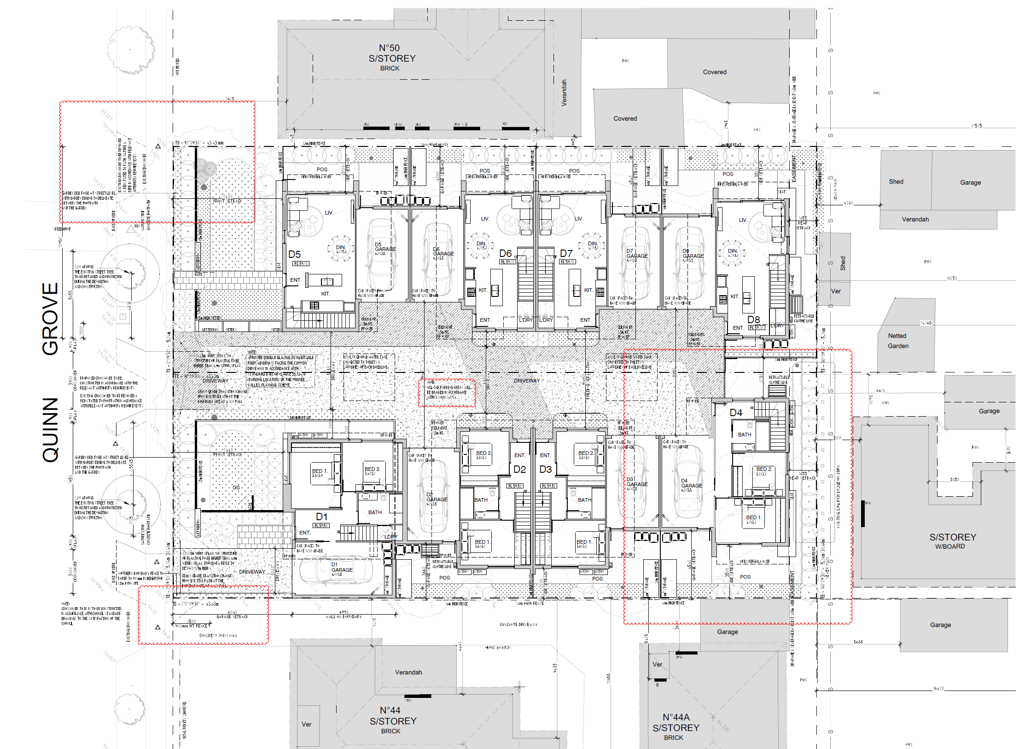

1. In summary, the Council’s grounds of refusal based on the substituted amended plans relate to:

* The proposal not being an acceptable design response that positively contributes to the local neighbourhood character;
* The failure to provide the one residential visitor car space specified in the planning scheme;
* The failure to meet some of the standards of clause 55 meaning that the proposal is not an acceptable outcome; and
* The proposal is an overdevelopment and will have an adverse impact on the streetscape and amenity of the surrounding area.

1. The Tribunal has also received three statements of grounds from surrounding properties. These statements raised concern about inadequate resident and visitor parking in a narrow street, traffic generation, impact on waste collection and delays in the street, amenity impacts of privacy and noise, and a desire for two dwellings per lot (i.e. a total of four dwellings) instead of this proposal for eight dwellings.
2. Having considered the submissions, expert evidence, statements of grounds, other materials tabled, the relevant planning scheme policies and provisions and the *Planning and Environment Act 1987*, I have decided to refuse to grant a permit. Having said that, it is various aspects of the detail contained in this particular design that are not acceptable rather than the general proposition of a proposed design with a central driveway and two storey townhouses surrounding it. How many townhouses can be accommodated on the site is dependent upon achieving an acceptable design response to the character and amenity of the neighbourhood. So, the number of dwellings is not a reason why I have refused this proposal. Rather it is details of the design that are of concern.
3. The main reasons why I have reached this decision are explained below having regard to the following key issues:

* Whether the design is an acceptable response to the neighbourhood character;
* Whether the design achieves acceptable amenity impacts, both internally and externally;
* Whether the car parking provision, traffic and waste collection is acceptable.

### Various aspects of the design detail are not an acceptable response to the neighbourhood character

1. The Council accepts that this site is suitable for an increased development of housing upon it. The Council’s key concerns relate to the acceptability of the design response to the existing and preferred neighbourhood character. The Council’s submission describes the area surrounding this site as follows:

4.9 The site is located within a well established residential hinterland area predominantly of low rise detached single storey, low density development with a number of infill developments. Prevailing materiality and design of dwellings are double fronted brick and tiled hipped roofs, fencing is low to none. Quinn Grove comprises of typical width nature strips, street trees, and traffic pacification devises such as speed humps and round abouts. The local road layout comprises of a grid layout with sections of curvilinear road alignments, typical of garden suburban areas.

4.10 The site is approximately 150 metres south of Local Activity Centre (zoned Commercial 1) at the intersection of Quinn Grove and Dinah Parade. The site is located approximately 550 metres northeast of the Milleara Shopping Centre

1. The Council’s reference in its paragraph 4.9 (above) to a number of infill developments may not convey the current prevalence of these. Ms Milner’s evidence provides the following illustration of the number of medium density developments in the immediate surrounds:

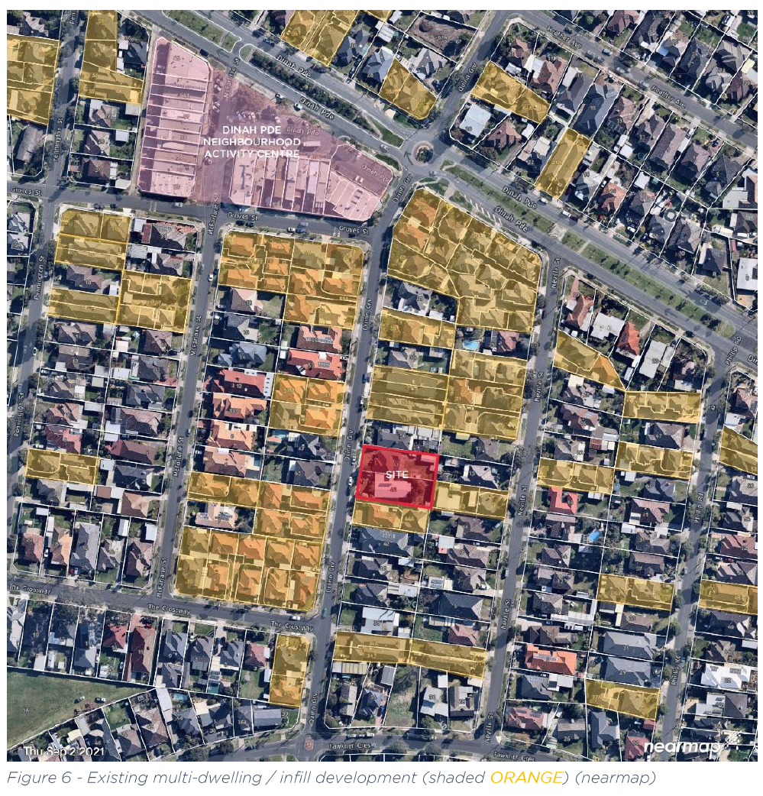

1. Ms Milner’s figure (above) illustrates that there are examples of developments of one dwelling built behind the other, which are often single storey. There are also examples of side by side developments, which are mainly double storey. Hence, there is not a predominant backyard character in this neighbourhood. Instead, there are numerous examples of two storey buildings that are located proximate to the rear boundaries of properties. Within this existing neighbourhood context, this proposal to have development on this site extending along its length is acceptable in broad terms. The built form in the existing neighbourhood context surrounding this site is a mix of one and two storey elements, including cantilevered elements. This proposal contains similar built form characteristics, so again in a broad sense such characteristics are an acceptable response to the neighbourhood.
2. The Council is concerned about the proposal’s two double storey dwellings at the rear of the site (refer to extract of first floor plan below). They are close to the rear boundary, have limited setbacks including limited differentiation between ground and first floor levels, and have similar materials and finishes at both floor levels. The landscape concept plan contains limited to no landscaping along the rear boundary. The Council points out examples of side by side development that mean the two storey form is proximate to, but also set back from the rear boundary. The Council also points out examples of developments with one dwelling located behind the other, including where a rear two storey building has its first floor set back further than the ground floor creating greater separation for any visual bulk impact of the two storey component from the respective rear boundary.

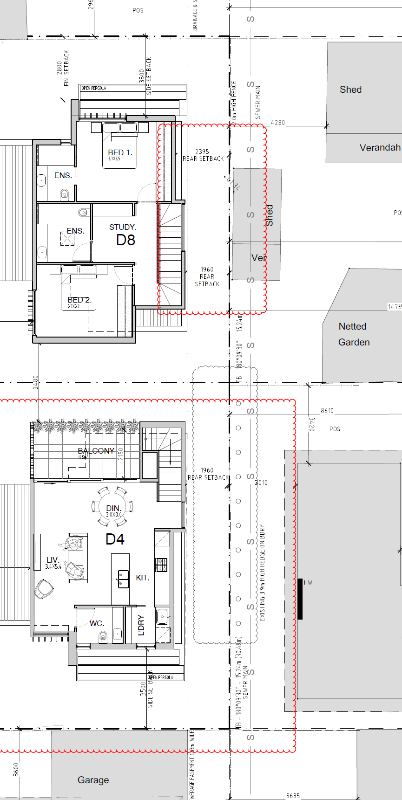

1. I agree with the Council that the difference in the ground and first floor rear setbacks is minimal, and the depiction of the differences in the materials and finishes is not sufficiently clear or evident in the elevations and schedule/legend of materials and finishes provided. The landscaping proposed is minimal along the rear boundary, albeit the existing 3.9 metre high hedge on the adjoining property’s side of the rear boundary next to dwelling 4 does assist to minimise dwelling 4’s visibility. Also, the rear two dwellings are generally sited closer to the rear boundary than other existing medium density housing developments that are adjacent to the same rear boundary line to the north and south of this site. An example of this is the unit to the rear of dwelling 4 that is shown to have a setback of 3 metres from the common rear boundary. Overall, I am not persuaded the combination of the rear setbacks and design detail of the proposed two rear dwellings has acceptably responded to the rear interface.
2. Ms Milner identifies that the front setback envisaged by standard B6 in clause 55.03-1 is 8.033 metres and this proposal requires a variation as its minimum setback is 7.4 metres. The street setback objective in clause 55.03-1 is for the setback to respect the existing or preferred neighbourhood character and make efficient use of the site. This overall design demonstrates that the proposed front setback achieves both these outcomes as illustrated in the following extract from the ground floor plan. The proposal’s front setback sits comfortably between the adjoining properties.

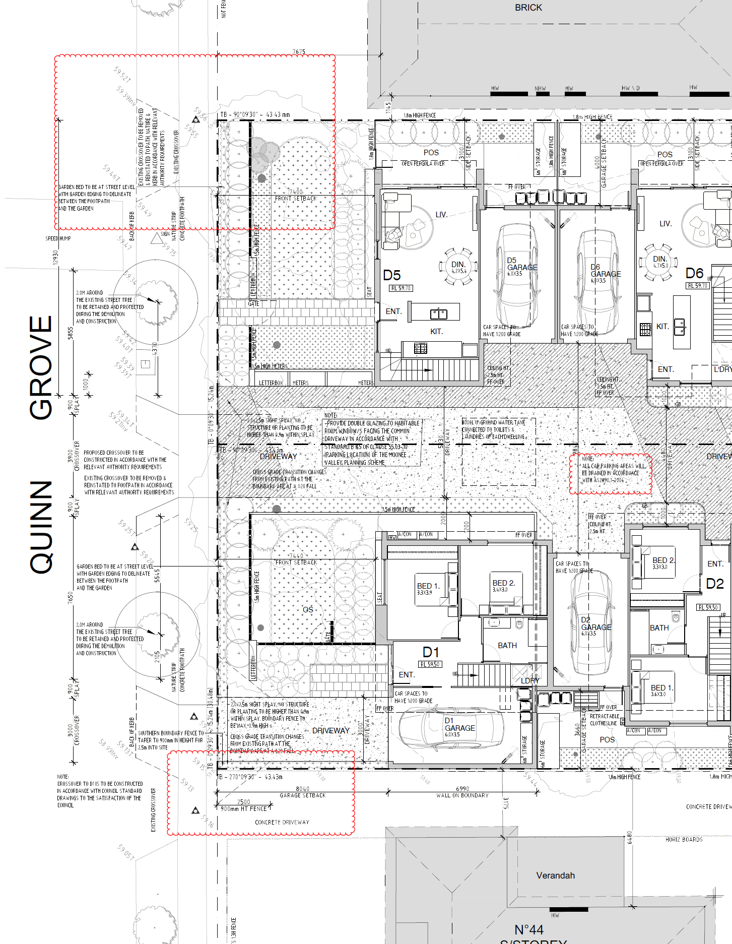

1. Having found the front setback of the dwellings to be acceptable, I also find the front fencing and side fencing needs further consideration. This neighbourhood precinct description points out streets have an open feel with an absence of front and side fencing. The transparency in the front fence design assists and balances the proposal’s inclusion of front fencing to a 1.5 metre height, so that part of the design is an acceptable design response. However, there are solid elements in the front fence design including alongside the side meter boxes. The applicant submits the setback of the front fence is deliberate to allow for a landscape emphasis and a garden setting. Whilst this is acknowledged, it is still important that the design of the front fencing itself is acceptable.
2. There is also side fencing along the central driveway and within the front setback area generally are solid and high and is also not acceptable. Generally, in this neighbourhood, the side fencing tapers down to the street frontage. There is a notation of this occurring alongside the driveway to dwelling 1 with a 900mm high fence for a distance of 2.5 metres from the street frontage. A similar outcome should be achieved in the centre of this development. These are details in the design, particularly the solid aspects and the side fencing, that needs to be reconsidered to provide an acceptable response.
3. The front two dwellings have no or limited shelter over the front entries. Ms Milner agrees with the Council that these dwellings could have an architectural feature over the front entries to address this. The applicant’s response was to query what a front porch would look like in this design. Shelter to the front entries is desirable and this is a matter of design detail that should be considered in any new proposal.
4. The design of the central driveway within the front setback area also needs further consideration. The driveway is considerably wider than the 3.9 metre wide crossover at the site’s front boundary. The applicant explains this is deliberate to allow for vehicles to pass each other but acknowledges a passing area is not a planning scheme requirement. Within this neighbourhood context, the extent of paving in the front setback area should only be what is necessary to provide vehicle access on to and off the site as is required by the planning scheme. This in turn may increase the amount of area that can be made for available for landscaping within and adjacent to the front setback area.
5. One of the benefits of the proposed layout of the dwellings is the ability to provide northerly oriented private open space areas. The configuration of the traditional dwelling layout on the north side of the central driveway have north facing ground level open space areas accessible from the principal living area. The reverse living dwelling configuration on the south side of the central driveway have north facing first floor balconies accessible from the principal living area. The two types of private open space provision and their locations in general terms are acceptable, but the amount of space provided within the development does not acceptably contribute to the neighbourhood character.
6. The General Residential zoning of this site encourages medium density housing, but it is also in an incremental change area with a garden suburban character (as identified in the relevant planning policies). The Council points out this is not an area where medium density housing is strongly encouraged. As such, the increased density of housing on this site needs to be balanced with providing acceptable amounts of space, including private open space, that contributes to an incremental change that is respectful of the garden suburban character. This situation is exacerbated by the fact that two of the proposed dwellings (dwellings 6 and 7) are provided with less private open space area (30 square metres) than is suggested in the relevant clause 55 standard (40 square metres).
7. Ms Milner is of the view the smaller areas of private open space for dwellings 6 and 7 is acceptable. She points out there is a network of public open space in the surrounding area including Ross Hill Park about 450 metres away to the east. She also points out the private open space of these two dwellings is north facing, a minimum of 3 metres in dimension and is integrated with a living area at ground floor. The applicant submits a lesser area for two bedroom dwellings means a lesser burden in terms of upkeep and maintenance. Whilst all these factors individually have some merit, on balance I am not persuaded a development of this size should be permitted with less open space than the planning scheme suggests when looking at private open space provision and a garden character in combination.
8. The design details of concern identified in these reasons need to be reconsidered so as to achieve an outcome that is respectful of and contributes to the neighbourhood character.

### The design can achieve acceptable amenity impacts, both internally and externally

#### Internal amenity

1. In terms of parking location, clause 55.03-10 contains an objective to protect residents from vehicular noise within developments. Standard B15 suggests that the central driveway should be located at least 1.5 metres from habitable room windows. This proposal has one metre setbacks to habitable rooms in the middle four dwellings. Ms Milner suggests this objective can be addressed by including double glazing. Double glazing is not a design response contemplated in clause 55.03-10. Rather, it is meant to be a design response through the sill heights or setbacks of the windows. The Council submits this is indicative of the proposal trying to do too much, particularly as there are limited landscaping opportunities in this central driveway area. The swept paths, habitable room window setbacks and sill heights and the landscaping opportunities within the central driveway should all be reviewed and acceptably addressed as part of any new proposal.
2. The entry to dwellings 4, 6, 7 and 8 have no shelter or transitional space around their respective entry. Mr Furness’ swept path diagrams illustrate that these areas are being relied for vehicles to be able to manoeuvre. This is not an acceptable design outcome. The design should be reconsidered to provide entry areas that are well clear of anticipated swept paths for vehicles so that pedestrian entries are safe. The entries should also be provided with some shelter as is suggested in standard B26 of clause 55.05-2.
3. The hedge at the rear of dwelling 4 may have an impact upon the level of daylight access into bedroom 2. The design of this dwelling should be considered having regard to the hedge’s retention, even if (as the applicant submits) it will be cut back to the fence line.

#### External amenity impacts

1. The Tribunal has received a statement of grounds from 1/44 Quinn Grove, which is the front dwelling of a two dwelling development located on the adjoining property to the south. They are concerned about a loss of sky view from their north facing windows; the winter shadow to their living areas; increased residential noise as three dwellings will be close to them; and that there will be a loss of privacy to their house and open space.
2. Overshadowing is to be considered for private open space rather than habitable room windows, and the shadow cast is acceptable. 1/44 Quinn Grove’s north facing windows are sufficiently set back from the common boundary that standard B20 about allowing adequate solar access is not triggered. As such, sunlight to these windows is acceptably maintained. There will no doubt be noise associated with the use of three dwellings along this common boundary, but in an area where medium density housing is encouraged such an impact is acceptable.
3. In regard to the potential for overlooking, dwellings 2 and 3 have open plan kitchen windows at first floor level looking south, and the south elevation contains a note that these almost full length windows will be ‘obscured’. This overlooking analysis and detail is not sufficient to address the overlooking objective in clause 55 to limit overlooking into 1/44 Quinn’s private open space and habitable room windows (if necessary). Ms Milner’s evidence is that overlooking is ‘a bit fuzzy’ in the plans but could be resolved through conditions. This is a detail that needs to be clearly addressed in any new proposal and should not be left to permit conditions. Any screening devices should be integrated into the design.

### The car parking provision, traffic and waste collection is acceptable

#### Car parking provision

1. The statements of grounds from residents raise particular concern about what they perceive to be inadequate resident and visitor parking in a narrow street.
2. One of the residents points out the 2016 census reveals the average number of motor vehicles per dwelling in Moonee Valley is 1.6, which would equate to around 13 vehicles for this proposal. All of the resident car parking required by the planning scheme is provided in this development. This level of car parking may be less than that revealed in the 2016 census, but that is what the planning scheme calls for and there is nothing in the planning scheme that encourages or contemplates a greater level of car parking than the standard requirements.
3. One visitor car space is required by the planning scheme for this proposal, and none is provided on the site. Mr Furness’ expert evidence statement identifies that this proposal will generate a peak demand of one visitor car space, and that this demand will be in the evenings and on weekends. His evidence statement also sets out parking survey results that illustrate there is a very low demand for on-street parking (e.g. 13% occupancy at midday on a Saturday). Ms Milner’s evidence also identifies that Quinn Grove is a street where some properties are exempt from the need to provide visitor parking (as extracted below) because they are within the PPTN area:

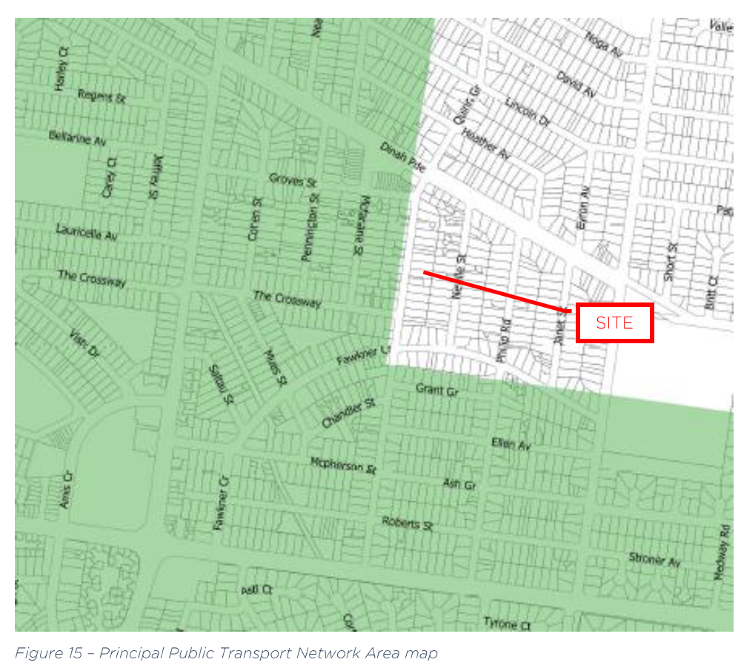

1. This mapping of the PPTN area means the east side of this section of Quinn Grove may need to provide visitor parking depending on size of development, but the west side of street does not need to. In this case, I am satisfied that a waiver of the one required visitor car space is acceptable as:

* Mr Furness’ evidence demonstrates availability of on-street parking at the peak demand time on a weekend,
* The neighbourhood is well served by services and facilities including public transport, and
* The Council has not raised any concerns with a waiver of one visitor car space.

1. Furthermore, having regard to other matters of design detail that I have already identified are of concern, it is important that the design response is otherwise acceptable in terms of setbacks, landscaping and built form. In my opinion, these design aspects are of greater importance than requiring one visitor car space on the site, so the design would be best served by utilising the available site area to address these design aspects.

#### Traffic generation and waste collection

1. The residents are concerned that vehicles parking on both sides of the roadside will reduce Quinn Grove to a congested single lane thoroughfare in places. Furthermore, they are concerned the traffic generated will decrease visibility and increase danger for cars entering and leaving properties. Quinn Grove is a Council managed road and the Council’s traffic engineers have raised no concerns with the consequential traffic generated by the required resident car spaces. In this circumstance, I am not persuaded this concern is a reason why this proposal should be refused.
2. There was a concern expressed about the collection of garbage bins in terms of the failure to comply with the Council’s spacing guidelines, the delay to be caused during collection in the street, and the impact on available on-street parking when collection is due. The Council do not object in principle to waste collection from this proposal occurring via Council’s kerbside collection. As this is not a matter of concern to the Council, I am not persuaded this concern is a reason why this proposal should be refused.

### Conclusion

1. For these reasons, the decision of the Responsible Authority to refuse to grant a permit is affirmed. No permit is issued.

|  |  |  |
| --- | --- | --- |
| Rachel Naylor  **Senior Member** |  |  |

1. The submissions and evidence of the parties, the supporting exhibits given at the hearing, and the statements of grounds filed have all been considered in the determination of the proceeding. In accordance with the practice of the Tribunal, not all of this material will be cited or referred to in these reasons.