VICTORIAN CIVIL AND ADMINISTRATIVE TRIBUNAL

|  |  |
| --- | --- |
| planning and environment LIST | vcat reference No. P11608/2021  Permit Application no. YR-2021/100 |

|  |
| --- |
| CATCHWORDS |
| Section 77 of the *Planning and Environment Act 1987* (Vic); Commercial 1 Zone; Design and Development Overlay – Schedule 12; Bushfire Management Overlay; Three storey mixed use development; Character; Internal amenity; Access and car parking. |

|  |  |
| --- | --- |
| **Applicant** | Chay Ryan |

|  |  |
| --- | --- |
| **responsible authority** | Yarra Ranges Shire Council |
| **Respondent** | MMC Main Pty Ltd |
| **Referral Authority** | Country Fire Authority |

|  |  |
| --- | --- |
| SUBJECT LAND | 18-20 Main Road (Part Lot 1 LP96652)  MONBULK VIC 3793 |
| HEARING TYPE | Hearing |
| DATEs OF HEARING | 21 and 22 March 2022 |
| DATE OF ORDER | 31 March 2022 |
| CITATION | Ryan v Yarra Ranges SC [2022] VCAT 339 |

# Order

### Name of respondent amended

1. Pursuant to section 127 of the *Victorian Civil and Administrative Tribunal Act 1998* (Vic), the name of the respondent is amended to:

MMC Main Pty Ltd

### Permit application amended

1. Pursuant to clause 64 of schedule 1 of the *Victorian Civil and Administrative Tribunal Act 1998* (Vic), the permit application is amended by substituting the following plans for the application plans:

* Development plans prepared by DCA Design:
  + Drawing nos. TP01 – TP24;
  + All dated 27 January 2022, except TP02 dated 18 May 2021; and
  + All Revision B, except TP02 marked as Revision A.
* Landscape plan prepared by John Patrick Landscape Architects Pty Ltd, drawing no. L-VCAT01 ground floor, dated January 2022.

### Permit granted

1. In application P11608/2021 the decision of the responsible authority is set aside.
2. In planning permit application TR-2021/100, a permit is granted and directed to be issued for the land at 18-20 Main Road (Part Lot 1 LP96652), Monbulk, in accordance with the endorsed plans and the conditions set out in Appendix A.
3. The permit allows the following:

* To use the land for accommodation (dwellings).
* To construct a building or construct or carry out works, associated with accommodation and retail premises.
* To waiver the car parking requirement (three spaces).

|  |
| --- |
| **Margaret Baird**  **Senior Member** |

# Appearances

|  |  |
| --- | --- |
| For applicant | Mr A Walker of counsel, instructed by Mr H Gerrard, Glossop Town Planning.  Mr Walker called the following persons to present expert evidence:   * Mr K Twite, town planner. * Mr T Hardingham, traffic engineer. |
| For responsible authority | Mr G Crawford, Principal Statutory Planner. |
| For respondent | Mr J Lyons, town planner, Ratio Consultants. |
| For referral authority | No appearance. |

# Information

|  |  |
| --- | --- |
| Description of proposal | Mixed use development comprising 12 dwellings (seven, three bedroom townhouses and five, two bedroom apartments); two food and drink premises (cafés) with an aggregate leasable floor area of 118 m2 ; and 22 car spaces. Vehicle access is proposed via a 3.6 metre wide, entry-only, access from Main Road and vehicle egress is to be via the laneway at the rear of the land. Rear townhouses may have two-way access from the rear lane. |
| Nature of proceeding | Application under section 77 of the *Planning and Environment Act 1987* (Vic) – to review the refusal to grant a permit. |
| Planning scheme | Yarra Ranges Planning Scheme (**scheme**). |
| Zone and overlays | Commercial 1 Zone (C1Z); Bushfire Management Overlay – Schedule 1 ‘Badgers Creek, Belgrave South, Healesville, Lilydale, Monbulk, Montrose, Mooroolbark, Mt Evelyn, Wandin North BAL-12.5 areas’ (**BMO1**); Design and Development Overlay – Schedule 12 ‘Town Centres – Healesville, Monbulk, Seville, Warburton, Yarra Glen and Yarra Junction’(**DDO12**). |
| Permit requirements | Clause 34.01-1 – to use of the land for accommodation (dwellings) given the ground floor frontage exceeds two metres.  Clause 34.01-4– to construct a building or construct or carry out works.  Clause 43.02-2 (DDO12) – to construct a building or construct or carry out works.  Clause 44.06-2 (BMO1) – to construct a building or construct or carry out works associated with accommodation and retail premises.  Clause 52.06-3 – to waive car parking (three spaces). |
| Relevant scheme policies and provisions | Clauses 11, 13, 15, 16, 17, 18, 21, 34.01, 43.02, 44.06, 52.06, 53.18, 55, 58, 65 and 71. |
| Land description | The subject land is on the south-west side of Main Road. It is approximately 29 metres wide, has an area of 1,323m2, has a significant slope, and contains a single storey commercial building. The land has access from Main Road and a six metre wide rear gravel, sloping, laneway. A school crossing abuts the site’s frontage. |
| Tribunal inspection | After the hearing on 22 March 2022 (unaccompanied). |

# Reasons[1]

## Introduction

1. The subject land fronts Main Road, Monbulk, and is at the south-eastern end of the commercial activity area of this rural township.
2. The permit application sought approval for a mixed use project, which was refused by the Council. The permit applicant has applied to the Tribunal for review of that decision.
3. Subsequently, the applicant has filed amended plans, which I have substituted in this proceeding without objection by any party or other person. The proposal includes two cafés, with apartments above, and two attached rows of townhouses to the rear of the mixed use building. An extract of a render prepared by the project architect, below, is an impression of the amended development as seen from the opposite side of Main Road.

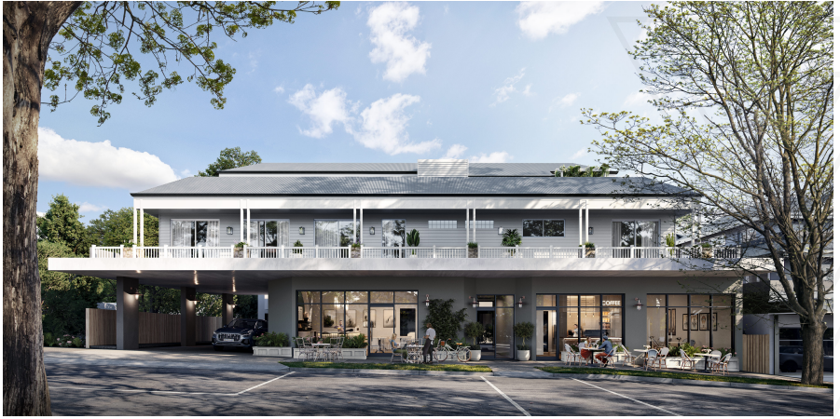

## Overview of parties’ positions

1. Based on the substituted plans, the Council supports the grant of a permit, subject to the inclusion of permit conditions that address its concerns. Not all of those conditions are, however, agreed between the Council and applicant. The disputed conditions relate to sealing of the rear lane and arrangements for waste management.
2. The respondent opposes the permit application. It submits the proposal is inconsistent with the requirements of the scheme. The respondent relies on multiple grounds. It submits the proposal is an inappropriate built form response, is inconsistent with the existing and preferred character outcomes, is an inappropriate equitable development outcome, is inconsistent with DDO12, fails to deliver appropriate internal amenity outcomes, and has inadequate car parking and access arrangements.
3. A statement of grounds has been lodged by a person who opposes a waiver of car parking spaces associated with the development.
4. The applicant relies on the expert evidence of Mr Twite and Mr Hardingham. The applicant submits the proposed development, at three storeys, responds appropriately to the opportunities offered by a large site in the commercial strip of the Monbulk town centre and to the relevant built form control DDO12. The third storey is set back, so that it is not easily discernible from the opposite side of Main Road, and will match the height of the development that has been approved on the adjacent site to the west.
5. The applicant submits there are no unreasonable adverse amenity impacts arising from the proposed development. It submits the apartments and townhouses have a good standard of internal amenity. Further, the applicant argues that the small waiver that is sought under clause 52.06 of the scheme is acceptable, waste collection can be appropriately managed, and there are no unreasonable adverse traffic impacts which arise as a result of the proposed development.

## Tribunal findings

### Strategic and planning context

1. The strategic context set by the scheme is relevant to an assessment of this permit application. It is not a key point of dispute in this proceeding. I refer to some key matters next, with relevant clauses of the scheme listed in the ‘Information’ section of these reasons. These have all been considered as relevant to the facts and amended permit application.
2. Monbulk is a rural township.[2] It is one of multiple large and small centres where it is policy to establish sustainable and attractive townships which can support a range of residential, commercial, retail, community and recreational facilities and services.[3]
3. The commercial centre of Monbulk is in the C1Z while surrounding land is zoned Low Density Residential (**LDRZ**).[4] A school and public reserve are opposite the land, on the north-east side of Main Road.

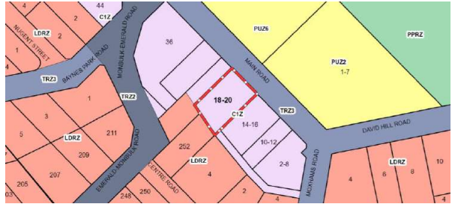

1. The purpose of clause 34.01 is:

* To implement the Municipal Planning Strategy and the Planning Policy Framework.
* To create vibrant mixed use commercial centres for retail, office, business, entertainment and community uses.
* To provide for residential uses at densities complementary to the role and scale of the commercial centre

1. The application of this zone and DDO12 seek to give effect to the strategic directions for this location.[5]

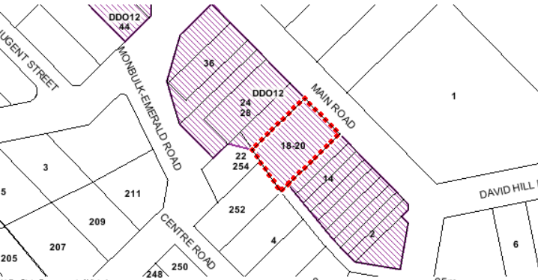

1. There is a clear focus on retaining compact townships with their distinct village-like character and environmental features.[6]
2. Among other things, policy supports increased housing diversity and greater housing choice,[7] enhanced viability and vibrancy of the townships, continuity of shopping activity at street frontages in the core retail area, good design, and a high quality level of amenity which helps to define and enhance the individual character of each town.[8]
3. There are specific policy objectives for sustainable towns[9] where, among other things, residential development is directed into sustainable locations through the residential framework. A policy objective for residential accommodation in commercial areas is to provide housing choice and increase activity levels within commercial centres.[10] Strategies and policy guidance are:

Strategies

* Encourage shop top housing where the potential exists for residential accommodation to be constructed in conjunction with new retail or business developments and where the resultant building scale is compatible with the local urban character.
* Encourage housing in commercial centres to take advantage of existing infrastructure and under-utilised sites.
* Ensure future residential opportunities can be incorporated into commercial developments.

Policy Guidance

Proposals for residential use in commercial areas should meet the following criteria:

* Residential accommodation does not occupy the ground floor or street frontage within the core commercial and retail area of the centre.
* The design, scale and density of the residential accommodation be compatible with the environmental and built character of the centre, and be responsive to the land capability of the site.
* That entrances and private outdoor open space are located to avoid conflicts with commercial businesses, particularly service areas at the rear of commercial premises.
* The residential accommodation provide sufficient off street parking.

1. DDO12 addresses (among other places) the Monbulk town centre. The character statement is:

These town centres will be dominated by a main street that retains a classic and attractive country town character. The built form of new development will reinforce this character and retain the distinctive features associated with the historic development of the town, including established trees and views to rural features such as nearby wooded hills or farmland.

1. The design objectives are:

* To enhance the distinctive built form and streetscape characteristics of the town centre.
* To reinforce the main street as the focus of business and pedestrian activity in the town centre.
* To maintain visual links between the town centre and its rural hinterland.
* To protect and enhance the amenity of residential and public places within and adjoining the town centre.
* To provide safe and convenient on site car parking that has a minimal visual impact on public places.

1. Clause 4.0 of DDO12 sets out design requirements relating to town character, landscaping, interface with public places and residential areas, and car park design. I have considered these fully, as relevant in this case, and refer to some of the requirements later in these reasons.
2. Clauses 34.01, 43.02 and DDO12 contain decision guidelines that I have considered as appropriate. Other policies include built form (clause 21.06) and landscape (clause 21.07). Clause 55 is a relevant decision guideline in clause 34.01. Clause 58 is applied to the proposed apartment development.
3. The subject land is part of a large BMO. A range of scheme policies address bushfire risk and management.[11] This matter is prioritised by the scheme. Bushfire risk has not been a focus of submissions or evidence.

### Decision-making context

1. The Tribunal must decide whether the proposal represents an acceptable outcome having regard to the relevant provisions and policies in the scheme. I have considered all the material filed and presented by parties and others within this scope.
2. Clause 71.02-3 explains that the Planning Policy Framework seeks to ensure that the objectives of planning in Victoria (as set out in [section 4](https://www.austlii.edu.au/cgi-bin/viewdoc/au/legis/vic/consol_act/paea1987254/s4.html) of the [*Planning and Environment Act 1987*](https://www.austlii.edu.au/cgi-bin/viewdoc/au/legis/vic/consol_act/paea1987254/)(Vic)) are fostered through appropriate land use and development planning policies and practices that integrate relevant environmental, social and economic factors in the interests of net community benefit and sustainable development. In addressing ‘Integrated decision-making’ clause 71.02-3 includes:

The Planning Policy Framework operates together with the remainder of the scheme to deliver integrated decision making. Planning and responsible authorities should endeavour to integrate the range of planning policies relevant to the issues to be determined and balance conflicting objectives in favour of net community benefit and sustainable development for the benefit of present and future generations. However, in bushfire affected areas, planning and responsible authorities must prioritise the protection of human life over all other policy considerations.

### Relevance of the permit for part 22 and 24-28 Main Road, Monbulk

1. In 2021, another division of the Tribunal determined to grant permit YR-2018/495 for a three storey mixed use development on the land at part 22, 24-28 Main Road.[12] The property abuts the subject land, to its north-west.
2. The approved development involves 20 apartments above three retail premises with a basement car park accessed from Main Road. There are no endorsed plans and construction has not commenced. The respondent in the current proceeding was the permit applicant in YR-2018/495. The architect for that approved development is the same as the current case.
3. The parties have different submissions about the weight to be given to this permit. The respondent says it should carry limited weight whereas the applicant says it is highly relevant and should be given considerable weight.
4. Permit YR-2018/495 is a relevant matter, however, there is no certainty that the approved development will be constructed. My decision takes this into account. The Tribunal’s decision has been referred to by the parties.
5. The image, below, shows a render of the proposal considered by the Tribunal in *MMC Main*:[13]

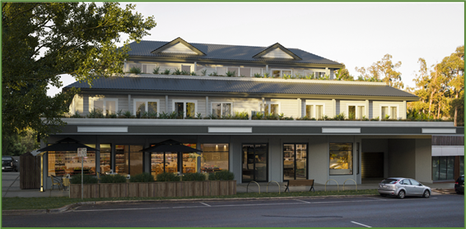

### Character, built form and massing

#### Respondent’s concerns

1. The respondent challenges the agreed position of the Council and applicant that the design, scale and siting achieve an acceptable outcome. The applicant relies on Mr Twite’s evidence.
2. The respondent submits that the proposal demonstrates inconsistencies with the existing and preferred built form and character outcomes sought by the scheme, including various matters within DDO12. Key issues raised by the respondent are:

* The townhouse typology;
* Overall building height;
* Dominance of the built form including:
  + the visibility of the third floor;
  + the position of the second floor forward of the adjacent approved development; and
  + the presentation of side elevations;
* The provision of vehicle access from Main Road when rear lane access is available to the subject land;
* An insufficient landscape response;
* The impact on equitable development opportunities.

#### Tribunal findings

##### Overall concept

1. Having regard to the purpose of clause 34.01, DDO12 and policies in the scheme, the concept of cafés at ground level addressing Main Road, with residential development (using varied formats and sizes), is an expected and acceptable outcome to give effect to the scheme’s policies and provisions. The concept of a three storey mixed use development, broadly, is not a specific issue in this proceeding, neither is the proposed use of the land for dwellings which triggers a planning permit.

##### Townhouse typology

1. The respondent criticises the proposed townhouse typology of three storey townhouses (plus roof terraces). It submits this represents a significant departure from the existing character of the area. It also criticises the consequent design response, to which I refer below.
2. There is not an obvious presence of townhouses; plainly the LDRZ is relevant in explaining why. The C1Z has seen limited redevelopment, such as mixed use redevelopments, although there are some new buildings such as the nearby ALDI supermarket.
3. There is a clear scheme direction with respect to housing diversity. The proposal offers a different housing product to much available stock, thereby adding to choice in a location sought by the scheme. The proposal includes a mix of dwelling sizes and layouts, with five apartments and seven three bedroom townhouses across two attached rows. I do not accept submissions that the townhouse typology is, in principle, unacceptable.

##### Form, scale, siting and design

1. The subject land contains a single storey building. Side setbacks provide access to the rear of the land via separate crossovers. A panel beater is to the south-east of the subject land, with an expansive open parking area to its frontage. The property to the north-west contains single storey buildings, and is the subject of permit YR-2018/495. A recently developed ALDI is at the south-east corner of Main Road and Emerald-Monbulk Road. No adjacent site has heritage controls. Opposite is the low-rise treed environment associated with the school and reserve, with parking.
2. Clause 4.0 of DDO12 addresses town character and other matters. It includes the following:

* New development should reinforce the pattern of existing development in the town centre with mostly narrow fronted shops and strongly articulated facades.
* Building heights should not exceed two storeys (7.5 metres). A third level may be permitted where the overall height of the building will match that of an adjacent building or where it is set back so as not to be easily discernible from the opposite side of the street.

For the purpose of this schedule ‘Building height’ means the vertical distance between the highest point of the building and the natural ground level immediately below that point. It does not include architectural features and building services.

* New development should complement the character and appearance of existing heritage buildings.
* Verandahs should be provided on the street frontage of buildings to provide continuous weather protection.
* Building facades should be articulated by incorporating a variety of materials, textures and colours that enhance the particular qualities of buildings in the town centre.
* Big box structures with bland facades, and building bulk that is out of proportion with other elements of the town centre, are discouraged.
* Building designs should reinforce a rural town character adopting disaggregated building forms, articulated facades, and design detailing that uses lighter materials such as timber.
* Long blank walls should be avoided by incorporating wherever possible retail premises that abut the blank sides of such structures.
* Contemporary design that complements the scale and detail of existing buildings in the town centre is preferred.
* All roof-mounted mechanical equipment should be concealed by screens that are designed as an integral part of the building.

1. With respect to interfaces with residential areas, clause 4.0 of DDO12 includes:

* New buildings should be constructed with zero setbacks from the main street frontage.
* Buildings should provide an active interface with the main street and passive surveillance to all abutting streets and other public places using techniques such as clear glazed windows and upper level balconies.
* Reflective and opaque glazing is discouraged particularly on street frontages.
* Buildings should avoid large expanses of blank walls particularly at street level.
* New crossovers and car parking between a building and its frontage are discouraged.

1. The parties agree that the preferred maximum height of 7.5 metres is discretionary. As set out above, DDO12 contemplates third storeys where the overall height of the building will match that of an adjacent building or where it is set back so as not to be easily discernible from the opposite side of the street.
2. The proposed building exceeds the preferred maximum height. It would abut an approved development to the north-west that is also three storeys involving a recessed upper floor, but that building has not been built. The proposed development is higher, but not such so as to be unacceptable in this streetscape and town centre.
3. Another limb to this DDO12 consideration is where a proposed building is set back so as not to be easily discernible from the opposite side of the street. The diagram below, presented by the Council, demonstrates the extent to which the upper level would be perceived from the opposite footpath. I find the form is sufficiently recessed to achieve DDO12 design objectives. The protrusion of the lift and stair are minor elements in the overall presentation of the upper floor from the public realm, and are acceptable by the way in which they have been integrated into the design.[14] The building’s overall architectural composition, such as in terms of materials, articulation of the front façade, glazing, roof form, verandah and pedestrian spaces, are an acceptable response to DDO12.

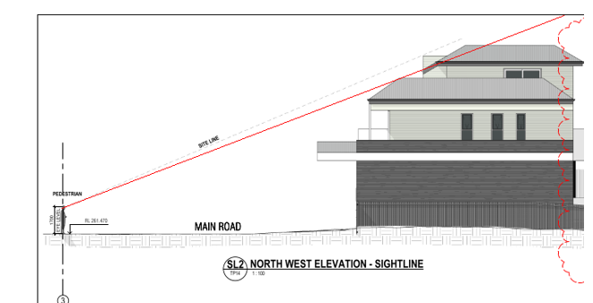

1. The image included at my paragraph 3 also assists to understand the extent to which the upper level would be perceived, based on the DDO12 requirement. It is self-evident that the side elevations would be clearly seen over the open-frontage of the panel beater site and, unless developed, the land at 22, 24-28 Main Road. If permit YR-2018/495 is acted upon, the two buildings would be read with similarities but distinguishable differences.[15]

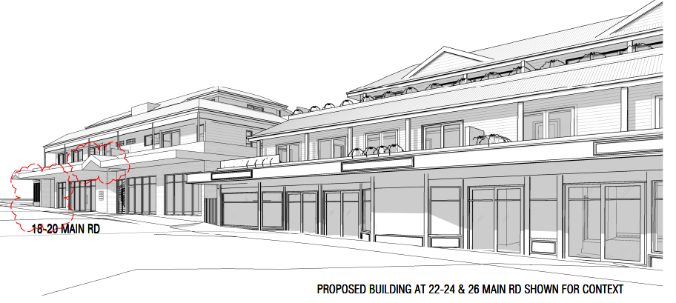

1. The proposed development sits forward of the adjacent approved form, at first floor level, as Mr Lyons has highlighted. Mr Lyons states that the built form associated with the third floor is accentuated by a minimum setback of only 4.22 metres from the front title boundary, whilst the width of the third storey, and the location of the lift core to the front of the third floor facing the street, result in an increased visibility of the third storey from the street interface/public realm.
2. The position of the proposed first floor is an acceptable approach and is not inconsistent with DDO12. The proposed building and approved building would complement one another and work toward enhancing the distinctive built form and streetscape characteristics of the town centre. The proposal reinforces the main street and does not affect any significant viewlines.
3. Sides of the proposed development are less articulated, but I do not consider they are unacceptable when viewed from the public realm. The elevation, below, indicates breaks in the built form and varied materials and finishes. Development of the panel beater site can be expected at some future time.

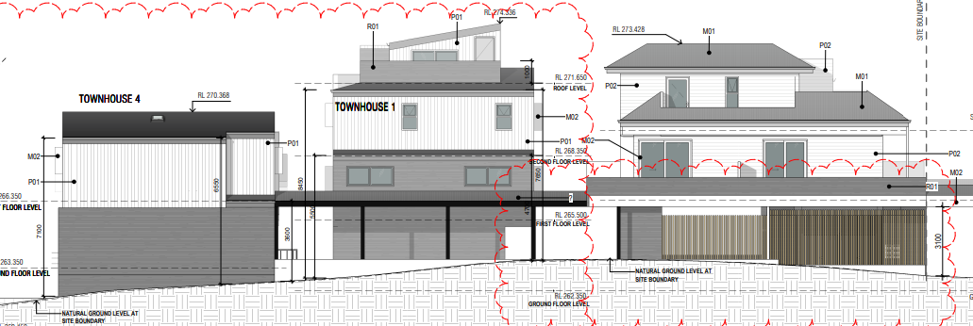

1. For interfaces with residential areas, clause 4.0 of DDO12 includes:

New buildings abutting a residential property should meet the side and rear setback objectives in Clauses 54.04-1 and 55.04-1, and the overshadowing open space objectives in Clauses 54.04-5 and 55.04-5 of this planning scheme.

1. The scale toward the rear of the Main Road building, comprising townhouse rows, has sections of walls with sheer elements whose presence would be accentuated by the slope. The Council and Mr Twite disagree as to whether Standard B17[16] is fully met for a section of the rear elevation (shown on the north-west elevation for a section of townhouse 7). Despite this, both consider the outcome to be acceptable for this C1Z and given the interface conditions to which I refer below. Standard B17 is well-exceeded for other parts of this elevation and for side setbacks. I find the limited extent of non-compliance is not material in this case.

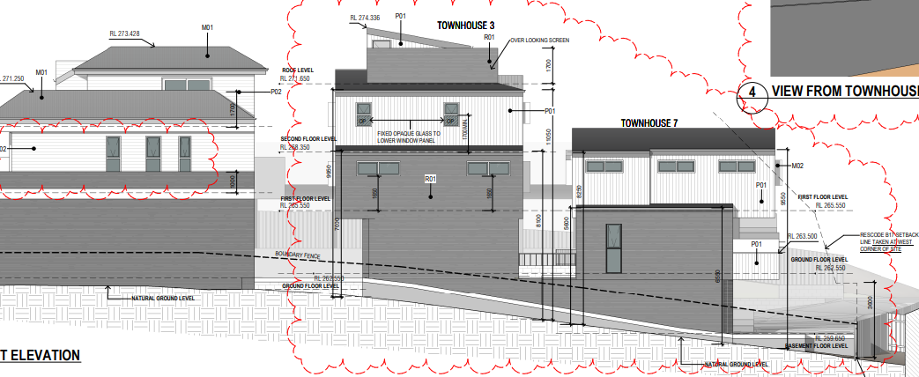

1. There are other large format buildings in the town centre with less articulation than proposed in the current design, notably the supermarkets. The approved development on the adjacent property also has a substantial form to its rear, which was found to be acceptable in *MMC Main*. The interface considerations in the proposal before me have had regard to the slope, the circumstances of abutting sites, and the potential for landscaping to supplement some vegetation on one adjacent site (as I refer to below).

##### Crossover to Main Road

1. The subject land has a wide frontage to Main Road and has two crossovers to this frontage. A school crossing abuts the site’s frontage. The land also has rear access via a lane off Moxhams Road. The lane is also accessed by two other properties, is gravel, has a deep swale to one side, and slopes down to the subject land.[17]
2. The respondent submits the proposed vehicle access from Main Road is not appropriate and is not consistent with DDO12. It says all vehicle access should be from the rear right of way. It distinguishes the subject land from that at 22, 24-28 Main Road where there is no rear access so that a basement car park could only be accessed from Main Road.
3. DDO12, and urban design policy more generally, seek to minimise intrusions into active street frontages associated with strip centres such as this, and to minimise the visual impact on parking. This is evident in clause 4.0 of DDO12 that includes:

* New crossovers and car parking between a building and its frontage are discouraged.
* Car parking should be designed as an integral part of a development.
* On-site parking for vehicles should be located to have a minimal visual impact on the streetscape and adjoining public spaces.
* Parking between the front of the building and the street should generally be avoided.
* The number of vehicle crossovers should be minimised and where possible provided from laneways or secondary street frontages.

1. The proposal minimises the exposure of any parking areas from the public realm. It does not use a new crossover. It will remove an existing crossover. The proposed access would be single-width, and one-way into the site. All vehicles would exit via the rear laneway.
2. While no access to/from Main Road would be preferred, DDO12 does not prohibit the proposed outcome which improves on both the existing site conditions and involves a narrower access/crossover than the double-width allowed in permit YR-2018/495. I also note a valid permit remains in place for the subject land where double crossovers have been allowed.[18]

##### Landscaping

1. The respondent submits the proposed landscaping response is inconsistent with the landscaped context of the surrounds, where significant landscaping exists. The proposal seeks to plant one tree in the south-west corner of the land, but otherwise relies on low-lying shrubs, which the respondent says do not represent an appropriate interface to the adjoining sensitive uses.
2. Clause 4.0 of DDO12 includes the following requirements with respect to landscaping:

* Landscaping should be integrated with the design of the development and complement the landscaping of adjoining public places.
* Established canopy trees should be retained, protected and incorporated into the landscaping of the site.
* Additional canopy trees should be planted, wherever practical, to provide shade and visual interest.

1. The subject land has no trees today. A very large street tree, which Council describes as a weed species, abuts the land and is required to be removed for this development given the zero lot line to Main Road. This is not opposed by the Council and a new tree is intended to be planted.
2. I agree with the Council that DDO12 and C1Z specifically contemplate development built to the street frontage. Most proposals would require the tree to be removed and replaced with a suitable tree species that would, in time, add to the amenity of the streetscape. The outcome is acceptable, giving weight to the Council’s acceptance of this aspect of the proposal.
3. The development allows for some perimeter planting and will supplement vegetation that exists to part of the rear boundary. This is not a substantial contribution but I find it is acceptable in this case. It is relatively similar in its extent of rear landscaping approved in *MMC Main*.

##### Equitable development opportunities

1. The respondent’s submission raises concerns with respect to equitable development opportunities for properties to the north-west and south-east that are also in the C1Z and DDO12.
2. The respondent states that it is common practice to enable the sharing of development potential by establishing either a minimum 4.5 metre setback where habitable windows are located, or alternatively a wall on boundary that would allow future development to also provide a wall on boundary. The respondent submits the proposed side setbacks fail to provide appropriate equitable development opportunities by its setbacks and outlook from habitable room windows.
3. The respondent’s submission cites setback distances which, on the facts are less than 4.5 metres. However, the proposed development does not direct apartments or townhouses with a sole orientation to an adjacent commercial site. This contrasts with the approved development to the north-west at 22, 24-28 Main Road which has a number of units with their sole orientation to the subject land and has balconies close to the subject land. This approved development borrows amenity from the subject land. By contrast, the proposal ensures that the proposed dwellings are sited and oriented to avoid borrowing from the property to the north-west, notwithstanding that the setbacks are, in some locations, less than 4.5 metres.
4. For similar reasons, I also find that the proposal would affect the reasonable development opportunities of the land at 12-14 Main Road. One section of boundary wall is proposed to the rear of the proposed development but this would not prejudice development opportunities.

#### Conclusion

1. For the above reasons, I find the proposal achieves an acceptable outcome when assessed against the provisions of clauses 34.01, 43.02, DDO12 and relevant scheme policies.
2. I accept the submissions for the Council and submissions and evidence for the applicant. I am not persuaded to accept the respondent’s submissions that the proposal fails to achieve an acceptable response to DDO12 or clause 34.01. It is not inequitable with respect to development opportunities for properties to the north-west and south-east.

### Off-site amenity impacts

1. The Council and applicant agree the proposal will not have an unreasonable impact on the amenity of abutting properties in the LDRZ. The applicant relies on Mr Twite’s evidence.
2. The respondent has referred to concerns about visual bulk but no other off-site amenity impacts. The abutting property owners and occupiers of 252 and 254 Emerald Monbulk Road are not parties in this proceeding and have not lodged statements of grounds contending their amenity will be adversely or unreasonably affected.
3. Both residential properties sit lower in the landform. Their siting and orientation is relevant to the acceptability of the outcome. The material filed by the Council and applicant demonstrates that the orientation of the dwelling at 254 Emerald Monbulk Road is such that the proposal will have minimal mass and bulk impacts upon habitable room windows and secluded private open space. The dwelling at 252 Emerald Monbulk Road is set back 20 metres from the common boundary and has a gutter level of 258.63 AHD. It also has a vegetated rear open space and boundary planting.
4. I am satisfied when considering clause 55.04 that the proposed setbacks to abutting residential properties are acceptable given the specific circumstances of the residential interface. All other numerical clause 55 standards would be achieved, such as with respect to overshadowing (B21), or can be met by permit conditions, such as with respect to screening to balconies and windows (B22). The Council and applicant agree on additional screening measures, consistent with Mr Twite’s evidence. That is, first floor balconies and second floor bedrooms in townhouses 4 - 7 can be screened using measures that maintain a horizontal outlook whilst preventing a downward view. It is reasonable for this matter to be addressed by permit conditions.

### Internal amenity

1. The Council and applicant consider the proposed apartments and townhouses achieve an acceptable level of internal amenity. The applicant relies on Mr Twite’s evidence.
2. The respondent disagrees. It submits the proposal fails to provide sufficient internal amenity outcomes for the proposed future residents of the development, including through poor daylight outcomes, small (non-compliant) bedrooms, and poor private open space options.
3. These matters have been extensively explored through the hearing. Concerns about daylight have been addressed by the spacing between parts of the development and off-set windows that allow daylight and ensure internal overlooking is addressed. I agree with the applicant that habitable rooms have some outlook and windows do not need to be screened to prevent internal overlooking as the plans show that windows have been offset by 1.5 metres (clause 55.04). In addition, the balcony overhangs do not unreasonably affect internal amenity.
4. Three townhouses rely on roof decks for their private open space. Standard B28 of clause 55.05-4 expressly contemplates a roof-top area of 10 square metres with a minimum width of two metres and convenient access from a living room. The three townhouses have stair access to the roof top decks which meet these dimensions. Meeting Standard B28 achieves an acceptable internal amenity outcome in this case.
5. The issue of bedroom sizes is a more substantive matter. Multiple townhouses have second and third bedrooms that are small and are tightly configured when allowing for door openings and furniture.
6. As discussed through the hearing, there are several ways bedrooms could be improved, notwithstanding a minimum bedroom size is not included in clause 55 relating to the townhouses. This includes rationalising multiple bathrooms and changing doors to achieve a more functional layout. There is also some potential for modifications to several townhouses to accommodate changes to the internal access to facilitate movement for waste management vehicles (as I refer to below) which is likely to require some internal modifications to two townhouses, based on Mr Walker’s submissions.
7. I am persuaded to accept the applicant’s suggestion that any required changes can be addressed by a permit condition. I adopt Mr Walker’s suggestion that, where not already provided, all second and third bedrooms be modified to have at least one dimension that is a minimum of three metres and each to have a minimum floor area of at least 9m2 with associated internal modifications to dwellings.
8. A further matter raised in the respondent’s submission is with respect to acoustic measures given the adjacent panel beating premises. While permit conditions have not been proposed by the parties to address this, I consider it is prudent for it to be considered in amended plans, and I have included this as a permit condition.

### Parking

#### On-site parking supply

1. The Council and applicant agree that the proposed parking waiver is acceptable. The respondent expresses concern about the adequacy of car parking and the proposed waiver. Similar concerns are made in the statement of grounds filed by Ms Crutchley.
2. The development provides an on-site loading space, bicycle parking (although not required by the scheme) and 22 car spaces. Most car spaces are for the residential uses, with two spaces for the cafés (one each). Parking is dispersed around the development in association with the different residential and commercial components.
3. Based on the provisions of clause 52.06, a reduction of one residential visitor space and two café spaces is required.
4. A traffic report was submitted with the permit application and traffic evidence (with updated parking surveys) has been tendered and presented in this proceeding. This material assesses the relevant matters in clause 52.06-7.
5. The information shows that there is capacity for visitor overflow to be accommodated off-site while customer provision off-site is typical of this location for small retail premises. Concerns about a parking shortfall are noted, but the waiver is modest and will not (based on the available information) utilise a disproportionate amount of the public resource for café users or residential visitors. The requested waiver in parking is acceptable based on the decision guidelines in, and purpose of, clause 52.06.
6. The requested waiver is less than that granted for the adjacent development at 22, 24-28 Main Road. There is no indication of a broader issue about the cumulative impact of multiple parking waivers.

#### Car park access

1. It is necessary to address access to the proposed car spaces, and whether it meets the purpose of clause 52.06.
2. The Council has some concerns about the width of garage doors while the respondent refers to tight areas including correctional or reversing movements that are needed to either enter or exit most of the parking spaces.
3. The evidence is that the proposal meets AS2890.1 and this is accepted. However, I agree that the manoeuvrability for garages associated with townhouses 4-7 could be improved, as Mr Crawford suggests, by deleting the landscape beds between them. Widening garages doors for all townhouses, where possible, is an appropriate permit condition even though only minor adjustments will result.
4. Above, I have noted adjustments may be needed for waste collection vehicles and, as discussed at the hearing, I consider dimensions for car spaces and access aisles are required where not shown on the plans. These matters can be addressed by permit conditions.
5. The Council and applicant have different views about the layout of car spaces to the rear of the cafés. The Council seeks the removal of wheel stops and the addition of a kerb to the pathway whereas the applicant relies on its evidence that the proposal is acceptable as designed. The plans show wheel stops and varied pavement details for the pathway. I find this is an acceptable outcome and is not required to be changed to a different format.

## Conditions

1. Submissions about potential permit conditions have been made by all parties. I have taken these into account. The Council and applicant disagree on two matters, on which I set out findings next. I add the respondent says the proposal does not appropriately provide for waste collection.

### Arrangements for waste collection

1. The proponent proposes different arrangements for the apartments/cafés (Council collection) and townhouses (private collection).
2. The Council is responsible for waste management. The Council submits it cannot manage split Council and private waste collection. The Council also does not support storing of bins for the townhouses on Main Road as this will obstruct pedestrian access. The Council’s preference is that Council waste services be used, however, the number of Council bins that would be required for the proposal cannot be stored in the site frontage for Council waste collection. Consequently, the Council submits all waste generated by the proposed development will require private waste collection. Further, the Council says private waste collection vehicles should not double park on-street as proposed, given the impacts this will have on traffic and the nearby primary school and community hub. Waste collection should only occur on site.
3. I have considered the evidence presented by the applicant in response to these concerns. Ultimately, the Council is responsible for waste management and I accept its concerns about the proposed arrangements, including with respect to bins on Main Road. It recommends permit conditions requiring an amended waste management plan detailing a small waste collection vehicle, rather than the larger regular Council vehicle. Further, the development plans need to be amended to show adequate manoeuvring space be provided to allow waste collection vehicles to enter via Main Road and exit via the rear lane.
4. I am satisfied these matters can be resolved by permit conditions.

### Upgrading the lane

1. The laneway is accessed via Moxhams Road[19] and is approximately 6.0 metres wide. As indicated earlier, it serves two other properties which are closer to Moxhams Road and who benefit from the lane. They currently use it based on the photographs tendered by the parties and my site visit. The lane falls toward, and terminates at, the subject land.

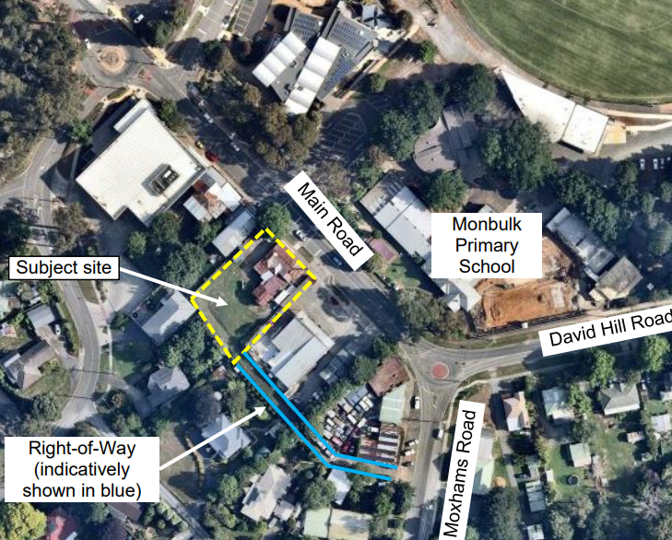

1. The Council and applicant agree that the rear lane requires upgrading as a consequence of the proposed development. There is a nexus.
2. The proposal has been described as involving one-way access from Main Road and egress via the lane. As discussed at the hearing, the plans show two-way access at the rear to service four townhouses. The CFA’s conditions refer to this as required for its access, to all-weather standard (rather than sealed).
3. The Council considers the permit holder should be responsible for sealing 3.5 metres width of the laneway, where it relies on one-way traffic movement through the site. If there is some two-way traffic, then the Council submits the full width of six metres should be sealed. The applicant submits there is not a warrant to seal the access; it is willing to provide all weather access but not partly or fully implementing concrete surfacing.
4. The one-way treatment is agreed but there is a need and likelihood of two-way movement at the rear of the property, notably for townhouses 4-7 and for CFA access. On Mr Hardingham’s estimate, the proposal would generate up to six vehicles per hour based on one-way movement. His oral evidence that this could be eight vehicles per hour with some two way movement by townhouses 4-7. That nearby Centre Road is compacted gravel, as cited in the evidence, is not influential as I have no information about the circumstances of that road. Having said that, I am aware of many roads through the Yarra Ranges that are unsealed.
5. Given the configuration of the lane, including its slope and deep swale, and the potential for two-way movement, the lane requires improvement to allow for the predicted vehicle volumes and for cars to meet and pass. There will also be regular use by waste vehicles.
6. Is requiring the applicant to upgrade the land to all weather access sufficient, or should some or all of it be sealed? I do not consider it fair or necessary for the full width of the lane’s entire construction in concrete to be borne by one owner in the context of this permit application and likely traffic volumes. However, I am persuaded that the specific circumstances warrant sealing of the rear lane from the south-east boundary of the subject land to Moxhams Road at a width of 3.5 metres, at the permit holder’s cost.

## Conclusion

1. For the reasons given above, the Council’s decision is set aside. A permit is granted subject to the conditions in Appendix A.

|  |
| --- |
| **Margaret Baird**  **Senior Member** |

# Appendix A – Permit Conditions

|  |  |
| --- | --- |
| Permit Application No: | YR-2021/100 |
| Land: | 18-20 Main Road (Part Lot 1 LP96652)  MONBULK VIC 3793 |

|  |
| --- |
| What the permit allows |
| In accordance with the endorsed plans:   * To use the land for accommodation (dwellings). * To construct a building or construct or carry out works, associated with accommodation and retail premises. * To waiver the car parking requirement (three spaces). |

## Conditions:

### Amended plans

1. Prior to the commencement of the development (excluding demolition), amended plans and documents must be submitted to and approved by the responsible authority. When approved the plans and documents will be endorsed and form part of the permit. The plans must be drawn to scale, with dimensions, and be generally in accordance with plans prepared by DCA Design Building Design Consultants dated 27/1/2022 Rev B (TP01, TP03 – TP15) but modified to include the following:
   1. Where not already provided, all second and third bedrooms modified to have at least one dimension that is a minimum of 3 metres and each to have a minimum floor area of at least 9 m2 with associated internal modifications to dwellings.
   2. Delete the landscape beds between the garages of townhouses 4-7.
   3. Consider acoustic treatments for habitable room windows facing the site at No. 12-14 Main Road.
   4. Show dimensions of access aisles and car spaces.
   5. The garage doors for townhouse dwellings widened as much as practicable to provide maximum clearance for turning in and out movements.
   6. The canopy over the footpath set back 0.75m from the kerb line and dimension of the canopy amended accordingly.
   7. Provision of a 2m (minimum) high fence on the south-west boundary at the cost of the developer.
   8. Café 1 car space relocated adjacent to Café 1 doorway.
   9. In townhouses 4-7 inclusive, screening to the south-west facing ground level balconies, and first floor master and bedroom 2 windows, using horizontal louvres (to limit downward views) generally in accordance with *Figure 30 Ground floor balcony screening* in the statement of evidence by Mr K Twite dated January 2022 in application for review P11608/2021, unless an alternative is to the satisfaction of the responsible authority.
   10. Headroom dimensioned to allow the passage of waste collection vehicles including at grade transitions.
   11. Delete the note on plans relating to the “ROW” and replace it with a note “*Upgrade the right-of-way at the permit holder’s cost in accordance with conditions 3, 26, 37 and 38 of permit YR-2021/100*”.
   12. Plans to show the upgrading of the right-of-way from the south-east boundary of the site to Moxhams Road at a width of 3.5 metres at the permit holder’s cost.
   13. Larger south-east facing windows provided to dwellings 4 - 7 ground floor living rooms under stairs to provide passive surveillance of common property.
   14. Line marking and signage to be provided in the car park to advise motorists of the location of visitor parking and to show where access is limited to a one-way direction (such as at the bottom of the ramp).
   15. Correct the name of apartments and retailing on the south-west elevation.
   16. Plant and solar panels on apartment and retail building located as far south-west as practicable.
   17. Screening of equipment and plant to the south-west shown on the south-west elevation - apartments and retail and plans.
   18. Landscape plan as required Condition 11.
   19. Construction management plan as required by Condition 13.
   20. Waste Management Plan as required by Condition 41 including any changes required by this plan including as a consequence of on-site private waste collection.
   21. Sustainable Management Plan as required by Condition 42 and any changes required by this plan (to allow waste vehicle access through the site).

All of the above must be to the satisfaction of the responsible authority.

1. The building and works as shown on the endorsed plans, reports or other documents as included in this permit must be undertaken, constructed and maintained to the satisfaction of the responsible authority and must not be altered unless with the further written consent of the responsible authority.

### Upgrading of lane

1. The applicant is required to upgrade the rear right-of-way from the south-east boundary of the site to Moxhams Road at a width of 3.5m, at the permit holder’s cost, to the satisfaction of the responsible authority. Plans must be submitted to the responsible authority, for approval, before the development commences, in accordance with Conditions 37 and 38. The works must be completed to the satisfaction of the responsible authority before the use commences and/or development is occupied.

### Engineering

1. Prior to the occupation of the permitted development, the existing concrete vehicle crossing in Main Road must be removed and replaced with a new concrete vehicle crossing and all Council assets, including the nature-strip, reinstated to the satisfaction of the responsible authority.
2. All vehicles must enter and exit the site in a forward direction to the satisfaction of the responsible authority.
3. Prior to the occupation of the permitted development a detention system, must be constructed/installed to drain all impervious areas, to the satisfaction of the responsible authority.
4. Prior to the occupation of the permitted development the car parking spaces and vehicular access ways shown on the endorsed plan must be fully constructed, sealed, delineated and/or signed and drained to the satisfaction of the responsible authority.
5. Prior to the occupation of the permitted development piped drainage must be constructed to drain all impervious areas, including balcony planters and management of rainwater, to the satisfaction of the responsible authority.
6. Prior to the commencement of the development (excluding demolition), Development Stormwater Drainage, Engineering Plans and Computations must be submitted to, and approved by, the responsible authority. Development Stormwater Drainage Engineering Plans and Computations must be in line with all the requirements of the approved point of discharge certificate. <https://www.yarraranges.vic.gov.au/Development/Roads-drains/Applications-and-permits/Submit-Engineering-Plans-and-Stormwater-Drainage-Computations>
7. Prior to the occupation of the permitted development, the construction of all civil works within the site, including detention system must be fully completed and subsequently inspected and approved by a suitably experienced Civil Engineer at the arrangement and expense of the owner/developer. This person must supply written certification that the works have been constructed in accordance with this permit and to relevant standards to the satisfaction of the responsible authority.

### Landscaping

1. Before the development starts, the Landscape Concept Plans prepared by John Patrick Landscape Architects Pty Ltd dated Jan 2022, must be amended in accordance with Council’s Landscape Guidelines to show:
2. Townhouses numbered correctly
3. Any changes as required by Condition 1 of this permit (waste vehicle turning circles).
4. Medium canopy tree on the south west boundary adjacent to town house dwelling 5 garage.
5. Small canopy tree south west of the visitor car space.
6. Additional screen planning on the south west boundary.

All of the above must be to the satisfaction of the responsible authority and be consistent with the Bushfire Safety Plan required by Condition 40.

1. Landscaping generally in accordance with this approved plan must be completed prior to occupation of the permitted development, or if not occupied, within three (3) months of completion of the permitted development. New planting must be maintained or replaced as necessary. When approved the landscape plan will be endorsed to form part of this permit.

### Construction Management Plan

1. Before the development starts, a Construction Management Plan must be submitted to, and be approved by, the responsible authority. When approved, the Construction Management Plan will be endorsed and will then form part of this permit. The Construction Management Plan must address (but is not limited to):
2. Hours of construction.
3. Methods to contain dust, dirt and mud within the site and the method and frequency of clean-up procedures.
4. The protection measures for site features to be retained including vegetation, structures and pathways.
5. A liaison officer for contact by residents and the responsible authority in the event of queries or problems experienced.
6. Parking facilities for construction workers.
7. Measures to minimise the impact of construction vehicles arriving and departing from the land.
8. An outline of requests to occupy public footpaths or roads and anticipated disruptions to local services.
9. The measures to minimise noise and other amenity impacts from mechanical equipment and construction activities, especially outside of daytime hours.
10. Details of the arrangements for any temporary storage of construction materials on the site.

The development must be undertaken in accordance with the approved Construction Management Plan to the satisfaction of the responsible authority.

1. All external lighting provided on the site must be baffled so that no direct light is emitted beyond the boundaries of the site and no nuisance is caused to adjoining properties.
2. Any air-conditioning unit must comply with EPA guidelines. Any roof top air-conditioning unit must be suitably screened when viewed from directly opposite the site on Main Road, to the satisfaction of the responsible authority.
3. The bushfire protection measures forming part of this permit or shown on the endorsed plans, including those relating to construction standards, defendable space, water supply and access, must be maintained to the satisfaction of the responsible authority on a continuing basis. This condition continues to have force and effect after the development authorised by this permit has been completed.

### Yarra Valley Water

1. The owner of the subject land must enter into an agreement with Yarra Valley Water for the provision of water services.
2. The owner of the land must enter into an agreement with Yarra Valley Water for the provision of sewerage services.
3. Unless otherwise agreed by Yarra Valley Water, the development as approved by this Planning Permit (excluding demolition) must not commence until such time that the smart pressure sewer network as part of Community Sewerage Area CSA032 Monbulk as constructed by Yarra Valley Water is completed.
4. Noise levels emanating from the land must not exceed those set out in Environmental Protection Authority’s publication 1826.4 Noise limit assessment protocol for the control of noise from commercial, industrial and trade premises and entertainment venues or subsequent applicable policy to the satisfaction off the responsible authority.

### Street tree removal

1. Prior to any buildings and/or works the permit holder must contact Council’s arborist to arrange for any approved roadside tree removal at the permit holder’s cost.
2. Prior to the removal of roadside tree, a cost recovery fee of $400 per tree must be paid to Council for the planting of new tree. New tree will be planted at a time and location determined by the responsible authority.

### CFA

1. The building(s) must be constructed to a minimum Bushfire Attack Level of 12.5 (BAL-12.5).
2. Flammable objects on any balcony, including such things like door mats and plants, must not be located within 1 m of any window or door.
3. Access for emergency vehicles must be provided to the rear Townhouses 4, 5, 6 and 7 (accessed via the right-of-way), which meets the following requirements:
   1. Have a minimum trafficable width of 3.5 metres of all-weather construction, or as otherwise required by other conditions within this Permit.
   2. Be clear of encroachments for at least 0.5m on each side and 4m above the accessway.
   3. Traffic controls shall be implemented and signed to the satisfaction of the responsible authority to ensure emergency vehicle access at all times.

### Engineering

1. Prior to the occupation of the permitted development the right-of-way must be constructed and sealed, as required by other conditions in this permit, at the cost of the permit holder in accordance with the endorsed plans to the satisfaction of the responsible authority.
2. Prior to the occupation of the permitted development a detention system, must be constructed/installed to drain all impervious areas, to the satisfaction of the responsible authority.
3. Prior to the occupation of the permitted development piped Council outfall drainage must be constructed to the satisfaction of the responsible authority.
4. The Council works as required by this permit must be maintained in good condition and repair by the developer for a period of twelve months from the date of practical completion to the satisfaction of the responsible authority.
5. Prior to an Off Maintenance inspection and subsequent return of the maintenance bond, “As Constructed” plans of all Council works together with a CCTV footage and report in accordance with the Water Services Association of Australia (WSA) 05-2008 2.2 Code of Practice, of the full length of all Council piped drainage, must be submitted to, and approved by, the responsible authority.
6. Prior to the occupation of the permitted development the two (2) existing concrete vehicle crossings in Main Road must be removed and replaced with a new nominal 6.1 metre trafficable width concrete vehicle crossing and all Council assets, including the nature-strip, must be reinstated to the satisfaction of the responsible authority.
7. Prior to the occupation of the permitted development the construction of all civil works within the site, including detention must be fully completed and subsequently inspected and approved by a suitably experienced Civil Engineer at the arrangement and expense of the owner/developer. This person must supply written certification that the works have been constructed in accordance with this permit and to relevant standards to the satisfaction of the responsible authority.
8. The car parking spaces, vehicular access ways and drainage approved by this permit are to be maintained and must not be obstructed or made inaccessible to the satisfaction of the responsible authority.
9. Prior to the approval of engineering construction plans an inspection / surveillance fee to the value of 2.5% of the estimated cost of the works required by Condition must be paid to the responsible authority.
10. The works as required by Condition 26 to 28 of this permit must be maintained in good condition and repair by the developer for a period of three months from the date of practical completion to the satisfaction of the responsible authority.
11. A maintenance bond to the value of 5% of the estimated cost of works included in Condition 26 to 28 of this permit or $5000, whichever is the greater, must be paid to the responsible authority on the practical completion of the works.
12. Except with the written consent of the responsible authority, before any road and/or drainage works associated with the development start, detailed construction plans must be submitted to and approved by the responsible authority. If a Functional Layout Plan has been endorsed the construction plans must be generally in accordance with the approved Functional Layout Plans. When approved the construction plans will then form part of the permit. The plans must be drawn to scale with dimensions and three copies must be provided. The plans must include:
    1. Engineering plans and specifications of the proposed works that are to become public assets such as the sealing and upgrade of the right of way off Moxhams Road.
13. Before any road/drainage works associated with the development start, detailed construction plans to the satisfaction of the responsible authority must be submitted to and approved by the responsible authority. When approved, the plans will be endorsed and will then form part of the permit. The plans must be drawn to scale with dimensions and be consistent with other requirements in this permit, including Condition 3. The plans must include:
    1. for the full length of the right-of-way, a fully sealed pavement of 150mm thickness 32MPa concrete, as per Council’s Standard Drawing SD/A2.

All works constructed or carried out must be in accordance with those plans prior to the occupation of the development.

1. Prior to the occupation of the permitted development, or any other time which the responsible authority agrees, the following must be provided to the responsible authority:
   1. Copies of the “as constructed” engineering drawings. The responsible authority may determine to accept digital data as an alternative.

As constructed attributes and measurements as digital data in a GIS ready format of the information component of the subdivision relating to drainage assets and assets with the road reserve.

1. Prior to the commencement of the use, a Bushfire Safety Plan addressing:
   1. operation / non operation of the use under all fire danger ratings;
   2. response to fire danger ratings;
   3. routes and alternate routes of egress;
   4. notification procedures including informing patrons of warnings and updates;
   5. instructions on defending in place if patrons cannot safely leave the site;

must be provided to the satisfaction of the responsible authority. Except with the written consent of the responsible authority once approved the Bushfire Safety Plan must be implement to the satisfaction of the responsible authority.

1. Prior to the commencement of the development (including the removal of any trees or other vegetation), a Waste Management Plan must be submitted to and approved by the responsible authority. The Waste Management Plan must include:
   1. Private waste collection provided for all premises.
   2. Size of collection vehicle including length, width, height and turning circle radius.
   3. Method of waste and recyclables collection.
   4. Turning circles for waste collection vehicle demonstrating that such can enter via Main Road and exit the site via the Right of Way in a forwards direction with landscaping, columns and building corners altered accordingly.
   5. Headroom required to allow the passage of waste collection vehicles including at proposed grade transitions.
   6. Dimensions of bin collection areas, method of presentation of bins for waste collection including any management of bin storage areas on site on collection days (whether visitor parking / loading bays are to be used for bin storage, signage required or other matters).
   7. The number and type of bins to be provided.
   8. Hours of waste and recyclables collection to be consistent with the requirements of this permit (7am to 6pm Monday to Friday) and outside school drop off and pickup times (8am to 9am, 2:30pm to 4pm schooldays).

When approved, the plan will be endorsed and will then form part of the permit. Except with the written consent of the responsible authority, waste collection from the development must be in accordance with the plan, to the satisfaction of the responsible authority.

1. Before the development starts, a Sustainable Management Plan (SMP) prepared by a suitably qualified professional, must be submitted to, and approved in writing by, the responsible authority.
2. The SMP must address the 10 key Sustainable Building Categories:
   1. Management;
   2. Energy;
   3. Water;
   4. Stormwater;
   5. IEQ;
   6. Transport;
   7. Waste;
   8. Urban Ecology;
   9. Innovation; and
   10. Materials.

The SMP must be accompanied by a report from an industry accepted performance measurement tool.

1. Prior to the occupation of the development, a report from the author of the SMP, approved as part of this permit, or similarly qualified person or company, must be submitted to the responsible authority. The report must be to the satisfaction of the responsible authority and must confirm that all measures specified in the SMP have been implemented in accordance with the approved Plan.
2. This permit will expire if one of the following circumstances applies:
   1. The development is not started within four (4) years of the date of this permit.
   2. The development is not completed within six (6) years of the date of this permit.

In accordance with Section 69 of the *Planning and Environment Act 1987* (Vic), an application may be submitted to the responsible authority for an extension of the periods referred to in this condition.

**- End of conditions -**

1. The submissions and evidence of the parties, supporting exhibits, and the statements of grounds filed have all been considered in the determination of the proceeding. In accordance with the Tribunal’s practice, not all of this material will be cited or referred to in these reasons.
2. Clause 21.03.
3. Clause 21.05.
4. Property report extract.
5. Property report extract. DDO12 extends along Main Road further to the north-west.
6. Clauses 21.03, 21.04 and 21.05. Objective 2 in clause 21.04-1 includes encouraging one and two bedroom dwellings in all multi-unit developments.
7. Clauses 21.03, 21.04 and 21.05.
8. Clause 21.05.
9. Clause 21.05.
10. Clause 21. 04.
11. Such as clauses 13.02-1S.
12. *MMC Main Pty Ltd v Yarra Ranges SC* [2021] VCAT 608 (***MMC Main***). I refer to this land as **22, 24-28 Main Road**, although I note the development plans refer to part 22, 24-26 Main Road.
13. *MMC Main*, [7].
14. In Mr Walker’s submission, so as to look like a chimney.
15. Image included in plan TP01 (Rev B).
16. Clause 55 being a relevant decision guideline for the proposed townhouses and clause 58 (pre VC174) applying to the proposed apartments. It is also called up through clause 4.0 of DDO12.
17. There was a gate and multiple cars in the lane at the time of my site visit.
18. Planning permit YR-2018/130 was issued by the Council on 4 July 2019 for the use and development of the subject site for motor repairs (tyre and auto service centre), display of advertising signage and reduction in car parking requirements.
19. Image extracted from a traffic impact assessment by O’Brien Traffic (24 February 2021), at page 2.