VICTORIAN CIVIL AND ADMINISTRATIVE TRIBUNAL

|  |  |
| --- | --- |
| planning and environment LIST | vcat reference No. P512/2021  Permit Application no.P735/2020 |
|  | |

|  |  |
| --- | --- |
| **Applicant** | Warwick Archer |

|  |  |
| --- | --- |
| **Responsible Authority** | Banyule City Council |

|  |  |
| --- | --- |
| SUBJECT LAND | 97 Albion Crescent  GREENSBOROUGH VIC 3088 |

|  |  |
| --- | --- |
| HEARING TYPE | Hearing |

|  |  |
| --- | --- |
| DATE OF HEARING | 4 November 2021 |

|  |  |
| --- | --- |
| DATE OF ORDER | 1 December 2021 |

|  |  |
| --- | --- |
| CITATION | Archer v Banyule CC [2021] VCAT 1436 |

# Order

1. In application P512/2021 the decision of the responsible authority is set aside.
2. In planning permit application P735/2020 a permit is granted and directed to be issued for the land at 97 Albion Crescent Greensborough VIC 3088 in accordance with the endorsed plans and the conditions set out in Appendix A. The permit allows:

* Construction of a second dwelling

|  |  |  |
| --- | --- | --- |
| Jane Tait  **Member** |  |  |

# Appearances

|  |  |
| --- | --- |
| For Warwick Archer | Mr Spiro Neofitou, town planner, Planning Vision Pty Ltd |
| For Banyule City Council | Mr Jacob Hart, development planner |

# Information

|  |  |
| --- | --- |
| Description of proposal | To construct a two-storey dwelling to the rear of the existing dwelling. The site layout includes retention of the existing dwelling facing Albion Crescent and construction of the new dwelling at the rear with access from the main driveway along the east boundary.  The ground floor of the new dwelling contains a master bedroom, en-suite, kitchen, living areas and laundry. The first floor contains two bedrooms, retreat, and bathroom. The new dwelling is set back 1.2 metres from the west boundary and includes a double garage abutting the east boundary.  No works are proposed to the existing dwelling, except for a fence enclosing the secluded private open space. |
| Nature of proceeding | Application under section 77 of the *Planning and Environment Act 1987* – to review the refusal to grant a permit. |
| Planning scheme | Banyule Planning Scheme |
| Zone and overlays | Neighbourhood Residential Zone - Schedule 3 (NRZ3)  Design and Development Overlay – Schedule 8 (DDO8)  Vegetation Protection Overlay – Schedule 1 (VPO1)  Development Contributions Plan Overlay (DCP01) |
| Permit requirements | Clause 32.09-6 – Construction of two or more dwellings  Clause 43.02-2 – Construct a building or carry out works that are within the dripline of a tree for which a permit is required to remove, destroy, or lop under any Vegetation Protection Overlay or Environmental Significance Overlay also affecting the land. |
| Land description | The subject site is located on the south side of Albion Crescent, Greensborough. It has a 19.66 metre frontage, depth of 59.89 metres and site area is 1096 square metres. There is a 2.44 metre drainage and sewerage easement along the south and west boundary.  The site has a moderate slope of approximately 5 metres that rises from the front to the rear. There is no significant vegetation on the site but there is a large Mealy Stringybark (16 metres high) in the nature-strip in front of the site.  The site is occupied by a two-storey rendered brick house that is set back 8.4 metres from the frontage and 1.83 metres from the west boundary. The driveway is in the eastern setback that leads to a ground floor double garage that is located at the front of the dwelling. This driveway extends to the rear of the dwelling to a double garage that abuts the east boundary. There is an outdoor Alfresco area abutting the south elevation of the dwelling that contains solar panels on the roof. The remainder of the rear yard is used for the storage of building materials associated with the owner’s business. |
| Tribunal inspection | An unaccompanied site inspection was conducted after the hearing. |

# Reasons[1]

## What is this proceeding about?

1. Warwick Archer (the ‘applicant’) has applied to construct a second dwelling and buildings and works within the dripline of a protected tree at 97 Albion Crescent, Greensborough. The site layout includes retention of the existing two storey dwelling with frontage to Albion Crescent and construction of a two-storey dwelling at the rear with access from the main driveway along the east boundary.

Figure 1 – Ground floor plan – TP.05A

Dwelling 2

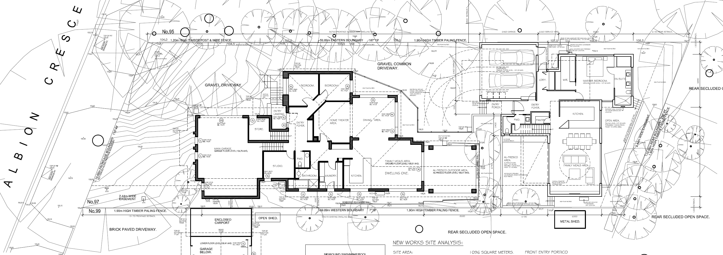

Dwelling 1 1

Figure 2 – First floor plan – TP.06A

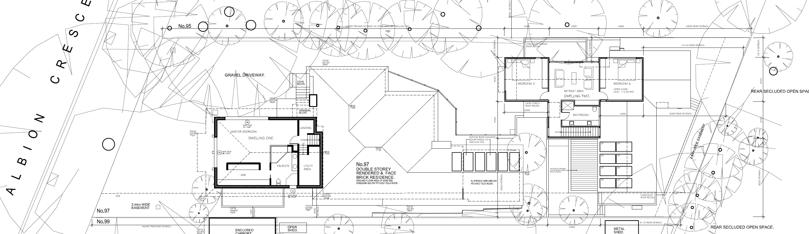

Figure 3 – Elevations

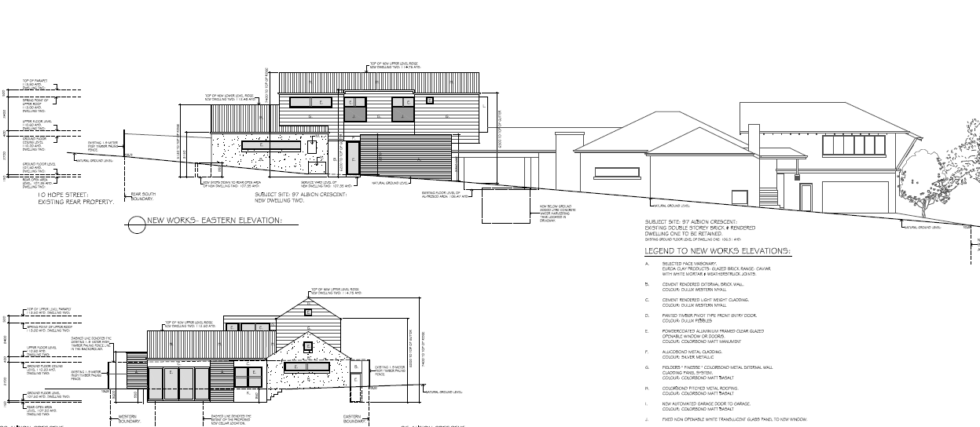

1. Banyule City Council (the ‘Council’) refused the application on grounds the proposal is inconsistent with State and local policies relating to neighbourhood character due to the mass, bulk, and scale of the built form. The grounds state the proposal is an overdevelopment and it will erode the spacious character of the area and insufficient space has been provided for canopy tree planting. There are also grounds that the built form will have an overbearing impact on local residential amenity and the accessway has not been designed and engineered to serve the development in accordance with Clause 52.06 – Car Parking.
2. Council says this area is identified to accommodate some limited increase in residential development provided it is sensitively designed. It argues this has not been achieved as the cumulative impact of the intensity of the development, siting and design is in direct conflict with the existing and preferred neighbourhood character outcomes sought by policy. It also submits the development fails to provide appropriate areas for the planting and maturity of canopy trees.
3. The applicant argues the proposal is an appropriate design response which not only increases residential development by a desirable level but also creates housing diversity. He says the proposal is not an overdevelopment and it provides a net benefit with additional canopy tree planting that meets the preferred neighbourhood character of the area. He submits the design response will not result in unreasonable off-site amenity impacts.

## What are the key issues?

1. I find the following key issues in this matter:

* Does the proposal respond to its zoning and policy context?
* Is the proposal an acceptable response to the preferred neighbourhood character?
* Does the development respond to the landscape character of the area?
* Are the off-site amenity impacts acceptable?
* Are the car parking and access arrangements acceptable?
* Is the proposal an overdevelopment of the site?

1. Planning does not seek ideal outcomes, or outcomes which respond positively to every relevant policy. Rather, acceptable outcomes are the measure by which planning decisions are to be made. I must decide whether the proposal will produce an acceptable outcome having regard to the relevant policies and provisions in the Scheme. Clause 71.02-3 requires the decision-maker to integrate the range of policies relevant to the issues to be determined and balance conflicting objectives in favour of net community benefit and sustainable development.
2. Having considered the submissions presented regarding the applicable policies and provisions of the Scheme and assisted by my inspection, I have decided to set aside Council’s decision. I find the siting and scale of the second dwelling will not detract from the existing and preferred landscape character of this area provided there is an additional setback to the east boundary and the Alfresco area is deleted for the existing dwelling as conditions on the permit. My reasons follow.

## Does the proposal respond to its zoning and policy context?

1. The site is in a Neighbourhood Residential Zone Schedule 3 (NRZ3) that has purposes to recognise areas of predominately single and double storey residential development and to manage and ensure that development respects the identified neighbourhood character, heritage, environmental or landscape characteristics. There are no variations to clause 55.
2. In accordance with Clause 32.09-10 a maximum building height for a dwelling is 9 metres and must not contain more than two storeys at any point. The new dwelling proposes a maximum height of 7.4 metres and meets the requirements of clause 32.09-10. The development provides 35.7% of the site as garden area and satisfies clause 32.09-4.
3. The site is within Vegetation Protection Overlay Schedule 1 – Plenty River East Area (VPO1). No tree removal, destruction or lopping of native vegetation is proposed as part of this application.
4. The site is within a Design and Development Overlay Schedule 8 – Plenty River East Neighbourhood Character (DDO8). A permit is required for buildings and works located within the drip line of a tree for which a permit is required to remove, destroy, or lop under any Vegetation Protection Overlay or Environmental Significance Overlay also affecting the land.
5. Council submits that a permit is required as construction of the driveway (Draft Condition 12) with a sealed surface would constitute works within the dripline of Trees 1, 18 and 19, which are protected trees in accordance with the VPO1. It also says the garage of the new dwelling is within the dripline of Tree 10. I find that the sealing of the driveway is not required and therefore there are no works within the dripline of Trees 1, 18 and 19. I will expand on these reasons further below. I am also satisfied the garage and retaining walls of the new dwelling are outside the dripline of Tree 10. Therefore, no permit is triggered in accordance with the DDO8.
6. The site is also within a Development Contributions Plan Overlay Schedule 1 (DCPO1). A payment is required for all development covered by this overlay and standard conditions will be included on the permit.
7. The Planning Policy Framework (PPF) contains several policies that encourage well designed and site responsive designs in areas that are well located in terms of public transport and existing services. This includes strategies at Clause 11 (Settlement) that state consideration should be given to consolidation and intensification of existing urban areas. Policies at Clause 16 (Housing) encourage diverse and higher density housing on well located sites, including those with good public transport connections. These policies need to be balanced against other policies such as Clause 12 (Environmental and Landscape Values) that states planning should help to protect the health of ecological systems and the biodiversity they support (including ecosystems, habitats, species, and genetic diversity) and conserve areas with identified environmental and landscape values.
8. The Local Planning Policy Framework (LPPF) at Clause 21.04-1 (Housing) notes that one of the key issues is achieving a balance between the objectives of protecting residential amenity and providing for desired future neighbourhood character outcomes and providing for urban consolidation and satisfying housing demand. Strategies for housing include protecting residential amenity and providing for the future neighbourhood character of residential areas.
9. Clause 21.06-2 (Residential Areas Framework) identifies the subject site is within a Limited Incremental Area (LICA). These areas are described as:

These are located east of the Plenty River. They are characterised by tall trees, undulating topography and two storey dwellings that sit below the tree canopy.

These areas will provide for sensitively designed single dwellings and some dispersed medium density dwellings that respect the valued attributes of the existing neighbourhood character, with an emphasis on protecting trees and creating new opportunities for vegetation.

1. Clause 22.02 Residential Neighbourhood Character Policy expands on the above objectives and strategies. The policy identifies character precincts in the residential areas and articulates the preferred character, design objectives and desirable design response for development. The subject site is located within the Semi Bush (West) Precinct Area[2]. This policy provides a set of objectives and associated design responses that I will discuss further in my neighbourhood character findings below.

### Policy arguments

1. Council argues to implement the objectives and strategies of the PPF and LPPF in relation to housing, it has included the subject site in a NRZ which is identified as having limited opportunities for increased residential densities due to the valued neighbourhood character and landscape characteristics. It argues that there is a need to balance the built form in the natural landscape of the surrounding area to ensure development makes a positive contribution to the desired future character. It says this includes the need to retain and plant significant trees. Council submits whilst vegetation is to be planted, the site coverage, building area, retaining walls and hard surface areas fail to provide planting to improve/enhance the landscape character that is required by policy.
2. The applicant submits the development is site responsive design that will enhance the public realm. He argues the proposal is fully compliant with the objectives sought under the LICA as it is only for one additional dwelling on a large site. He submits the proposal does not involve the removal of any significant trees and the development includes the planting of several indigenous canopy trees around the existing and new dwelling.

### Tribunal findings

1. I find as the site is within an established residential area that has good access to shops, social and physical infrastructure it is a suitable location for a limited increase in housing, such as a second dwelling on a lot. I note Greenhills Primary School is located at the western end of Albion Crescent and Browns Reserve is located 300 metres from the site. Shops and bus services are located nearby.
2. Whilst the site is within a NRZ3 and LICA, it does not exclude medium density development provided it respects the existing and preferred neighbourhood character. I acknowledge this neighbourhood has valued attributes relating to its landscape character. This is also identified in the statement of nature and significance of vegetation to be protected in the VPO1 and design objectives of the DDO8. I also note that there is an emphasis on protecting trees and providing opportunities for new trees that is reflected in the design responses for the Semi Bush (West) Precinct Area.
3. The main issue is whether the second dwelling has responded to the zoning, policies and overlays given the constraints imposed by the location of the existing dwelling, neighbouring trees, overall landscape character of the area and slope. I find the proposal adequately responds to the Planning Scheme and physical constraints as the siting and scale of the two-storey dwelling will not be obtrusive in this landscaped setting. However, my findings are based on amendment of the plans to increase the ground floor set back to the east boundary and removal of Alfresco area for the existing dwelling to increase landscaping potential throughout the site. My reasons follow.

## Is the proposal an acceptable response to the preferred neighbourhood character?

### What is the existing neighbourhood character?

1. The subject site is in an established residential area that contains predominately detached dwellings. Due to the undulating topography, there is a mixture of single and two storey dwellings. Dwellings are generally set back 5-20 metres from the frontage and contain large areas of landscaping that includes medium to large native canopy trees. The dwellings are from the 1970’s-2000’s and include a variety of styles, roof forms and materials. Car parking is generally located to the side or rear of dwellings.

Figure 4 – Aerial Photograph[3]

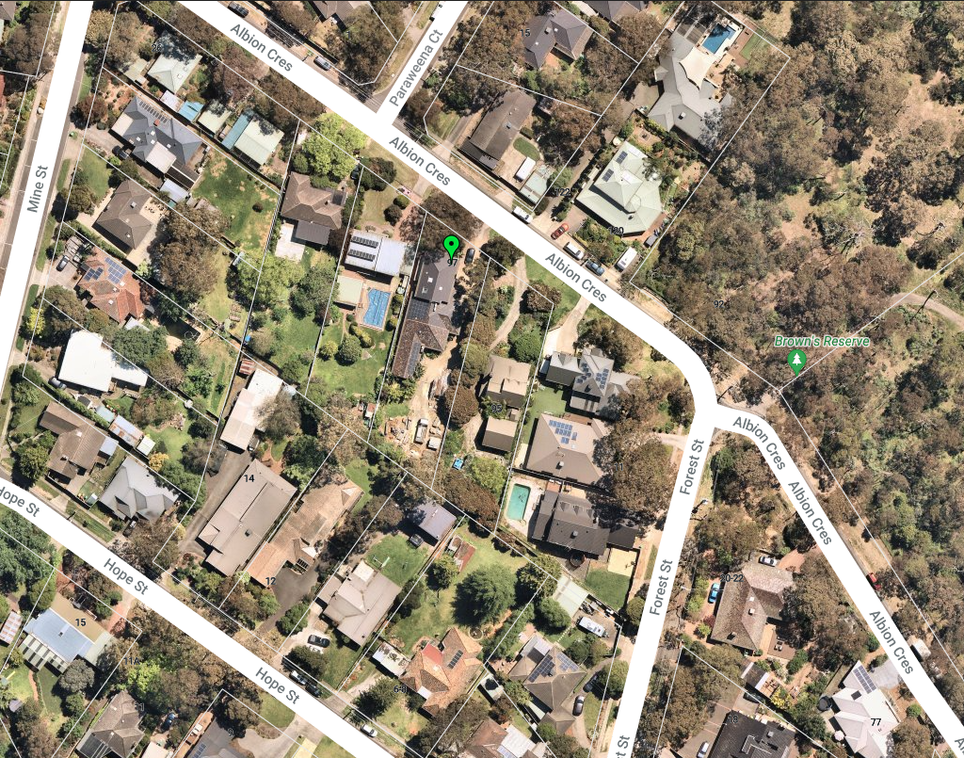

1. Garden styles contain a mix of exotic and native species but the taller native canopy trees on-site and in nature-strips provide a strong landscape character of the area. This canopy cover is also evident in nearby reserves such as Browns Reserve that form a backdrop to the dwellings in the neighbourhood. Frontages are generally open to the street and footpaths are located on one side of the street only. In the nature-strip immediately in front of the site is a large Mealy Stringybark (16 metres high) but there is limited vegetation in the rear yard of the subject site.
2. Abutting to the west is a split-level detached house at 99 Albion Crescent. This dwelling is set back 12.3 metres from the frontage and there is an enclosed garage abutting the common boundary. To the east is a two-storey rendered house at 97 Albion Crescent that is set back 19.5 metres from the frontage and 5.9 metres from the west boundary. This setback contains a driveway that leads to a brick garage in the rear yard. There is a series of exotic trees growing along the common boundary. Further east is a dwelling at 91 Albion Crescent that is setback 5.4 metres from the frontage. To the south are the rear yards of two detached dwellings at 10 and 12 Hope Street. There is also a large two-storey outbuilding in the rear yard of 10 Hope Street.
3. Medium density development is evident in the area including at 120 and 122 Albion Crescent with a battle-axe two dwelling development, 16 Mine Street (2 dwellings) and 76 Greenhill Road.

### What is the preferred neighbourhood character?

1. The subject site is in the Semi-Bush (west) Precinct. The Statement of Preferred Future Neighbourhood Character at Clause 22.02-6 states the character is to be retained and enhanced by retaining existing canopy trees, and other significant vegetation, designing site layouts with spacing around dwellings to allow for the planting and the future growth of trees to maturity, minimising the excavation of sites, designing developments with only one single width crossover and a driveway that is softened with curves and vegetation and maintaining open front boundary treatments coupled with vegetation in front gardens.

### Building scale

1. The precinct guidelines have an objective to ensure buildings and extensions do not dominate the streetscape and do not adversely affect the outlook and amenity of neighbouring dwellings. Design responses are for second storey portions of buildings to be recessed from ground level wall faces or incorporated within roof spaces, where possible, and to minimise overall height. They also recommend the design of buildings at the rear of site to follow the topography of the land and respond sensitively to each interface.
2. Council argues the new dwelling does not respond to its context due to the continuous built form which provides limited relief to neighbouring properties. It says the location and scale of the existing dwelling places constraints on the site and the vacant area at the rear is not suitable for a dwelling of this scale. It argues the new dwelling location is incompatible with the character values and built form evident in the surrounding area.
3. The applicant argues the height and scale of new building is consistent with the existing dwellings in the immediate area. He argues the new dwelling will not penetrate the tree canopy and will be nestled in the landscape. He says the upper level is modest in size and well set back from all boundaries. He submits the first floor is smaller than the ground floor footprint and only a small section is cantilevered over the garage, which will have no impact on the area.

#### Tribunal findings

1. I do not share Council’s concerns about the scale of the new dwelling at the rear of the site for the following reasons:

* The site layout includes the retention of the existing dwelling at the front of the site and utilisation of the existing driveway along the east boundary. Therefore, the new dwelling is partially screened in the streetscape;
* The overall height (i.e. 7.6 metres) is consistent with existing dwellings nearby. This height meets the requirements of zone at Clause 32.09-6;
* The first floor is generally recessed in from the side and rear boundaries. The dwelling is set back 2.01-2.44 metres from the east boundary and 8.33-10.1 metres from the south boundary. These setbacks exceed the minimum setbacks recommended in Clause 55.04-1 (Standard B17 – Side and rear setbacks);
* The dwelling is partially excavated into the rear of the site by approximately 950mm to lower the overall height;
* The design includes varied roof forms and materials at ground and first floor level;
* There are adequate side and rear setbacks which are suitable for screen planting to soften the building scale for nearby properties;
* Two-storey built form is not foreign in the rear yards of nearby properties. There is a large two-storey outbuilding in the rear yard of 10 Hope Street to the south-east that is located near the common boundary; and
* The first floors of the existing and proposed dwelling are separated by approximately 18.5 metres separation which ensures there is not excessive built form throughout the site.

1. I acknowledge first floor bedroom 2 of the new dwelling is cantilevered over the garage. However, given the dwelling is located at the rear of the site and this feature is recessed back from the east boundary, it provides visual interest to ensure that it will not be overbearing in the streetscape or for abutting properties.

## Does the development respond to the landscape character of the area?

1. Some of the objectives of the preferred character for the Semi-Bush area at Clause 22.02-6 are to maintain and enhance the indigenous vegetation dominated vistas, streetscapes, and backdrops, and encourage the replanting of indigenous plants and to ensure buildings maintain the spaciousness and bush character of front gardens. There is also an objective to ensure that adequate space is available on private land for the retention and planting of vegetation. The precinct design responses are to retain existing trees where-ever possible, plant at least one medium tree for every 150 square metres of site and set back buildings a sufficient distance from at least one side or rear boundary to enable the planting and growth of medium to large canopy trees.
2. The Semi-Bush precinct also recommends that if more than one dwelling is proposed, sufficient separation should be provided between each dwelling to allow for the planting and future growth of small to medium trees and understorey vegetation and building site coverage should not exceed 40% to provide sufficient site area for planting, growth, and retention of vegetation. These objectives are also reflected in the design objectives of the DDO8 which are to ensure that the heavily vegetated character of the area is respected and to maintain the spaciousness and bush character of front gardens.
3. Council argues the Semi-Bush (West) Precinct highlights the highly valued native vegetation dominated environment. It says these areas are becoming scarce due to vegetation clearance and more intense development. It says the proposal will not be absorbed into this vegetation dominated landscape due to the lack of suitable space around the dwellings for canopy tree planting and other vegetation. It submits the special characteristics of this precinct will not be protected nor enhanced.
4. Council submits site coverage of 49.2% demonstrates that there is insufficient room for planting and the growth of vegetation. It also says that buildings should be set back one side or rear boundary to enable the retention and future growth of medium to large canopy trees with sufficient area for growth and maturity. It submits the new dwelling occupies approximately 350 square metres at the rear of the site, which is constrained by easements. It argues that considering the size of the dwelling (i.e. 194 square metres), limited setbacks and retaining walls, there is little space for tree planting. It also referred to the *Banyule City Council Tree Planting Zone Guidelines* (2011)[4] (the ‘guidelines’) and submits insufficient space is provided for the establishment and growth of trees to the intended height and spread that are nominated in the landscape plan.
5. The applicant refutes this proposition and says there is more than adequate room in the frontage, at the rear of the site, and in the secluded open space of each dwelling for the planting of canopy trees. He relies on the evidence of Mr Thomson who considers the redevelopment allows sufficient space to provide a landscape outcome which can highly contribute to amenity and neighbourhood character.
6. Mr Thomson considers the development provides adequate planting space for medium to large canopy trees at a rate of more than 1: 200 square metres which is recommended in Clause 22.02. He says his landscape plan includes the planting of two indigenous canopy trees in the frontage to complement the existing street tree and planting of indigenous shrubs and native screen trees along the east, south and west boundaries which will create an attractive and functional garden that will enhance the landscape character of the area. He also considers the soil volumes are sufficient for the growth of canopy trees and other smaller species. He also considers the guidelines:

unhelpful formulae (that) ignores the evidence provided by thousands of existing mature trees growing in urban areas in close proximity to buildings, hard surfaces and other trees. A strict application of the formula would have an unfortunate unintended effect of unnecessarily reducing the number of canopy trees planted in urban areas.[5]

### Tribunal findings

1. I am satisfied adequate space has been provided throughout the site for landscaping to maintain and enhance the indigenous vegetated dominated character of this area for the following reasons:

* The new dwelling is set back 2.46-6.15 metres from the rear boundary. Due to the configuration of the site, there is space outside the drainage easement for the planting of three medium and tall canopy trees including two Banksias and an Acacia;
* There is also space along the south boundary for a Grevillia hedge (3 metres at maturity) which will filter views to the south;
* Two Eucalyptus and a Black Sheoak are proposed to be planted in the frontage setback which will complement the existing Mealy Stringybark in the nature-strip. This planting is in accordance with the design objectives of the precinct to provide additional indigenous canopy tree planting in the streetscape; and
* Canopy tree planting is proposed within the secluded open space of both dwellings, including 5 medium canopy trees around the Alfresco area of the existing dwelling.

1. I am not persuaded by Council’s argument that the proposal is unsatisfactory as the development does not provide the minimum growing areas specified in the guidelines. I accept Mr Thomson’s evidence that sufficient soil volume is provided for the growth of the canopy trees and agree with the findings in *Vimalanathan v Banyule CC* where it is noted:

Council is concerned that the proposed landscaping has not had regard to the Banyule Tree Planting Guidelines that suggest a growing area of 90 square metres should be provided. I do not share this concern. A landscape plan prepared by suitably qualified person should have the necessary skills and experience to select tree species suitable to the location, the soil type, the climate, etc. The Guidelines are just that – a guide that *suggests* (not requires) what *should* (not must) be provided. The Guidelines are not a mandatory requirement. I agree with the applicant that this amount of new tree planting accords with the preferred future character and vegetation aspirations in the planning scheme.[6]

1. At the hearing the applicant offered to increase the ground floor east setback of the new dwelling from 1.2 metres to 1.6 metres. I consider this amendment will provide enough space for the planting of screen vegetation along the east boundary and will further enhance the landscape character at the rear of the site. I will include it as a condition on the permit.
2. Whilst I am satisfied that adequate space has been provided around the new dwelling for landscaping, I raised concerns about the ability for canopy tree planting to grow abutting the Alfresco area of the existing dwelling. I note the Alfresco area is set back approximately 1.4 -2.2 metres from the internal boundary. I also raised concerns about the internal amenity of the dwelling due to the lack of uncovered secluded private open space. In response to these concerns, the applicant offered to remove the roof of the Alfresco area or even delete this structure.
3. Mr Thomson considers the setbacks to the boundaries for the existing dwelling can accommodate the canopy trees shown on the landscape plan. He acknowledges these setbacks may result in trees not reaching their full height and canopy spread, but he considers there is enough space for them to successfully grow. I questioned him about the impact on the growing potential of the trees if the Alfresco area was uncovered. He agreed that there would be more space for canopy spread if this occurred.
4. Based on this advice, I consider the Alfresco area should be deleted. I have come to this conclusion as it will provide additional space for canopy tree spread between the dwellings. The amendment will also assist in reducing the extent of built form along the length of the site which will reflect the spacious character of the area. Lastly, removal of the Alfresco area will provide occupants of this dwelling with useable uncovered space that is directly accessible from the family room. I will include this as a condition on the permit.

## Are the off-site amenity impacts acceptable?

1. Council is concerned that there will be a continuous built form that provides very limited visual relief to the neighbouring properties. It says this will have an overbearing physical impact upon local residential amenity that is contrary to Clauses 15.01-1 (Urban Design) and Clause 21.04-1 (Housing). It says the location and scale of the existing dwelling constrains the site and there is a lack of suitable space around the dwelling for screen landscaping.
2. The applicant argues the dwelling will not be visually bulky when viewed from any adjoining properties. He says there is an existing brick building along the east boundary and the new design response replaces this wall.

### Tribunal findings

1. I find the new dwelling will not result in unreasonable visual bulk impacts on neighbouring properties. I have come to this conclusion for the following reasons:

* The ground floor east elevation will be set back 1.6 metres from the east boundary and screen landscaping can be planted in the eastern setback to filter views;
* The new dwelling faces the driveway and garage of the adjoining dwelling at 97 Albion Crescent;
* The garage on the boundary generally replaces the existing garage. This wall meets the boundary wall height and requirements of Clause 55.04-2 (Standard B18 – Walls on boundaries);
* The upper level is a smaller component than the ground floor area. This level is set back a minimum of 2.1 metres from the east boundary, 8.3 metres from the south boundary and 8.02 metres from the west boundary. These setbacks exceed the minimum distances recommended in Standard B17 and will be a recessive element at the rear of the site;
* There will be limited overshadowing or daylighting impacts on neighbouring properties. This is demonstrated on the shadow diagrams at TP.10A-TP12A;
* There is an 18.5 metre separation between the upper levels of the dwellings on the subject site. This siting ensures that there is not excessive built form throughout the site; and
* The new dwelling includes a variety of materials, window openings and roof forms that provide visual interest in all elevations.

## Are the car parking and access arrangements acceptable?

1. Council has included a ground of refusal that the development does not meet Clause 52.06-11 which states driveways are to be constructed and drained and treated with an all-weather seal or some other durable surface. Council opposes the retention and extension of the existing gravel driveway and argues it may impact neighbouring trees.
2. The applicant submits the existing driveway is to be retained and this is consistent with precinct guidelines that recommends driveways should be finished in earthy tones. He argues that there are numerous single dwellings and medium density developments nearby that have crushed rock surfaces. He considers as the new dwelling is to be located to the rear, there is limited visibility in the streetscape and the existing driveway functions well.

### Tribunal findings

1. Given the site is in a Semi-Bush precinct and DDO8 that highly values native vegetation-dominated residential environment, I find retention of the gravel driveway will complement the existing and preferred neighbourhood landscape character of the area. I consider this is a softer surface to concrete and it will be an ‘earthy natural tone’ which is recommended in the precinct guidelines.
2. I note there is an existing concrete apron at the front of the site to prevent discharge of the gravel and numerous drainage points along the length of the driveway to ensure water is adequately managed on the site. I also note that retention of the gravel will ensure there is a permeable surface within the dripline of existing trees growing along the east boundary in the adjoining property. This will minimise the impact on nearby vegetation. I also acknowledge there are dwellings nearby with gravel driveways, such as at 8 Hope Street and 22 Crest Street, that complement the landscape character of the area.

## Is the proposal an overdevelopment of the site?

1. Council submits that cumulatively, the impact of the intensity of development, landscaping and design is in direct conflict with the existing and preferred neighbourhood character and is therefore an overdevelopment of the site. It argues a more modest form of development is required that strengthens views of garden and positions vehicles and upper levels to be secondary elements in the streetscape.

#### Tribunal findings

1. I find that to properly address overdevelopment you must look beyond the arithmetic non-compliance in the Planning Scheme and examine the context of the site in terms of its physical characteristics and policy framework. In this context, I consider development of an additional two-storey dwelling is consistent with the level of change envisaged for a LICA. I also note the development achieves substantial compliance with the various Res Code standards, including site coverage and off-site amenity impacts, and that sufficient space is provided around both dwellings for landscaping.

## Any other issues?

1. The plans show the existing and proposed dwelling encroaching over the 2.44 metre easement along the west boundary. Council’s drainage engineer advised that as the new dwelling and retaining walls are to be constructed over the western drainage and sewerage easement, structures of a permanent nature will not be granted Build Over Easement approval. The drainage engineer advised he was not supportive of excavation in the easement and that it may affect the overland flow that is expected for this section of the site.
2. The applicant says the owner was advised that there were no drainage assets in the easement. Council was not able to confirm this from the drainage referral. Therefore, to clarify the matter, I ordered Council to advise the Tribunal and the applicant if there are any drainage assets in the easement and what conditions are required to protect this asset.
3. In response to this order, Council advised the drainage easement is an encumbrance on the property title to allow access rights for the maintenance of existing drainage assets or the installation of new drainage assets within the easement. It submitted that requirements apply whether there are existing assets or not. It recommended the inclusion of a condition on the permit that a separate application for Build Over Easement approval must be submitted to the Responsible Authority for approval for the location of the existing dwelling and all retaining walls, footings, and stairs etc associated with the new dwelling that encroach upon and within the easements affecting the subject site.  It suggested that this condition must specify that when approved, condition 1 plans will be endorsed reflecting the easement encroachments for which permission has been obtained.
4. Alternatively, Council advised that the easement along the west boundary could be removed. It says this is the preferred option and suggested that the condition would need to say that prior to the endorsement of plans, a separate application for Removal of Easement on western boundary must be submitted to Council for approval. It recommends the development approval is conditional upon the certification of the Removal of Easement.
5. In response to this advice, the applicant advised that he had reviewed Council’s suggested permit conditions and accepts the inclusion of the condition to remove the drainage easement.
6. I agree that the best course of action is to remove the western drainage and sewerage easement to provide clarity for all parties. However, I will amend the wording of the condition to require the removal of the easement prior to the commencement of works instead of prior to the endorsement of the plans. This provides the applicant with flexibility to make the necessary approvals to Council and other responsible authorities.

## What conditions are appropriate?

1. Conditions were discussed at the hearing and any changes to the permit conditions contained in Appendix A of this order reflect those discussions plus further consideration by the Tribunal.

## Conclusion

1. For the reasons given above, the decision of the responsible authority is set aside. A permit is granted subject to conditions.

|  |  |  |
| --- | --- | --- |
| Jane Tait  **Member** |  |  |

# Appendix A – Permit Conditions

|  |  |
| --- | --- |
| Permit Application No | P735/2020 |
| Land | 97 Albion Crescent  GREENSBOROUGH VIC 3088 |

|  |
| --- |
| What the permit allowS |
| In accordance with the endorsed plans:   * Construction of a second dwelling |

## Conditions

1. Before the development permitted by this permit commences, amended plans to the satisfaction of the Responsible Authority must be submitted to and approved by the Responsible Authority. When approved, the plans will be endorsed and will then form part of the permit. The plans must be drawn to scale with dimensions and be submitted in an electronic format acceptable to the Responsible Authority. The plans must be substantially in accordance with the plans prepared by George Sarikizis and submitted on the 5 October 2020 but modified to show:
   1. The ground floor of the new dwelling set back a minimum of 1.6 metres from the east boundary;
   2. Deletion of the Alfresco area for the existing dwelling;
   3. Amend the TPZ for Tree #6 to have a 9.6m TPZ shown on the plans;
   4. Amend the TPZ for Tree #10 to have a 8.4m TPZ shown on the plans;
   5. Any separate structure containing electrical meters or other site services must not exceed 1.5 metres in height and must be located behind the front line of the dwelling facing the street or adjacent to the side boundary fence;
   6. Gas and water meters to be nominated on the plans and sited or screened to minimise visibility from neighbouring properties and the public realm;
   7. The location for any split system air conditioner units and/or hot water systems at ground level to minimise visibility from the public realm and neighbouring properties;
   8. The installation of eaves or shading devices to all north-facing windows and balconies, designed to provide appropriate shading during summer and allow solar access during winter;
   9. The mail boxes located in accordance with Australia Post guidelines;
   10. Driveway gradients notated and to demonstrate compliance with the Design Standards of Clause 52.06;
   11. Provision of rainwater storage tanks for both dwellings (as stipulated in any endorsed Sustainability Design Assessment) its location, sizing and a notation of the connections and end use;
   12. All upper floor habitable room windows shown on the endorsed plans to comply with Standard B22 ‘Overlooking’;
   13. All sustainable design features indicated in the submitted Sustainable Design Assessment (SDA) must be provided on a separate plan. Where sustainable design features outlined in the SDA cannot be visually shown, include a notes table providing details of the requirements (i.e. energy and water efficiency ratings for heating/cooling systems and plumbing fittings and fixtures, etc);
   14. Development Drainage Plans in accordance with Condition 2 of this permit;
   15. A Landscape Plan in accordance with Condition 3 of this permit;
   16. A Sustainable Design Assessment in accordance with Condition 4 of this permit;
   17. Tree Preservation Fencing in accordance with Condition 8 of this permit;
   18. A Tree Management & Protection Plan in accordance with Condition 9 of this permit.

### Easement Removal

1. Before the development starts, the drainage and sewerage easement on western boundary shown in Green as TP 641276S must be removed from the title.

### Development Drainage Plans

1. Before the development permitted by this permit commences, Development Drainage Plans to the satisfaction of the Responsible Authority must be submitted to and approved by the Responsible Authority. The plans must be prepared by a suitably qualified engineer or similar person showing a properly prepared design with computations for the internal drainage and method of disposal of stormwater from all roofed areas and sealed areas including:
   1. The use of an On-site Stormwater Detention (OSD) system;
   2. The connection to the Council nominated legal point of discharge;
   3. The integration, details and connections of all Water Sensitive Urban Design features in accordance with the submitted Sustainable Management Plan and STORM report and include drainage details as a result of landscaping;
   4. All drainage plans must show for Trees #1, #3, #4, #6-19 and #21: The tree number; the structural root zone (SRZ) radius; and the tree protection zone (TPZ) radius, each as detailed and calculated within the arborist report submitted with the application authored by **Dr Peter Yau June dated 2020** except the TPZ and SRZ of Trees #6 & #10 must be amended as outlined in Condition 1(a) and (b).

### Landscape Plan

1. Before the development permitted by this permit commences, a satisfactory detailed landscaping plan must be submitted to and approved by the Responsible Authority. Such plan must be generally in accordance with the Landscape Plan prepared by Habitat dated September 2020 and must show:
   1. Amendments required by Condition 1 of this permit;
   2. Relocate the proposed *Eucalyptus goniocalyx* to a central location within the front setback;
   3. Removal of the proposed *Acacia melanoxylon* and replacement with a small native canopy tree from Council’s *Native Canopy Tree List*;
   4. Remove the proposed *Waterhousia floribunda* and replacement with a hedging species such as *Acmena smithii* (Sublime) or *Syzgium australe* (Pinnacle);
   5. Relocation of the Pyrus. ‘Cleveland Select’ to outside the louvre shade area in the northern courtyard of the new dwelling;
   6. The identification of existing vegetation (which is not intended to be removed), and nomination of vegetation for removal throughout the site;
   7. Provision of formed garden beds with edging along the front property boundary and within the front setback to prevent cars parking;
   8. Planting adjacent to driveways and within landscaping zones to consist of varying heights and species;
   9. A notation that ‘All landscaping works for the development (as shown on the endorsed plans) must not alter the existing ground level or topography of the land within the TPZ of all retained/neighbouring trees outside of the approved building envelope.
   10. An indigenous and/or drought tolerant planting theme;
   11. A schedule of all proposed trees, shrubs and ground cover, which includes the location and size at maturity of all plants, the botanical names of such plants and the location of all areas to be covered by grass, lawn or other surface material as specified;
   12. Tree species and planting locations must be carefully selected to avoid canopy or root conflicts with overhead wires, easements and existing trees;
   13. Location and details of paving, steps, retaining walls, water tanks, clotheslines, fence design details and other landscape works including cut and fill;
   14. Location, details and cross section drawings of all Water Sensitive Urban Design features in accordance with the submitted Sustainable Management Plan and STORM report, with reference to connection details on the engineering plans.

When approved the plan will be endorsed and form part of this permit. Landscaping in accordance with this approved plan and schedule must be completed prior to the occupation of the development.

### Sustainability Design Assessment

1. Before the use and/or development permitted by this permit starts, a Sustainable Design Assessment (SDA) to the satisfaction of the Responsible Authority must be submitted to and approved by the Responsible Authority. When submitted and approved, the SDA and associated notated plans will be endorsed to form part of the permit.

## OTHER ACTIONS REQUIRED PRIOR TO COMMENCEMENT OF DEVELOPMENT

### Development Infrastructure Levy

1. Prior to the commencement of development, the permit holder must pay to Banyule City Council a development infrastructure levy and community infrastructure levy in accordance with the amount specified in Table 6 of the *Banyule Development Contributions Plan 2016-17, September 2018*. The contribution amount payable in the table will be adjusted annually from 1 July 2017, each year to cover inflation, by applying the Consumer Price Index for Melbourne (All Groups) as published by the Australian Bureau of Statistics.

### Tree Protection

1. Unless otherwise approved in writing by the Responsible Authority, prior to the commencement of any building and or demolition works on the land, a Tree Protection Zone (TPZ) must be established and maintained during and until completion of all buildings and works including landscaping, around all trees shown to be retained on endorsed plans, Trees #1, #2, #10, #12, #13, #17-22, #24 and #25 to the satisfaction of the Responsible Authority:
   1. Tree protection zone measures are to be established in accordance to Australian Standard 4970-2009 as calculated within the arborist report submitted with the application authored by **Dr Peter Yau dated 19 June 2020.**
   2. Tree Protection Zone measures are to be established in accordance withAustralian Standard 4970-2009 and including the following:
      1. Erection of solid chain mesh or similar type fencing at a minimum height of 1.8 metres held in place with concrete feet.
      2. Signage placed around the outer edge of perimeter fencing identifying the area as a TPZ. The signage should be visible from within the development, with the lettering complying with AS 1319.
      3. Mulch across the surface of the TPZ to a depth of 100mm and undertake supplementary watering in summer months as required.
      4. No excavation, construction works or activities, grade changes, surface treatments or storage of materials of any kind are permitted within the TPZ unless otherwise approved within this permit or further approved in writing by the Responsible Authority.
      5. No trenching is allowed within the TPZ for the installation of utility services unless tree sensitive installation methods such as boring have been approved by the Responsible Authority in writing.
      6. Where construction is approved within the TPZ, fencing and mulching should be placed at the outer point of the construction area.
      7. Where there are approved works within the TPZ, it may only be reduced to the required amount by an authorised person only during approved construction within the TPZ and must be restored in accordance with the above requirements at all other times.
      8. For street trees, protection must be to the extent of the entire nature strip where the Calculated Tree Protection Zone (TPZ) occurs (not obstructing a footpath or cross-over).
      9. For neighbouring trees, protection must be to the extent of the calculated Tree Protection Zone (TPZ) where it occurs within the subject Land.
      10. Ground protection must be laid down where access is required through a TPZ outside the fenced area. It must consist of a permeable membrane beneath a layer of mulch or crushed rock with rumble boards on top. Rumble boards should be of a suitable thickness to prevent soil compaction and root damage. Ground protection must only be removed once all buildings and works have been completed.

At least 14 days prior to commencement of works, you must submit a ‘Statement of Compliance’ (from a suitably qualified Arborist - AQF Level 5) which must include photographic evidence of the installed TPZ requirements. Submission must be made to [enquiries@banyule.vic.gov.au](mailto:enquiries@banyule.vic.gov.au) referencing the address and planning permit number.

### Specific Tree Protection Measures

1. During the construction of any buildings or works, the following tree protection requirements must be carried out to the satisfaction of the responsible Authority:
   1. A suitably qualified project Arborist (AQF Level 5) must ensure that all buildings, works, pruning or root severance within a TPZ does not adversely impact the health and or stability of any retained tree now or into the future.
   2. Any root severance within a TPZ must be undertaken by the project arborist in accordance with the Australian Standard AS4373-2007 Pruning of Amenity Trees using sterilised, specialised tree root pruning equipment. There must be no root pruning within the SRZ of any tree. There must be no works undertaken within the TPZ other than those endorsed by the Responsible Authority (RA).
   3. Buildings and works for the construction of the retaining wall adjacent to Trees #7, #8 & #9 as shown on the endorsed plans must not alter the existing ground level or topography of the land within 2.4m of the south boundary fence.
   4. Where the driveway area is within the TPZ of retained trees, it must be constructed at the existing soil grade using porous materials that allows water to penetrate through the surface and into the soil profile. There must be no grade change within the TPZ, and no roots are to be cut or damaged during any part of the construction process.
   5. The project arborist must supervise the site demolition and preparation works where those works occur within the TPZ of Tree #14. No roots greater than 40mm in diameter are to be cut or damaged. All plant machinery and construction equipment must operate from outside the TPZ. There must be no works undertaken within the TPZ other than those endorsed by the Responsible Authority (RA).
   6. The project arborist, site manager and builders must ensure that TPZ measures are being adhered to throughout the entire building process, including site demolition, levelling and landscape works.

### Tree Management & Protection Plan

1. Before the plans required by Condition No. 1 of this permit are endorsed, a Tree Management & Protection Plan (TMPP) to the satisfaction of the responsible authority, must be submitted to, and approved in writing by, the responsible authority. The TMP must be prepared by a suitably qualified and experienced Arborist in relation to the management and maintenance of the Trees #1, #3, #4, #6-19 and #21. The Tree Management & Protection Plan must include (but not be limited to):
   1. A tree protection plan drawn to scale.
   2. All tree protection zones and structural root zones to be indicated on the plan.
   3. Reference and consider all other Tree Protection measures conditioned as part of planning permit P735/2020.
   4. The design modifications and or specific construction techniques set out in the Arborist Report by **Dr Peter Yau** – 19 June 2020.
   5. The types of footings used within tree protection zones. Which must also be indicated on the plans
   6. A management regime, for all trees during the demolition, construction and post-construction phases of the development including;
   7. All remedial pruning works that are required to be performed. Details of the pruning must reference Australian Standard AS4373:2007 *Pruning of amenity trees*, and include a detailed photographic diagram specifying what pruning will occur. Any proposed pruning must also consider any scaffolding requirements for construction of dwellings/units, all tree pruning must then be carried out by a suitably qualified Arborist (AQF Level 3, minimum) in accordance with Australian Standard *AS4373-2007 Pruning of Amenity Trees*, and must be restricted to the removal of no greater than 15% of the total live canopy of individual trees unless otherwise agreed in writing by the Responsible Authority.
   8. Details of how root systems of the trees to be impacted will be managed. This must detail any initial non-destructive trenching (if required), requirements regarding all excavations within TPZ’s and pruning of any roots required which must be undertaken by a project Arborist.
   9. The location/design of tree protection fencing for retained trees, mulching/ watering requirements and TPZ areas where ground protection systems will be used.
   10. Tree removal methods for approved vegetation
   11. Details regarding site access by vehicles, machinery and storage of any related building materials in relation to the TPZ of retained trees.
   12. Details and location of all underground services in relation to the TPZ of retained trees. Plans must include notations that state all services will either be located outside TPZ’s or bored under the tree protection zone unless written approval is received from the responsible authority
   13. Supervision timetable and certification (sign off sheet) of all tree management activities undertaken by the project Arborist to the satisfaction of the responsible authority.

The approved Tree Management Plan must be implemented to the satisfaction of the responsible authority. Written confirmation from the project Arborist that the tree management works undertaken are satisfactory and are in accordance with the approved Tree Management Plan must be submitted to the responsible authority, to its satisfaction.

### Council Trees

1. No Council trees are to be removed without the prior written consent of the Responsible Authority.

## ACTIONS REQUIRED UPON COMPLETION OF DEVELOPMENT

### Occupation of Development

1. Unless otherwise agreed in writing by the Responsible Authority the development permitted by this permit must not be occupied until the development has been completed to the satisfaction of the Responsible Authority in accordance with the permit and endorsed plans (including, but not limited to built form and layout, parking, landscaping, drainage, street numbering, replacement of street trees).

## ONGOING REQUIREMENTS OF THIS PERMIT

### General

1. The development as shown on the endorsed plans or described in the endorsed documents must not be altered or modified except with the written consent of the Responsible Authority.

### Car Parking/Access

1. Areas set aside for the parking of vehicles together with the aisles and access lanes must be properly formed to such levels that they can be utilised in accordance with the endorsed plans. The areas must be constructed, drained, and maintained in a continuously useable condition to the satisfaction of the Responsible Authority.
2. Areas set aside for the parking and movement of vehicles as shown on the endorsed plan(s) must be made available for such use and must not be used for any other purpose to the satisfaction of the Responsible Authority.

### Urban Design and Landscaping

1. All external surfaces of the building elevations must be finished in accordance with the schedule on the endorsed plans and maintained in good condition to the satisfaction of the Responsible Authority.
2. Any air-conditioning or cooling units, condensers and the like must not be located on external walls and, if located on balconies, must be screened, to the satisfaction of the Responsible Authority.
3. All pipes (except down-pipes), fixtures, fittings and vents servicing any building on the site must be concealed in service ducts or otherwise hidden from external view to the satisfaction of the Responsible Authority.
4. Outdoor lighting must be provided, designed, baffled and located to the satisfaction of the Responsible Authority such that no direct light is emitted outside the boundaries of the subject land.
5. Unless otherwise agreed in writing by the Responsible Authority, all telecommunications and power connections (where by means of a cable) and associated infrastructure to the land must be underground to the satisfaction of the Responsible Authority.
6. The owner must ensure that the garden areas shown on the endorsed plan and schedule shall only be used as gardens and shall be maintained in a proper, tidy and healthy condition to the satisfaction of the Responsible Authority. Should any plant be removed or destroyed it may be required to be replaced by a plant of similar size and variety.
7. Unless otherwise agreed in writing by the Responsible Authority, no vegetation (other than that indicated on the endorsed plan or exempt from planning permission under the provisions of the Banyule Planning Scheme) shall be damaged, removed, destroyed or lopped.

### Waste Management

1. No receptacles for any form of rubbish or refuse (other than public waste bins) may be placed or allowed to remain in view from a public road or thoroughfare except during collection. Odour must not be emitted from any such receptacle to cause offence to any person outside the subject land, to the satisfaction of the Responsible Authority.

### Maintenance of property

1. The occupiers must promptly remove or obliterate any graffiti on the subject site which is visible to the public and keep the site free from graffiti at all times to the satisfaction of the Responsible Authority.

### Landscaping Maintenance

1. The owner must ensure that the garden areas shown on the endorsed plan and schedule shall only be used as gardens and shall be maintained in a proper, tidy and healthy condition to the satisfaction of the Responsible Authority. Should any plant be removed or destroyed it may be required to be replaced by a plant of similar size and variety.

### Permit Expiry

1. In accordance with section 68 of the *Planning and Environment Act 1987*, this permit will expire if one of the following circumstances applies:
   1. The development is not commenced within two years of the date of this permit; or
   2. The development is not completed within four years of the date of this permit.

**– End of conditions –**

1. The submissions and evidence of the parties, any supporting exhibits given at the hearing and the statements of grounds filed have all been considered in the determination of the proceeding. In accordance with the practice of the Tribunal, not all this material will be cited or referred to in these reasons.
2. This designation is found in the *Banyule City Council Neighbourhood Character Strategy 2012* which is reference document at Clause 22.02-9.
3. Source: Nearmap 27 October 2021.
4. The guidelines are a reference document at Clause 22.02-9.
5. Landscape evidence – pt 6.4.
6. *Vimalanathan v Banyule CC* [2020] VCAT 977 – pt 11.