Federal Court of Australia

Hells Angels Motorcycle Corporation (Australia) Pty Limited v Redbubble Ltd [2021] FCA 1090

|  |  |
| --- | --- |
| File number(s): | QUD 403 of 2020 |
|  |  |
| Judgment of: | **GREENWOOD J** |
|  |  |
| Date of judgment: | 8 September 2021 |
|  |  |
| Catchwords: | **INTELLECTUAL PROPERTY** – consideration of an application to re‑open a proceeding to enable the applicant to agitate four further examples of contended trade mark infringement arising out of searches of the first respondent’s website conducted on 6 August 2021 and 13 August 2021 – consideration of the best method of addressing the resolution of claims of trade mark infringement in relation to four contended further examples – consideration of whether those examples are best dealt with in the present proceeding reserved for consideration and judgment on 13 July 2021 |
|  |  |
| Legislation: | *Federal Court of Australia Act 1976* (Cth), ss 37M and 37P |
|  |  |
| Cases cited: | *Hells Angels Motorcycle Corporation (Australia) Pty Limited v Redbubble Limited* [2019] FCA 355 |
|  |  |
| Division: |  |
|  |  |
| Registry: |  |
|  |  |
| National Practice Area: |  |
|  |  |
| Sub-area: |  |
|  |  |
| Number of paragraphs: | 20 |
|  |  |
| Date of hearing: | 7 September 2021 |
|  |  |
| Counsel for the Applicant: | Mr D Eliades |
|  |  |
| Solicitor for the Applicant: | Bradley Rees Hogan |
|  |  |
| Counsel for the First Respondent: | Mr R Cobden SC with Ms E Bathurst |
|  |  |
| Solicitor for the First Respondent: | Allens |

ORDERS

|  |  |  |
| --- | --- | --- |
|  | | QUD 403 of 2020 |
|  | | |
| BETWEEN: | HELLS ANGELS MOTORCYCLE CORPORATION (AUSTRLAIA) PTY LIMITED ACN 123 059 745  Applicant | |
| AND: | REDBUBBLE LTD ACN 119 200 592  First Respondent  HELLS ANGELS MOTOR CYCLE CORPORATION  Second Respondent | |

|  |  |
| --- | --- |
| order made by: | GREENWOOD J |
| DATE OF ORDER: | 8 SEPTEMBER 2021 |

**THE COURT NOTES THAT** on 31 August 2021, the first respondent provided a report to the solicitor for the applicant, subject to particular confidentiality undertakings, in relation to various matters concerning the matters identified in Annexures GH‑16, GH‑17, GH‑19 and GH‑20 to the affidavit of Mr Gavin Hansen sworn 21 August 2021.

THE COURT ORDERS THAT:

1. Leave is granted to the applicant to re‑open its case to include Examples 8, 9, 10 and 11 referred to in the affidavit of Mr Hansen sworn 21 August 2021.
2. Leave is granted to the applicant to file, serve and rely upon the affidavit of Mr Hansen in the proceeding.
3. By 8 September 2021, the applicant file and serve points of claim in relation to the four further examples in suit.
4. By 8 September 2021, the applicant file and serve a further amended originating application to include the four further examples in suit.
5. By 14 September 2021, the first respondent file and serve a response to the points of claim of the applicant.
6. By 16 September 2021, the applicant file and serve a reply to the response of the first respondent to the points of claim.
7. By 17 September 2021, the applicant file any further affidavit material upon which it proposes to rely in relation to relief sought concerning the four further examples referred to in the affidavit of Mr Hansen sworn 21 August 2021.
8. By 1 October 2021, the first respondent file and serve any further evidence it proposes to rely upon in answer to the evidence of the applicant in chief concerning the four further examples.
9. By 11 October 2021, the applicant file and serve any evidence in reply upon which it proposes to rely.
10. By 15 October 2021, each of the applicant and the first respondent file a brief supplementary outline of contentions in relation to the four further examples.
11. By 25 October 2021, the applicant deliver to the Associate to the Hon Justice Greenwood a paginated supplementary Court Book in printed and electronic form including an index agreed between the parties.
12. The hearing in relation to matters arising in relation to the four further examples is set down to commence at 10.15am on 2 November 2021 for one day with a day held in reserve on 3 November 2021.
13. The costs of and incidental to the case management hearings in relation to the four further examples are reserved.
14. Pursuant to s 23 and s 37P of the *Federal Court of Australia Act 1976* (Cth), rule 1.32 and rule 1.36 of the *Federal Court Rules 2011*, these orders and the reasons for judgment in support of these orders are made and published from Chambers.

Note: Entry of orders is dealt with in Rule 39.32 of the *Federal Court Rules 2011*.

REASONS FOR JUDGMENT

GREENWOOD J:

1. These proceedings were the subject of a case management hearing conducted on Tuesday, 7 September 2021 at 9.45am so as to address matters about which the parties have not been able to reach agreement.
2. Because the present questions in controversy, in what I will call “this part of the proceeding”, have arisen in slightly unusual circumstances, it is desirable to identify those circumstances and contextualise the present aspects of the proceeding.
3. The present applicant, Hells Angels Motorcycles Corporation (Australia) Pty Limited (“HAMCAU”) previously brought proceedings (QUD 902 of 2015) against the present first respondent, Redbubble Limited (“Redbubble”) in which the applicant asserted infringement of the trade marks in suit in these proceedings. The trade marks in suit in the earlier proceeding and this proceeding are set out as **Attachment “A”** to these reasons which identifies the trade marks and the goods in respect of which each mark is registered.
4. It is not necessary to set out in these reasons the precise content of the claims made in the earlier proceeding. It is sufficient to note that the applicant established infringements of its trade marks in respect of three examples (Examples 1, 3 and 4 in the earlier suit) arising out of the offering for sale and supply of goods the subject of the trade mark registrations by reference to the “signs” then in issue in that proceeding: *Hells Angels Motorcycle Corporation (Australia) Pty Limited v Redbubble Limited* [2019] FCA 355.
5. Judgment was given in that matter on 15 March 2019. Examples 1, 3 and 4 from the earlier proceeding are set as **Attachment “B”** to these reasons. The final orders in that proceeding included an injunction restraining Redbubble from infringing the applicant’s trade marks, in particular terms.
6. The present proceeding (QUD 403 of 2020) was commenced by an originating application and statement of claim filed on 31 December 2020. In these proceedings, the applicant contends that its trade marks in suit have been infringed by conduct pleaded as seven examples of conduct as set out in the statement of claim. The particular formulation of the infringing conduct (by reference to the facts pleaded concerning each example) is set out at paras 20, 24, 28, 32, 35, 39 and 43 of the statement of claim. It is not necessary to set out the details of that formulation in respect of each example. It is clear enough from the pleading.
7. By the corresponding pleading to each of those paragraphs, Redbubble in its amended defence makes admissions about particular matters solely for the purposes of the proceeding, asserts other matters and otherwise denies the contentions. The trial of the action concluded on 13 July 2021 with judgment reserved. Colour copies of each of the seven examples are **Attachment “C”** to these reasons. In the proceeding, the applicant contends that Redbubble has infringed and is continuing to infringe the trade marks in suit and that it threatens, intends and will, unless restrained, continue to engage in infringing conduct. The applicant says that Redbubble has profited from the infringing conduct. It says that it has sustained loss and damage by reason of the infringement conduct and will continue to suffer damage unless Redbubble is restrained. It seeks additional damages under the *Trade Marks Act 1995* (Cth) based on the number of infringements and the circumstance that it was successful against Redbubble in the earlier proceedings. It contends that Redbubble has not taken proper steps to recognise and protect the interests of the applicant in terms of the applicant’s rights under the *Trade Marks Act.*
8. On 21 August 2021, Mr Gavin Hansen swore an affidavit in relation to the results of searches he conducted of the Redbubble website on 6 August 2021 and 13 August 2021. Mr Hansen is the trade mark officer of the applicant and his role is one of monitoring, predominantly online, and identifying uses of signs which might be considered deceptively similar to those the applicant is entitled to use under the authority of the trade mark owner, Hells Angels Motorcycle Corporation (US).
9. As a result of those searches, Mr Hansen says that he identified another four examples of use of the applicant’s trade marks. The examples are described as Examples 8, 9, 10 and 11. The examples are identified by annexures to his affidavit in this way: Example 8 corresponds to GH‑16; Example 9 corresponds to GH‑17 and GH‑18; Example 10 corresponds to GH‑19 and Example 11 corresponds to GH‑20 and GH‑21. Each of GH‑16, GH‑17, GH‑18, GH‑19 and GH‑20 are attached to these reasons as **Attachments “D”, “E”, “F”, “G” and “H”**. Within the four examples, there are very many uses of the trade marks.
10. Further screenshots in relation to Example 11 are set out at Annexure GH‑21 of Mr Hansen’s affidavit. It is not necessary to attach those examples to these reasons.
11. In light of Mr Hansen’s affidavit of 21 August 2021, the applicant expressed concern that searches it had caused to be undertaken had revealed Examples 8, 9, 10 and 11. The applicant expressed concern that it seemed to fall to the applicant to embark upon a process of regularly searching the Redbubble website to determine for itself whether examples of infringing use were occurring and then to take fresh proceedings in respect of those matters each time it discovered further examples of contended infringement.
12. The applicant sought to bring on an interlocutory application in relation to the four further examples. In light of the applicant’s concern, the issue of the four further examples was brought before the Court by way of a further case management hearing.
13. In the course of that case management hearing, the Court sought to identify the way in which the applicant would seek to address the four further examples especially in the context of the trial of the proceeding having been conducted with judgment reserved. An entirely fresh proceeding could have been commenced but it seemed appropriate to consider other ways in which the further four examples might be addressed.
14. The Court suggested that the appropriate course was to re‑open the proceeding presently reserved to enable the applicant to agitate relief in the proceeding in respect of the four further examples in addition to the seven examples already in suit. Having regard to s 37M(1) of the *Federal Court of Australia Act 1976* (Cth) (the “FCA Act”) which provides that the overarching purpose of the civil practice and procedure provisions is to facilitate the just resolution of disputes: (a)  according to law; and (b)  as quickly, inexpensively and efficiently as possible, it seemed appropriate to the Court to re‑open the reserved proceeding to enable these four further examples to be brought within the present proceeding.
15. The source of the power (apart from any other provision of the FCA Act) to make such an order can be found in s 37P of the FCA Act and, in particular, ss 37P(1), (2) and (3)(a).
16. Accordingly, the Court proposes to make orders for the re‑opening of the proceeding with consequential programming orders which would enable this new part of the proceeding to be heard on 2 November 2021 with the further date of 3 November 2021 held in reserve.
17. In the course of the case management hearing on Tuesday, 7 September 2021, various proposals for programming orders were discussed. It seemed appropriate that the applicant ought to formulate the character of the contended infringements in respect of the four new examples, much along the lines of the pleading at paras 20, 24, 28, 32, 35, 39 and 43 adapted relevantly to the circumstances of the four examples as the applicant may determine. Alternatively, the applicant may frame the examples in different terms but that is a matter entirely for the applicant.
18. The applicant might choose to do that by way of points of claim referenced to the facts in Mr Hansen’s affidavit or otherwise. It is not necessary to produce an entirely amended statement of claim marked up showing the amendments concerning the four examples.
19. The efficient way to progress the matter is to simply identify the facts (probably by Mr Hansen’s affidavit and any other affidavit relevant to the matter) with points of claim identifying the basis upon which the relevant examples are said to constitute an infringement.
20. Redbubble ought to then put on points of response. A reply can then be put on by the applicant in relatively short order. There were discussions about the timeframe for completing other steps. I have reflected on those timeframes and I am satisfied that the appropriate way to ensure that this discrete issue in relation to the four further examples is progressed to an efficient hearing is to adopt the programming orders set out in the formal orders attached to these reasons. The costs of the case management hearing are reserved.

|  |
| --- |
| I certify that the preceding twenty (20) numbered paragraphs are a true copy of the Reasons for Judgment of the Honourable Justice Greenwood. |

Associate:

Dated: 8 September 2021

**ATTACHMENT “A”**

*Trade marks in suit*

* 1. Australian Trade Mark No. 526530:
     1. for the words HELLS ANGELS and MC
     2. for the image of a face, profile with winged helmet appearing as follows:



* + 1. registered in Class 16 in respect of printed matter; bookbinding material; photographs; printers type.
    2. has the priority date with effect from 8 January 1990.
  1. Australian Trade Mark No. 723219:
     1. for the words HELLS ANGELS.
     2. registered in Classes 9, 12, 14, 16, 25, 26, 28 and 41 and relevantly registered in:
        1. Class 16 in respect of printed matter including magazines, pamphlets and brochures, labels in this class, flags in this class, instructional and teaching material (except apparatus), playing cards, stationery including pens and posters.
        2. Class 25 in respect of clothing including leather belts and jackets, footwear and headgear; headbands and armbands not being made of leather and being goods included in this class.
     3. has the priority date with effect from 2 December 1996.
  2. Australian Trade Mark No. 723463:
     1. for the image of a face, profile with winged helmet appearing as follows:



* + 1. registered in Classes 9, 12, 14, 16, 25, 26 and relevantly registered in:
       1. Class 16 in respect of printed matter including magazines, pamphlets and brochures, labels in this class, flags in this class, instructional and teaching material (except apparatus), playing cards, stationery including pens and posters.
       2. Class 25 in respect of clothing including leather belts and jackets, footwear and headgear.
    2. has the priority date with effect 5 December 1996.
  1. Australian Trade Mark No. 1257992 (IR 971196):
     1. for the words HELLS ANGELS.
     2. registered in Classes 14, 16, 25, 26, 41 and relevantly registered in:
        1. Class 16 for printed matter, newspapers, periodical publications, books, photographs, stationery and adhesive materials (stationery); paper, cardboard, paper articles and cardboard articles, book-binding material, artists' materials, paint brushes, ordinary playing cards; printers' type and cliches (stereotype); all included in this class.
        2. Class 25 for articles of clothing, footwear and headwear, including coats, jackets, trousers, overalls, shirts, pullovers, sweaters, hats, vests, waistcoats, cardigans and belts (for wear).
     3. has the priority date with effect from 11 July 2008.
  2. Australian Trade Mark No. 1257993 (IR 971198):
     1. for the image of a face, profile with winged helmet appearing as follows:

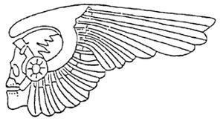

* + 1. registered in Classes 14, 16, 25, 26, 41 and relevantly registered in:
       1. Class 16: for printed matter, newspapers, periodical publications, books, photographs, stationery and adhesive materials (stationery); paper, cardboard, paper articles and cardboard articles, bookbinding material, artists' materials, paint brushes, ordinary playing cards; printers' type and cliches (stereotype); all included in this class.
       2. Class 25 for articles of clothing, footwear and headwear, including coats, jackets, trousers, overalls, shirts, pullovers, sweaters, hats, vests, waistcoats, cardigans and belts (for wear).
    2. has the priority date with effect from 11 July 2008.
  1. The trade marks in suit are and were at all relevant times registered, subsisting and in full force and effect.

**ATTACHMENT “B”**

**Example 1**



**Example 3**

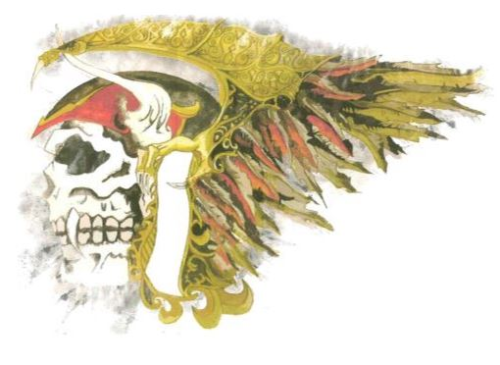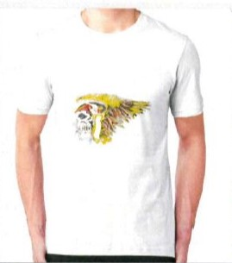

**Example 4**

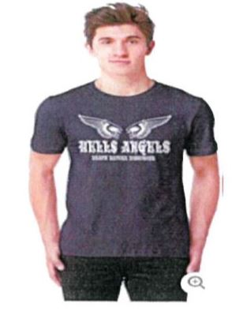



**ATTACHMENT “C”**

**Example 1**

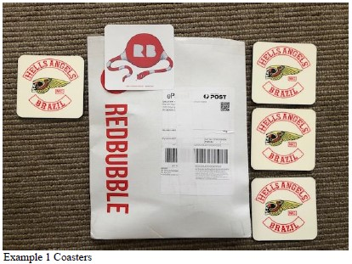

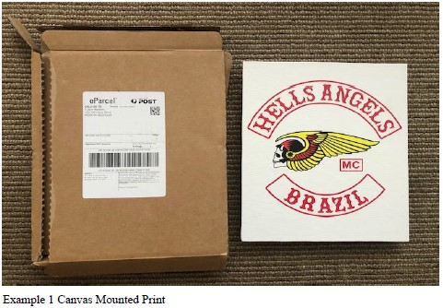

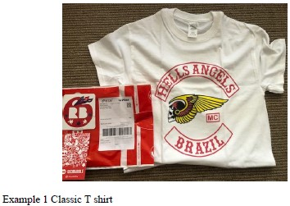

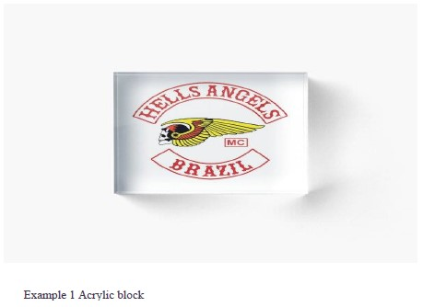

**Example 2**

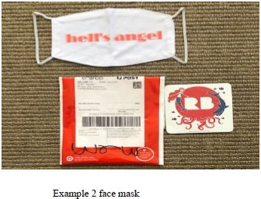

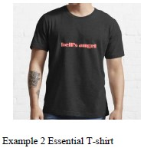

**Example 3**

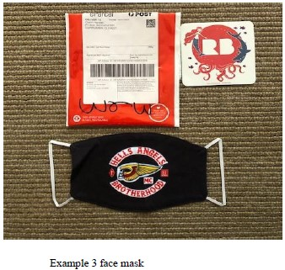

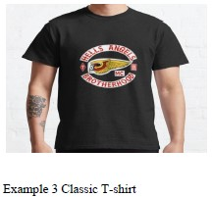

**Example 4**

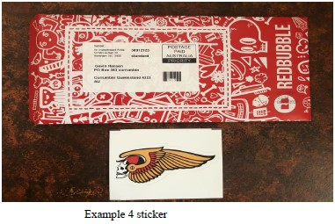

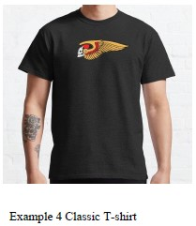

**Example 5**

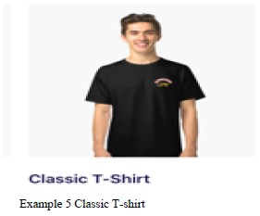

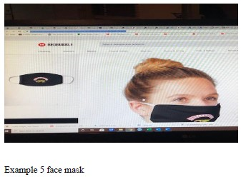

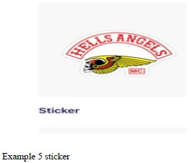

**Example 6**

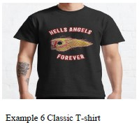

**Example 7**

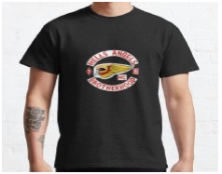

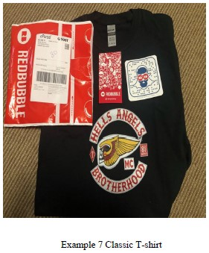



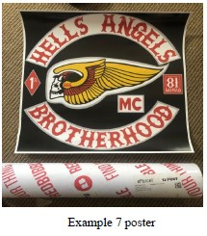

**ATTACHMENT “D”**

**“GH-16”**

**CLOTHING**

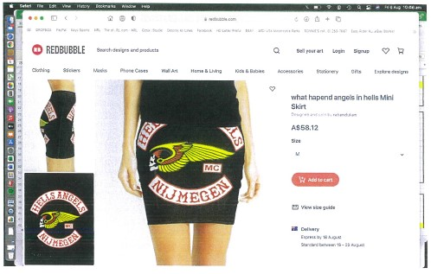

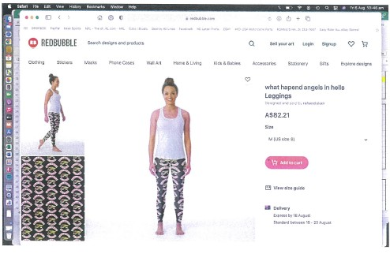

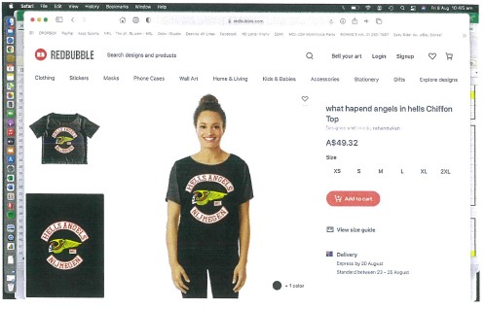

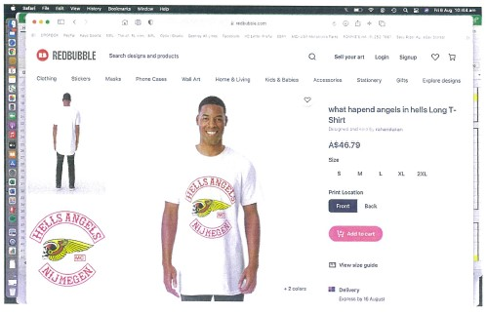

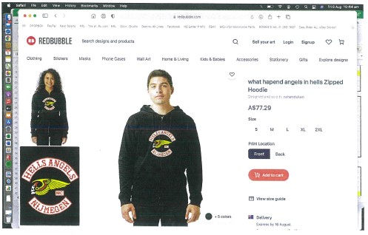

**PRINTED MATTER**

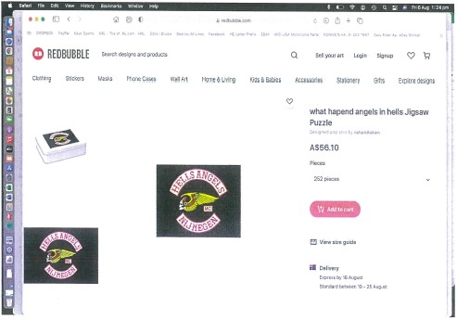

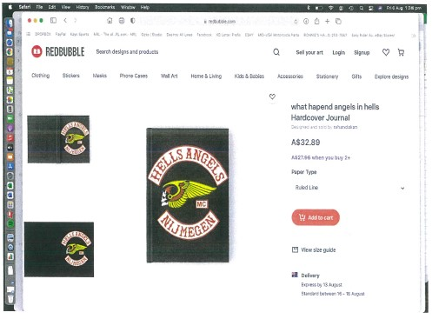

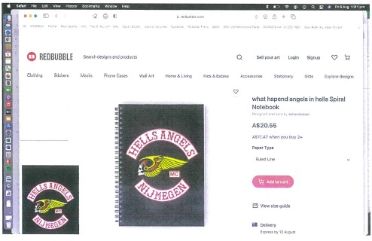

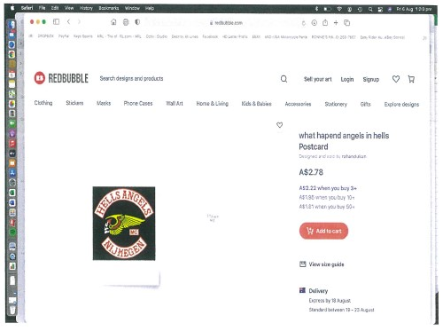

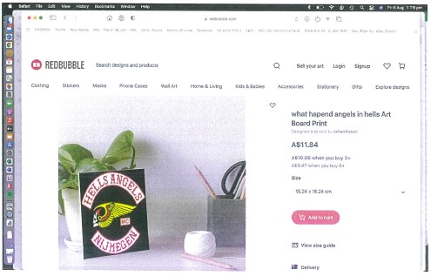

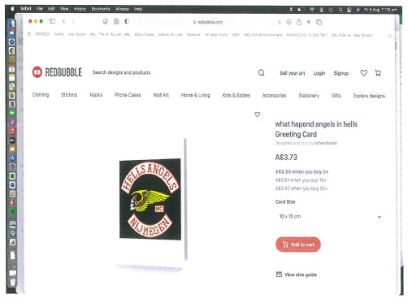

**ATTACHMENT “E”**

**“GH-17”**

**CLOTHING**

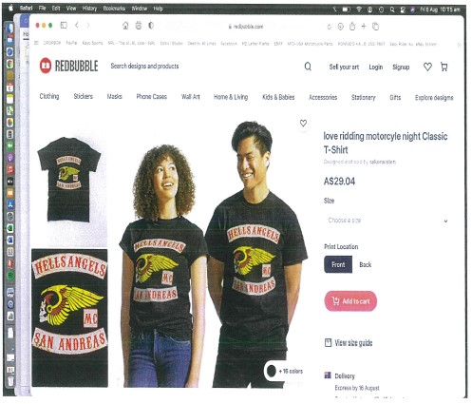

**PRINTED PRODUCTS**

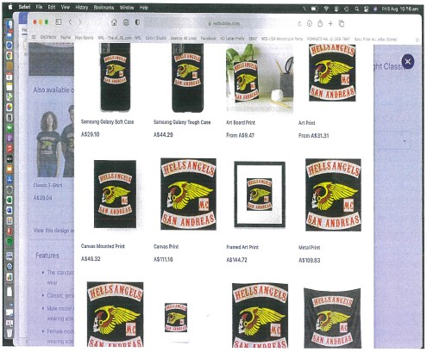

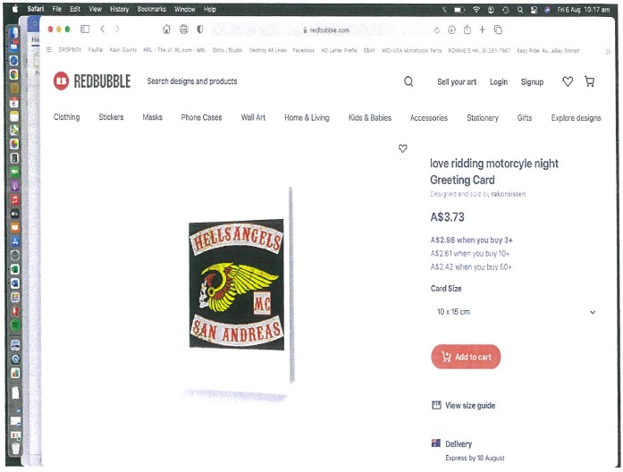

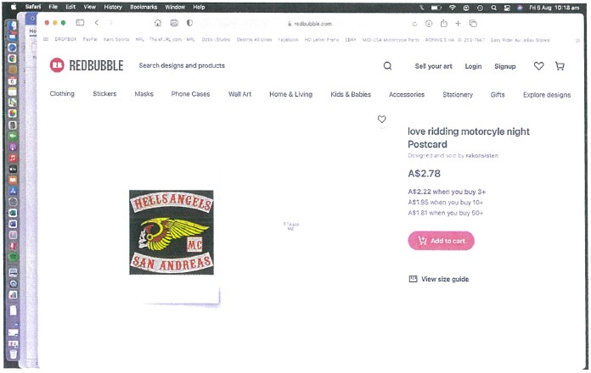

**ATTACHMENT “F”**

**“GH-18”**

**CLOTHING**

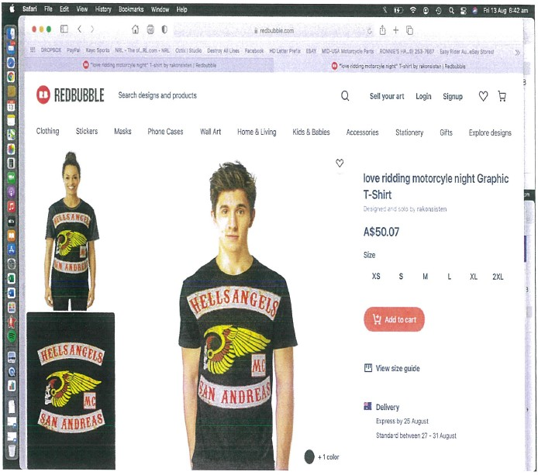

**PRINTED PRODUCTS**

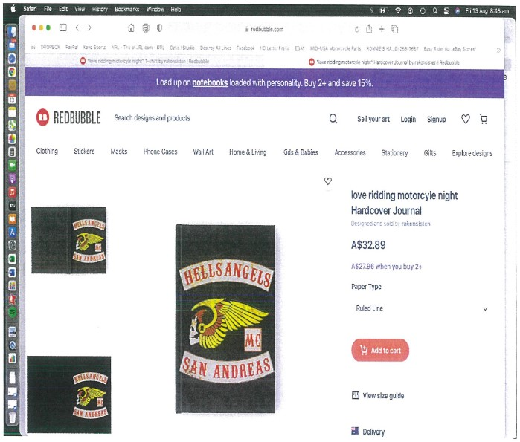

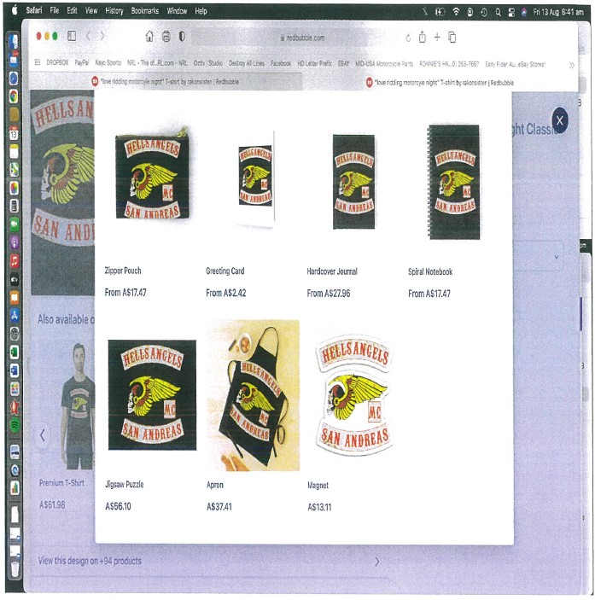

**ATTACHMENT “G”**

**“GH-19”**

**CLOTHING**

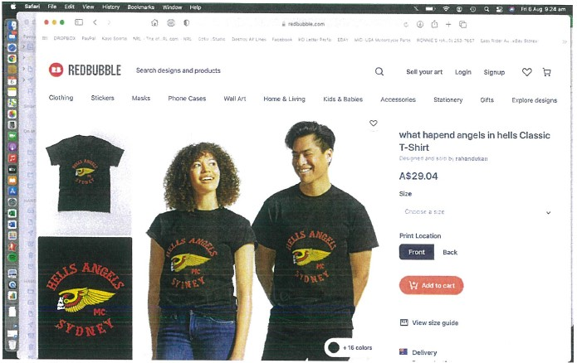

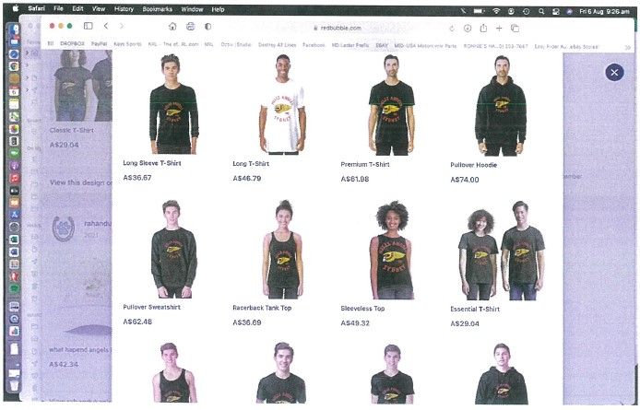

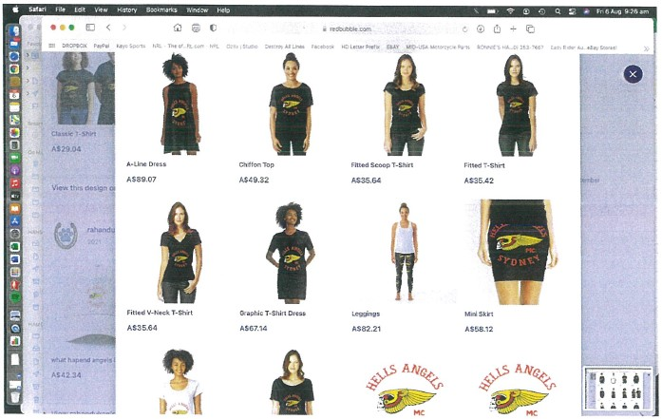

**PRINTED PRODUCTS**

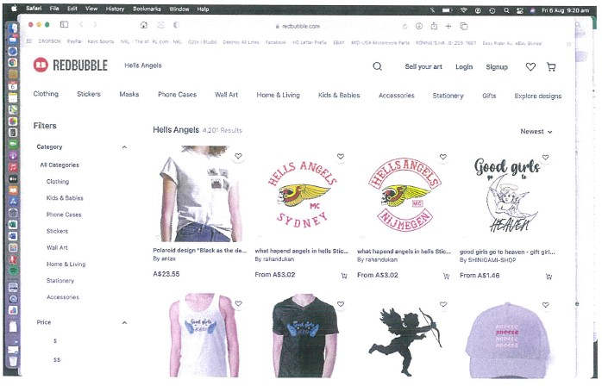

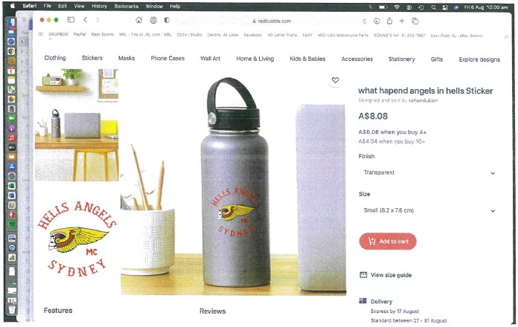

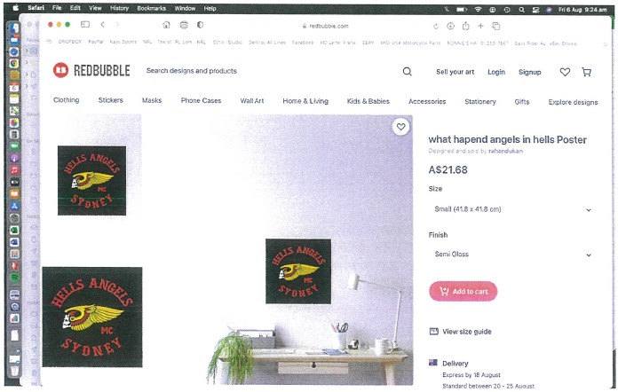

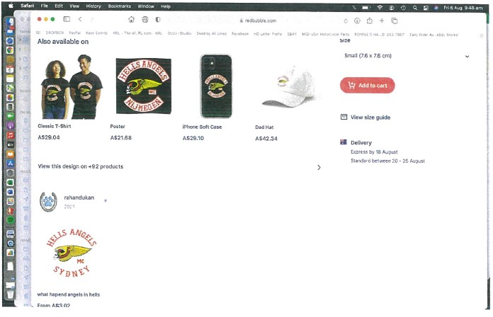

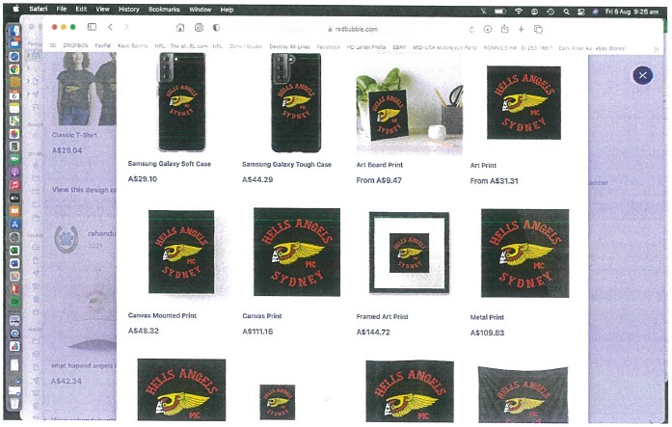

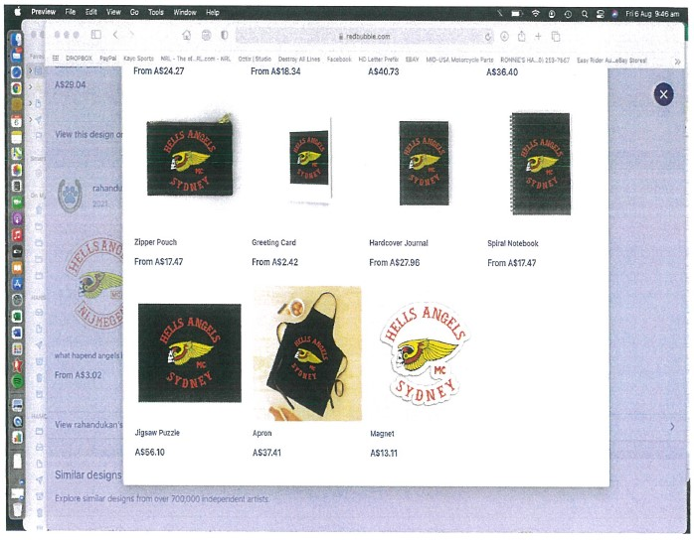

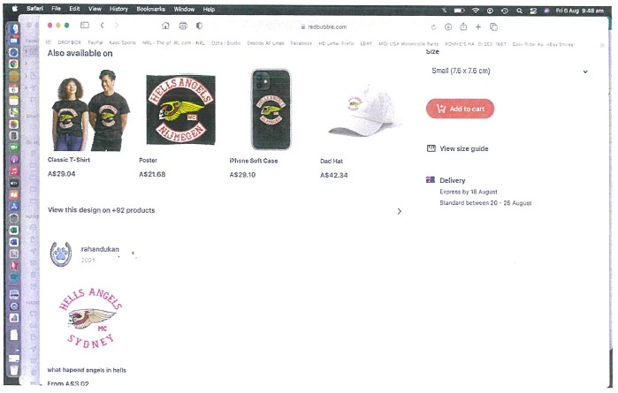

**ATTACHMENT “H”**

**“GH-20”**

**CLOTHING**

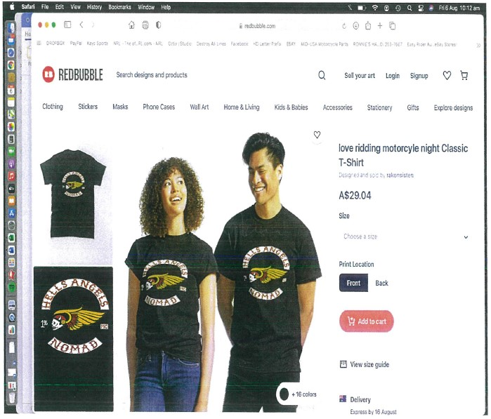

**PRINTED PRODUCTS**

