VICTORIAN CIVIL AND ADMINISTRATIVE TRIBUNAL

|  |  |
| --- | --- |
| planning and environment LIST | vcat reference No. P1405/2020  Permit Application no. MV/871/2019 |
| CATCHWORDS | |
| Section 79 of the *Planning and Environment Act 1987*; Moonee Valley Planning Scheme; Essendon North Major Activity Centre; Mt Alexander Road Corridor; Commercial 1 Zone; Design and Development Overlays DDO3 and DDO10; Seven to Eight Storey Building; Response to Design Objectives; Impacts on Amenity. | |

|  |  |
| --- | --- |
| APPLICANT | Kincrest Pty Ltd |
| responsible authority | Moonee Valley City Council |
| RESPONDENTs | David William Matthews, Jill & David Jeffrie, Joseph Amerena, Frances Amerena, Joseph Michael McShanag, Justin Iannotti, Mary Anne Arundell & Colman Francis Moloney, Kevin Robert Tonge, Desmond Michael Terrence Toal |
| SUBJECT LAND | 995-1001 Mt Alexander Road and 1 Thorn Street ESSENDON VIC 3040 |
| HEARING TYPE | Hearing |
| DATEs OF HEARING | 17, 18 & 19 March 2021 |
| DATE OF ORDER | 20 April 2021 |
| CITATION | Kincrest Pty Ltd v Moonee Valley CC [2021] VCAT 354 |

# Order

### Joinder of parties

1. Pursuant to section 60 of the *Victorian Civil and Administrative Tribunal Act 1998:*

* the following persons are joined as a party to the proceeding:

C F Moloney, F Amerena

* persons who are named as joint parties in any joint statement of grounds who were not original objectors are joined as joint parties to the proceeding.

### Permit application amended

1. Pursuant to clause 64 of Schedule 1 of the *Victorian Civil and Administrative Tribunal Act 1998*, the permit application is amended by substituting the following plans filed with the Tribunal for the permit application plans:

|  |  |
| --- | --- |
| * Development plans: | Prepared by Rothe Lowman Architects, drawing numbers TP00.00, TP00.01, TP00.02, TP00.03, TP01.00 – TP01.10, TP02.01 – TP02.04, TP03.01 – TP03.05, all Rev C, all dated 9 February 2021. |
| * Landscape plans: | Vivid Green, all Rev C, all dated 9 February 2021. |

### No permit granted

1. In application P1405/2020, the decision of the responsible authority is affirmed.
2. In planning permit application MV/871/2019, no permit is granted.

|  |  |  |
| --- | --- | --- |
| **Margaret Baird**  **Senior Member** |  | **Stephen Axford**  **Member** |

# Appearances

|  |  |
| --- | --- |
| For Kincrest Pty Ltd | Mr N Sutton, Planning & Property Partners (with Mr S Edwards). Mr Sutton called the following persons to present expert evidence:   * Mr C Goss, author of photomontages. * Ms S Jordan, town planner. * Mr J Patrick, landscape architect. * Ms C Dunstan, traffic engineer. * Mr C Czarny, urban designer. |
| For Moonee Valley City Council | Mr R Winograd, Mecone. |
| For Jill & David Jeffrie, Joseph Amerena, Frances Amerena, Mary Anne Arundell & Colman Francis Moloney, Desmond Michael Terrence Toal, Justin Iannotti | Mr D Loughnan, G2 Planning. |
| For David William Matthews | Mr D Matthews. |
| For Kevin Robert Tonge | Mr K Tonge. |
| For Joseph Michael McShanag | Mr J McShanag. |

# Information

|  |  |
| --- | --- |
| Description of proposal | Multi-level mixed-use building of up to eight storeys and a roof top communal terrace. It includes 735m2 of commercial floorspace and 61 apartments. It has two levels of basement parking and at-grade parking for 90 car spaces and 81 bicycle spaces. Vehicle access is from Thorn Street. |
| Nature of proceeding | Application under section 79 of the *Planning and Environment Act 1987* – to review the failure to grant a permit within the prescribed time.[1] |
| Planning scheme | Moonee Valley Planning Scheme [**scheme**]. |
| Zone and overlays | Commercial 1 Zone [**C1Z**]. Design and Development Overlay Schedules 3 Mt Alexander Road Corridor [**DDO3**] and 10 North Essendon Activity Centre [**DDO10**]. Mt Alexander Road is in a Road Zone Category 1. We note Mt Alexander Road is in a Heritage Overlay HO80. |
| Permit requirements | Clause 34.01-1 to use the land for accommodation. Clause 34.01-4 to construct a building or construct or carry out works.  Clause 43.02-2 to construct or carry out works.  Clause 52.06 to reduce car parking.  Clause 52.29 to alter access to a Road Zone Category 1. |
| Relevant scheme policies and provisions | Clauses 11 (including 11.03-1L), 15, 16, 17, 18, 19, 21, 34.01, 43.02, 52.06, 52.29, 52.34, 53.18, 58, 65 and 71. |
| Land description[2] | The subject land is on the north-west corner of Mt Alexander Road and Thorn Street. It comprises four lots with a total area of 2,023m2. The land falls by some 2.5 metres to the west. No. 995 Mt Alexander Road is occupied by a car yard, a single storey commercial building is at No. 1001 Mt Alexander Road and a dwelling is at No. 1 Thorn Street.  Mt Alexander Road is a wide boulevard with a tram service, and is lined with palm trees. Commercial and residential buildings extend along Mt Alexander Road. Older forms are lower when compared with recent development of 5-7 storeys. |
| Tribunal inspection | Prior to the hearing, as parties were advised at the commencement of the hearing. |

# Reasons[3]

## Introduction

1. Kincrest Pty Ltd [**applicant**] proposes to redevelop a large corner site in North Essendon with a multi-level mixed-use building. It applied to the Moonee Valley City Council [**Council**] for a planning permit for this project. As the Council failed to grant a permit within the prescribed time, the permit applicant has applied to the Tribunal seeking approval.
2. Plans have been substituted in this proceeding, without objection by any party.
3. The concept of a mixed-use building on the land is not in contention in this proceeding and is acceptable. We find that there is policy support in the scheme for the intensive development of the subject land in accordance with its zoning and the policies and controls guiding development in this location. This includes the proposed land uses and ground level activation. These outcomes align with the purpose of clause 34.01.
4. The two key issues are the proposal’s response to design objectives for this location particularly in terms of height, bulk, mass, and design; and the potential impact on the amenity of neighbouring properties. Additional concerns raised by residents focus on traffic and parking.
5. For reasons set out in this decision, we conclude that the height, massing and adverse amenity impacts of the proposed development are unacceptable. We find the proposal does not present an appropriate development outcome for the site or locality based on the scheme’s strategic directions for the North Essendon Major Activity Centre.

## Overview of parties’ positions

1. No party suggests that the subject land is not suitable for intensive redevelopment in accordance with its zoning and the strategic outcomes for the land’s location. No party opposes the proposed mix of land uses, including the use of land for accommodation for which a planning permit is required. Commercial uses present to ground level street frontages to activate this aspect of the public realm. We do not need to assess these matters but give weight to them in our overall consideration of the acceptability of this proposal and net community benefit.
2. Despite several areas of agreement, the Council opposes a permit issuing, as do multiple respondents and other persons who have lodged statements of grounds in this proceeding. The proposal is particularly contentious because of its built form and design and its response to both the physical and policy contexts, including potential impacts on the amenity of neighbouring properties. Residents opposing the grant of a permit have other concerns including about increased traffic and parking.
3. The applicant submits the Tribunal should grant a permit because:

* The proposal has strong strategic policy support.
* The proposal provides an appropriate built form response.
* There are no traffic engineering reasons to refuse a permit.
* The design offers excellent amenity to future occupants.
* The proposal has acceptable off-site amenity impacts.
* The proposal offers a number of particular benefits including that:
  + The amalgamated site is large and represents a rare opportunity to meet state and local policy encouraging intensification in locations such as this.
  + The proposal would bring legibility to an important corner in the North Essendon Major Activity Centre.

1. The applicant’s expert evidence concludes (among other things) that the proposal exhibits architectural design excellence; it responds to the existing and preferred character of the Mt Alexander Road corridor and the North Essendon Major Activity Centre as a whole; and the proposal will make a positive contribution to the enhancement of the public domain including through activation of both street frontages and minimising essential services at street level.
2. Further, it submits the Council has sought to downplay the land’s attributes as a “key site” pursuant to the North Essendon Major Activity Centre policy at clause 11.03-1L, and instead relies on the fact that the land is not identified as such in DDO3. The applicant contends the Council has sought to draw an artificial distinction between the two sides of Mt Alexander Road in Precinct C-1 of DDO3. The Council has also made submissions about the concept of net community benefit that, in the applicant’s submission, are misconceived and erroneously rely on the Tribunal’s decision in *CBD Development Group*.[4]

## Strategic context

1. The subject land is in the North Essendon Major Activity Centre.[5] DDO3 and DDO10 are part of the implementation of the *North Essendon Activity Centre Structure Plan*. They draw on the *Mt Alexander Road Corridor Urban Design Guidelines 2010* and the *North Essendon Activity Centre Built Form Guidelines 2012*, both of which are reference documents in the scheme.
2. All three lots that comprise the subject land are zoned C1Z, as shown on the zoning map below.

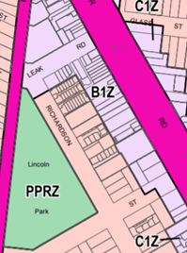 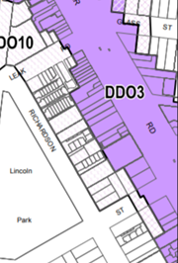

1. The two lots fronting Mt Alexander Road share identical controls, with DDO3 providing design guidelines. No. 1 Thorn Street is subject to DDO10 which sets lower development expectations, as part of the residential periphery. No. 3 Thorn Street is the only other lot that fronts this section of Thorn Street in the C1Z. It contains a single storey house in DDO10. One and two storey housing on the east side of Richardson Street are part of the Activity Centre, zoned GRZ1, in DDO10.
2. To the immediate north of the site is a retained church building. The building has been incorporated into a six storey mixed-use development that wraps around and steps down to four storeys behind the church. This development is prominent in the streetscape, readily seen along Mt Alexander Road including as a backdrop to the subject land. It is up to 19.4 metres high (above NGL) and is in DDO3. More development on the east side of Mt Alexander Road is also within DDO3. These are shown in a diagram included in Mr Czarny’s evidence[6] (citing storeys):

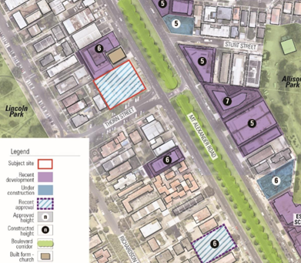

1. Clause 43.02 and, as indicated, Schedules 3 and 10 apply. The purpose and decision guidelines apply.
2. The design objectives of DDO3 (Mt Alexander Road corridor) are:

* To encourage building design and development that will enhance the visual appearance of the Mt Alexander Road Corridor.
* To minimise the impact of development on adjoining land uses in terms of appearance, amenity and streetscape presentation.
* To ensure any development adjacent to a heritage building does not compromise the building and is of a respectful scale and form.
* To achieve excellence and diversity in architecture, which incorporates Environmentally Sustainable Design initiatives.
* To prevent the visual intrusion caused by the inappropriate siting, massing and appearance of buildings and works.
* To provide a pedestrian friendly environment along all street frontages and active frontages in commercial areas.
* To enhance the role of sustainable transport modes and locate access to development so as to protect the transport function of the corridor.

1. The decision guidelines in DDO3 include:

* The response of the proposed development to each of the urban design objectives of this schedule and the Mt Alexander Road Corridor Urban Design Guidelines 2010.
* The preferred maximum heights, setbacks and Precinct Specific Guidelines specified in Table 1 to this schedule.
* The design, scale, height and visual bulk of the development in relation to surrounding land uses and built form character of the corridor.
* The treatment of surrounding sensitive interfaces and any impacts on residential amenity.

1. The design objectives for DDO10 place a stronger focus on the peripheral residential area. They include:

* To ensure new development complements the village character of North Essendon.
* To increase residential density above commercial properties and provide a range of housing types and styles.
* To increase density in the residentially zoned streets surrounding the core commercial area while reducing any adverse amenity impacts on the surrounding area.
* To ensure the height and bulk of new development does not adversely impact on the amenity of adjoining properties.
* To maintain the established pattern of front and side setbacks.
* To ensure new development demonstrates a high standard of contemporary design.
* To provide well-located, accessible and safe car parking areas which do not visually dominate the streetscape.
* To integrate planting and landscaping in new development to enhance the appearance and amenity of buildings and spaces.

1. Decision guidelines in DDO10 include:

* How the proposed development responds to each of the urban design objectives of this schedule.
* The preferred maximum height, setbacks and precinct specific provisions specified in Table 1 to this schedule.
* The design, scale, height and visual bulk of the development in relation to the surrounding land uses and built form character of the corridor.
* Whether the building materials, colours and finishes reflect the surrounding built form.
* The treatment of surrounding sensitive interfaces and any impacts on residential amenity.
* The layout and appearance of areas set aside for car parking, access and egress and the location of any proposed off street car parking.
* The impact of any variation in heights to those as specified in Table 1 to the schedule and whether these variations continue to meet the objectives of the schedule.
* Whether the proposed development is consistent with the North Essendon Activity Centre Built Form Guidelines 2012.

1. The parties have referred to the *Mt Alexander Road Corridor Urban Design Guidelines* *2010* and *North Essendon Activity Centre Built Form Guidelines* *2012* which we have considered in our assessment. Several plan extracts are in Appendix A together with the DDO3 Precinct Map where the subject land is within Precinct C-1 and Table 1 from each of DDO3 and DDO10. The later show the preferred maximum heights including 18 metres (five storeys) for Precinct C-1. There are also precinct specific guidelines with respect to setbacks for amenity protection.
2. It was common ground that the subject land is not an identified landmark or gateway.
3. The local policy at clause 11.03-1L states that more intensive development can be considered in commercial areas, referring to:

* A total land parcel area of greater than 1,000 square metres and with a frontage greater than 20 metres;
* A site located within 400 metres of a tram stop or train station;
* A site where new vehicle access to the site can be achieved either via a side street or via a rear lane (where access is not more than 25 metres from the laneway entry); and
* A site that can demonstrate that the additional height has no significant amenity impacts, which includes overlooking, overshadowing or significant detriment to existing view lines.

1. This is a general position as is consistent with the *Mt Alexander Road Corridor Urban Design Guidelines* and also included in a Note on the Built Form Controls Map from the *North Essendon Activity Centre Built Form Guidelines 2012* (see our Appendix A).[7] The *North Essendon Activity Centre Structure Plan* identified “key sites”. DDO3 refers to “key sites” being within Precinct B, C-2, D, F or H, not Precinct C-1 within which the subject land is located.
2. We accept the subject land meets a number of the “key sites” criteria referred to in clause 11.03-1L in terms of its size and frontage, location relative to public transport and the provision of access via a side street. We accept a substantial consolidated site offers potential for a larger building as it has an increased ability to manage off-site amenity impacts, such as through increased setbacks. It appears to us that the DDO3 envelope has been framed to marry proposed heights with setbacks – taller and broader forms may need deeper setbacks and different articulation to ameliorate and mitigate impacts.
3. The *Mt Alexander Road Corridor Urban Design Guidelines* *2010* identify the corners of Thorn and Thistle Streets as “*visually prominent*” with opportunities as follows: “*Potential redevelopment sites on larger parcels and significant corner locations adjacent to Thorn and Thistle Street’s”.* [sic] [8] This prominence is a function of factors including the broad road reserve, corner location and topography.
4. As will be evident later in these reasons, we have not been persuaded that the additional height over 18 metres and up to eight storeys (excluding plant and roof top)[9] has no significant amenity impacts. We further note that the *North Essendon Activity Centre Built Form Guidelines 2012* refer to the potential as to up to six storeys (21 metres) on the key sites that meet all of the criteria which differs from DDO3 for precinct C-2 (18 metres, five storeys) (refer to table reproduced in Appendix A).
5. We have had regard to policy outcomes through, for example, *Plan Melbourne 2017-2050*.[10] The applicant emphasises that the need for housing has only grown more pressing since the preparation of the Council’s *Housing Strategy* and associated documents relating to the North Essendon Major Activity Centre as well as the *Mt Alexander Road Corridor Urban Design Guidelines* dating from 2011-2012. We accept the settlement and housing strategies in the scheme are important. However, they must be balanced with other policy objectives. Planning for this activity centre takes account of a wide range of policies with a package of land use and built form outcomes addressing intensification as well as urban design outcomes tailored for this location.
6. Additional scheme provisions and policies are relevant to our decision, listed in the “Information” section of these reasons. We have considered them fully but do not recite them.

## overview of Proposal

1. The proposed mixed-use building is up to eight levels with a roof top communal terrace. It places most of its development to the Mt Alexander Road frontage, with units facing both east and west around a central corridor, over a base of retail, five storeys of residential above, and a recessed sixth level of residential to make seven storeys in all.
2. This format returns along Thorn Street. As a result of the fall of the land to the west, the development extends to eight storeys before stepping down towards No. 1 Thorn Street, the commencement of the DDO10. The question of the number of storeys was a matter of contention and is discussed further below.
3. The general arrangement of these two frontages can be seen in the photomontage provided from the south-east.

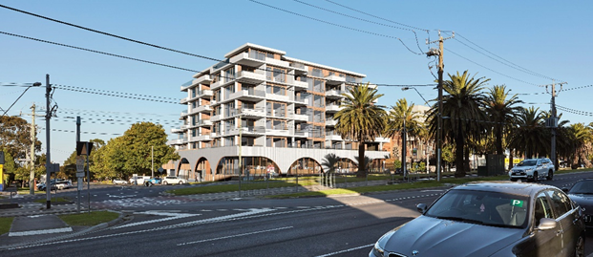

Photomontage view from the south-east (without landscape) prepared by Orbit Solutions Pty Ltd

1. Addressing the residential interface to the west is first the upper-level basement that sits out of the ground by two thirds of a storey height because of the slope of the land. There is a narrow setback from the western boundary that provides for a limited opportunity for landscaping along the interface save for a widening at both the north and south ends.
2. Above this, set back approximately 3.7 metres - 4 metres (because the boundaries are not truly rectangular) is three levels of residential made up of one level of units in the “mezzanine” level and two levels of “duplex” units (two storey town house style units) that open onto a small central courtyard.
3. The duplex units are capped by a “green roof” – a roof system that would include a growing medium and appropriate planting intended to minimise water run-off and add to the thermal performance of the units.
4. The arrangement of the return addressing the residential interface to the west is evident in the section view, below.

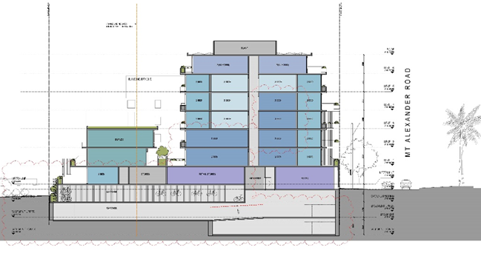

Section AA (residential interface to the left), prepared by Rothe Lowman Architects

1. At the start of the hearing, the Council sought clarification with respect to the number of storeys the building should be described as containing and the correct height of the building. Figures vary in the expert reports. We agree these facts and matters are important to clarify, including because the scheme provisions and associated reference material are described in terms of both storeys and metres.
2. The Council submits the building should fairly be described as an eight storey building since for at least part of the frontage to Thorn Street it has eight measurable storeys above ground (excluding rooftop plant and lift overrun). The applicant maintains the building is effectively seven storeys, as the eight levels visible on Thorn Street are an artefact of the slope of the land, which causes the upper basement to extend out of the ground towards the west. And for much of the frontage to the east of the upper level setbacks it is less than a full storey in height.
3. Slightly confusing the matter, the drawings nominate the floor above the upper basement as “mezzanine” because it does not extend fully towards the Mt Alexander Road frontage, but terminates when it meets the taller ground floor addressing Mt Alexander Road. This can be seen in the south elevation, below.

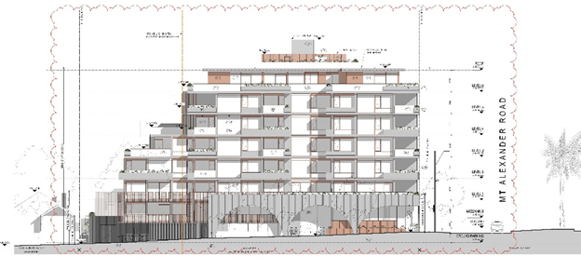

South Elevation Drawing TP02.02, Rothe Lowman Architects

1. Clarification of the proposed height to the top of the parapet of the uppermost level is clearer. The applicant demonstrates that the parapet sits at a height of AHD 76.200. With the natural ground level at the Mt Alexander Road / Thorn Street intersection of AHD 52.010, it results in a maximum height above pavement at this point of 24.190 metres, as indicated in the south elevation.
2. The Tribunal agrees that the building will present as a seven storey building to Mt Alexander Road. However, the relatively tall ground floor will impact the apparent height of the building. It is relevant to take account of the height in metres above the street, particularly when assessing the physical context that includes other recent buildings in the North Essendon Major Activity Centre.
3. We also find that the building will present as eight storeys for a significant part of Thorn Street. We note that because of the slope of the land, the building is also likely to be read as being of this scale from parts of the residential area to the west, albeit one with significant steps in its façade.

## BUILT FORM AND URBAN DESIGN

### What are the key issues?

1. Form and urban design issues relate primarily to the building height in this proceeding. Both Council and respondents are concerned that the building is too tall, resulting in unacceptable impacts on the established context and failing to respond appropriately to the scheme’s vision for this area. The applicant says that the response to the local context is appropriate and the design brings advantages that result in a net community benefit.
2. The issues were generally discussed in terms of the address to each interface. In order to determine the acceptability of the proposed design, we must consider the following key questions:

* Is the interface to Mt Alexander Road acceptable?
* Is the interface to Thorn Street acceptable?
* Will the proposed development cause unacceptable impacts to the established housing / residential periphery to the west?
* Is the relationship with the existing church and the associated residential development acceptable?
* Are the off-site amenity impacts acceptable?

1. We have broken down the question of built form into the way the proposed development addresses each interface. However, this does not mean there is no interaction between these issues and, ultimately, we have made an integrated assessment to determine if the built form and urban design response, overall, represents an acceptable outcome.
2. In relation to the strategic advantages of the amalgamated site, we have considered matters including:

* Does this site meet the criteria for a “key site”?
* Is this site a gateway or cue to assets such as Lincoln Park?
* Are there other factors that could support additional height?

1. There are also a number of other issues including the architectural treatment of the retail base and landscaping that we will address briefly.
2. We have been assisted by various descriptions of the existing and approved developments. [11] These are summarised in “*Development Analysis within Precinct C1, DDO3*” tendered by the Council listing development proposals in the area and stating the heights in metres for several that have been built.

### Is the interface to Mt Alexander Road acceptable?

1. The Council says that the way the proposed building addresses Mt Alexander Road is unacceptable. Mt Alexander Road is one of Melbourne’s recognised high value boulevards and the way that new development responds it is critical to retaining its character.
2. In summary, the Council says that the present planning policy which has been in effect since 2010 has led to a relatively consistent streetscape. It submits this is the clear intent of the policy and can be seen most readily on the east side of Mt Alexander Road, which is much further progressed in its redevelopment.
3. Council contends that this demonstrates two important characteristics that the proposed development fails to deliver: a consistent lower street wall built to the front boundary with upper levels recessed behind; and a generally consistent height of five or six storeys.
4. Although there has been less development on the west side of Mt Alexander Road, those that have been constructed including the development to the immediate north, have also demonstrated these characteristics.
5. In contrast, Council notes that the proposal has an effectively sheer presentation of six storeys to the street at the corner of Mt Alexander Road and Thorn Street, with a seventh storey that is still visually prominent. It says the uniform treatment and lack of articulation of the five levels above the base contribute towards an excessively prominent presentation.
6. Further, at seven storeys to this frontage, and a maximum height of 24.190 metres above street level (to the top of the parapet, excluding rooftop plant) the proposed building would be the tallest along the boulevard by a significant margin, and will be a discordant element in the streetscape.
7. The respondents support Council’s position and note that the context on the east side of Mt Alexander Road is also different, with no immediate residential interface. Instead, these blocks interact with either more high density development or public open space.
8. The applicant argues that the proposal responds appropriately to its immediate context. It says the Thorn Street / Mt Alexander Road intersection is an important location since it leads to Lincoln Park, an important piece of open space supporting the North Essendon Major Activity Centre.
9. It acknowledges that this location is not identified as a “gateway” or “landmark” site in the scheme, but says that the proposed additional height and distinctive corner treatment is relatively restrained and suitably “marks” the location. This is supported by the ground level retail frontage that returns around the corner, and together will improve the “legibility” of the location.
10. The applicant submits the development is virtually opposite at No. 1074 Mt Alexander Road that is also seven storeys. This demonstrates this height can be accommodated within the relatively wide expanse of the boulevard.
11. Mr Czarny in giving urban design evidence, says the design employs other measures that ensure it provides a suitable interface to the boulevard. These include the arched colonnade to the ground floor retail that he says provides a strong “base”; the use of a variety of balcony forms to articulate the residential façade and the prominent corner treatment. In his view, the outcome is a recessive façade to Mt Alexander Road apart from the corner return, which he finds would assist to mark the corner.
12. He notes that there is a definite “step” in the façade at its northern extent. This would align with the four storey façade of the development to the north, and provide a consistent context for the retained church.
13. Ms Jordan notes that the DDO includes the traditional shopfront area of the North Essendon retail precinct. In her view, the emphasis on a two storey street edge and progressive setbacks above is more applicable to that environment, whereas the context for this project is different.
14. The applicant disagrees that the context on the east side of Mt Alexander Road is very different, pointing out that the public open space is also sensitive to impacts such as overshadowing and is used by many members of the community.

#### Tribunal findings

1. We agree with Council that there is a preference within the scheme to establish a generally consistent streetscape in response to the Mt Alexander Road boulevard setting. The approach appears to have been applied with a high degree of consistency albeit with some developments of six storeys and one opposite of seven. We are mindful that some of the higher forms on the east side of Mt Alexander Road do not have the same context as the subject land, notably in terms of topography and interfaces to a public park rather than dwellings that are downslope.
2. We acknowledge that the heights provided within DDO3 are preferred heights and there is flexibility to craft a varied response if the context and other factors warrant.
3. In addition to meeting “key site” to which we have already referred, the applicant relies on the prominence of the site on the Mt Alexander Road / Thorn Street intersection and the opportunity to “mark” this corner with a taller and more visually prominent architecture.
4. We agree that the site is prominent and this is assisted by the wide intersection where there is by necessity a break in the boulevard planting. However, there is nothing in policy to support this corner being picked out and indeed we find if it were, it could reduce the legibility of the traditional shopping strip of North Essendon, which is the heart of the Activity Centre.
5. While we agree that the façade above the base is well articulated with balconies and returns, we find that in total it presents as a relatively uniform architectural form for the five storeys above the base. The photomontage from the south-east illustrates this. This contrasts with other developments in the precinct that use architectural forms to break up the upper level facades, while not always strictly following the built form guidelines of the DDO.
6. We find the relatively uniform façade contributes to a perception of excessive visual dominance.
7. We find the suggestion that the possible connection to Lincoln Park (which begins with Richardson Street to the west) requires marking with a taller form is not persuasive. We think that an active base that turns the corner into Thorn Street would be a sufficient way to bring legibility to this location, and attract users to the precinct who may then wish to access the park.
8. We note the comparison with the existing seven storey building at No. 1048-1060 Mt Alexander Road. Although nominally the same number of storeys to part of that proposed, its height above street level is indicated as 23.16 metres (to the top of the seventh floor parapet, excluding roof plant). This is lower than the proposed development.
9. On our site visit, we noted that this existing seven storey building is the only development where the top level is beginning to be visible above the rows of palms in the centre of the boulevard, when viewed from the opposite side of the street. We do not say it is so visible as to be dominating, but it is evident.
10. We note that the seventh storey on that existing building is relatively short in length compared to its base; contrasting with the design response in this application. We find that the broad form of the seventh level is likely to be strongly visible especially from angled viewpoints, and is also likely to appear over the top of the boulevard planting from the eastern footpath.
11. Overall, we find that the vertical form of the façade in association with the breadth of the top floor and the prominent corner treatment is not acceptable. We are concerned that at the height proposed, the development will dominate the central boulevard planting and present as visually dominant particularly when viewed from the east side of the boulevard.

Is the interface to Thorn Street acceptable?

1. The Council says the building fails to respond to the planning controls in both DDO3 (that applies to the lots addressing Mt Alexander Road) and DDO10 (that applies to No.1 Thorn Street).
2. This is because the proposal exceeds the recommended heights by a significant margin in both cases. Within the DDO3 area, the Council says the building would rise to eight storeys and exceed the recommended maximum height of 18 metres by 7.45 metres, which it argues is a considerable margin. Within the DDO10 area the building rises to five storeys or 17.2 metres compared with the recommended maximum of four storeys or 15 metres. The Council submits that the DDO provision would achieve a reasonable transition towards the one and two storey dwellings, whereas an additional storey would create an unacceptably abrupt change at the setbacks proposed.
3. The Council notes that the arrangement places the greatest bulk to address the side street – a street that includes houses covered by a Heritage Overlay and thus unlikely to change significantly.
4. It submits one of the advantages of a larger site should be the ability to focus the built form towards the more robust interface, which in this case would be Mt Alexander Road.
5. Respondents support Council’s position. They submit the significant heights above the DDO preferred maxima would not only be out of character with the lower scale surrounds, but would lead to unacceptable impacts on amenity through visual bulk, overshadowing and overlooking.
6. The applicant maintains that the extent of exceedance is minor, being less than a full storey for the DDO10 area, while the setback to the higher form is generous. This provides a stepped approach to the form emphasising the corner. This is further reinforced by the arched “base” that returns into Thorn Street.
7. It submits the parking level will not “read” as a full storey, and that in any case the proportion of the façade that is eight storeys is quite low, and is an outcome of the slope of the land.

#### Tribunal findings

1. We agree with Council that the extent of non-compliance with the recommended heights along Thorn Street would create a discordant element in the streetscape and potentially undermine the vision expressed through the scheme’s provisions. This is a side street leading into the residential area.
2. Thorn Street separates dwellings within Heritage Overlay HO1 from the subject land. We have not been presented with any material to enable us to reach a conclusion that the proposed development would directly impact on the heritage values of HO1. However, we find that the excessive height within the DDO3 area will add to the impact of the lesser exceedance in the DDO10 part of the site. The combination adds up to a building that will is too large for its context. Numerically, the proposal may arguably not be a radical or vast departure from the height provisions that form the basis of the future character or some constructed forms (eg. No. 1048-1060 Mt Alexander Road). But the way in which the whole building is composed and its mass is positioned represents a departure that fails to achieve the design objectives.
3. The cumulative impact will have more serious implications for the interface with No. 3 Thorn Street, which we discuss next.
4. We feel the combination of retention of the existing street tree, three additional street trees and planting at different levels on the structure would have provided a satisfactory interface. This is assisted by returning the arch form along Thorn Street to give emphasis to the retail opportunity.

### Will the proposed development cause unacceptable impacts on the established housing / residential periphery to the west?

1. The Council and respondents submit that the proposal does not provide an adequate transition to the housing to the west, including No. 3 Thorn Street which is a single storey dwelling within a commercial zone.
2. They say that although technically the western interface is a side boundary to No. 1 Thorn Street, we should consider the amalgamated site as a single site. In that case they say it is more of a rear boundary and deserves a more generous setback.
3. Council says the development then rises in height too quickly, and the total of eight storeys is well beyond that expected by the scheme. It notes that the fifth storey of the development is set back from the west by only 10 metres and will be clearly visible from the adjoining properties.
4. The applicant submits the western transition is appropriate because of the setbacks. It contends the setbacks to the rising built form are relatively generous and there is only minor incursion into the recommended setbacks provided within the DDO. In addition, the landscaping strip is sufficient for effective screen planting, and there is a widening at both the north and south that will allow for canopy trees.

#### Tribunal findings

1. We find that the proposed transition is not acceptable for a number of reasons.
2. Firstly, the landscape treatment is very limited, with a 1500 mm wide planting strip for most of the eastern boundary to No. 3 Thorn Street, except for a widening at the northern end that is partly compromised by an overhanging balcony.
3. Further, the northern widening is not adjacent to the main open space for the dwelling.
4. We note that No. 3 Thorn Street would be an isolated site in the commercial zone. A more generous landscape strip at least for the depth of the rear open space would allow a more effective buffer while the residence at No. 3 Thorn Street remains. It would also provide improved opportunities should the small site redevelop, and allow easier maintenance of the space.
5. Of equal concern is the potential for the combined development to appear visually dominant when viewed from the rear yards of the houses facing Richardson Street. We note the slope of the land means the proposed development would appear taller from these sites than would be the case in more even ground.
6. We observe that the existing six storey development to the north of the subject site is already very evident from views between the houses on Richardson Street. We acknowledge that while this is a dramatic change for these residences, it should be within their expectations given their proximity to an area identified for change (including in the residential periphery).
7. The proposed development, in extending significantly above that, presents excessive building bulk and is beyond reasonable expectations that are informed by the scheme. Although the forms are well set back, and are said by the applicant to not exceed the DDO margins by a great deal, the setbacks envisaged in the DDO are based upon the recommended height of six storeys. In this case that standard is exceeded by a significant amount, and the effect is increased because of the slope of the land.
8. This is one of the differences with some recent developments on the east side of Mt Alexander Road. As well as lacking the direct residential interface, they have a relatively flat gradient that does not accentuate height impacts.

### Is the arch form acceptable?

1. The ground floor retail façade features a shallow “arch” form to both the Mt Alexander Road frontage and the eastern half of the Thorn Street frontage.
2. The Council queries the use of a shallow arch form. It observes this architectural form is not found in the local context and submits the form does not contribute towards protecting and enhancing the urban character as sought by policy.
3. The applicant agrees that the arch form is new to the area, but says this is a positive attribute because it introduces a distinctive element that will assist to identify the location as an active streetscape. The arches also form a shallow colonnade that, in addition to presenting a strong image for the retail base, also afford weather protection for the entry to the retail uses.

#### Tribunal findings

1. We accept that the arch form will contribute towards a distinctive streetscape and help to develop a contemporary identity for this location. This is an area that is identified for significant change, and it is reasonable that new character elements can be introduced (given absence of any specific strategic direction on this point in the DDOs or in policy).
2. However, as we raised in the hearing, there are some disadvantages to the shallow arch form. For example, because of the shape of the arches, views to the retail premises can be restricted and relatively hidden spaces created could lead to security concerns. Having said that, we accept that the security issues could be eliminated by blocking off the spaces in some way, and this could have been addressed through an appropriate permit condition. The fact that the colonnade is relatively shallow also assists to minimise any shielding of retail frontages. As a result, we find that the proposed use of arches would be acceptable. In design terms, it makes a positive contribution in this proposal.

### Is the interface with the church acceptable?

1. Through Mr Czarny’s evidence, the applicant submits the northern elevation recognises the configuration of the adjoining Grace apartments and associated church, with applied setbacks to match up to four storeys and ensuring perceivable spatial separation between the two forms from the eastern streetscape.

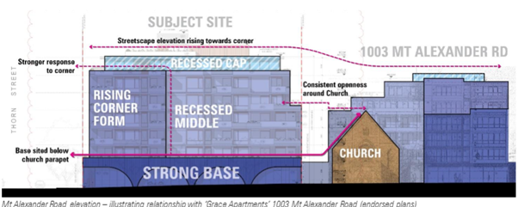

Extract from Mr Czarny’s evidence at page 12

1. The image, above, was used to assist to explain the basis of this opinion.

#### Tribunal findings

1. The recessed position of the church is shown in a Nearmap image from Ms Jordan’s evidence.[12] It shows the strong adjacent street wall to the north and the manner in which the new built form has been stepped back from that street wall and sits behind the retained form.

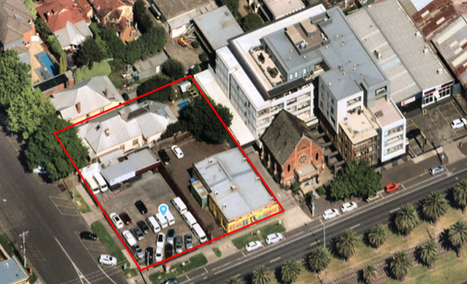

1. Contrasting with the strong street wall and wrap-around form of No. 1003 Mt Alexander Road, the site plans give an indication of the manner in which the proposed building is very close to the northern boundary, and forward of the church.

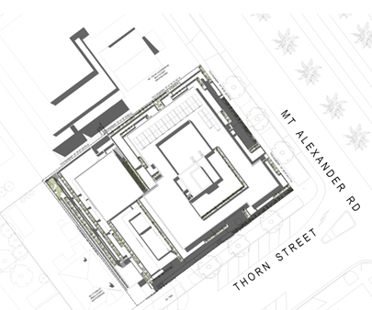

Church with single storey front portico

1. The church does not appear to be in a Heritage Overlay. Notwithstanding, we are not satisfied with the interface between the retained church and proposed development. The image included in Mr Czarny’s evidence does not, we find, demonstrate the way in which the building sits forward of the church and the position of the “recessed middle” that we consider is not significantly visually recessed. Where it does step back, it is relatively shallow. We find, the development unreasonably crowds the church form.

### Conclusion

1. For these above reasons, we find the proposal fails to appropriately respond to the design objectives of DDO3. Variation in heights to those as specified in Table 1 to Schedule 3 do not continue to meet the objectives of the Schedule, particularly to:

* Minimise the impact of development on adjoining land uses in terms of appearance, amenity and streetscape presentation.
* Prevent the visual intrusion caused by the inappropriate siting, massing and appearance of buildings and works.

1. Further, we are not persuaded that the departures from the preferred built form outcomes of DDO10 are acceptable, particularly because of the demonstrable amenity impacts to adjoining properties.
2. Permission under clause 43.02 is therefore refused.

## Amenity impacts

1. In this physical and strategic context, where substantial and intensive development is called for by the scheme, the applicant submits expectations in relation to off-site amenity impacts must be moderated. It submits reasonable expectations of an adjoining property, insofar as amenity is concerned, can only involve change. This is not a typical residential hinterland setting. No. 3 Thorn Street, and all of the properties fronting Richardson Street to the west of the subject land, are within the Activity Centre. While these properties are zoned GRZ and their development potential will accordingly be lesser than the subject land, the applicant submits they are within an area earmarked for change and amenity expectations must be construed in that context.
2. The applicant relies on Ms Jordan’s and Mr Patrick’s evidence (and recommendations) in support of its submissions that the proposal will not cause any unreasonable amenity impacts. Overshadowing of land to the west generally subsides by 11am, and there is no overshadowing to the north. Similarly, overlooking is appropriately managed to the west and the applicant is content for a condition to be imposed such as that recommended by Ms Jordan.
3. Respondents strongly disagree. Mr Loughnan submits DDO3 and DDO10 objectives have significant focus on the amenity of the area and of adjacent properties. Both require attention to heights and setbacks and also to planting and landscaping in new development. Mr Loughnan submits the development has almost continuous car parking/basement form across the site with a narrow planter box and so there is incapacity for any landscape presence by way of deep soil vegetation with canopies to assist in providing an effective buffer to the rear.
4. Mr Matthews raises concerns about the visual impact of the development with respect to multiple Grace apartments. Issues of concern include impacts on solar access, daylight and overlooking.

### Tribunal findings

1. We have referred earlier to our concerns about the visual impact of the development for residential properties in DDO10. Notwithstanding redevelopment can be expected along the east side of Richardson Street and potentially No. 3 Thorn Street, the proposed development goes beyond reasonable expectations based on the provisions of DDO3 and DDO10.
2. We find the form would be visually oppressive not only to No. 3 Thorn Street but other properties that form part of the residential periphery. The proposed landscape edge and building setbacks are insufficient to mitigate the impacts.
3. Additional shadowing to No. 3 Thorn Street could be lessened by a development that is more closely aligned with the DDO3 and DDO10 interface provisions. The same is the case with respect to a number of other residential properties that are affected in the morning.
4. We agree with Mr Loughnan and Mr Matthews that overlooking treatments require resolution. Given our overall conclusions, we do not address this in detail.

## Traffic and parking

1. Given the above conclusions, we do not address issues relating to traffic and parking in detail. These are not grounds upon which the Council relies, rather, impacts are of concern to respondents. Their concerns have been referred to through submissions and in statements of grounds. They focus on matters such as increased traffic, safety, overflow parking, waste collection, added pressure on public transport and construction.
2. Put succinctly, we find the proposed reduction in parking under clause 52.06 is acceptable. It is relevant that clause 52.06 does not require the provision of visitor parking given the location of the subject land within Principal Public Transport Network. Further, the Council’s traffic engineers are satisfied with the capacity of the road network to accommodate additional traffic safely. Development is expected in this location and that will bring with it additional vehicle movements.
3. Use of Thorn Street for access to the site is appropriate; it is most unlikely that approval would be gained to use the arterial Mt Alexander Road for operational and functional reasons. Adequate measures to ensure the safety of pedestrians can be provided.
4. Waste collection and construction management can be addressed by permit conditions, as is typical for development of this scale and nature.

## Net community benefit

1. The Tribunal must determine whether the application will produce an acceptable outcome having regard to the relevant policies and provisions in the scheme. The key policies and provisions have been listed in the ‘Information’ section of these reasons and have been considered fully by us, as relevant to the facts and the permit application. Clause 71.02-3 requires the decision-maker to integrate the range of policies relevant to the issues to be determined and balance conflicting objectives in favour of net community benefit and sustainable development.
2. Overall, we find the proposal’s negative impacts outweigh its positive and neutral outcomes. Net community benefit is not achieved.
3. The proposed development is too large for its physical context and does not respond appropriately to the policy context and clause 43.02. While positive features include activating the ground level, the development of this land is assessed within a context where the Council has established a suite of provisions that have specific design objectives and set expectations for height and visual bulk. While another design vision and ambition could have been developed by the planning authority, we must apply the one that has been included in the scheme. The urban form sought is consistent with the defined local character of the particular precinct and area and has regard for interface conditions.
4. We accept the proposal offers land use benefits in terms of the ground level retail and additional housing. Consolidation of the land has enabled an opportunity to achieve multiple scheme objectives on a corner lot. These benefits include greater utilisation of well-located land with ready access to a wide range of services, facilities and public transport.
5. Other developments in this precinct have met this expectation or have exceeded maximum heights by a relatively small margin. By contrast, the proposal exceeds this expectation more substantially. The consequence would be to create a discordant element in the Mt Alexander Road streetscape. Because of the building’s size, breadth and mass, accentuated by the fall of the land, it would present an unacceptable bulk to the residential periphery to the west. There are additional consequences with respect to the direct amenity impacts on some properties in terms of overshadowing and potentially overlooking (although the latter could be refined).

## CONCLUSION

1. For the above reasons, a permit is not granted and no permit is to issue.

|  |  |  |
| --- | --- | --- |
| **Margaret Baird**  **Senior Member** |  | **Stephen Axford**  **Member** |

# APPENDIX A

Essendon Major Activity Centre per clause 11.03-1L

(subject land notionally indicated in red circle, per Council’s submission)

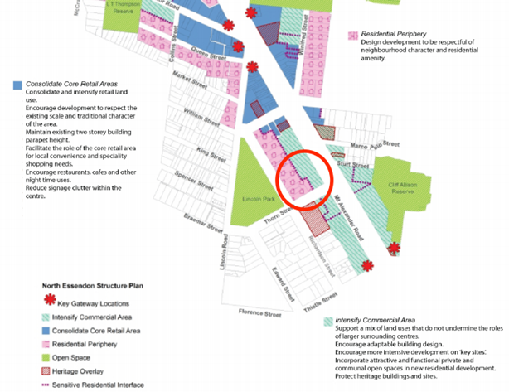

North Essendon Activity Centre Structure Plan

(subject land notionally indicated in green circle, per Council’s submission)

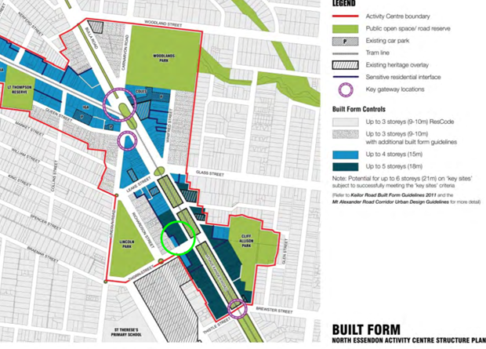

DDO3 Map 1

(subject land notionally indicated in red circle, per Council’s submission)

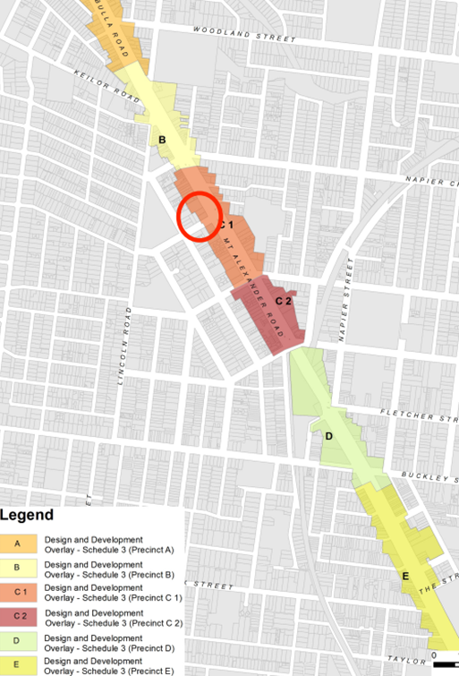

DDO3

Height and setback provisions – Table 1 in DDO3

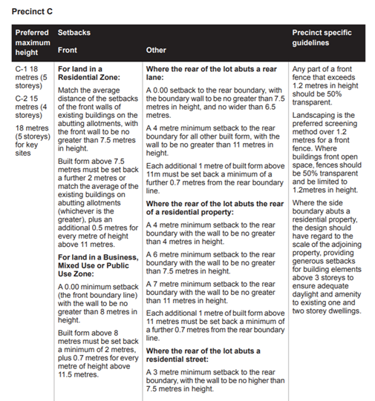

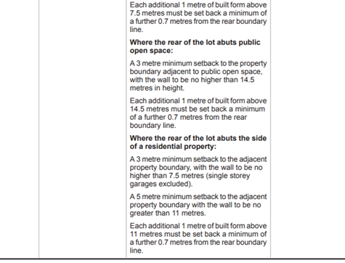

DDO10

Height and setback provisions – Table 1 in DDO10 for commercial properties

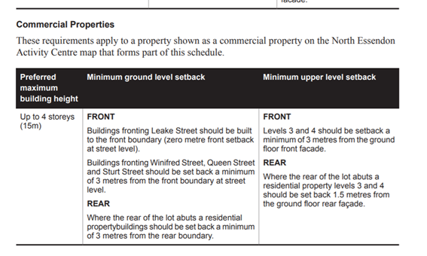

1. Section 4(2)(d) of the *Victorian Civil and Administrative Tribunal Act 1998* states a failure to make a decision is deemed to be a decision to refuse to make the decision.
2. Mt Alexander Road is angled partly towards the north-west but for convenience we refer to the interface to Mt Alexander Road as “east”.
3. The submissions and evidence of the parties, supporting exhibits and the statements of grounds filed have all been considered in the determination of the proceeding. In accordance with the practice of the Tribunal, not all of this material will be cited or referred to in these reasons.
4. *CBD Development Group (Essendon) Pty Ltd v Moonee Valley CC* [2018] VCAT 1069.
5. Clause 11.03-1L, DDO3 and DDO10.
6. Statement of evidence at page 9.
7. *Mt Alexander Road Corridor Urban Design Guidelines*, at page 43. It continues *“In consideration of these characteristics, sites within designated precincts which can demonstrate compliance with the above may be appropriate for an increased height limit under the Design Controls. In order to achieve ‘key site’ status, applicants are required to provide a response to each of the above criteria in addition to providing a visual impact assessment as part of their applicant documentation.* *Where the application is assessed by Council as not meeting the criteria the lower preferred building height applies”.*
8. Pages 59 and 60.
9. Relying on the definition of building height in clause 73.
10. 2017 and Addendum 2019.
11. For example, paragraphs 91 and 97 of the Council’ submission.
12. Statement of evidence, at page 9.