FEDERAL COURT OF AUSTRALIA

Ergon Energy Corporation Ltd v Australian Energy Regulator [2012] FCA 393

Citation: |  | Ergon Energy Corporation Ltd v Australian Energy Regulator [2012] FCA 393
Parties: |  | ERGON ENERGY CORPORATION LTD ACN 087 646 062 v AUSTRALIAN ENERGY REGULATOR
File number: |  | QUD 194 of 2010
Judge: |  | LOGAN J
Date of judgment: |  | 19 April 2012
Catchwords: |  | ENERGY AND RESOURCES – economic regulation of electricity supply and distribution – whether a street lighting service of a registered distribution network service provider falls within the definition of “distribution service” of the National Electricity Rules  Held: street lighting service falls within the definition of “distribution service” pursuant to the National Electricity Rules
Legislation: |  | Administrative Decisions (Judicial Review) Act 1977 (Cth) ss 3, 16, Sch 3  Competition and Consumer Act 2010 (Cth) ss 44AE, 44AI, 44AJ, 44AK  Telecommunications Act 1997 (Cth) s 7  Electricity Act 1994 (Qld) s 4  Electricity Act 1976 (Qld) s 6  Electric Light and Power Act 1896 (Qld) ss 3, 51  Government Owned Corporations Act 1993 (Qld)  Acts Interpretation Act 1915 (SA)  National Electricity (South Australia) Act 1996 (SA)  Electricity Reform Act 2000 (NT)  Electricity – National Scheme (Queensland) Act 1997 (Qld) ss 6, 7, 8, Attachment (National Electricity (Queensland Law) (‘National Electricity Law’), National Electricity (Queensland) Regulations made under the national Electricity (Queensland) Law (‘National Electricity Rules’)  National Electricity Law ss 2, 3, 7, 88, Pt 7, Sch 2  National Electricity (Economic Regulation of Distribution Services) Amendment Rules 2007  National Electricity Rules r 6.1.1, r 6.2.4, r 6.8.1, r 6.8.2, r 6.11.1, r 6.11.2, r 6.12.1, r 6.12.3, ch 10, ch 11
Cases cited: |  | Alcan (NT) Alumina Pty Ltd v Commissioner of Territory Revenue (2009) 239 CLR 27 followed  Australian Broadcasting Tribunal v Bond (1990) 170 CLR 321 cited  Australian Communication Exchange Ltd v Deputy Commissioner of Taxation (2003) 77 ALJR 1806 followed  DB Rreef Funds Management Ltd v Commissioner of Taxation (2005) 218 ALR 144 followed  Hurstville City Council v Hutchinson 3G Australia Pty Ltd (2003) 200 ALR 308 considered  Hutchinson 3G Australia Pty Ltd v City of Mitcham (2006) 80 ALJR 711 considered  Minister for Immigration and Multicultural Affairs v Singh (2000) 98 FCR 469 considered
Date of hearing: | 20 - 21 April 2011
Place: | Place_SentenceCase
Division: | GENERAL DIVISION
Category: | Catchwords
Number of paragraphs: | 58
Counsel for the Applicant: | Mr P O'Shea SC with Mr T Bradley and Mr S Walls
Solicitor for the Applicant: | Clayton Utz
Counsel for the Respondent: | Mr P Hanks QC with M P Gray
Solicitor for the Respondent: | Corrs Chambers Westgarth

IN THE FEDERAL COURT OF AUSTRALIA
QUEENSLAND DISTRICT REGISTRY
GENERAL DIVISION | QUD 194 of 2010

BETWEEN: | ERGON ENERGY CORPORATION LTD ACN 087 646 062  Applicant
AND: | AUSTRALIAN ENERGY REGULATOR  Respondent

JUDGE: | LOGAN J
DATE OF ORDER: | 19 APRIL 2012
WHERE MADE: | BRISBANE

THE COURT ORDERS THAT:

- The application is dismissed.
- The applicant is to pay the respondent’s costs of and incidental to the application to be taxed if not agreed.

Note: Entry of orders is dealt with in Rule 39.32 of the Federal Court Rules 2011

IN THE FEDERAL COURT OF AUSTRALIA
QUEENSLAND DISTRICT REGISTRY
GENERAL DIVISION | QUD 194 of 2010

BETWEEN: | ERGON ENERGY CORPORATION LTD ACN 087 646 062
AND: | AUSTRALIAN ENERGY REGULATOR

JUDGE: | LOGAN J
DATE: | 19 APRIL 2012
PLACE: | BRISBANE

REASONS FOR JUDGMENT
- The question at the heart of this case is whether the term “distribution service”, which is defined to mean “a service provided by means of, or in connection with, a distribution system”, applies to the service provided via the street lighting system of the applicant, Ergon Energy Corporation Limited (Ergon)?
- As might be suspected from considering the very name of the respondent, the Australian Energy Regulator (AER), the answering of that question requires an explanation of the contemporary statutory provision for the economic regulation of electricity supply and distribution in Australia, the roles undertaken by Ergon and AER and a description of the electricity distribution and street lighting systems operated by Ergon. The evidence concerning those systems was not materially controversial. It forms the basis for the description of those systems and other facts which I relate below.

Ergon and Electricity Industry Functional Responsibilities
- Functional responsibility within the electricity industry is divided according to whether an entity is concerned with the generation, distribution or supply to the consumer of electricity.
- Ergon is an unlisted public company. It is beneficially owned by the State of Queensland and is a government owned corporation (GOC) for the purposes of the Government Owned Corporations Act 1993 (Qld).
- Ergon is a registered distribution network service provider (DNSP) under the National Electricity Rules (NER) of which more shortly. The only other DNSP in Queensland is another GOC beneficially owned by the State of Queensland, Energex Limited. Energex distributes electricity throughout South East Queensland with Ergon being responsible for the distribution of electricity throughout the rest of Queensland.
- In keeping with the division of functional responsibility mentioned, entities different from Ergon and Energex are responsible for the generation of electricity. In Queensland electricity generation is undertaken at power stations owned by GOCs and other generation is undertaken at power stations owned by privately owned entities.
- The transmission of electricity from these power stations along high voltage power lines is undertaken by what are known in electricity industry regulatory terminology as transmission network service providers. There is but one of these in Queensland, PowerLink Queensland (PowerLink), which is also a GOC. The distribution networks of both Energex and Ergon are linked to PowerLink’s high voltage transmission lines and progressively step down voltage for commercial, industrial and domestic use. The retail sale of electricity is undertaken by yet further entities. In Ergon’s distribution region the main retailer is a subsidiary of it known as Ergon Energy Queensland Pty Ltd (EEQ). In Energex’s distribution region the major electricity retailers are Origin Energy Limited and AGL Energy Limited.

Economic Regulation of the Australian Electricity Industry
- Since the late 1990s and with the exception of the Northern Territory, the economic regulation of the electricity industry in Australia has been undertaken pursuant to a co-operative scheme of Federal, State and Australian Capital Territory legislation and subordinate legislation. Probably because of unique local circumstances, the industry is separately regulated in the Northern Territory, q.v. the Electricity Reform Act 2000 (NT). For the rest of mainland Australia and Tasmania, the industry is regulated by what is known as the National Electricity Law (NEL) and rules, the NER, made under that law.
- The source of the NEL is a schedule to a South Australian Act, the National Electricity (South Australia) Act 1996 (SA) (South Australian Act). The Queensland legislation which forms part of the co-operative national scheme is the Electricity—National Scheme (Queensland) Act 1997 (Qld) (Queensland Act). The design of that Queensland Act is to adopt and apply as laws of Queensland both the NEL (necessarily including the NER made pursuant to that law) and regulations made pursuant to the South Australian Act: see s 6 and s 7. As so adopted and applied, they are known respectively as the National Electricity (Queensland) Law and the National Electricity (Queensland) Regulations. Unless otherwise indicated, a reference in these reasons for judgment to the NEL and the NER is a reference to that law and those rules made pursuant to that law as adopted and applied for Queensland.
- A qualification to Queensland’s adoption and application of the NEL and NER is that that does not carry with it the application to them of either the Acts Interpretation Act 1915 (SA) or other Acts of South Australia: s 8, Queensland Act.
- The AER is a body corporate established by s 44AE(1) of what is now known as the Competition and Consumer Act 2010 (Cth) (Competition and Consumer Act). Sections 44AI, 44AJ and 44AK of the Competition and Consumer Act make provision for the conferral with the Commonwealth’s consent of duties on the AER under State or Territory laws. The NEL and the NER are examples of such laws. To that end, r 6.1.1 of the NER provides:
6.1.1 AER's regulatory responsibility

The AER is responsible, in accordance with this Chapter, for the economic regulation of distribution services provided by means of, or in connection with, distribution systems that form part of the national grid.

- Previously, the Queensland Competition Authority, rather than the AER, had the responsibility for the economic regulation of Ergon. For regulatory periods on and from 1 July 2010 this responsibility was transferred to the AER.
- The NER (r 6.2.4) require the AER to make a distribution determination for each DNSP. Those rules also make elaborate provision for a progressively staged process leading to the making of such a determination. Thus, a precursor to the making of such a determination is the preparation and publishing by the AER of what is termed a “framework approach paper”: r 6.8.1, NER. In that document the AER must set out its likely approach and the reasons for that likely approach in the forthcoming distribution determination: r 6.8.1(b), NER. Amongst the subjects which must be addressed in a framework approach paper are:
- the classification of distribution services (r 6.8.1(b), NER); and
- the form or forms of the control mechanisms to be applied by the distribution determination (r 6.8.1(c), NER).
These subjects, in turn, must ultimately be addressed by what are known as “constituent decisions” which form part of the distribution determination.
- Subject to presently immaterial qualifications specified in r 6.12.3, a framework approach paper binds neither the AER nor a DNSP: r 6.8.1(h), NER. For its part, a DNSP such as Ergon must, when required, submit to the AER a regulatory proposal for distribution services provided by means of or in connection with that DNSP’s distribution system. That regulatory proposal must include a classification proposal which specifies how the distribution services to be provided by the DNSP should be classified: r 6.8.2, NER.
- The progressive stages under the NER leading to the making of a distribution determination further provide for the AER to invite written submissions, publish a draft determination, hold a pre-determination conference and permit a DNSP to submit a revised regulatory proposal. The AER is obliged to consider any submissions made in relation to the draft determination, to consider any revised regulatory proposal and to make a distribution determination in relation to the DNSP: r 6.11.1, NER. This determination must then be published by the AER together with that body’s reasons for making that determination, “including the constituent decisions i.e. the decisions made in accordance with r 6.12 on which the distribution determination is predicated”: r 6.11.2. The “constituent decisions” include (r 6.12.1(1) & (12), NER):
(1) a decision on the classification of the services to be provided by the Distribution Network Service Provider during the course of the regulatory control period; and

(12) a decision on the control mechanism for alternative control services (to be in accordance with the relevant framework and approach paper).

The Distribution Determination
- So far as this case is concerned, the AER’s framework approach paper of 27 August 2008 (p 28, Table 2.5) included a decision that Ergon’s street lighting service be classified as an alternative control service. Ergon’s disagreement with this classification in an earlier submission was noted in the framework approach paper. Ergon’s position was that its street lighting service was not a distribution service and that, accordingly, it was unregulated.
- The AER maintained its position that Ergon’s street lighting services were distribution services for the purposes of the NER in its distribution determination dated 4 May 2010, which was published on 6 May 2010. Those reasons reveal that it decided for the purposes of that determination by a constituent decision that, for the purposes of r 6.12.1(1) of the NER, the classification of services applicable to Ergon was as specified in appendix A to the reasons for decision. The following is the material excerpt from appendix A:
AER Service Group | AER Classification | Activities included in service group | Ergon Energy service
Street lighting services | Alternate control service | Provision, construction and maintenance of street lighting | Street Lighting – Provision and Operating and Maintenance

- The AER made a further constituent decision (table 17.16 of the reasons for decision refers) that, for the purposes of r 6.12.1(12) of the NER, the control mechanism to apply to Ergon’s street lighting services was:
- caps on the prices of individual services in the first regulatory year of the next regulatory control period;
- price paths for the remaining regulatory years of the next regulatory control period.
- The distribution determination is applicable to the regulatory period which runs from 1 July 2010 to 30 June 2015 with each regulatory year in that period commencing on 1 July. Thus, the first regulatory year runs from 1 July 2010 to 30 June 2011.

Ergon’s Judicial Review Application
- Ergon has sought the judicial review of the classification and control mechanism constituent decisions described above pursuant to the Administrative Decisions (Judicial Review) Act 1977 (Cth) (AD(JR) Act).
- It was common ground between the parties that the Court has jurisdiction under that Act to review those decisions. Consent does not, of course, confer jurisdiction. Having regard to observations made in Australian Broadcasting Tribunal v Bond (1990) 170 CLR 321, particularly by Mason CJ at 337, as to a reviewable decision for the purposes of the AD(JR) Act generally being a decision which is final or operative and determinative, it is perhaps moot as to whether it is the distribution determination which is the “decision to which this Act applies” in terms of s 3(1) of the AD(JR) Act, as opposed to a constituent decision. However, the position is not all one way, notably because the preamble to r 6.12.1 of the NER provides, “A distribution determination is predicated on the following decisions by the AER (constituent decisions)”. That certainly supports a view that each constituent decision is a “decision to which this Act applies” for the purposes of the AD(JR) Act. Express reference is made in paragraph (b) of the definition of that term in s 3(1) of the AD(JR) Act to decisions, “by a Commonwealth … under an enactment referred to in paragraph (ca) or (cb) of the definition of enactment”. In turn, those paragraphs of the definition of “enactment” direct attention to Sch 3 to the AD(JR) Act. Schedule 3 to the AD(JR) Act describes Acts of the States, the Australian Capital Territory and the Northern Territory, and parts of such Acts, that are enactments for the purposes of that Act. The description in item (da) in Sch 3 is as follows:
(da) the National Electricity (South Australia) Act 1996 of South Australia, or an Act of another State or of the Australian Capital Territory or the Northern Territory that applies the Schedule to that South Australian Act as a law of that other State or of that Territory

Taken in conjunction with the definitions in s 3(1) of the AD(JR) Act, that description is certainly apt to refer to a distribution determination under the NER and, at least arguably, also to refer to a “constituent decision”. Further, even if, truly, it is the distribution determination which is the reviewable decision, the relief which the Court could grant under s 16 of the AD(JR) Act in the event that a ground of review were made out would include the setting aside of part of that decision; materially, so much of it as was predicated upon the nominated constituent decisions. In these circumstances, to sound an interrogative note as to what constitutes the reviewable decision may be to highlight a distinction without a substantive difference in terms of outcome. For it would still be necessary, in the event of setting aside an imputed constituent decision additionally to set aside by way of consequential relief so much of the distribution determination as was predicated upon that constituent decision.
- However approached, the position reached is that the Court has jurisdiction. In these circumstances, it seems to me that my duty is to decide the case upon the bases argued and the assumptions mutually made by the parties: Australian Communication Exchange Ltd v Deputy Commissioner of Taxation (2003) 77 ALJR 1806 at [41]; DB Rreef Funds Management Ltd v Commissioner of Taxation (2005) 218 ALR 144 at [20] per Sackville J.
- The grounds of review put forward by Ergon are:
- the AER did not have jurisdiction to make the constituent decisions and those decisions were not authorised by the NER, because street lighting services were not within the definition of “distribution service” in ch 10 of the NER; and
- the constituent decisions involved an error of law, in that the AER misconstrued the phrase “distribution service” in ch 10 of the NER to include street lighting services when street lighting services were not within the definition of “distribution service” in ch 10 of the NER.
As can be seen, in one way or another these grounds require the answering of the question posed in the opening paragraph of these reasons for judgment. The parties correctly approached the answering of that question on the basis that it involved finding whether or not a jurisdictional fact existed. What constitutes Ergon’s streeting lighting service is a question of fact and whether or not that service falls within the definition of “distribution service”, in the NER, properly construed, governs whether the AER has any regulatory jurisdiction in relation to that service to that extent.

The definition of “distribution service” and other definitions
- Chapter 10 of the NER contains what is described as the Glossary. In that chapter is to be found the plethora of definitions of words and terms employed in the NER.
- “Distribution service” is defined as follows:
distribution service

A service provided by means of, or in connection with, a distribution system.

Throughout the NER italics are used to indicate that a word or term is defined for the purposes of those rules. The Glossary defines “distribution system” in this way:

distribution system

A distribution network, together with the connection assets associated with the distribution network, which is connected to another transmission or distribution system.

Connection assets on their own do not constitute a distribution system.

In the NER, italics are used to indicate words and terms which are defined. Thus what is revealed in the quoted definitions is what might aptly be described as the matryoshka or “Russian doll” method of definitional drafting. By that I mean that the definitions of these terms in turn incorporate other defined terms, layer upon successive layer, to some or all of which it is necessary to have recourse in order to construe any one given definition. The risk with this method of drafting is that, if over-employed, definitional comprehension is sacrificed in the pursuit of definitional comprehensiveness. Be this as it may, the result it is necessary to set out a number of further definitions from the Glossary:
distribution network

A network which is not a transmission network.

connection assets

Those components of a transmission or distribution system which are used to provide connection services.

transmission or distribution system

A transmission system or distribution system that:

1. is used to convey, and control the conveyance of, electricity to customers (whether wholesale or retail); and
2. is connected to another such system.

connection service

An entry service (being a service provided to serve a Generator or a group of Generators, or a Network Service Provider or a group of Network Service Providers, at a single connection point) or an exit service (being a service provided to serve a Transmission Customer or Distribution Customer or a group of Transmission Customers or Distribution Customers, or a Network Service Provider or a group of Network Service Providers, at a single connection point).

network

The apparatus, equipment, plant and buildings used to convey, and control the conveyance of, electricity to customers (whether wholesale or retail) excluding any connection assets. In relation to a Network Service Provider, a network owned, operated or controlled by that Network Service Provider.

connect, connected, connection

To form a physical link to or through a transmission network or distribution network.

Ergon’s street lighting services
- Ergon supplies street lighting services to the State of Queensland, more particularly to its Department of Transport and Main Roads in respect of the road network under that department’s control and to various local governments within Queensland in respect of road networks under the control of those local governments.
- Ergon is not the exclusive supplier of street lighting services either to the State or to local governments. Each is able to own, operate and, via suitably qualified staff or contractors, maintain street lights. Predominantly though (to the order of 96%), the street lighting within Ergon’s distribution area is owned, operated, maintained and supplied by it to the State or, as the case may be, a local government. Sometimes, as frequently occurs in new urban developments, Ergon’s ownership of street lights is the result of a transfer to it of those street lights by a local government as a sequel to their installation by a developer as a condition of local government town planning approval for a development.
- Charges to the State or local governments for street lighting services supplied to them by Ergon are rendered by its retailer subsidiary, EEQ. The amount of those retail charges is, in practice, set by the Queensland Competition Authority.
- Ergon’s street lights typically comprise the following:
- a pole, in the case of a stand alone street light which is not affixed to an existing electricity mains pole;
- a light fitting (otherwise known as a “luminair”), which is the case and cover for the lamp - the equivalent of a shade and socket for a household lamp;
- a lamp - the equivalent of a household light bulb or fluorescent tube;
- a photoelectric (PE) cell, which switches the lamp on and off, depending on when it becomes dark and when it becomes light on a given day;
- the ballast, starter or other control device, within the light fitting, which initiates the lamp, when the PE cell switches it on; and
- the wiring (the street light circuit) that connects the lamp or lamps to the electricity mains circuit. The function of the street light circuit is to draw electricity from the mains circuit to power the lamp - the equivalent of the wiring in a house that provides electricity to household lights.
- The mains circuit is part of the electricity distribution system. It consists of overhead and underground power lines carrying voltages ranging from 33,000 volts to 415 volts, together with related transformers and regulators. In a traditional road setting, the mains circuit is an overhead line strung along power poles running in parallel with a road. In other places, the mains circuit may be located underground, again running parallel to a road.
- In either case, a street light circuit is connected to a mains circuit by a fuse. In general, every street light has a fuse. That fuse point is a point of separation, electrically, between the street light circuit and the mains circuit. The fuse serves to isolate the street circuit from the mains circuit, in the event of a fault or failure in the street light circuit or in the lamp. Sometimes, where there is more than one street light on a power pole, there may be but one connection point to the mains circuit for all of the lights mounted on that pole. Another instance where there may be multiple, interconnected street lights connected to a mains circuit via a single connection point is in a street lighting system which serves a main road under the control of the Department of Transport and Main Roads. Where street lighting is required for such roads the practice is for that department to install a set of interconnected, column mounted street lights the circuit for which has a single connection point with a mains power circuit.
- The fuse point for power pole mounted street lights is mounted on the pole itself. In respect of street lighting powered from underground mains cables, the fuse point is not on the street light pole but rather found within a small, ground mounted low voltage pillar (LV pillar) which is placed on the side of a road or on a property boundary. An LV pillar has a removable cover. The fuse point which connects the street lighting circuit to the mains power circuit is located on the pillar under that cover.
- Ergon provides its street lighting service via the street lighting system described. The electrical separation which occurs at the fuse point between a street light circuit of any of the kinds mentioned and the mains power circuit, be that circuit overhead or underground, formed a key part of the submissions made by Ergon as to why its street lighting service was not a “distribution service” on what was said to be the true construction of that definition in the NER. For that reason and in addition to the description which I have given, it is of assistance to reproduce plan diagrams for each which formed part of the evidence led in the case which show that electrical separation fuse point and of the typical configuration of mains power pole mounted street lights and separately mounted street lights connected to underground mains.
Diagram 1 - Typical Power Pole Mounted Street Light and Mains Power Connection

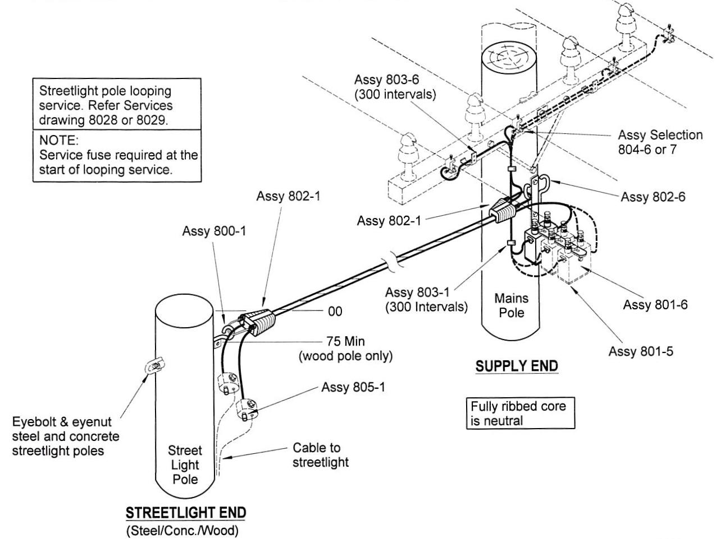

Legend for Diagram 1

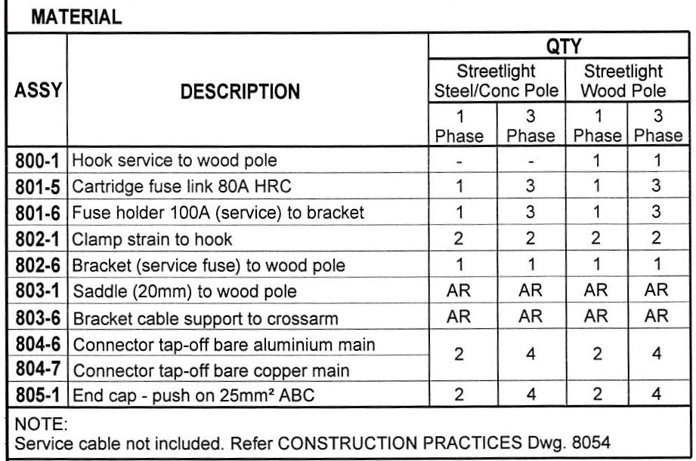
Further notes for Diagram 1 and Legend:
- Assy = Assembly
- Conc = Concrete
Diagram 2 - Typical Connection between pole mounted street light and underground mains power

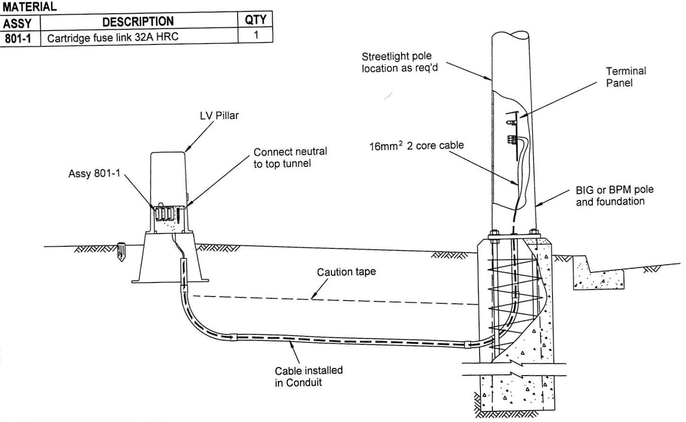

Does Ergon’s street lighting service constitute a “distribution service”?
- Taking account of incorporated definitions, Ergon analysed the definition of “distribution service” in this way. A distribution service is a service provided “by means of” or “in connection with” a distribution system. The latter consists of:
- the apparatus, equipment, plant and buildings used to convey and control the conveyance of electricity to customers; and
- connection assets;
and is connected to another transmission or distribution network.
- Ergon submitted that there were two important elements of the definition:
- it is based on assets, ie apparatus, plant etc, used for a particular purpose namely, the conveyance of electricity to customers; and
- those assets must be connected to another transmission or distribution system.
- Ergon further submitted that its street lighting assets, ie light fittings, lamps, supporting brackets and poles dedicated to street lighting, were neither used for the conveyance of electricity nor to control its conveyance. All that they were used for was to illuminate streets. The street lighting system was electrically separate from the distribution system; hence the importance, so Ergon submitted, of the fuse point. A fuse, it submitted was a “connection asset”. A distribution system included the distribution network and a connection asset but extended no further. Once electricity reached a connection point then, whatever was on the other side of that point, be it a street lighting system or a customer (either domestic or the proprietor of a transmission or another distribution system), that did not form part of that particular distribution system. The various assets constituting the street lighting system could not part of the distribution system. From this it followed, so it was submitted, that the provision, construction and maintenance of street lighting assets could not be a service provided “by means of” Ergon’s street lighting system.
- As to the alternative, “in connection with”, Ergon acknowledged that this conjunctive phrase had a wide operation but drew attention to authorities concerning the meaning of this and cognate phrases which are collected and discussed in the joint judgment of Black CJ, Sundberg, Katz and Hely JJ in Minister for Immigration and Multicultural Affairs v Singh (2000) 98 FCR 469 at 477, [28] - [29] (Minister for Immigration and Multicultural Affairs v Singh). That case and the authorities there discussed establish that:
- though the phrase does indeed have a very broad operation, that operation is usually limited by the context in which the phrase is used, the words with which it is associated and the object or purpose of the statute in which the phrase appears;
- so important and case specific are these limiting factors that, save in respect of statements as to the general meaning of the phrase, reference to reported cases is of little assistance; and
- the phrase does not necessarily require a causal connection between the matters which are said to be connected.
- Nonetheless, Ergon submitted that context was sufficiently analogous for two cases in which the meaning of the phrase “in connection with” as used in the definition of “facility” in s 7 of the Telecommunications Act 1997 (Cth) (Telecommunications Act) was considered were of assistance in the resolution of the present case. For the purposes of that Act the term “facility” is defined in this way:
“facility” means:

(a) any part of the infrastructure of a telecommunications network; or
(b) any line, equipment, apparatus, tower, mast, antenna, tunnel, duct, hole, pit, pole or other structure or thing used, or for use, in or in connection with a telecommunications network.

The matryoshka or “Russian doll” method of definitional drafting is also evident in this definition in that “telecommunications network” and “line” are each defined terms and each also, in turn, incorporates at least one other defined term in its definition. Perhaps the use of this method in other provisions governing utilities was not a coincidence. Fortunately, the point Ergon sought to make did not require an excursion through definitional layers.
- The first case was Hurstville City Council v Hutchinson 3G Australia Pty Ltd (2003) 200 ALR 308 (Hurstville City Council v Hutchinson 3G Australia). The controversy in this case arose from a proposal of Hutchinson to replace a council owned light pole providing illumination to a park with a different pole of the same height and volume from which pole illumination would still be provided but which would additionally be suitable for the attachment of antennae and a communications dish as part of a wireless free network which Hutchinson was establishing. So as to frustrate Hutchinson, the Council removed the light pole from the park. In response, Hutchinson began excavating at that site for the purpose of erecting a replacement pole suitable to its needs. The council sought, unsuccessfully, in the Land and Environment Court to restrain this activity. It then appealed to the Court of Appeal. Hutchinson’s power under statute to replace the existing pole without the Council’s consent depended upon whether it could be characterised as a “facility” as defined in the Telecommunications Act. In the course of his reasons for judgment allowing the appeal, Mason P, with whom Handley and McColl JJA agreed, observed, (200 ALR at [67]) of paragraph (b) of the definition of “facility”:
Part (b) of the definition makes perfect sense if construed as being confined to any line, equipment etc or thing that is purpose built or dedicated by its inherent nature for use in or in connection with a telecommunications network or which is actually used accordingly. It is not necessary to treat an existing (non purpose-built) pole, structure or thing upon which a "facility" is placed as the facility itself.

- The use Ergon sought to make of this observation for the purposes of the present case was to argue, by analogy, that a dedicated street light pole, lighting arm on a power pole or the bulb or luminair attached to either type of pole was neither purpose built nor intended by its inherent nature for use in the distribution system. From this it was said to follow that the provision, construction and maintenance of such assets could not be a service provided in connection with assets comprising a distribution service; hence these activities could not constitute a “distribution service”.
- The other case concerning the definition of “facility” in the Telecommunications Act relied upon by Ergon was Hutchinson 3G Australia Pty Ltd v City of Mitcham (2006) 80 ALJR 711 (Hutchinson 3G Australia v City of Mitcham). This case, too, arose against the background of a dispute between Hutchinson and a local government the resolution of which depended upon whether particular infrastructure not owned by Hutchinson nonetheless fell within the definition of “facility” in the Telecommunications Act. In this case the infrastructure consisted of power poles know in South Australia as “stobie poles”. Pursuant to an arrangement which Hutchinson had struck with the Electricity Trust of South Australia (ETSA), the ETSA had erected replacement stobie poles at sites in its network which Hutchinson had identified as suitable for its telecommunications needs. Unlike the poles which they replaced, the replacement stobie poles were designed to be additionally suited to the additional placement on them of telecommunications equipment. In its submissions as to why those poles were “facilities”, Hutchinson relied upon the reference to “purpose built” in the passage quoted from Hurstville City Council v Hutchinson 3G Australia.
- Hutchinson’s reliance on this earlier judgment proved misplaced with the High Court holding that the definition directed attention to the function which a structure was designed to serve not to the motive for its installation. The relevant part of the judgment is to be found in the following passage which, because of the importance it played in Ergon’s submission, I set out in full:
85 However, merely establishing that ETSA erected stobie poles at the relevant sites in order to permit installation by Hutchison of its facilities does not necessarily demonstrate that those poles were intended for such use. This is because the definition of the term "facility" in the Telco Act requires that attention be directed, not to the motive for the installation of a structure or thing, but the function which that structure or thing serves or was designed to serve.

86 The definition of the expression "telecommunications network" has previously been set out in these reasons. That definition contemplates a "system" or a "series of systems" engaged in the carrying of communications by means of guided and/or unguided electromagnetic energy. In attempting to characterise the function which was served or sought to be served by the replacement poles, the question thus arises: were the replacement poles intended for use in connection with a "system"?

87 The Case Stated indicates that the poles were replaced in order to meet the structural demands of carrying such facilities as the three panel antennae, the microwave dish and the mounting pole which together form part of a downlink site. In other words, the replacement poles were designed, in part, to accommodate the physical act of installing telecommunications equipment. However, there is nothing to suggest that, as such, they were intended to satisfy the requirements of a "system" or a "series of systems" of the sort described in the definition of "telecommunications network".

88 The locations of the poles, though conducive to the operation of a telecommunications network and recognised by Hutchison as such when it selected them as sites for the installation of its downlink facilities, were not selected in order to facilitate that operation. Instead, ETSA had erected poles at those locations as part of its electricity distribution business.

89 Moreover, it was not the set of requirements attendant upon the operation of a system which prompted the need for poles of a larger cross-section at the Colonel Light Gardens site, the Bellevue Heights site, the Torrens Park site and the Kingswood site. It was instead the requirements attendant upon the task of installing individual items of equipment on those poles.

- The use Ergon sought to make of the passages quoted from Hurstville City Council v Hutchinson 3G Australia and Hutchinson 3G Australia v City of Mitcham for the purposes of the present case was to argue, by analogy, that a dedicated street light pole, lighting arm on a power pole or the bulb or luminair attached to either type of pole was neither purpose built nor intended by its inherent nature for use in the distribution system; nor were these designed to serve or have the function of serving a distribution system. From this it was said to follow that the provision, construction and maintenance of such assets could not be a service provided in connection with assets comprising a distribution service; hence these activities could not constitute a “distribution service”.
- Ergon further submitted that the definition of “distribution service” in the NER had to be construed in the context of the rule making power in Pt 7 of the NEL. Within that part, s 88 requires that rules may only be made if the Australian Energy Market Commission is satisfied that the rule, “will or is likely to contribute to the achievement of the national electricity objective”. That objective is set out in s 7 of the NEL:
The objective of this Law is to promote efficient investment in, and efficient operation and use of, electricity services for the long term interests of consumers of electricity with respect to -

(a) price, quality, safety, reliability and security of supply of electricity; and
(b) the reliability, safety and security of the national electricity system.

- Again, there are defined terms within this definition but none, Ergon contended, extended to the control of the provision, construction or maintenance of street lighting. Thus, Ergon’s submission was that the exclusion of street lighting services from a “distribution service” was supported both by context and relevantly analogous authority.
- Ergon’s case for exclusion of street lighting services was well and persuasively put by its counsel. It has at least a superficial attraction but, upon reflection, I have reached the conclusion that it ought not to succeed. I have reached that conclusion substantially for the reasons advanced by the AER. Because of that, I do not separately reproduce the AER’s submissions. These will be evident enough from the explanation which follows as to why the application must be dismissed.
- The starting point in any case concerning the construction and application of a provision in a statute or subordinate legislation must be the text of that provision, the context in which that provision appears and the purpose or object of the statute or subordinate legislation concerned. This proposition has been stated on many occasions at ultimate appellate level but the following passage from the joint judgment of Hayne, Heydon, Crennan and Kiefel JJ in Alcan (NT) Alumina Pty Ltd v Commissioner of Territory Revenue (2009) 239 CLR 27 at [47] is particularly apposite:
This Court has stated on many occasions that the task of statutory construction must begin with a consideration of the text itself. Historical considerations and extrinsic materials cannot be relied on to displace the clear meaning of the text. The language which has actually been employed in the text of legislation is the surest guide to legislative intention. The meaning of the text may require consideration of the context, which includes the general purpose and policy of a provision, in particular the mischief it is seeking to remedy.

[Footnote references omitted]

- The cautionary note sounded in the passage quoted in relation to historical considerations is singularly apt in the present case. It was heeded in the submissions made by Ergon, which did not place these at the forefront.
- Regard to Queensland legislative history shows that there has been an enduring association between electricity supply and distribution and the provision of street lighting which extends back to colonial times. The Electric Light and Power Act 1896 (Qld) (since repealed) (Electric Light and Power Act) made it illegal to supply electricity and to construct electricity lines or works without authorisation by Order-in-Council or by licence issued by the Minister charged with the administration of that Act. The Act contemplated that an “Electricity Authority”, which might be either a local government or a company, might be authorised or licensed for such purposes. For the purposes of that Act, the term, “Works” was defined (s 3) in a way which included not just electricity lines but also, materially, “lamps”. Also materially, one of the offences created by the Act (s 51(5)) was the wilful extinguishment of any public electric lamp or light. This legislation clearly contemplated that an “Electricity Authority” might not only supply and distribute electricity but also operate public street lighting.
- The Electric Light and Power Act survived, much amended, until 1976 when it was repealed by the Electricity Act 1976 (Qld) (since repealed) (Electricity Act 1976). That Act provided for a major reorganisation of the electricity generation, distribution and supply industry in Queensland. The definition (s 6) of “works” in that Act also made express reference to “lamps”. The Electricity Act 1976 was, in turn, repealed, by the Electricity Act 1994 (Qld) which, again much amended, remains on the statute book. In this legislation, too, the definition of “works” is cast in a way which includes lamps: see, via s 4 and the “dictionary” in Sch 5, s 12(1).
- Thus, for over a century, the provision of lighting has been legislatively regarded in Queensland as associated with the distribution of electricity. Why this might be so arises as a matter of necessary inference from the evidence led in this case. Electricity distribution networks, especially as voltages are stepped down to those suitable for domestic and light industrial use, tend to be placed in and along public road reserves. There is an obvious convenience about the placement of electrically powered street lights on power poles placed in these same reserves. Similar considerations attend the street light placed on dedicated street light poles drawing power from underground parts of the electricity distribution system. Each run along public road reserves.
- However attractive such historical considerations may be, primacy must be given to the text of the definition of “distribution service” in the NER, to the context in which that definition is found and to the purpose or object of the NER as a subordinate part of the NEL. This would be a necessary discipline even were the NER just Queensland subordinate legislation. They are not. They form part of a national scheme. It would doubtless be possible to conduct an historical survey not only of the legislation in the parent jurisdiction for that scheme, South Australia but also of the legislation in the other participating jurisdictions in relation to electricity and the provision of public street lighting. A recollection of history in respect of a gas fuelled street lights gradually being replaced by electric lights in the latter 19th Century, coupled with the Queensland experience related, instructs that it is inherently likely that in each of these other jurisdictions there is to be found in colonial and later legislation regulating the electricity industry reference to public lights or lamps. I have not embarked upon such a survey because it would be apt to distract from the language employed in the definition to hand.
- A consequence of focussing on the text of the definition of “distribution service” is that it emphasises that the language employed in that definition is different to the definition of “facility” considered in the two Hutchinson cases mentioned. The composite phrase “by means of or in connection with” found in the definition of “distribution service” creates a quite different focus to the composite phrase “or for use, in or in connection with” found in paragraph (b) of the definition of “facility”. There is no doubt that Ergon’s street lighting service is not provided “by means of” a “distribution system”. The AER did not contend that it was. The analysis, related above, which Ergon made of what definitionally constitutes a “distribution system” and the importance in the application of that definition to the facts of identifying the electrical separation which occurs at the fuse point demonstrates why this concession was correctly made. Street lights do not form part of the “distribution system”.
- The phrase “in connection with” has chameleon like qualities with its meaning much affected by the context in which it appears. As used as part of the larger composite phrase in paragraph (b) of the definition of “facility” the overall result is to focus on items designed for use in or in connection with a telecommunications network, as the outcomes in the two Hutchinson cases reveal. This might be contrasted with and is narrower in focus than the way in which “in connection with” is employed in the definition of “distribution service” in the definition in the NER. The narrow focus on the “distribution system” is achieved by “by means of”. The remaining part of the composite phrase, “in connection with”, does not require that the service be provided via the “distribution system”, as defined, only that the service be connected with that system. To construe “in connection with” as requiring that the service be provided via the “distribution system”, as defined, would duplicate a field already covered by “by means of”. In context, synonymous phrases for “in connection with” are “in association with” or “in conjunction with”. So construed the placement of street lights be they on power poles or on stand alone poles also running along road reserves and the immediacy of the connection between street lights and the “distribution system” falls readily and naturally within the definition of “distribution service”.
- That approach to the construction of the phrase conforms to its general features as described in Minister for Immigration and Multicultural Affairs v Singh. Further, the difference in language between the definition of “distribution service” and the definition of “facility” exemplifies the wisdom of the Full Court’s counselling in that case that reference to other decided cases concerning the phrase “in connection with” will rarely be of assistance.
- Contrary to Ergon’s submission, consideration of the wider context in which the definition of “distribution service” appears does not detract from this conclusion. Reference has already been made to the “National Electricity Objective” as set out in s 7 of the NEL. The interpretation of the NER is governed by Sch 2 to the NEL: s 3, NEL. Within Sch 2 to the NEL, r 7 makes it plain that a purposive approach to the construction of the NEL and rules made thereunder is to be preferred. The term, “electricity services” found within the “National Electricity Objective” is defined by s 2, NEL as follows:
electricity services means services that are necessary or incidental to the supply of electricity to consumers of electricity, including -

(a) the generation of electricity;
(b) electricity network services;
(c) the sale of electricity.

In turn, “electricity network service” is defined by s 2 of the NEL thus:
electricity network service means a service provided by means of, or in connection with, a transmission system or distribution system.

The similarity of language between the definition of “electricity network service” and the definition of “distribution service” is obvious. A street lighting service having the features described above fits naturally within a service which is “incidental” to the supply of electricity to consumers and, in any event, is within the definition of “electricity network service” as being a service provided “in connection with” a distribution system. Thus, so far as wider context is concerned, when regard is thus had to these subordinate defined parts of the “National Electricity Objective”, no tension emerges in relation to the construction of the definition of “distribution service” in the NER promoted by the AER.
- As it happens, to construe the definition of “distribution service” in a way which includes street lighting services accords with the basis upon which some of the transitional provisions found within ch 11 of the NER are cast. These include an alternative version of ch 6 of the NER which is intended to apply to New South Wales distribution network service providers during the regulatory period running from 2009 to 2013. One such provision is r 6.2.3B, entitled “classification of NSW Distribution Network service Providers”. Within that clause, paragraph (b) characterises the “construction and maintenance of public lighting infrastructure” (which includes street lighting) as a “distribution service”. Chapter 6 and ch 11 were inserted into the NER by the National Electricity (Economic Regulation of Distribution Services) Amendment Rules 2007 (Amendment Rules). It is, of course, possible that the Amendment Rules were cast on a false premise as to the meaning of the definition of “distribution service” in the NER as they stood prior to the amendments which they inserted. If, properly construed, the meaning of that definition did not embrace street lighting services then that meaning could not be changed by an amendment cast on a false premise as to that meaning. It is just that in this case the amendment was not cast on a false premise.
- For these reasons then, Ergon’s street lighting service falls within the definition of “distribution service” within the NER. In these circumstances, it is unnecessary to consider whether, had the conclusion been otherwise, relief under s 16 of the AD(JR) Act ought nonetheless to have been refused as a matter of discretion. The application must be dismissed, with costs.

I certify that the preceding fifty-eight (58) numbered paragraphs are a true copy of the Reasons for Judgment herein of the Honourable Justice Logan.

Associate:

Dated: 18 April 2012

