**ORDER**

VCAT REFERENCE: P10062/2022,P10063/2022,P10064/2022

Planning and Environment List

|  |  |  |
| --- | --- | --- |
|  | **CATCHWORDS**  *Valuation of Land Act 1960* (Vic); sections 17, 21(4), 22, 24, 25; whether a ‘larger property’; sections 2(3), 13DC; definition of ‘site value’; recommended adjustments to site value on the objection; Notice of Recommendation; Notice of Confirmation; decisions before Tribunal; powers of Tribunal on review of a confirmation of recommended adjustments to site value; | |
| **PROCEEDING TYPE:** | | Review of a decision on the valuation of land (*Valuation of Land Act 1960, s 22*) |
| **APPLICANT:** | | |  |  |  | | --- | --- | --- | | **Applicant** | **Land** | **VCAT reference** | | Tavrest Pty Ltd. | 49-51 Clements Avenue BUNDOORA VIC 3083 | P10064/2022 | | Tavrest Pty Ltd. | 53 Clements Avenue BUNDOORA VIC 3083 | P10063/2022 | | Tavrest Pty Ltd. | 55-61 Clements Avenue BUNDOORA VIC 3083 | P10062/2022 | |
| **RESPONDENT:** | |  |
| **Valuation Authority** | | Valuer General - Victoria in P10062/2022, P10063/2022 and P10064/2022 |

|  |  |
| --- | --- |
| **HEARING TYPE:** | Hearing |
| **HEARING DATE:** | 12, 13 and 14 September 2023 |
| **ORDER MADE BY:** | Carol Daicic, Deputy President  Justine Jacono, Senior Member |
| **DATE OF FURTHER INFORMATION / SUBMISSIONS:** | 22 and 26 September 2023 |
| **INTERIM ORDERS:** | 15 September 2023 |
| **ORDER DATE:** | 31 October 2024 |
| **CITATION:** | Tavrest Pty Ltd v Valuer General - Victoria (Land Valuation) [2024] VCAT 343 |

ORDERS

**P10062/2022 – 55 - 61 Clements Avenue, Bundoora:**

1. The decision of the Valuer-General to issue a Notice of Confirmation dated 17 August 2022 confirming a recommended Site Value of $1,985,000 as a 1 January 2021 is confirmed.

**P10063/2022 – 53 Clements Avenue, Bundoora:**

1. The decision of the Valuer-General to issue a Notice of Confirmation dated 17 August 2022 confirming a recommended Site Value of $535,000 as a 1 January 2021 is confirmed.

**P10064/2022 – 49 - 51 Clements Avenue, Bundoora:**

1. The decision of the Valuer-General to issue a Notice of Confirmation dated 17 August 2022 confirming a recommended Site Value of $845,000 as a 1 January 2021 is confirmed.

**Carol Daicic, Deputy President Justine Jacono, Senior Member**

|  |  |
| --- | --- |
|  |  |

APPEARANCES

|  |  |
| --- | --- |
| For Applicant | Mr N Rush and Mr P. Rush  (in person) |
| For Valuation Authority | Mr J. Collopy, Lawyer, Land Use Victoria Legal  (in person) |

REASONS

WHAT IS THIS PROCEEDING ABOUT?

Background

1. These proceedings concern the assessment of Site Value (**SV**) as at 1 January 2021 of land used for industrial purposes at:
   * 49-51 Clements Avenue, Bundoora, Vic 3083 (**Lot 9**)
   * 53 Clements Avenue, Bundoora, Vic 3083 (**Lot 8**); and
   * 55-61 Clements Avenue, Bundoora, Vic 3083 (**Lots 4, 5, 6 & 7**),

(together, the **subject properties**).

1. On 1 January 2021, Tavrest Pty Ltd (**Applicant**) owned the subject properties and other land in Clements Avenue, Bundoora (**Clements Avenue**).
2. The Applicant is liable to pay municipal rates and taxes on all of the land that comprises the subject properties.[1]
3. On 24 July 2021, Banyule City Council (**Council**) issued valuation and rates notices for the subject properties containing assessments of SV, Capital Improved Value (**CIV**) and Net Annual Value (**NAV**) as at the relevant date of 1 January 2021 (**relevant date**).
4. On 20 September 2021, pursuant to s 16 of the *Valuation of Land Act 1960* (Vic) (**VL Act**), the Applicant objected to the valuations and rates notices assessed for the 2021-2022 rating year, on which these notices were based. In each case, the grounds for the objection were that the valuations were too high.[2]
5. In accordance with s 21(2A) of the VL Act, the Valuation Authority must refer the objection to the valuer who made the valuation. The Valuation Authority for Council at the relevant date was the Valuer-General Victoria (**Valuation Authority**). David Archer of Matheson Stephen Valuations was the contract valuer who made the valuations.
6. Between 10 March 2022 and 7 July 2022, David Archer communicated with the Applicant about the objections.
7. On 25 July 2022, David Archer recommended an adjustment to the valuations assessed and contained in the valuation and rates notices by reducing the SVs, CIVs and NAVs for the subject properties respectively. The recommendations were made to the Valuer-General Victoria in its supervision role (**Valuer-General**) in accordance with s 21(3)(b)(i) of the VL Act.
8. On 17 August 2022, the Valuer-General confirmed David Archer’s recommended adjustments for the subject properties, pursuant to s 21(4)(b) of the VL Act.
9. A summary of the valuations of SVs for the subject properties is set out below:

| **Site Value** | **Returned Valuations** | **Notices of Recommendation** | **Notices of Confirmation** |
| --- | --- | --- | --- |
| P10062/2023  55-61 Clements Avenue, Bundoora  (1 assessment) | $2,090,000 | $1,985,000 | $1,985,000 |
| P10063/2023  53 Clements Avenue, Bundoora  (1 assessment) | $566,000 | $535,000 | $535,000 |
| P10064/2023  49-51 Clements Avenue, Bundoora  (6 assessments) | $1,000,000 | $845,000 | $845,000 |

1. On 15 November 2022, the Applicant made three applications for review to the Victorian Civil and Administrative Tribunal (**VCAT**) under s 22 of the VL Act, seeking review of the Valuer-General’s decisions of 17 August 2022 confirming the recommended valuations (SVs, CIVs and NAVs) of the subject properties as at the relevant date.
2. The only ground for each application for review was that the SVs assigned to the subject properties were too high.[3]
3. The Applicant did not seek to review the CIVs or NAVs confirmed by the Valuer-General for the subject properties respectively.
4. The applications for review are heard and determined together, but remain as three separate proceedings.

STATUTORY PROVISIONS

**Definitions and determining value**

1. Definitions which are relevant in these proceedings are set out in section 2 of the VL Act include:

**Site value:**

**site value** of land, means the sum which the land, if it were held for an estate in fee simple unencumbered by any lease, mortgage or other charge, might in ordinary Authorised by the Chief Parliamentary Counsel 10 Valuation of Land Act 1960 No. 6653 of 1960 circumstances be expected to realise at the time of the valuation if offered for sale on such reasonable terms and conditions as a genuine seller might be expected to require, and assuming that the improvements (if any) had not been made;

**Improvements:**

**improvements**, for the purpose of ascertaining the site value of land, means all work actually done or material used on and for the benefit of the land, but in so far only as the effect of the work done or material used increases the value of the land and the benefit is unexhausted at the time of the valuation, but, except as provided in subsection (2AA), does not include—

(a) work done or material used for the benefit of the land by the Crown or by any statutory public body; or (b) improvements comprising—

(i) the removal or destruction of vegetation or the removal of timber, rocks, stone or earth; or

(ii) the draining or filling of the land or any retaining walls or other works appurtenant to the draining or filling; or

(iii) the arresting or elimination of erosion or the changing or improving of any waterway on or through the land—

unless those improvements can be shown by the owner or occupier of the land to have been made by that person or at that person's expense within the fifteen years before the valuation;

**Capital Improved Value:**

**capital improved value** means the sum which land, if it were held for an estate in fee simple unencumbered by any lease, mortgage or other charge, might be expected to realize at the time of valuation if offered for sale on any reasonable terms and conditions which a genuine seller might in ordinary circumstances be expected to require;

**Net Annual Value:**

**net annual value** of any land, means—

(a) except in the case of the lands described in paragraphs (b) and (c)—

(i) the estimated annual value of the land; or

(ii) five per centum of the capital improved value of the land— (whichever is the greater); or

(b) in the case of any rateable land which is—

(i) farm land; or

(ii) a house, flat or unit (other than an apartment house, lodging house or boarding house) in the exclusive occupation of the owner and used for residential purposes; or

(iii) a house or unit (other than an apartment house, lodging house or boarding house) in the exclusive occupation of a tenant and used for residential purposes; or

(iv) a residential unit in respect of which a residence right in a retirement village (as defined in the Retirement Villages Act 1986) exists— five per centum of the capital improved value of the land; or

(c) in the case of parklands, reserves or other lands owned by the Crown or any statutory authority, occupied (other than under any lease) for pastoral purposes only—the estimated annual value of it;

1. Given there is a contest between the parties about whether the subject properties form part of a larger property, it is convenient to set out s 2(3) of the VL Act and the definition of Estimated Annual Value as follows:

**Section 2(3) of the VL Act:**

(3) If it is necessary to determine the capital improved value or site value of any rateable land in respect of which any person is liable to be rated, but which forms part of a larger property, the capital improved value and site value of each part are as nearly as practicable the sum which bears the same proportion to the capital improved value and site value of the whole property as the estimated annual value of the portion bears to the estimated annual value of the whole property.

**Estimated Annual Value:**

**estimated annual value** of any land, means the rent at which the land might reasonably be expected to be let from year to year (free of all usual tenants' rates and taxes) less— (a) the probable annual average cost of insurance and other expenses (if any) necessary to maintain the land in a state to command that rent (but not including the cost of rates and charges under the Local Government Act 1989); and (b) the land tax that would be payable if that land was the only land its owner owned;

1. Section 5A of the VL Act directs how the valuation of land is to be undertaken, as follows:

**5A Determining value of land**

(1) Unless otherwise expressly provided where pursuant to the provisions of any Act a court board tribunal valuer or other person is required to determine the value of any land, every matter or thing which such court board tribunal valuer or person considers relevant to such determination shall be taken into account.

(2) In considering the weight to be given to the evidence of sales of other lands when determining such value, regard shall be given to the time at which such sales took place, the terms of such sales, the degree of comparability of the lands in question and any other relevant circumstances.

(3) Without limiting the generality of the foregoing provisions of this section when determining such value there shall, where it is relevant, be taken into account—

(a) the use to which such land is being put at the relevant time, the highest and best use to which the land might reasonably be expected to be put at the relevant time and to any potential use;

(b) the effect of any Act, regulation, local law, planning scheme or other such instrument which affects or may affect the use or development of such land;

(c) the shape size topography soil quality situation and aspect of the land;

(d) the situation of the land in respect to natural resources and to transport and other facilities and amenities;

(e) the extent condition and suitability of any improvements on the land; and

(f) the actual and potential capacity of the land to yield a monetary return.

1. Section 13DC provides for valuations generally:

**13DC Valuations generally**

(1) In every valuation for the purposes of the Local Government Act 1989, each separate occupancy on rateable land must—

(a) be computed at its net annual value, its capital improved value and, if required by a rating authority, its site value;

(b) be allocated an AVPCC based on the Valuation Best Practice Specifications Guidelines.

(2) A council may use in respect of rateable land within its municipal district valuations in force in respect of that land immediately before the constitution of the council for such period as the latest of the valuations might have been used by the council for which it was made.

…

(5) In a general valuation, regard must be had to every circumstance affecting the land at the date the valuation is returned that, were it to occur or come into existence subsequently, would be a circumstance in which, under section 13DF(2), a supplementary valuation could be made.

(6) If several parcels of land in the same municipal district are occupied by the same person and separated from each other only by a road or railway or other similar area across or around which movement is reasonably possible, the parcels must be regarded as together forming rateable land and valued accordingly.

(7) If any person is liable to be rated in respect of 2 or more unoccupied parcels of land in the same municipal district and the parcels form one continuous area, the parcels must be regarded as together forming rateable land and valued accordingly.

(7A) If a portion of a parcel of land on which a building is erected is occupied separately, or is obviously adapted to being occupied separately, from other land in the parcel, that portion must be regarded as forming a separate rateable property and must be valued accordingly.

(8) If any portion of a parcel or parcels of land forming rateable land for the purposes of a municipal rate or of a rate to be levied by any other rating authority using the valuation is subject—

(a) to a rate levied in respect of that portion only; or

(b) to a differential rate which differs from the rate levied in respect of the remainder of that parcel or those parcels—

the value of the land must be apportioned so as to show separately the value of the portion.

(9) If land comprising one undertaking extends continuously beyond the boundaries of any municipal district the value, for the purposes of any rate, of so much of the land as is within any one municipal district, must be assessed as part of the value of the whole of the land.

**General valuation of rateable land**

1. Section 11 of the VL Act requires a Valuation Authority to cause a general valuation of rateable land to be made each year.[4] In these proceedings, the relevant date for the purposes of the general valuation is 1 January 2021.
2. A Valuation Authority may appoint one or more qualified valuers to carry out the valuation.[5]
3. The ‘return’ valuation must contain the NAV, CIV and, if required, the SV of each separate occupancy on the relevant land.[6] This means that the valuer must return a valuation in the prescribed form, after making a statutory declaration that the valuation and return will be impartial and true to the best of the valuer’s judgment.[7]

**Notice and objection process**

1. The Valuation Authority must give notice of a valuation each year.[8]
2. Under s 16 of the VL Act, a person aggrieved by a valuation of any land made or caused to be made by a Valuation Authority may lodge a written objection to that valuation with the authority that gave the notice of valuation.[9]
3. The objection must be made within the relevant period and contain certain information about the particulars and grounds of objection, including the amount the objector contends is the correct value if the ground for objection is that the value assigned is too high or too low and the value assigned is not less than the prescribed amount.[10]
4. The VL Act sets out the grounds of objection in s 17 of the VL Act:

**17 Grounds for objection**

The grounds for an objection are—

(a) that the value assigned is too high or too low;

(b) that the interests held by various persons in the land have not been correctly apportioned;

(c) that the apportionment of the valuation is not correct;

(d) that lands that should have been included in one valuation have been valued separately;

(e) that lands that should have been valued separately have been included in one valuation;

(f) that the person named in the notice of valuation, assessment notice or other document is not liable to be so named;

(g) that the area, dimensions or description of the land including the AVPCC allocated to the land are not correctly stated in the notice of valuation, assessment notice or other document.

1. An objection must be determined in accordance with ss 20 and 21 of the VL Act.[11]
2. Section 20 of the VL Act provides for an exchange of information for objections relying on a ground that the value assigned is too high or too low and where the value assigned is not less than the prescribed amount.
3. For the purposes of s 20(2) of the VL Act, regulation 15 of the *Valuation of Land Regulations 2014* (Vic) (**VL Regs**) prescribes the information to be given by the valuer to the objector within one month of the objection being lodged with the Valuation Authority. The information includes the address of the land. The Rating Authority’s property reference number, details of the land and improvements, a description of the Rating Authority’s valuation approach and, if appropriate, a response to the information contained in the objection.
4. The objector may lodge a written submission concerning the valuation with the Valuation Authority within one month of receiving the prescribed information.[12]
5. The objection must be referred to the valuer who made the valuation.[13]
6. The valuer must provide the objector with a reasonable opportunity to discuss his or her objection.[14] However, if s 20 of the VL Act applies, s 21(2B) of the VL Act does not require the valuer to provide a reasonable opportunity for the objector to discuss the matter with him or her unless the objector lodges a submission under s 20(3).
7. The valuer must decide whether an adjustment in the valuation is justified or not. Relevantly, s 21(3) provides what the valuer must then do:

Within 4 months after receiving the objection, the valuer must—

(a) if he or she considers that no adjustment in the valuation is justified—give the objector written notice of that decision; or

(b) if he or she considers that an adjustment in the valuation is justified—

(i) recommend accordingly to the valuer-general; and

(ii) give the objector and the valuation authority a copy of the recommendation.

Powers of the Valuer-General if there is a recommendation made by the valuer to adjust the valuation

1. Where the valuer makes a recommendation that an adjustment in the valuation is justified under s 21(3)(b) of the VL Act, the matter then comes before the Valuer-General.
2. Section 21(4) of the VL Act provides:

The valuer-general, after consultation if practical with the valuer, must determine the objection as follows—

(a) the valuer-general may disallow the recommended adjustment in whole or part if, in his or her opinion, the adjusted valuation is not correct; or

(b) in any other case, the valuer-general must confirm the recommended adjustment.

1. The Valuer-General must give written notice of his or her decision to the objector, the valuer and any Rating Authority that uses or proposes to use the valuation, within 2 months after receiving the recommendation.[15]

Reviews and appeals from a decision of a valuer or the Valuer-General

1. An objector who is dissatisfied with the decision of a valuer or the Valuer-General on their objection, may apply to VCAT for review of the decision.[16]
2. Section 22 of the VL Act provides:

**Application to VCAT for review**

(1) An objector who is dissatisfied with the decision of a valuer or the valuer-general on the objection may apply to VCAT for review of the decision.

(2) If the valuer for a valuation authority has not given an objector notice of a decision on the objection or a copy of a recommendation under section 21(3)(b)(ii) within 4 months after the objection was lodged with the valuation authority, the valuer is deemed to have made a decision that no adjustment in the valuation is justified.

(3) If the valuer-general has not given an objector notice of a decision under section 21(5) within 2 months after a copy of a recommendation was given to the objector under section 21(3)(b)(ii), the valuer-general is deemed to have made a decision disallowing the recommended adjustment.

(4) An application under this section must be made—

(a) in the case of an application in respect   
of a deemed decision referred to in subsection (2)—within 9 months after the date on which the objection was lodged with the valuation authority;

(b) in the case of an application in respect   
of a deemed decision referred to in subsection (3)—at any time after the end of the 2 month period referred to in that subsection;

(c) in any other case—within 30 days after the date notice of the decision is given to the objector.

(5) An applicant under this section must serve a copy of the application on the valuation authority.

(6) The valuation authority must, within 1 month after being served with a copy of the application, forward to the principal registrar of VCAT the notice of objection, copies of any notices given under section 21 in connection with the objection and any information given or submissions lodged under section 20 in connection with the objection.

(7) The principal registrar of VCAT must notify the valuer-general of an application under this section.

(8) Despite subsection (2), the valuer for a valuation authority may give an objector notice of a decision on the objection or a copy of a recommendation under section 21(3)(b)(ii) more than 4 months after the objection was lodged with the valuation authority.

(9) Despite subsection (3), the valuer-general may give an objector notice of a decision under section 21(5) more than 2 months after a copy of a recommendation was given to the objector under section 21(3)(b)(ii).

1. Section 24 of the VL Act sets out the permitted grounds of review:

**24 Grounds of review or appeal**

(1) On a review or appeal the objector's case is limited to—

(a) the grounds of the objection; and

(b) any other grounds set out in the application for review or appeal—

unless VCAT or the Court (as the case requires) otherwise orders.

(2) If a ground for the objection or application is that the value assigned is too high or too low, the application for review or appeal (as the case requires) must state the amount that the objector contends is the correct value.

(3) Despite section 14(2) of the **Interpretation of Legislation Act 1984**, on a review or appeal in relation to the site value of any land contained in a general valuation or supplementary valuation as at 1 January 2018 or any later date, including a review or appeal on foot at the commencement of this subsection, no account is to be taken by VCAT or the Court (as the case requires) of section 2(8) or (9) (as in force at the date of the valuation) in determining the correct site value of the land.

1. Section 25 of the VL Act concerns the powers of VCAT or the Supreme Court on review or appeal:

**25 Powers on review or appeal**

(1) On a review or appeal, VCAT or the Court (as the case requires) may—

(a) by order, confirm, increase, reduce or otherwise amend any valuation; and

(b) make any other order it thinks fit.

(2) An appeal to the Court of Appeal from an order of the Court under this section lies only on a question of law and with leave of the Court of Appeal.

Note

Section 148 of the **Victorian Civil and Administrative Tribunal Act 1998** provides for appeals on a question of law from orders of VCAT.

1. The Tribunal has general powers and functions on review provided in s 51 of the *Victorian Civil and Administrative Act 1998* (Vic) (**VCAT Act**) which states:

**51 Functions of Tribunal on review**

(1) In exercising its review jurisdiction in respect of a decision, the Tribunal—

(a) has all the functions of the decision-maker; and

(b) has any other functions conferred on the Tribunal by or under the enabling enactment; and

(c) has any functions conferred on the Tribunal by or under this Act, the regulations and the rules.

(2) In determining a proceeding for review of a decision the Tribunal may, by order—

(a) affirm the decision under review; or

(b) vary the decision under review; or

(c) set aside the decision under review and make another decision in substitution for it; or

(d) set aside the decision under review and remit the matter for re-consideration by the decision-maker in accordance with any directions or recommendations of the Tribunal.

(3) Subject to subsection (4), a decision of a decision-maker as affirmed or varied by the Tribunal, or a decision made by the Tribunal in substitution for the decision of a decision-maker—

(a) is deemed to be a decision of that decision-maker; and

(b) subject to any contrary order by the Tribunal, has, or is deemed to have had, effect from the time at which the decision under review has or had effect.

(4) Subsection (3)(a) does not apply for the purposes of—

(a) an application to the Tribunal for review of the decision; or

(b) an appeal under Part 5.

(5) If an applicant does not appear (personally or by representative) at the hearing of a proceeding for review of a decision, the Tribunal must confirm the decision.

SITE VALUE

1. In *PTDA & Civic Nexus Pty Ltd v Commissioner of State Revenue (Review and Regulation)* [2016] VCAT 1457 (***PTDA***), Garde J AO RFD said with respect to SV (footnotes excluded):

19. In proceedings such as the present, there is no onus of proof. Rather the burden lies on each party to establish the accuracy of its own valuation.[[20]](https://www.austlii.edu.au/cgi-bin/viewdoc/au/cases/vic/VCAT/2016/1457.html" \l "fn20)

**…**

**Site Value**

50. The definition of site value in s 2(1) of the VL Act requires the assessment of land value on the basis that the land is held in an estate in fee simple and offered for sale on an unimproved basis. This involves disregarding improvements on the land unless those improvements are crown improvements or are to be taken into account under the statutory definition of ‘improvements’. In broad terms, site value is defined as what may be considered as the market value of an unencumbered estate in fee simple assuming no improvements had been made.[[51]](https://www8.austlii.edu.au/cgi-bin/viewdoc/au/cases/vic/VCAT/2016/1457.html?query=" \l "fn51) In assessing ‘site value’, all possible purchasers of the vacant land are taken into account.[[52]](https://www8.austlii.edu.au/cgi-bin/viewdoc/au/cases/vic/VCAT/2016/1457.html?query=" \l "fn52)

51 In assessing site value, land is assumed to be cleared of buildings but situated in the community with the amenities and facilities which have grown up around it.[[53]](https://www8.austlii.edu.au/cgi-bin/viewdoc/au/cases/vic/VCAT/2016/1457.html?query=" \l "fn53) The definition of ‘site value’ envisages a hypothetical sale of the land to be valued. The sale is on the open market, and the highest price reasonably attainable is in contemplation.[[54]](https://www8.austlii.edu.au/cgi-bin/viewdoc/au/cases/vic/VCAT/2016/1457.html?query=" \l "fn54)

52 The hypothetical sale in an open market envisaged by the definition of site value attracts the well-known test in Spencer v Commonwealth.[[55]](https://www8.austlii.edu.au/cgi-bin/viewdoc/au/cases/vic/VCAT/2016/1457.html?query=" \l "fn55) That is, the site value must be determined by asking what price for the land might reasonably be arrived at by a willing, but not anxious, buyer negotiating with a willing, but not anxious, seller. Both buyer and seller are assumed to be perfectly acquainted with the land and cognisant of all circumstances which might affect its value. The circumstances with which both buyer and seller are perfectly acquainted extend to all material uses of the land, development and commercial circumstances that affect the land and the surrounding land.

53 Site value is determined having regard to all of the considerations set out in s 5A of the VL Act, including the highest and best use of the land, the effect of laws and instruments which affect use or development, its shape, size, topography, soil quality, position and aspect, its situation having regard to natural resources and transport, and its actual and potential liability to derive a monetary return from its unimproved state. This includes its capacity to derive returns from prospective or possible development.[[56]](https://www8.austlii.edu.au/cgi-bin/viewdoc/au/cases/vic/VCAT/2016/1457.html?query=" \l "fn56)

PLANNING CONTROLS

1. At all relevant times, the subject properties were either included in the Industrial 1 Zone or Industrial 3 Zone under the Banyule Planning Scheme and affected by the Development Contributions Plan Overlay.

NATURE OF THE REVIEW TO VCAT ARISING FROM A DECISION MADE UNDER SECTION 21(4)(b) OF THE VL ACT

Decisions under review

1. The Applicant in these proceedings has applied to VCAT for review of three decisions made by the Valuer-General on 17 August 2022 to confirm the recommended adjustments of the SV valuations of the subject properties, made under s 21(4)(b) of the VL Act.
2. These three decisions determined the Applicant’s objections to the valuations of SV as at 1 January 2021, by confirming the valuer’s recommended adjustments upon the Applicant’s grounds of objection that the values of the subject properties were too high.
3. The outcome now sought by the Applicant in these proceedings is an order reducing the valuations of SV below the amounts confirmed in the Notices of Confirmation.

Principles applied in *S&JG Investments v Valuer-General Victoria* [2023] VCAT 246

1. The decision of *S&JG Investments v Valuer-General Victoria*,[17] (***S&JG* *Investments***) involved an objection to a valuation of land in the Central Business District of Melbourne on the ground that the valuation was too high.
2. The facts were that the valuer disallowed the objection under s 21(3)(a) of the VL Act, and the objector applied to VCAT for the review of that decision. VCAT heard a preliminary hearing about its powers in the disposition of that review and determined that it was not open to VCAT to make a new valuation higher than the valuer’s returned valuation. This was on the basis that it was not open to VCAT on review to do more than the valuer exercising his or her power under s 21 of the VL Act. The Tribunal said:

The power conferred by s 25 of the VLA and by s 51(2) of the VCAT Act is confined by the scope of the decision under review. Where the enabling enactment constrains the review, the Tribunal cannot expand the scope of the review function.

The powers under s 51 of the VCAT Act provide for a broader range of options than those set out in s 25 of the VLA. The Tribunal observes that the powers on review under s 25 are to be exercised ‘as the case requires’. This language is also used throughout s 24 of the VLA, which describes a ‘limit’ which applies as the case requires. The significant of this use of language will be discussed in detail below.

1. The Tribunal in its analysis indicated that the starting point is ‘what is the decision under review?’ and, in that case, because the decision of the valuer was to disallow the objection under s 21(3)(a) of the VL Act, there was no recommendation for an adjustment to the Valuer-General (in its supervision role*)* and therefore ss 21(3)(b) and 21(4) of the VL Act were of no relevance in that case.[18]
2. The Tribunal said that the Valuer-General effectively performs two distinct roles: a valuation role, as the Valuation Authority for each municipality, and a supervision role, involving the administration and supervision of state-wide functions across all municipalities. The Tribunal also highlighted the importance of not only ‘what’ is the decision, but ‘who’ makes the decision:[19]

In our view, both are important. Whilst the ‘what’ concerns the decision itself and thus informs the key issues in dispute, ‘who’ is the decision maker is also important in the context of who is the respondent and the clarity required given the two separate roles of the VGV (the supervision role and the valuation role, discussed above at [22]-[34]; see in particular [33]). It also provides a basis for consideration of whether the valuer ought to be joined as a party.

The wording of the right to review found in s 22(1) involves both the ‘who’ and the ‘what’.

1. The Tribunal then explained that:
   1. in merits review, VCAT is ‘tasked with determining the correct or preferable decision on the material before it, having regard to all the facts, matters and things that affect the value of the subject property’ at the relevant date and in accordance with the VL Act;[20]
   2. whilst the Tribunal cannot undertake its own separate valuation, VCAT as an expert Tribunal can use its expertise in a review of a valuation, and it may inform itself as it sees fit, while acting fairly and according to the substantial merits of the case;[21]
   3. section 22(1) of the VL Act expressly states that the relevant *decision* is that ‘on the objection’ and that the provision does not state it is a review of the *valuation*. These words should be given their plain and clear meaning, which means that the review of the *valuation* is in the context of the ground of the objection and not at large. In that case, the objection was that the valuation was ‘too high’ and so the question was ‘is the decision of the valuer that the valuation is not too high, correct?’;[22]
   4. the returned valuation is probative and that the valuation material available to the valuer who made the decision should be available to the Tribunal in order to review the decision.[23]
2. Further, the Tribunal said there were three subsidiary questions for consideration:
   1. ***What is the decision under review***:
      1. in that case, it was the decision of the valuer that no adjustment was justified under s 21(3)(a) of the VL Act;
   2. ***What matters are relevant to the Tribunal’s consideration in the determination of the review*:**
      1. in that case, the relevant matters were informed by the relevant decision, and the pathway of facts which unfolded in order for the valuer to arrive at that decision. It said: 'when the Tribunal stands in the shoes of the valuer, as it does on review, the Tribunal looks back down that same pathway.’ ;
      2. that is, the task was to ‘determine whether the decision of the valuer under s 21(3)(a) was the correct or preferrable decision and to otherwise arrive at the correct or preferrable decision.’; [24]
      3. the Tribunal will consider the factors set out in s 5A of the VL Act but will only need to apply the factors if an adjustment is justified;[25]
   3. ***In the circumstances, what powers of disposition are open to the Tribunal in determining the review?*:**
      1. the Tribunal said that its powers were informed by the nature of the inquiry, particularly the grounds relied upon by the objection pursuant to s 17 of the VL Act;
      2. where the objection was that the valuation was **‘**too high’, the options available to the valuer were to make no adjustment, or to adjust the valuation down. It was not open to the valuer to increase the valuation, in answering the ‘yes’ or ‘no’ question whether the valuation was too high;
      3. likewise, VCAT considered that it was constrained in the same manner where the ground of objection as that the valuation was ‘too high’. The task for the Tribunal is to stand in the shoes of the valuer and determine on the merits of the evidence before it whether the decision of the valuer on the objection was the correct or preferable decision.[26]
3. The Tribunal concluded that where the ground relied upon under s 17 of the VL Act by an objector in a review brought under s 22(1) of the VL Act is that the value assigned to the land is too high, the Tribunal may only either confirm or reduce the valuation. Further, as the returned valuation is probative, evidence of a higher valuation may be led but only as a method of proving that the returned valuation should be confirmed.[27]

Applying the legislative scheme in this context

1. These proceedings pertain to a review under s 22 of the VL Act.
2. It is common ground that it is open to the Applicant to seek review of the decisions of the Valuer-General to confirm the recommendations of the adjustments to SVs for the subject properties under s 21(4)(b) of the VL Act. We agree that s 22 of the VL Act expressly provides for this scenario and there is no suggestion that they were lodged outside of the statutory time period.
3. It is relevant that the Applicant’s ground of objection under s 17(a) of the VL Act is that the confirmations made by the Valuer-General of the recommended adjustments to the returned valuations for SV of the subject properties as at 1 January 2021 are ‘too high’.
4. Unlike the facts in *S&JG Investments*, the reviews do not arise from the decision of the valuer to *disallow* the objections to the returned valuations of SV. Rather, these proceedings arise from the decisions of the Valuer-General on 17 August 2022 to *confirm the recommendations* of the valuer, David Archer, that adjustments to the SV valuations were justified.
5. The powers of the Valuer-General under s 21(4)(b) are different powers to powers afforded to the valuer under s21(3)(a) or (b) of the VL Act. These differences are important because the Tribunal has all the powers of the original decision maker on review.[28] Thus, a close examination of the powers used with respect to the decision under review is required.
6. In turning to the powers under s 21(4) of the VL Act, the Valuer-General had two options when he considered the recommendations for the adjustments of SV valuations for the subject properties. The Valuer-General could disallow the recommended adjustment, in whole or in part, but this was conditional, if, *in his or her opinion*, the adjusted valuations were *not correct.* In any other case, the Valuer-General *must* haveconfirmed the recommended adjustments.
7. When properly construed, in considering the options available to the Valuer-General under s 21(4), the Valuer-General was bound to confirm the recommended adjustments if, *in his or her opinion*, the recommended adjustments *were correct*.
8. The first step was for the Valuer-General to form an opinion whether the recommended adjustments were correct based on the material before him. We have considered this below based on what was disclosed by the parties and provided in the Tribunal Book.
9. If the Valuer-General formed the opinion that the recommended adjustments *were* correct, then s 21(4) mandates that the Valuer-General must confirm the recommended adjustments because s 21(4)(b) contains the words ‘must’ and ‘in any other case’.
10. If, however, the Valuer-General forms the view that the recommended adjustments are *not correct*, then the legislative regime enlivens a discretion for the Valuer-General to make a decision under s 21(4)(a) of the VL Act.
11. Under s 21(4)(a) the Valuer-General *may* disallow the adjusted valuation in whole or in part if, in his or her opinion, the adjusted valuation is *not correct*. Whilst the power is conditional on the Valuer-General forming an opinion that the adjusted valuation is not correct, the word ‘may’ means the power to disallow the recommended adjustments under s 21(4)(a) is nevertheless discretionary.
12. And so, if the Valuer-General elects *not to disallow* the recommended adjustments, even if he or she considered those recommended adjustments are not correct, then the Valuer-General makes the decision under s 21(4)(b) of the VL Act because the words in s 21(4)(b) ‘in any other case’ apply.
13. For example, one scenario could be if the adjusted (i.e. recommended) valuations are lower than what is determined to be the ‘correct valuations’. The Valuer-General may decline to exercise discretion to *disallow* the recommended adjustments because under the ground of review the valuations are not too high. This would fall into the category of ‘in any other case *to disallow*,’ and Valuer General must confirm the recommended adjustments because that is what s 21(4)(b) requires.
14. Whether the Valuer-General exercises discretion to disallow the recommended adjustment in whole or in part will depend on the facts and circumstances in each case.
15. We were not addressed at the hearing about the nature of the Valuer-General’s decision making processes under s 21(4) of the VL Act when forming an opinion about whether the recommended adjustments were not correct. Given our findings, nothing turns on this. However, we have proceeded on the basis that we are entitled to take into account matters put to us at the hearing, including whether there is evidence or submissions to persuade us that either the recommended adjustments are not correct, and, if we consider they are not correct, whether we should exercise discretion to disallow them, in whole or in part, or nevertheless must confirm them.
16. Following the principles in *S&JG Investments*, the decision-making process for the Tribunal in these proceedings is:
    1. ***What are the decisions under review***:

* we are reviewing the decisions of the Valuer-General to confirm the recommended adjustments to SVs for the subject properties as at 1 January 2021;
  1. ***What matters are relevant to the Tribunal’s consideration in the determination of the review***:
     + - the relevant matters to our consideration are informed by the Valuer-General’s decisions, and the pathway of facts which unfolded in order for the Valuer-General to arrive at his decisions;
       - in this context, the Tribunal stands in the shoes of the Valuer-General and determines whether, in our opinion, the recommended adjustments to SV for the subject properties are *not* correct;
       - thus, the starting point for the Tribunal sitting in review is to consider the matters and material that were before the Valuer-General when he made his decisions to confirm the recommended adjustments; and
       - next, we consider the evidence and submissions put to us at the hearing about whether the recommended adjustments were *not* correct, and if so, on what basis;
  2. ***In the circumstances, what powers of disposition are open to the Tribunal in determining the review?* –** 
     + - our powers are informed by the nature of the inquiry, including the grounds relied upon by the objection pursuant to s 17 of the VL Act;
       - where the objections are that the valuations are **‘**too high’, the Tribunal on review must confirm the recommended adjustments if we consider they are correct;
       - if, after considering the evidence and submissions, we consider the recommended valuations are *not* correct, we must consider whether to exercise discretion and either:
         * set aside the Notices of Confirmation and disallow the recommendations in whole or in part. In effect, this means the returned valuations stand and a remittal back to the original decision-maker (the valuer) may be required for re-consideration[29]; or
         * nevertheless, decide *not to disallow* the recommended adjustments under s 21(4)(a), and rather confirm the Notices of Confirmation under s 21(4)(b) of the VL Act; and
       - whether we exercise discretion and disallow the recommended adjustments or confirm the recommended adjustments will depend on the facts and circumstances of the case.

DECISIONS TO ISSUE NOTICES OF CONFIRMATION BY THE VALUER-GENERAL ON 17 AUGUST 2022

1. Under s 21(4)(a) and (b) of the VL Act, the Valuer-General had to decide whether or not to disallow the recommendations contained in the Notices of Recommendation, in whole or in part, or whether he must confirm the recommendations.
2. The starting point is to consider the information that was before the Valuer-General in making his decision to issue Notices of Confirmation[30] in each proceeding upon receiving the Notices of Recommendation.
3. The Tribunal made Orders on 7 October 2022 as follows:

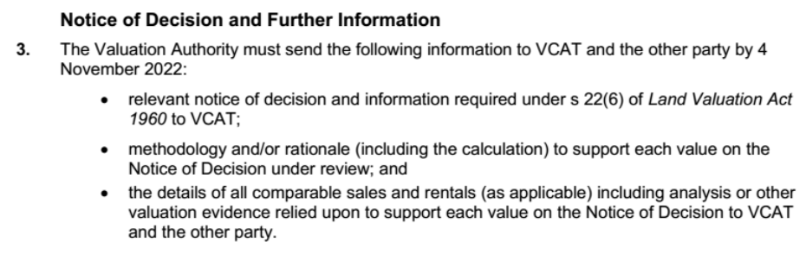

1. On 3 November 2022, the Valuation Authority filed the relevant notices and information pursuant to s 22(6) of the VL Act as referred to in the first bullet points of the above Order 3 of 7 October 2022.
2. On 1 December 2022, the Valuation Authority filed further information responding to the second and third dot points referred to in Order 3 of 7 October 2022 above. [31]
3. On 10 August 2023, the Tribunal made an Order, specifically requiring any further information that the Valuer-General considered in making his decision as follows:

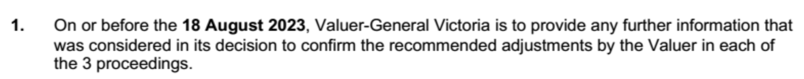

1. No further information was provided by the Valuer-General in response to the Tribunal Order 1 of 10 August 2023. In fact, the Valuation Authority confirmed at the hearing that no additional information was relied upon by the Valuer-General at the time it made its decision to issue the Notices of Confirmation.
2. The Tribunal therefore is informed by the information provided in the Tribunal Book and the information and notices prescribed in the VL Act.

Proceeding P10062/2022 – 55 to 61 Clements Avenue, Bundoora

1. We understand that the following information was provided to the Valuer-General:
   1. Objection and Cover Letter from the Applicant dated 20 September 2021;
   2. Prescribed Information from the valuer dated 10 March 2022;
   3. Objection Correspondence 10 March 2022 to 25 July 2022;
   4. Objection Submission from the Applicant dated 6 April 2022’
   5. Objection Submission from the Applicant dated 7 July 2022 and appendices; and
   6. Notice of Recommendation from the valuer dated 25 July 2022.

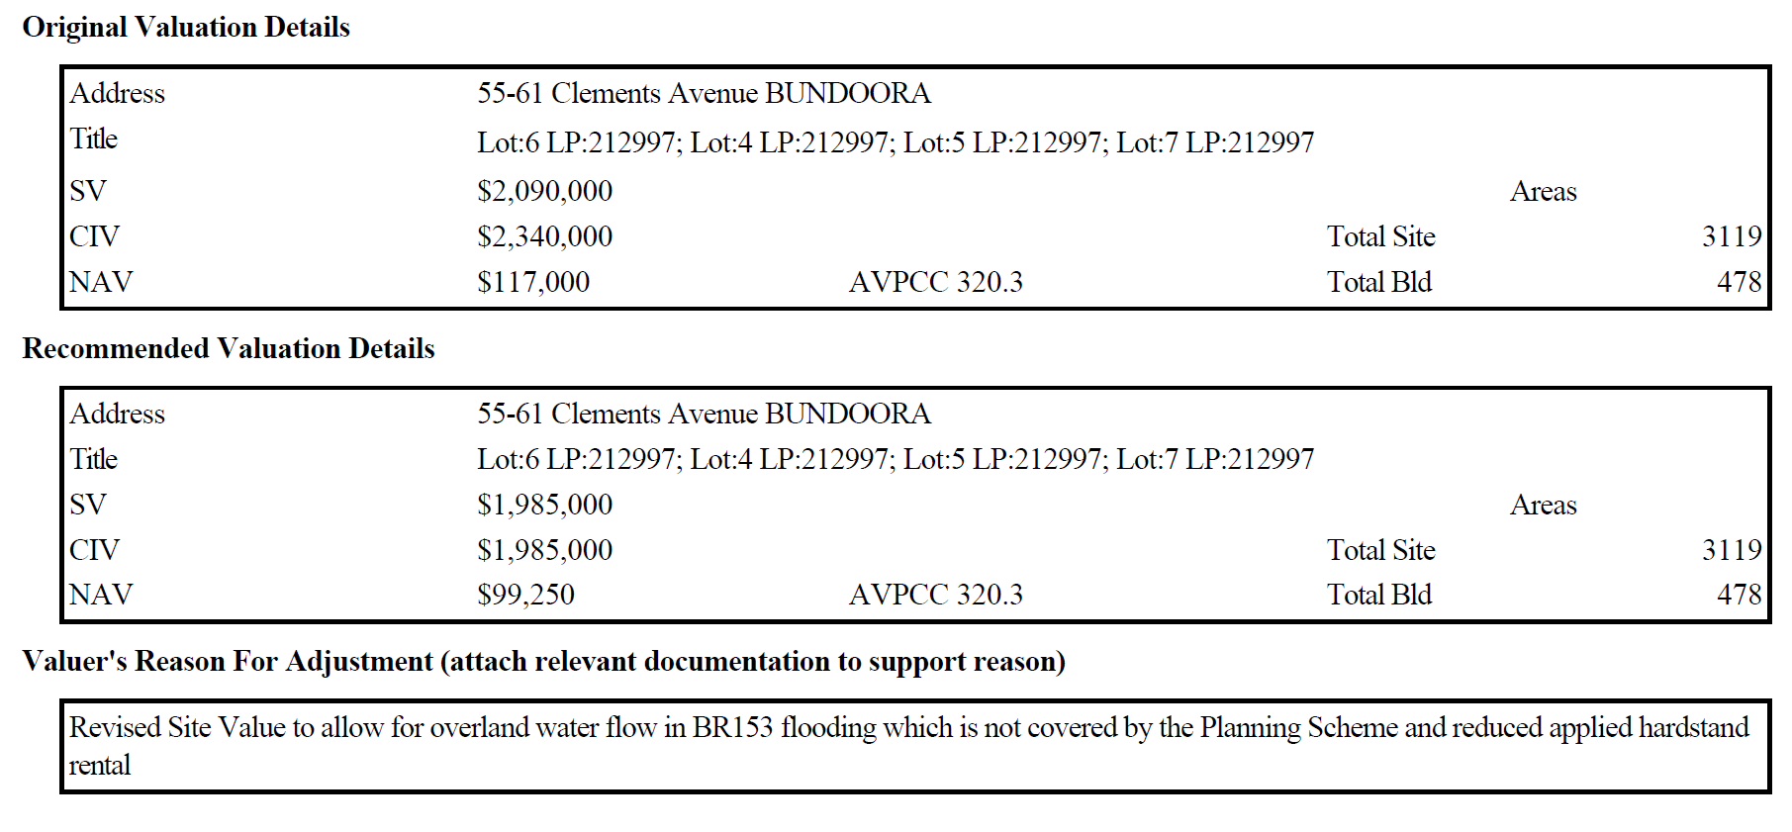

Proceeding P10063/2022 – 53 Clements Avenue, Bundoora

1. We understand that the following information was provided to the Valuer-General:
   1. Objection and Cover Letter from the Applicant dated 20 September 2021;
   2. Prescribed Information from the valuer dated 10 March 2022
   3. Objection Correspondence 10 March 2022 to 25 July 2022
   4. Objection Submission from the Applicant dated 6 April 2022;
   5. Objection Submission from the Applicant dated 7 July 2022 and appendices; and
   6. Notice of Recommendation from the valuer dated 25 July 2022.

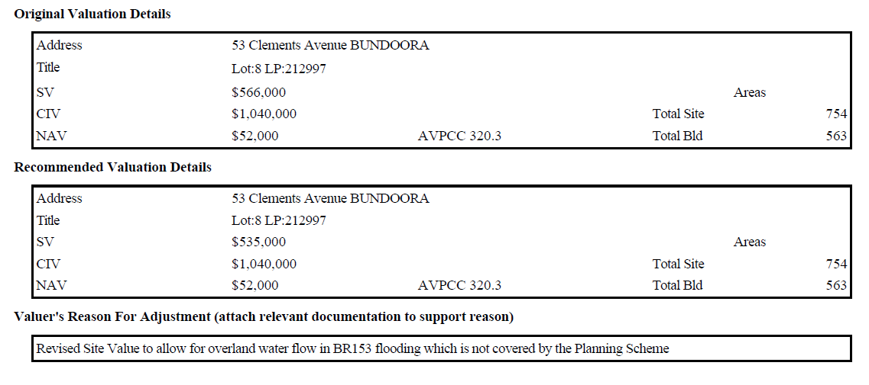

Proceeding P10064/2022 – 49 to 51 Clements Avenue, Bundoora

1. We understand that the following information was provided to the Valuer-General:
   1. Objections and Cover Letter from the Applicant dated 20 September 2021;
   2. Prescribed Information from the Valuer dated 10 March 2022;
   3. Objection Correspondence 10 March 2022 to 25 July 2022;
   4. Objection Submission from the Applicant dated 6 April 2022;
   5. Objection Submission from the Applicant dated 7 July 2022 and appendices; and
   6. Notice of Recommendations from the Valuer dated 25 July 2022.[32]

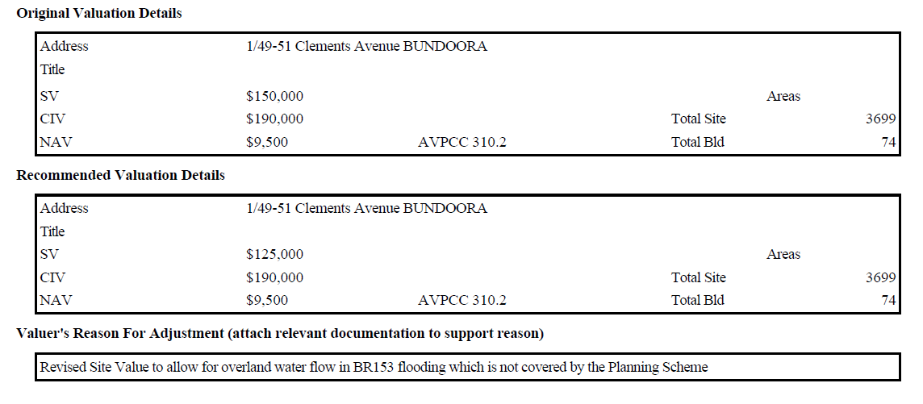

1. In consideration of:
   1. the objections lodged by the Applicant;
   2. the reasons for the objection and submissions;
   3. the correspondence between David Archer and the Applicant; and
   4. the valuer’s reasons on each Notice of Recommendation,

the Valuer-General formed the view to issue the Notices of Confirmation. The Notices of Confirmation were issued pursuant to s 21(4)(b) of the VL Act.

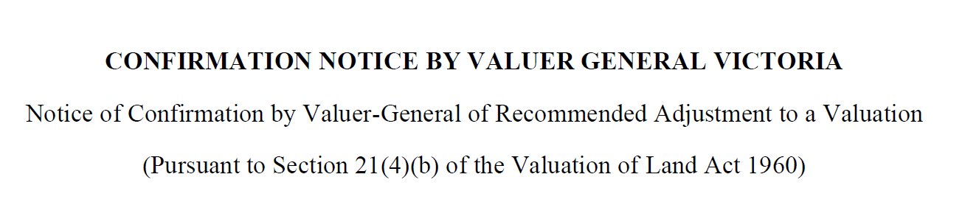

Tribunal Consideration

1. There was no report or document made available to the Tribunal which sets out any assessment undertaken by the Valuer-General upon receiving the Notices of Recommendation for consideration. So, we have reviewed and considered the information provided to the Valuer-General at the time to understand the bases of his decisions to issue the Notices of Confirmation for the SVs attributed to the subject properties in accordance with the Notices of Recommendation.
2. The details of the objections relating to the SV’s are primarily centred around what the objector referred to as the ‘SBO Overlay’. However, this is not a planning overlay affecting the subject land and is not part of the relevant planning scheme controls. The ‘SBO Overlay’ is described by the Applicant in its objection as follows:

The objection is based on the advice from Banyule City Council Development and Drainage Department that the above properties are subject to a Special Building Overlay for flooding. Tavrest Pty Ltd was first made aware of this overlay when advice was made on 9th of November 2020 by Luke Ross-Soden when an application for a building permit was made, a plan of which is provided in Figure 1. This overlay was not captured in the Planning Scheme and thus the valuers did not capture the impact of this overlay in their valuation assessments. The impact of this overlay is to restrict what can be constructed, either new or altered, on these sites to the following effects as outlined by the Banyule City Council Flood Level Consent Application.[33]

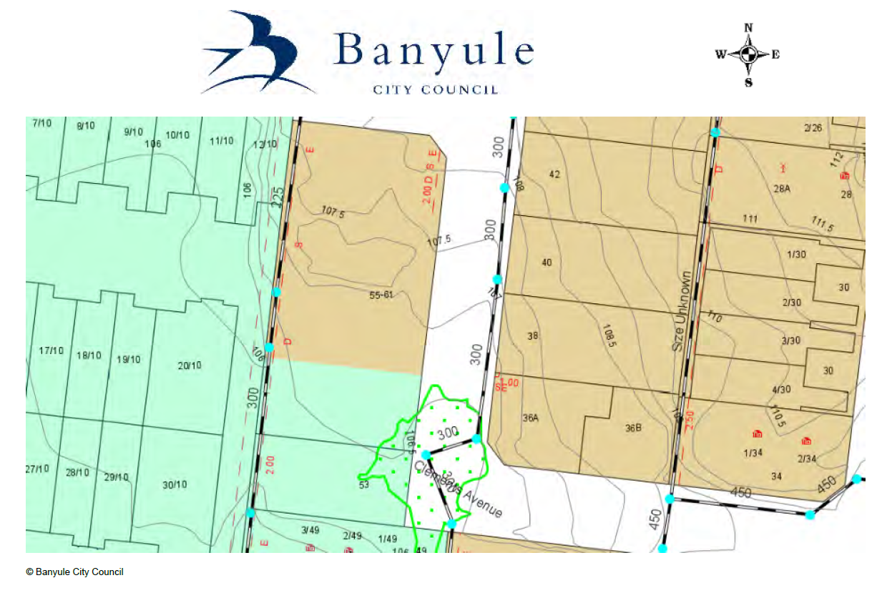

1. The correspondence regarding the objections between David Archer and the objector is detailed and extensive. David Archer stated in the Prescribed Information that the ‘SBO Overlay’ was not captured on the relevant planning scheme and therefore had not been included in the assessment of the SVs of the eight impacted properties, but he would investigate further with Council.[34]
2. On 16 June 2022, David Archer advised:

As I advised on 5th May, this area of overland flooding is not covered by the Planning Scheme and in my view has a relatively small impact of the overall area of each site, essentially impacting the front area of access, parking & setback of each site. On this basis, it is debateable if this overland flooding has any impact to these sites. I am prepared however to reduce the Site Value by 5% for this area of flooding without an official overlay.[35]

1. Subsequently, David Archer formed a view that for Lots 4-7 (55-61 Clements Avenue) and Lot 8 (53 Clements Avenue), a 5% adjustment should apply, and for Lot 9 (49-51 Clements Avenue) a 15% adjustment should apply.
2. Accordingly, Notices of Recommendation were issued with the Valuer’s reason for adjustment being an allowance for overland water flow referenced the council’s flood mapping as ‘BR153 flooding’ which is not covered by the relevant planning scheme.
3. We agree with David Archer that what the Applicant refers to as a ‘SBO Overlay’ is not an overlay control in the relevant planning scheme and therefore was incorrectly referred to as a ‘special building overlay’. According to Council, it is more appropriately referred to as a designation of land liable to flooding under the Building Regulations and it is bears reference ‘BR 153’(**BR153 Overland Flow**).[36][37]
4. In our view, David Archer thoroughly considered the Applicant’s reasons for the objection as is evident in the correspondence. He also formed a view that he considered that adjustments to the SVs were in fact justified, and made his recommendations to the Valuer-General accordingly.
5. Based on the information before the Valuer-General at the time, the Valuer-General decided to issue the Notices of Confirmation in accordance with the adjustments in the Notices of Recommendation. We have assumed that this is because the Valuer-General formed an opinion that the SV valuations were correct and he was then bound to confirm the recommended adjustments.
6. Now on review and in standing in the shoes of the Valuer-General, we must consider whether there was anything said at the hearing to enliven our discretion to disallow the recommended adjustments, in whole or in part, under s 21(4)(a) of the VL Act. This is predicated on a finding that the valuations in the Notices of Recommendation were, in our opinion, *not correct*.
7. If our discretion is enlivened because we find, in our opinion, that the recommended adjustments were not correct, we must nevertheless then consider whether we *should* exercise discretion under s 21(4)(a) of the VL Act to disallow the recommended adjustments. Otherwise, we must confirm the Notices of Confirmation because s 21(4)(b) of the VL Act states ‘in any other case’.

PROCEDURAL AND PRELIMINARY MATTERS AT THE HEARING

1. A number of practice day hearings were held prior to the hearing,[38] and a compulsory conference was held on 13 December 2022.
2. On 17 November 2022[39] and 30 November 2022, the Applicant and the Valuation Authority filed statements of contention respectively.
3. At the practice day hearing on 14 June 2023, the Tribunal made orders:
   1. adjourning the commencement of the hearing from 1 August 2023 to new hearing dates on 12, 13 and 14 September 2023; and
   2. providing for the filing of a Joint Key Issues Statement, any proposed questions of law, evidence and submissions.
4. On the 27 July 2023, the parties filed a Joint Key Issues Statement in accordance with the Tribunal’s Orders dated the 14 June 2023.
5. The parties outlined the following three key issues in dispute and each party’s contention on each issue: [40]

***Key Issue 1 – Is there a Larger Property that incorporates the Tavrest owned Land in:***

* ***55 - 61 Clements Avenue, Bundoora (P10062/2022);***
* ***53 Clements Avenue, Bundoora (P10063/2022);***
* ***49 - 51 Clements Avenue, Bundoora (P10064/2022);***
* ***36A - 46 Clements Avenue. Bundoora; and***
* ***63 Clements Avenue. Bundoora,***

*(****Tavrest Larger Property****)?*

**Applicant's Contention**

1. The occupancies, as valued at the prescribed date of 1 January 2021, that comprises these proceedings are:

* 55 - 61 Clements Avenue, Bundoora (P10062/2022)
* 53 Clements Avenue, Bundoora (P10063/2022)
* 49 - 51 Clements Avenue, Bundoora (which comprises 6 occupancies, being Units 1-6) (P10064/2022)

1. These occupancies are rateable lands that form part of a larger property, and the site value of each part is to be determined in accordance with s 13DC (6) (7) & s 2(3) of the Valuation of Land Act 1960 (Vic).
2. The larger property comprises the occupancies described in 1 together with the occupancies at:

* 36A - 46 Clements Avenue. Bundoora. and
* 63 Clements Avenue. Bundoora

**Valuation Authority's Contention**

The occupancies described in 3 above do not form a larger property.

The occupancies that comprise these three (3) proceedings have been correctly identified in the Notices of Recommendation and Confirmation Notices that the Applicant applies for review.

***Key Issue 2 - What is the value to be assigned to the portion of land subject to easements?***

**Applicant's Contention**

1. Nil value assigned to the easements as per Applicants Statement of Contention.

**Valuation Authority's Contention**

1. Value assigned to the easements as per Valuation Authorities Statement of Contention.

***Key Issue 3 - What are the appropriate comparative sales to be used in determining Site Value?***

**Applicant's Contention**

1. Properties to be used as per Applicants Statement of Contention.

**Valuation Authority's Contention**

1. Properties to be used as per Valuation Authorities Statement of Contention.
2. The Tribunal Orders made following the practice day hearing on 9 August 2023 including:

* an order for the Valuer-General to provide any further information that was considered in his decision to confirm the recommended adjustments of David Archer;
* David Archer to be available at the hearing to respond to any Tribunal questions; and
* the Tribunal remarked confirming that there was only one ground of review in each proceeding that the SV is too high, and there were no proposed questions of law.

1. The Applicant did not formally rely on any of the grounds set out in s 17(b) to 17(e) of the VL Act[41] relating to apportionment in the application for review form. However, the Valuation Authority did not challenge the Applicant’s contention that there was a ‘larger property’ and the apportionment not being correct in advance of the hearing and so we proceeded on this basis.
2. Submissions were provided by the Applicant on 15 August 2023 and the Valuation Authority on 23 August 2023.

APPLICANT’S SUBMISSIONS AT THE HEARING

Applicant’s landholdings in Clements Avenue

1. Clements Avenue was established in the mid-late 1980's as part of a 3-stage industrial subdivision of vacant land.
2. The Applicant purchased Stage 3 of this subdivision in its entirety at the completion of the town planning stage. The Applicant also completed the engineering & construction of the road and services before constructing the industrial tilt slab buildings. This occurred over a 20-year timeframe and remains an ongoing process with some lots remaining as car storage in support of adjoining occupancies.
3. The primary industry of Clements Avenue is the sale and servicing of motor vehicles in support of Northern Motor Group.[42]
4. The Applicant provided the following outline of its current land holdings in Clements Avenue:[43]

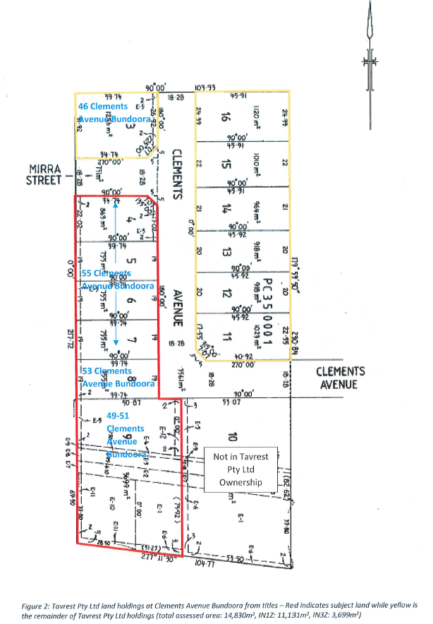

1. As the diagram shows, Clements Avenue is a cul-de-sac and the subject properties are shown in the red outline and are located to the south east. The properties shown in yellow outline are also owned by the Applicant.
2. The Applicant provided the following summary of property details for the subject properties:

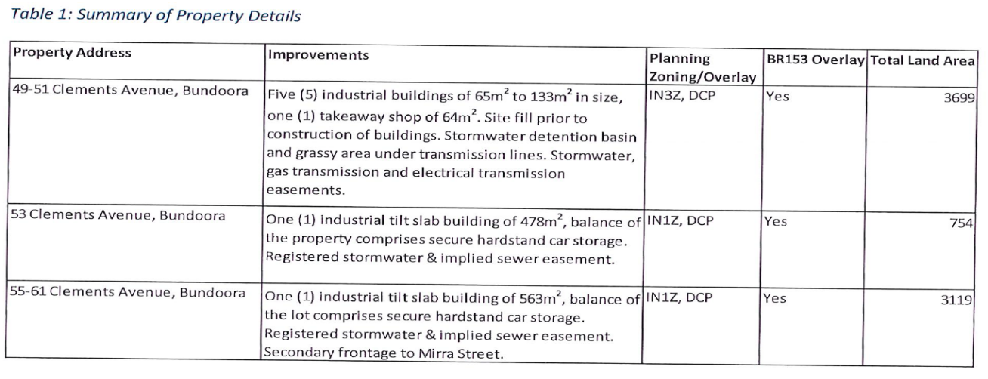

1. A table of occupancies at the relevant date was provided in response to a request made by the Tribunal at the Practice Day Hearing on 9 August 2023 and is outlined as follows:

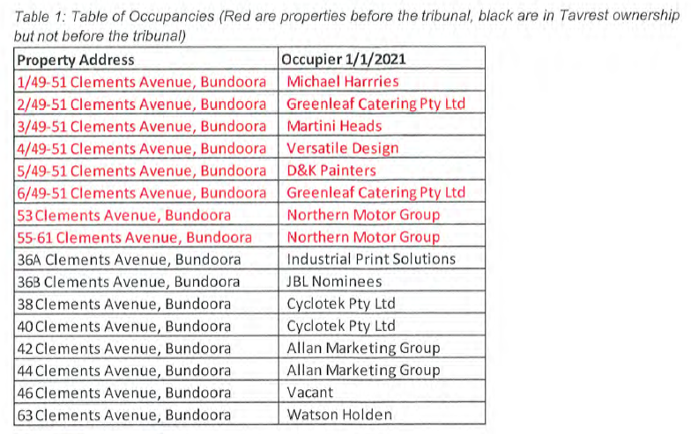

Disputed issues identified by the Applicant

1. The Applicant submitted there are three issues in dispute in these proceedings that are paraphrased from their submissions below:
   1. Facts in dispute:
      * + whether the SVs should be valued as one holding and apportioned to each occupiable area;
        + whether the appropriate methodology was used to value Lot 9; and
        + whether the appropriate comparability of sales evidence was completed.
   2. Differences in valuation approaches:
      * + no value should be applied to any part of the subject properties which are subject to an easement or implied easements;
        + a rate per m2 should be ascribed to the unencumbered land based on sales evidence; and
        + a rate per m2 should be applied based on sales evidence for properties that are in common ownership and where the hypothetical sales is a single transaction.
   3. Legal issues affecting the valuation of land:
      * + whether ss 2(1), 13DC(6) or 13DC(7) of the VL Act and s 3(1) of *Land Tax Act 2005* (**Land Tax Act**) are relevant in determining the SV of the subject properties because there are other properties owned by the Applicant in Clements Avenue;
        + whether the SV should be determined based on a single sale of the entire holding (including those properties owned by the Applicant which are not before VCAT) because, had improvements not been made and unencumbered by a lease, then the Applicant would be the occupier of the entire land holding (alternatively unoccupied) and thus the SV should be determined based on a single sale of the entire holding;[44]

* whether s 13DC(1) of the VL Act is relevant because a separate valuation should be computed for each separate occupancy, and an apportionment made of the SV for an entire holding to each separate occupancy in accordance with s 2(3) of the VL Act;[45]
* whether s 12(2)(d) of the *Subdivision Act 1988* (Vic) (**Subdivision Act**), s 3(1) Land Tax Act, ss 5B(1) & 5A(3)(f) of the VL Act are relevant in determining the valuation of an easement in:
  + defining the implied sewer easement affecting the land where a registered easement is not shown on the title plan;
  + determining the impact of a transmission easement and easement more generally; and
  + determining the actual and potential capacity of an easement to yield a monetary return.[46]

Genesis for the objections to the rates and valuation notices

1. In submissions, the Applicant stated that the initial reason for the Applicant’s objections to the rates and valuation notices was the discovery of an overland flow identified as ‘BR153’ [47]on Council’s flood mapping during building and approval processes (**BR153 Overland Flow**).[48]
2. The BR153 Overland Flow was not included in any planning overlay control in the Banyule Planning Scheme.
3. The Applicant submitted that the impact the BR153 Overland Flow had on SV was not in contention as a similar approach to valuing had been applied by both parties.

Applicant’s valuation methodology

1. The following key sales are included in Table 4: Summary of Sales Data in the Applicant’s methodology:[49]

* 2 Longview Court, Thomastown;
* 333 Settlement Road, Thomastown;
* 85 High Street, Thomastown; and
* 441 Grimshaw Street, Bundoora.

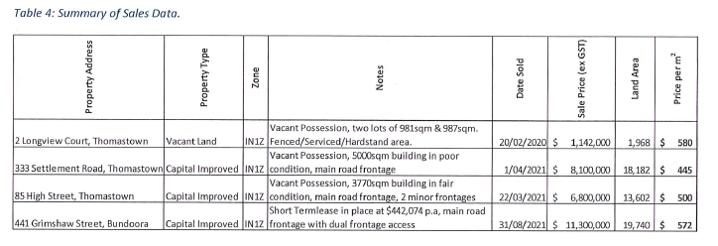

1. The Applicant’s methodology is outlined as follows:[50]
   * land area determined as per Table 3 and as shown in Figure 6 below. This is the area that is unencumbered by any easement or implied easement (last column):

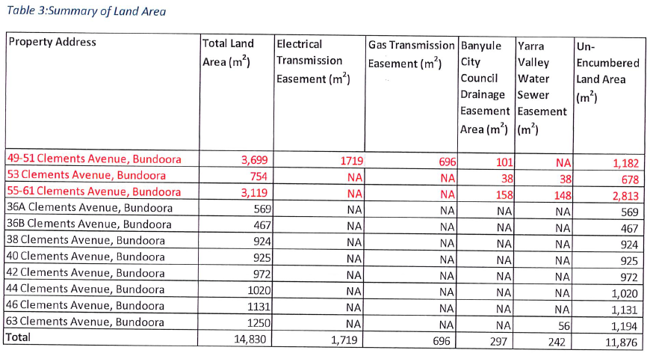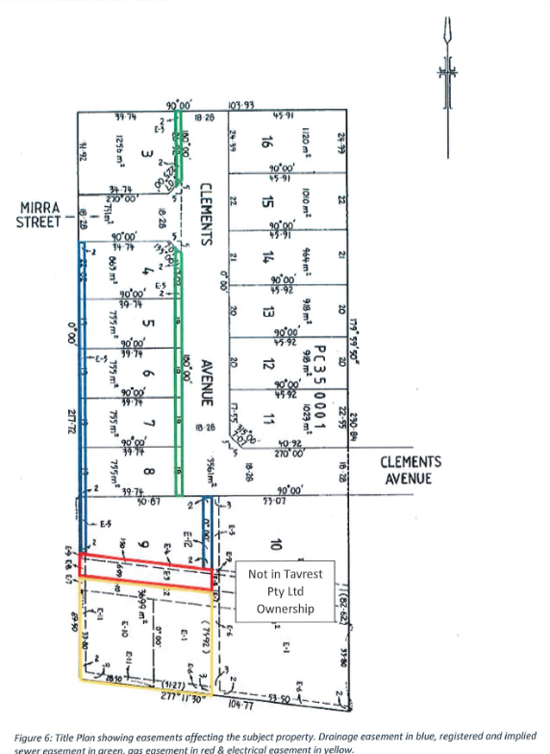

* + a m2 rate as determined by the sales evidence in Table 4 above. This was determined to be $550.00 per m2 on the basis it is assessed as one sale;
  + a 5% discount is applied to entire holding due to the BR153 Overland Flow;
  + SV of the entire holding is apportioned to each occupancy based on NAV proportion; and
  + value is rounded to the nearest $5000 interval as shown in Table 2 below:

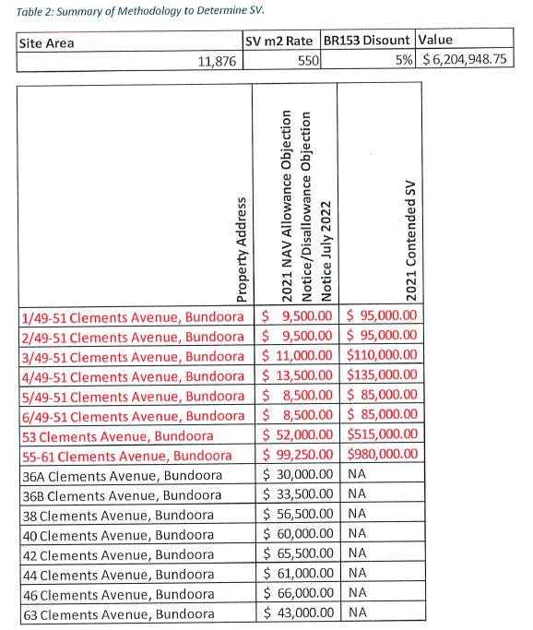

VALUER-GENERAL’S SUBMISSIONS AT THE HEARING

Valuation Reports dated 21 July 2023

1. At the hearing, the Valuer-General indicated that he relies on the Valuation Reports prepared by David Archer dated 21 July 2023 for each of the three proceedings. The Valuation Reports were prepared after the Notices of Confirmation which were issued on 17 August 2022.
2. As stated above, David Archer was the contract valuer who issued the Notices of Recommendation dated 25 July 2022 for the SVs, CIVs and NAVs with respect to the subject properties.
3. In these proceedings, the Applicant only seeks review of the SVs confirmed by the Valuer-General in the Notices of Confirmation dated 17 August 2022.
4. For each proceeding, the relevant Valuation Report prepared by David Archer details the recommended valuation, how the valuation was derived, and the sales evidence relied upon.
5. The following summary for each proceeding is extracted from David Archer’s Valuation Reports:

Proceeding P10062/2022

|  |  |
| --- | --- |
| **Property Address** | **55-61 Clements Avenue Bundoora** |
| Land Description, Titles and Land Area | Lot 4 LP212997 Volume 09914 Folio 446 Land Area – 863m2  Lot 5 LP212997 Volume 09914 Folio 447 Land Area – 755m2  Lot 6 LP212997 Volume 09914 Folio 448 Land Area – 755m2  Lot 7 LP212997 Volume 09914 Folio 449 Land Area – 755m2  Aggregate Area 3128 m2 |
| Zoning and Overlays | *Banyule Planning Scheme*  *Industrial 1 Zone (IN1Z)*  *Development Contribution Plan Overlay (DCPO1)* |
| Land and Buildings | *The Subject Land is also impacted by an Overland Flow, which is not contained in the planning scheme. The map below (provided by the Applicant) and understood to be part of Banyule Council’s mapping system identifies the Subject Land outlined in yellow. The green outlined area in the bottom right-hand corner (southeast corner) is the area subject to overland flow. The Valuation Authority estimates that is comprises 32 square metres which is approximately 1% of the total aggregate land area.*  *This is based on the Overland Flow having a triangular shaped area impacting approximately the southernmost 8.0m of the eastern boundary and an 8.0m impact of the eastern end of the southern boundary of Lot 7 LP212997.*  *Improvements contained the land comprise of a 2009 built concrete tilt slab warehouse with an area of approximately 478 square metres. Hardstand area of approximately 2,300 square metres. An internal inspection of the improvements was denied by the applicant. The warehouse is not impacted by the Overland Flow due to the setback.* |
| Valuation Method | *Direct Comparison was the valuation method used in the assessment of site value for the Subject Land. Analysis of industrial land sales and sales of improved industrial properties was undertaken to arrive at an appropriate rate per square metre of land for the Subject Land. As part of the objection review process the valuations were amended to reflect that the Subject Land is affected in part by the existence of the overland water flow which has been identified by Banyule City Council however does not form part of the Planning Scheme.*  *A rate of $670 per square metre was multiplied by the land area (3,119m2) to arrive at an initial value of $2,089,730. A deductive adjustment of -5% (-$104,486) to reflect the potential impact of the area subject to the overland water flow was applied to arrive at a recommended Site Value of $1,985,000 (overall $636 per square metre).*  *The initial rate of $670 is based on a larger aggregate area of 3,119 square metres. As outlined earlier the Subject Land comprises 4 separately titled industrial allotments that alternatively could be valued separately and the value aggregated to arrive at a total site value. This would have the effect of increasing the land rate to $750 per square metre for each lot. Current level of demand for industrial land would not require any reduction for bulk holding.*  *The overland water flow impacts only the southernmost portion of Lot 7. Therefore, the impacted area of Lot 7 of approximately 32 square metres equates to 4.23% of the site.* |
| Valuation Calculation |  |

Proceeding P10063/2022

|  |  |
| --- | --- |
| Property Address | 53 Clements Avenue Bundoora |
| Land Description, Titles and Land Area | Lot 8 LP212997 Volume 09914 Folio 450 Land Area – 755m2 |
| Zoning and Overlays | *Banyule Planning Scheme*  *Industrial 1 Zone (IN1Z)*  *Development Contribution Plan Overlay (DCPO1)* |
| Land and Buildings | *The Subject Land is also impacted by an Overland Flow, which is not contained in the planning scheme. The map below (provided by the*  *Applicant) and understood to be part of Banyule Councils mapping system identifies the subject land outlined in yellow. The green outlined area in the bottom right-hand corner (northeast corner) is the area subject to overland flow.*  *We estimated by electronic measurement the encumbered area comprises 75 square metres which is approximately 10% of the total land area.*  *Improvements contained the land comprise of a 2009 built concrete tilt*  *slab warehouse with an area of approximately 418 m2 with ground floor*  *office of 60 m2 and Mezzanine of 85 m2.* |
| Valuation Method | *Direct Comparison was the valuation method used in the assessment of site value for the Subject Land. Analysis of industrial land sales and sales of improved industrial properties was undertaken to arrive at an appropriate rate per square metre of land for the Subject Land. As*  *part of the objection review process the valuations were amended to reflect that the subject land is affecting in part of the existence of the overland water flow which has been identified by Banyule City Council however does not form part of the Planning Scheme.*  *A rate of $750 per square metre was multiplied by the land area (754 m2) to arrive at an initial value of $565,500. A deductive adjustment of -5% (-$28,300) to reflect the potential impact of the area subject to the overland water flow was applied to arrive at a recommended Site*  *Value of $535,000 (overall $709.55 per square metre).* |
| Valuation Calculation |  |

Proceeding P10064/2022

|  |  |
| --- | --- |
| Property Address | 49-51 Clements Avenue Bundoora |
| Land Description, Titles and Land Area | Lot 9 LP212997 Volume 09914 Folio 451 Land Area – 3,699m2 |
| Zoning and Overlays | *Banyule Planning Scheme*  *Industrial 3 Zone (IN3Z)*  *Development Contribution Plan Overlay (DCPO1)* |
| Land and Buildings | *The land is largely encumbered by a number of easements for electricity*  *supply, gas supply and drainage. There area encumbered by easements is estimated to be 2,419 square metres (65% of the land). The remaining*  *unencumbered land (located to the northern section of the site) has an*  *area of approximately 1,280 square metres. As addended in the image*  *below.*  *The Subject Land is also impacted by an Overland Flow, which is not contained in the planning scheme. The map below (provided by the Applicant) and understood to be part of Banyule Councils mapping system identifies the subject land outlined in yellow. The green outlined area which stretched from the frontage (driveway) and extends to the back within the easement area. We estimated that is comprises approximately 750 square metres which is approximately 20% of the total land area of 3,699 square metres based on our electronic measurement.*  *However approximately 610 square metres impacted by the Overland Flow is located within the easements and approximately 140 square metres impacted by the Overland Flow is located in the unencumbered area. The 140 square metres in the unencumbered portion of the site represents 11% of the unencumbered area.*  *Improvements comprise six unsubdivided occupancies constructed in 1990. Five are used as factories and one as a café with individual floor areas of between 64 and 133 square metres. An aggregate total Gross Floor area of 491 square metres. An internal inspection of the improvements was denied by the applicant. The warehouse is not impacted by the Overland Flow due to the setback.* |
| Valuation Method | *Direct Comparison was the valuation method used in the assessment of site value for the Subject Land. Analysis of industrial land sales and sales of improved industrial properties was undertaken to arrive at an appropriate rate per square metre of land for the Subject Land. As part of the objection review process the valuations were amended to reflect that the subject land is affecting in part of the existence of the overland water flow which has been identified by Banyule City Council however does not form part of the Planning Scheme.*  *A rate of $270 per square metre was multiplied by the land area (3,699m2) to arrive at an initial value of $998,730. This initial rate of $270 per square metre reflects the significant portion (approximately 54%) that is impacted by easements for High Tension Powerlines that traverse the land. A deductive adjustment of -15% (-$149,809) to reflect the potential impact of the area subject to the overland water flow was applied to arrive at a recommended Site Value of $845,000 (overall $228 per square metre).*  *This overall rate can be separated in into two sections:*  *The encumbered rate of $56 reflects an 10% value of the unencumbered rate (an adjustment of -90%).*  *This aggregate site value has then been apportioned by Estimated annual value across the 6 occupancies in accordance with the Valuation of Land Act 1960. This is outlined in the table below.* |
| Valuation Calculation |  |

Sales Evidence

1. David Archer’s relied upon the following 6 sales in each of his Valuation Reports.

|  |  |
| --- | --- |
| Sales Evidence | * Sale 1 – 32 Simms Road, Greensborough * Sale 2 – 313 Edwardes Street, Reservoir * Sale 3 – 147 Scanlon Drive, Epping * Sale 4 – 159 Para Road, Greensborough * Sale 5 – 14 Constance Court, Epping * Sale 6 – 237 Holt Parade, Thomastown |

1. The details of the sales evidence in David Archer’s Valuation Reports are set out below. David Archer also provided specific comments relating the sales to each proceeding in his respective Valuation Reports:

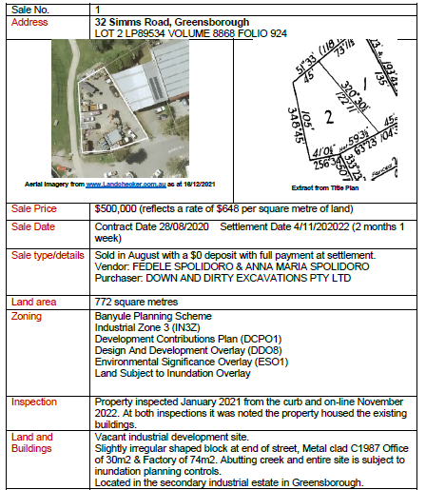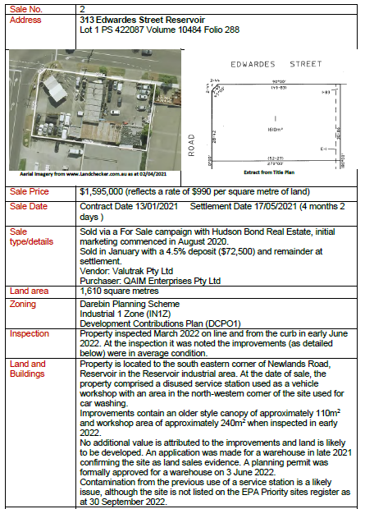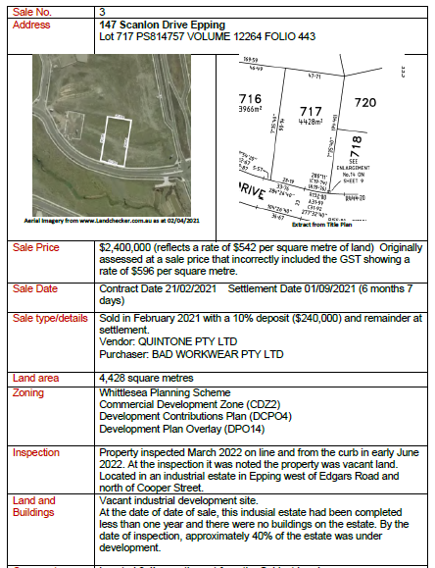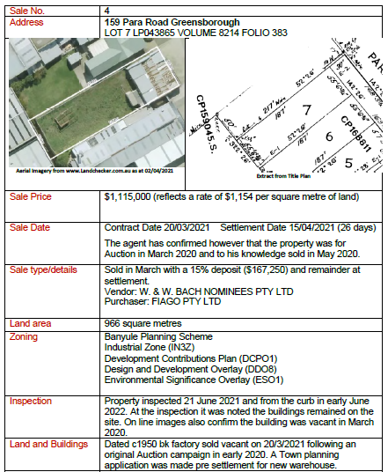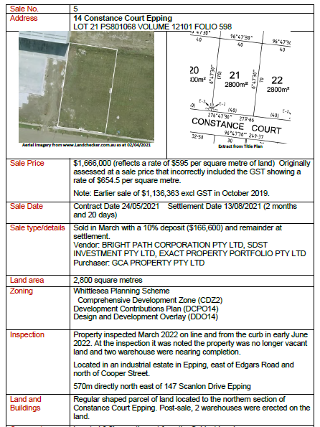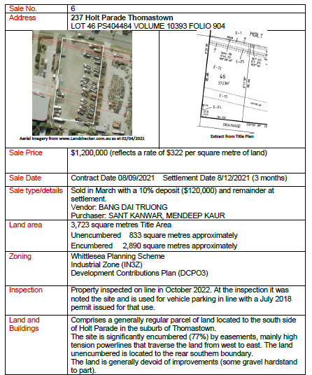

REPLY SUBMISSIONS

1. The Applicant made the following submissions about the sales relied upon by David Archer:

* 313 Edwardes Road, Reservoir is not comparable because:
  + the site sold after the valuation date in 2021;
  + the site has capital improvement and a significant dual major road frontage;
  + the site is presently tenanted for used car sales/car wash/mechanic & previously a fuel service station;
  + the site benefits from planning permit (D/808/2014) for motor vehicle sales and thus, the highest and best use of any redevelopment is for commercial purposes not industrial purposes; and
* the properties below are not comparable because they were sold in 2021 (after the valuation date) and are zoned Commercial 1 Zone or Commercial 2 Zone, and not Industrial 1 Zone or Industrial 3 Zone. Additionally, Epping forms part of a state significant industrial precinct as outlined in Clause 11.01-1R of the Banyule Planning Scheme;
* the properties which the Applicant submits are not comparable are:
* 14 Constance Court, Epping;
* 147 Scanlon Drive, Epping; and
* 100 Jersey Drive, Epping.[51]

1. Instead, the Applicant indicated that it relies on sales in the table below.
2. The Valuation Authority indicated that it relies on the analysis of the Applicant’s sales by David Archer contained in his Valuation Reports.
3. For convenience, David Archer’s comments have been extracted from David Archer’s Valuation Reports and included by the Tribunal in the last column:

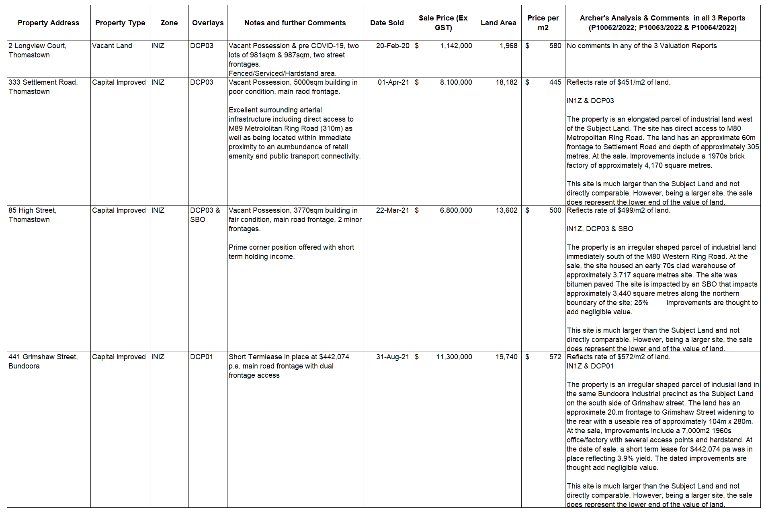

FURTHER INFORMATION PROVIDED DURING THE HEARING

1. Following the accompanied site inspection by the Tribunal and the parties, the Valuation Authority filed a document, with the leave of the Tribunal, containing amended calculations of SV prepared by David Archer dated 14 September 2023 (**Amended Calculations Document**).
2. Effectively, in the Amended Calculations Document, the SVs applicable to two of the proceedings (i.e. P10062/2022 and P10063/2022) were combined, and the number of assessments in proceeding P10064/2022 were reduced from 6 assessments to 5 assessments. Further details are set out below.

Proceedings P10062/2022 and P10063/2022

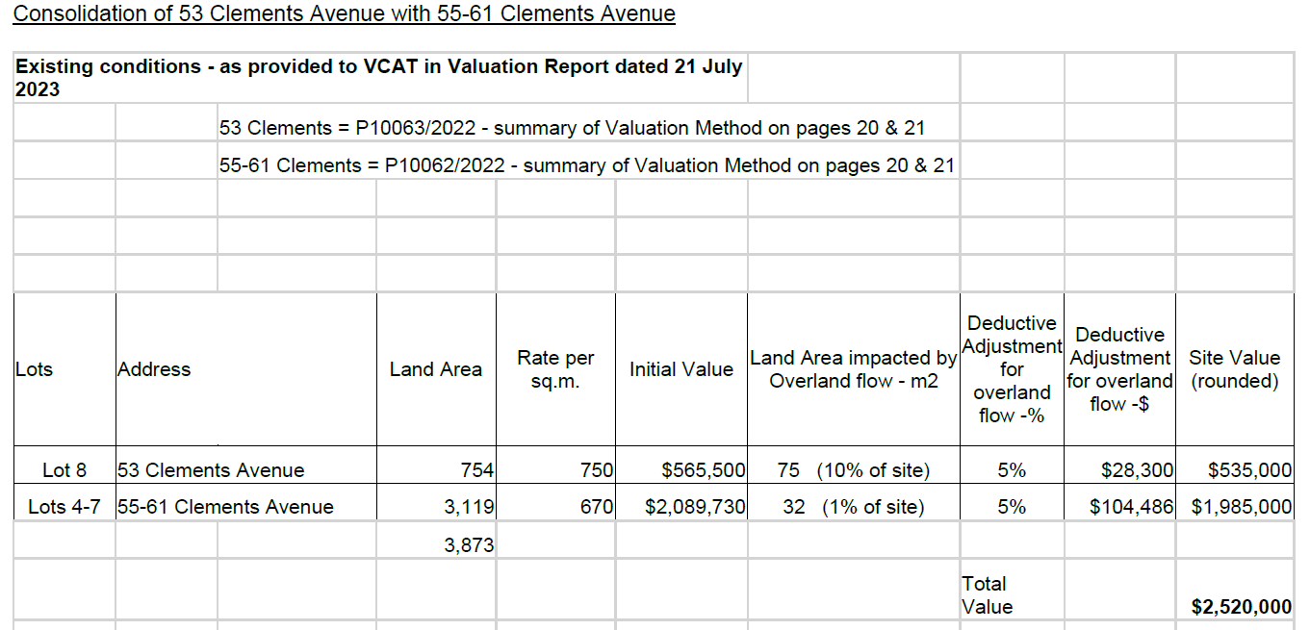

Consolidated Occupancies

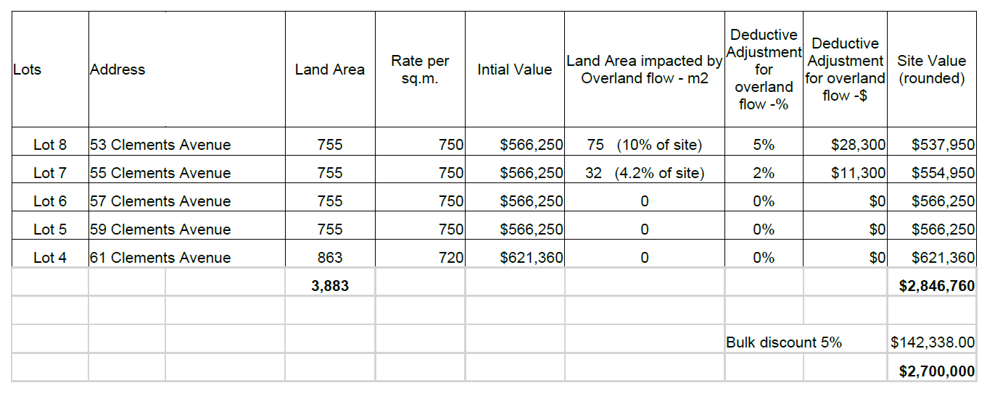

1. The Amended Calculations Document contains six changes made to the SVs stated in his Valuation Reports for the subject properties comprised in Lots 4, 5, 6 & 7, and Lot 8 respectively:
   1. the combined land area for Lots 4 to 8 had a minor change from 3,873m2 to 3,883m2;
   2. Lot 8 was assessed with Lots 4 to 7 as a single occupancy. As a consequence, the parcel (Lot 8) was included with Lots 4, 5, 6 and 7, now reflecting Lots 4 to 8;
   3. the overall land rate of $670/m2 that was applied to effectively 1 parcel (Lots 4, 5, 6 & 7 combined) was revised. David Archer acknowledged that there were always 4 parcels, however, he had previously valued one large parcel of 3,128m2;
   4. in valuing the 4 parcels individually, the rate/m2 increased to $750/m2 to those parcels with an area of 755/m2 (Lots 5, 6, 7 and 8) and a lower rate of $720/m2 applied to Lot 4 with a slightly larger land area of 863m2 but with a premium for a corner location;
   5. the deductive adjustment for BR153 Overland Flow reduced from 5% across Lots 4 to 7, to a 2% reduction applied to Lot 7 only; and
   6. a 5% bulk discount has been applied to the 5 parcels.

Proceeding P10064/2022

1. The changes to the SV applicable to the subject property in Lot 9 (proceeding P10064/2022) in the Amended Calculations Document are detailed in the two tables below:

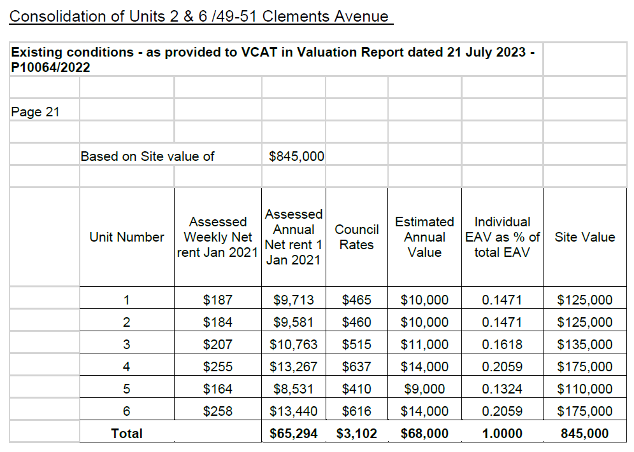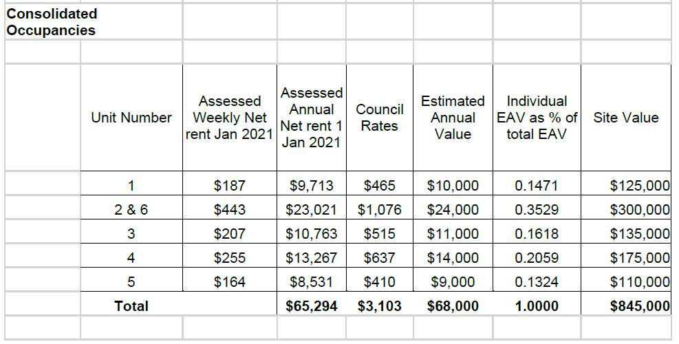

1. The changes reflect the same tenant occupying unit 2 and unit 6 and therefore those assessments have been combined to a single occupancy but the overall combined SV for Lot 9 did not change.

FURTHER INFORMATION PROVIDED AFTER THE HEARING

### Tribunal Order dated 14 September 2023

1. On the third day of the hearing, the parties agreed to the Tribunal making orders requesting further information from the Valuation Authority after the conclusion of the hearing.
2. The further information requested related to land which the Applicant contended forms part of a ‘larger property’ pursuant to s2(3) VL Act.
3. The Tribunal Orders required the Valuation Authority to provide SV information and the Estimate Annual Value (**EAV**) of each of the assessments as at the relevant date of 1 January 2021 which is not currently on the Tribunal case file for the land known as Lots 3 – 9 (inclusive) and 11 – 16 (inclusive) on LP 212997. Only the EAV calculation for Lot 9 LP 212997 had been filed, as it was the only parcel that had been previously apportioned in accordance with s 2(3) of the VL Act. The relevant orders are extracted below:

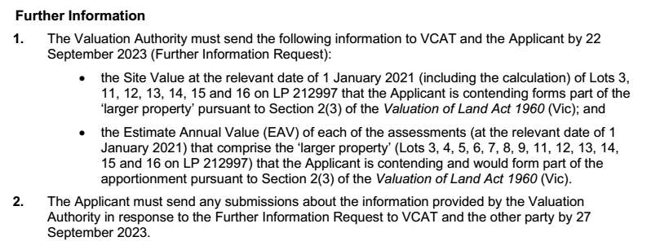

### Information provided by the Valuation Authority

1. In response to Order 1, the Valuation Authority provided the following information on 22 September 2023:

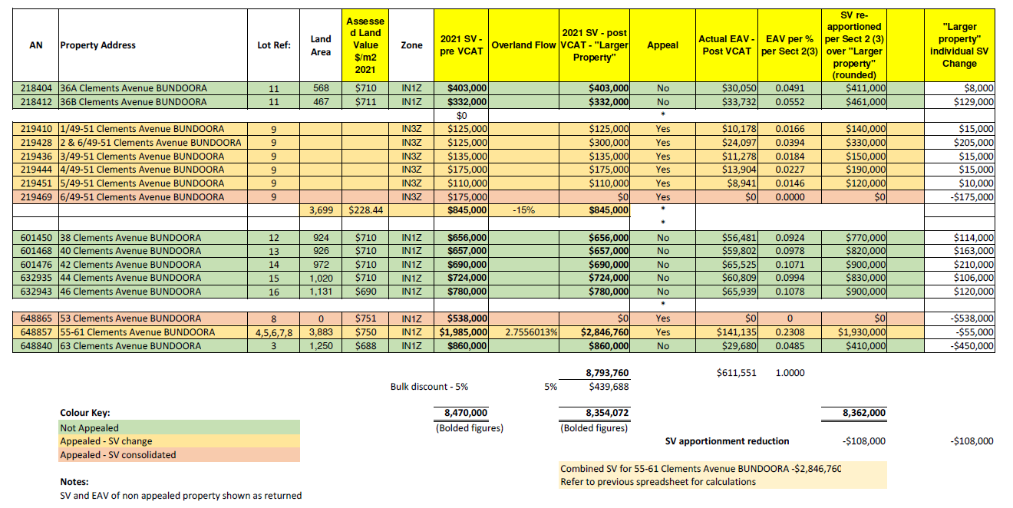

### Applicant’s submissions in response to post hearing further information

1. The Applicant responded to Order 2 of 14 September 2023 on 26 September 2023.
2. In response to the first dot point for Order 2, the Applicant provided a number of submissions including the following:

the Site Value at the relevant date of 1 January 2021 (including the calculation) of Lots 3, 11, 12, 13, 14, 15 and 16 on LP 212997 that the Applicant is contending forms part of the 'larger property' pursuant to Section 2(3) of the Valuation of Land Act 1960 (Vic)*; including the following:*

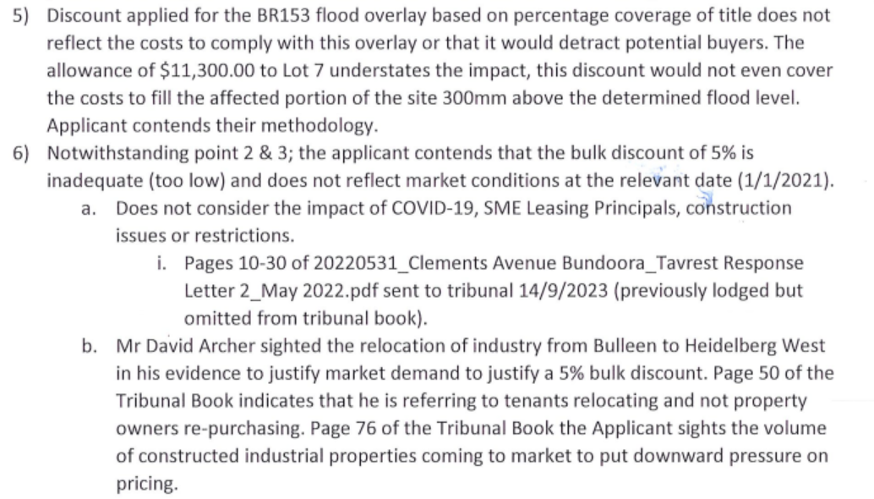

1. The Applicant made the following further submissions in response to the second part of Order 1 dated 14 September 2023.

the Estimate Annual Value (EAV) of each of the assessments (at the relevant date of 1 January 2021) that comprise the 'larger property’ (Lots 3, 4, 5, 6, 7, 8, 9, 11, 12, 13, 14 15 and 16 on LP 212997) that the Applicant is contending and would form part of the apportionment pursuant to Section 2(3) of the Valuation of Land Act 1960 (Vic):

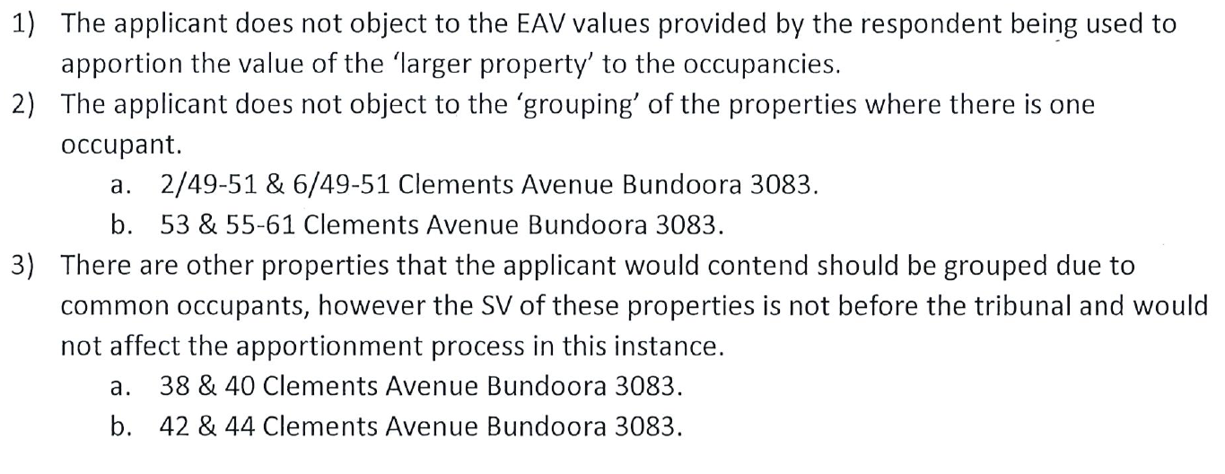

### Further information provided by the Applicant without leave after proceeding concluded

1. On 13 June 2024, the Applicant filed a further document addressed to the Valuer-General regarding material disclosure in relation to P10062/2022, P10063/2022 and P10064/2022. Subsequent to Council issuing Planning Permit P832/2022 for additional hardstand under the electrical transmission lines and consent to build on flood prone land the Applicant engaged an engineering firm to undertake flood modelling provided in the further document.
2. This information has been provided without leave of the Tribunal after the proceeding concluded.
3. In any event, it is not clear as to whether the information provided relates to the relevant date and what inference the Applicant seeks to be drawn from the information. David Archer has already adjusted the respective valuations which he has considered is warranted for the BR153 Overland Flow impacted land. That is, David Archer assessed the main impact of the BR153 Overland Flow to be at Lot 9 so a 15% allowance was applied. He also assessed a lesser impact to Lot 8 and Lot 7 with allowances of 5% and 2% applied respectively.
4. Thus, we do not consider it is appropriate to receive the information in fairness to the Valuation Authority. In any event, we do not consider the further documentation is relevant, and even if it was, it does not persuade us to increase the allowances applied by David Archer in his assessment.

CONSIDERATION OF KEY ISSUES RAISED AT THE HEARING

Key Issue 1 – is there a ‘larger property’ for the purpose of s 2(3) of the VL Act?

Applicant submissions

1. The Applicant contends that the occupancies are rateable land that form part of a larger property, and the SV of each part is to be determined in accordance with ss 13DC (6) and (7), and s 2(3) of the VL Act.
2. The Applicant submits that it manages all the land that it owns in Clements Avenue as a single landholding which justifies the existence of a ‘larger property’. This is evidenced by conduct and evidence including[52]

* the Applicant purchased the land as one title, developed the sub-division and progressively constructed the buildings which form part of the subject land at Clements Avenue. The exception is Lot 10 which was designed by the Applicant and sold to Nissan Australia with the intention of providing an 'anchor' business to Clements Avenue;
* the Applicant manages the occupancies to allow current tenants to expand/improve their respective businesses, and for new tenants not to adversely affect existing occupancies;
* the Applicant will intervene with on-street parking disputes between tenants without need for Council’s involvement;
* the Applicant has provided stormwater detention at Lot 9 which services the remainder of the development as part of the original plan of subdivision;
* on 25 February 2022, the Council indicated in its informal pre-application advice (reference Application P45/2022) that there may be the option to discontinue Mirra Street and allow the Applicant to buy-back the roadway and this may be subject to no objections from the owners of 9 or 10 Mirra Court Bundoora and Council’s Traffic Engineering Department;
* the Applicant grants leases over land which are not in line with title boundaries or occupancies to tenants to improve operation of their business. For example, there is a nominal lease of a driveway at 49-51 Clements Avenue to the Northern Motor Group;
* the existing title boundaries may not represent the highest and best use of the land, and subject to planning approval, it may be preferable to subdivide or amalgamate titles in the future;
* the construction of buildings is via a common party wall and there is also an example of services being shared across a title boundary;
* there has been alterations to car-parking of existing buildings to allow for tenants to work across multiple buildings as part of a single occupancy. This has also included across buildings not in the Applicant’s ownership;
* the Applicant may undertake works at the request of tenants as the needs of their businesses change;
* the Applicant obtains landlord building insurance on behalf of tenants and manages/addresses identified insurance risks. Insurance is a single policy recoverable proportionately to applicable tenants. This also includes the following risk management:
  + thermographic scanning of electrical circuit boards;
  + annual testing of on-street water mains on Clements Avenue / Mirra Street;
  + implementation of ‘Plot Works and Contractor Management Policy’ to tenants; and
  + risk engineering assessment;
* the Applicant engages and manages essential safety measures on behalf of tenants;
* the Applicant engages and manages gardeners for the maintenance of the nature strip and gardens for its tenancies;
* the Applicant administers the leases directly with tenants without the use of a rental agency;
* the Applicant’s financing arrangements are for one loan and the entire of portfolio of properties owned in Clements Avenue is registered as the security; and
* the Applicant is actively involved in the ongoing management of the properties that it owns in Clements Avenue in order to create an environment conducive to permitted uses under the planning scheme. This can include obtaining planning permits on behalf of tenants.

1. The Applicant also relies on a brochure entitled *Bundoora Enterprise’*(undated) which outlines their concept plan for managing occupancies in Clements Avenue as follows:

* The Bundoora Enterprise is a quality development providing a mix of industrial buildings to accommodate small, medium and large operators who wish to create a highly professional image. The Bundoora Enterprise has been designed specifically for light/service industrial use.
* Colourful and attractive masterplan landscaping is a major feature of Bundoora Enterprise. We feel that a proper working environment is of upmost importance in the success of your business. The Estate has been fully planned and construction has been programmed in progressive stages.
* A street-scape concept has been developed incorporating landscaping and building colour scheme, to ensure architectural homogeneity to guarantee that your investment is secure and has the ability to grow. At Bundoora Enterprise you will always know what is going to be next to you.
* We provide a choice of self-contained sites on their own land and with their own titles. Individual architectural effects have been incorporated in each building facade, so you will be identifiable by your building, not just by a number.
* The development has been planned with cooperation from the Shire of Diamond Valley. Ample sealed car parking spaces have been provided with specific attention to disabled parking and landscaping to ensure easy access and protection from direct sun light and excessive heat.
* Easy access has been a prime concern in designing the Master Plan of Bundoora Enterprise with particular emphasis given to traffic circulation and loading and unloading of goods.

Valuation Authority’s submissions

1. The Valuation Authority indicated that it now relies on the Amended Valuation Document prepared by David Archer filed on 14 September 2023.
2. David Archer’s updated advice in that further information was to effectively reduce the 8 assessments to 6 assessments. Only one parcel (Lot 9) should be valued in accordance with s 2(3) of the VL Act as a ‘larger property’ containing with 5 occupancies. The other assessment to comprise 5 parcels and 1 occupancy.
3. In response to questions from the Tribunal, David Archer indicated that that whilst he agreed with Justice Emerton’s reasoning in the decision of *Port of Melbourne Corp v Melbourne City Council & Valuer General Victoria* [2015] VSC 714 (***Port of Melbourne***) (refer below), he considered that ss 13DC(1) and 13DC(7A) *should* be the starting point for a rating valuation (contrary to the conclusion of Justice Emerton).
4. David Archer also agreed with the steps and sequencing set out in the decision of *PTDA* *& Civic Nexus Pty Ltd v Commissioner of State Revenue (Review and Regulation)* [2016] VCAT 1457 (***PTDA****)* in applying s 2(3) of the VL Act (refer below).

TRIBUNAL CONSIDERATION

*Caselaw*

1. The key authorities cited at the hearing in relation to whether this is a larger property for the purpose of apportionment across occupancies were:

* *Port of Melbourne Corp v Melbourne City Council & Valuer General Victoria* [2015] VSC 714 (***Port of Melbourne***); and
* *PTDA*[53].

1. In the *Port of Melbourne* decision, Justice Emerton stated:[54]

**The parties agree that s 13DC(1) requires net annual value, capital improved value and, if required, site value, to be ‘computed’ for each occupancy on rateable land and that, where s 2(3) applies, it tells the valuer how to value the occupancy. Whether a separate occupancy forms part of a larger property is a question of fact and depends on all the circumstances of the particular case.**

1. Her Honour’s conclusion are made in the following paragraphs:

* at paragraph 103:

I am not persuaded that the 1991 amending Act and the requirement in s 13DC(1) for ‘each separate occupancy’ to be computed at the specified values sheds light on when s 2(3) is to be applied. On its ordinary and grammatical meaning, s 13DC(1) requires a council to ‘compute’ each separate occupancy at its net annual value, its capital improved value and, if required, its site value. While computations must be made in respect of each occupancy on rateable land, the word ‘compute’ is not limited to the act of carrying out the valuation of the occupancy as a stand-alone parcel. Even where it is impossible to do so (whether because of the ‘inseparable interdependency’ of occupancies on the land or otherwise) and the methodology in s 2(3) must be used, s 13DC(1) requires the computation of each separate occupancy at the specified values. The task mandated by s 13DC(1) applies whether site value is to be determined by way of an apportionment under s 2(3) or by way of the valuation of each occupancy on a stand-alone basis.

* at paragraph 104:

I therefore reject the proposition that, by reason of the language in s 13DC(1), occupancy is the ‘starting point’ or ‘foundation stone’ for a ratings valuation. Section 13DC(1) tells a council that it must produce at least two, and possibly three, values for each occupancy on rateable land, but it does not say how this is to be done. The method to be used depends on other provisions in the Act, including s 2(3).

* at paragraph 109:

The defendants also point to s 13DC(7A) as limiting the operation of s 2(3). Section 13DC(7A) provides that if a portion of a parcel of land on which a building is erected is occupied separately from other land in the parcel, that portion must be regarded as forming a separate rateable property. The defendants argue that because a portion of a parcel of land on which a building is erected that is capable of being separately occupied is taken to form a ‘separate rateable property’ it cannot, therefore, form part of a ‘larger property’ for the purposes of s 2(3).

* at paragraph 110:

Again, I disagree. There is no reason why a ‘separate rateable property’ cannot form part of a ‘larger property’. The term ‘separate rateable property’ in s 13DC(7A) appears to be a remnant of the terminology used in the predecessor provisions to ss 13DC(6) – (9) enacted in 1969 (which are discussed below). As such, it is not inconsistent with the larger property concept, the antecedents of which have existed since 1914.

* at paragraph 111:

I do not consider that s 13DC(7A) supports the construction of s 2(3) advanced by the defendants.

* at paragraph 123:

I reject the submission that the ‘solution’ provided by s 2(3) is only to be invoked when no other course (or no other ‘fair’ or ‘accurate’ course) is open. The ordinary and grammatical meaning of s 2(3) calls for a factual inquiry into whether the occupancies form part of a larger property. It does not require, as matter of legal principle, stand-alone valuations of occupancies whenever possible. In my opinion, the authorities relied upon by the defendants do not provide support for any such principle…

* at paragraph 188:

**Conclusion on s 2(3)**

Section 2(3) is to be construed according to its ordinary and grammatical meaning. It calls for a factual inquiry into whether the port is a larger property of which the occupancies at the port form a part. There is no warrant to impose the necessity test to limit the circumstances in which s 2(3) will apply.

1. In the *PTDA* decision, Justice Garde AO RFD made findings that a site used for the purposes of a railway station (‘station site’) was part of one larger property with the subject land (a bus station) in that case for the following reasons:
2. the use and development of the subject land and the station site as a whole are governed by the same planning controls and the same Incorporated Document and Incorporated Plans;
3. the highest and best use of the station site includes the subject land is as an intermodal transport facility;
4. the station site, including the subject land, forms part of the same integrated transport hub; and they were constructed at the same time as part of a common development scheme;
5. both the station site and the subject land were constructed under the Public Private Partnership Agreement, and under the same concession with Civic Nexus as the concessionaire;
6. the train station and the bus station operate as an integrated facility with passengers transferring from train to bus transport and vice versa;
7. both the train station and the bus station are supported by the same retail and convenience facilities;
8. the train station and bus station have common facilities, including service areas, basement tunnels, travellers aid facilities, toilets and waiting areas. They are linked and continuous as part of an integrated facility;
9. both the train station and the bus station have pedestrian access from Spencer Street and Collins Street across the plaza area adjoining the train station; and
10. both the train station and the bus station have a common vehicle access road off Adderley Street. If it was found that there were two larger properties, it would be necessary to value each larger property on the assumed basis that the physical improvements found on each larger property were excluded from consideration. This would lead to the valuation of the train site separately from the bus site. Each would be valued devoid of improvements but assuming the other facility and the rest of the station complex existed.78 This would mean that some of the integrated facilities would be assumed to exist for the purposes of the valuation of each larger property.
11. His Honour set out the steps in applying s 2(3) of the VL Act:[55]

After identifying the subject land, s 2(3) of the VL Act requires a number of steps to be undertaken to assess site value. It is convenient to address the steps in the following sequence:

1. identify the larger property (or properties);
2. determine the site value of the larger property (or properties);
3. determine the EAV of the subject land;
4. determine the EAV of the other properties which together with the subject land constitute the larger property (or properties); and
5. determine the site value of the subject land as the sum which bears the same proportion to the site value of the larger property (or properties) as the EAV of the subject land bears to the estimated annual value of the larger property.
6. Further, in *PTDA* Garde J said:

[70] There are important purposes underlying s 2(3). The first is that s 2(3) achieves fairness to the owners and occupants of properties forming part of a larger property. The value of their properties is not assessed in isolation, but as part of the value of the larger property of which the occupancies form part. Thus, the site value of each individual property is constrained to its proper share of the site value of the larger property determined by the proportion that the EAV of the individual occupancy bears to the EAV of the larger property. Secondly, the apportionment process achieves certainty. Each owner of an individual occupancy forming part of a larger property can determine what share of the tax applicable to the larger property is to be borne by the individual occupancy. Thirdly, and most importantly, by using EAV as the basis for apportionment, the legislature seeks to achieve equity in payment of land tax amongst the various occupancies forming part of the larger property. This is done by apportioning the land tax payable on the site value of the larger property amongst the owners of each individual occupancy forming part of the larger property in accordance with the income earning potential of that occupancy. EAV is a convenient proxy for income earning potential. Thus, if a small part of a larger property is used for retail, and most of the property is vacant land (unless separately assessed), the land used for retailing will bear the brunt of the tax imposed on the larger property rather than the more extensive area of vacant land, which may have little or no actual income earning potential.

…

[72 Section 2(3) of the VL Act governs the determination of site value where the subject land ‘forms part of a larger property’. However, no specific guidance is given as to when a property forms part of a larger property, or as to how the extent of the larger property is to be determined. This assessment is left to the valuer undertaking the valuation. In the event of a dispute, it is for the Court or Tribunal to identify the larger property and determine its extent as a matter of fact.

1. The above authorities in *Port of Melbourne* and *PTDA* indicate that we should first make a factual inquiry into whether the subject properties form part of a larger property of the land owned by the Applicant in Clements Avenue and, if a larger property is identified, apply the relevant steps in assessing value.

*Applicant’s contentions*

1. The Applicant contends the facts warrant a finding by us that there is a ‘larger property’ in Clements Avenue for valuation purposes under the VL Act because:

* Lots 3 to 9 (inclusive) and Lots 11 to 16 (inclusive) LP 212997 are all owned by the Applicant;[56]
* the Applicant purchased the land as one title, developed the subdivision and progressively constructed the buildings that form part of the subject land. The development was planned from inception with an anchor tenant secured and lot 10 sold to Nissan Australia as an important link for the creation of an industrial park;
* the vision and development from the inception of the industrial park was of a single industry with allied services, with tenants to be connected within the space with the provision of some services to each other;
* the concept of controlling the tenancy mix has been adapted from the Director, Mr Paul Rush’s, past experience at a Westfield Shopping Centre site;
* the Applicant manages the occupancies in a manner which allows current tenants to expand/improve their business so that no new tenant adversely affects existing occupancies. Essentially, the Applicant manages the tenancy mix;
* buildings and car parking have flexibility to cater for tenants’ requirements as the occupancies are not constrained to title boundaries;
* the Applicant manages the industrial business park and provides the following services:
  + - controlling all properties and manages the tenancies within the framework of the *Bundoora Enterprise* concept. There are no separate agents, and the Applicant is the managing agents of the 13 lots who carries out inspections;
    - giving preference is to existing tenants’ business growth and expansion needs;
    - administering leases;
    - providing a single policy insurance;
    - undertaking annual compliance checks;
    - maintenance, including gardening and street scape; and
    - manages all planning and building permit requirements with Council.

*Application of the principles*

1. In line with the reasons in the decision of *Port of Melbourne*, we consider there are four categories of consideration on our facts in these proceedings. Whilst not exclusive, we consider these categories as follows:
   1. the planning, development, use and management;
   2. the integration of the site and tenancies (including common facilities);
   3. legal framework that supports the integrated use as a larger property, and
   4. the highest and best use of the land.
2. In addressing each of these four factors in turn, we consider that the planning, development, use and management of the land as outlined in the facts supports the concept of the Applicant’s ’larger property’, at least initially when the subdivision of Clements Estate took place. However, the lots in Clement Avenue are now in private ownership and the civil works completed and roadworks vested in the relevant road authority. The lots can be sold off as discrete parcels without necessarily impacting on another parcel, and approvals for future development can be obtained in accordance with the requirements of the relevant planning scheme at any time. The facts were different in *PTDA* which related to a train station and bus station forming part of a larger property with interconnected dependency of services to the public between them, and under the auspices of very specific planning controls, including an incorporated document forming part of the planning scheme. That is different to the facts before us where land was subdivided and identified for future use and development for industrial purposes under the relevant planning scheme.
3. Whilst the Valuation Authority focused on the lack of common property and facilities as a major indication that the properties owned by the Applicant could not be considered as a ’larger property’, we do not consider the lack of common property and facilities to be fatal. However, the fact there *is* no common property or facilities weighs against the contention that there is a ‘larger property’. The lots are contained in separate titles which happen to be owned by the same owner.
4. Whilst we agree that there is a level of co-ordination and control of the tenancy mix by the Applicant, this is entirely a matter that is within the Applicant’s discretion. The Applicant has chosen to manage its landholdings in this manner because it holds the view that there are good commercial benefits from doing so. However, there is no legal obligation or overarching requirement in any approval, statute or otherwise which requires the Applicant to manage the tenancy mix or provide the services in this manner. This weighs against a finding that there is a ‘larger property’ because the level of integration or dependency between tenancies is not legally binding and is transient at the discretion of the Applicant.
5. Although the development for the industrial business park appears to be in keeping with the *Bundoora Enterprise* brochure and is managed and operated so that the occupancies form part of a larger industrial estate, there is no overarching legal instrument aside from the relevant planning scheme which governs the use of all the properties. Further, the Applicant did not point to the existence of any industrial park plan governing the uses under the relevant planning scheme. Again, the *Bundoora Enterprise* is simply a preferred method of management of the landholdings in Clements Avenue implemented by the Applicant in order to create a harmonious tenancy mix to provide maximum yields and rental security. There is flexibility in the Applicant’s business model to vary this at any time, for example, to sell off lots subject to any tenancy agreements, or to remove any services the Applicant no longer wishes to supply. Again, this is within the Applicant’s remit. The *Bundoora Enterprise* brochure has no legal status and appears to be a business marketing tool. This may be attractive to certain potential tenants because they perceive business opportunities may arise from the proximity of car related services.
6. Relevantly, in considering the highest and best use (**H&B Use**) of the Applicant’s proposed ‘Tavrest Larger Property’, the Applicant contends that the H&B Use is as an Industrial Park with the 13 lots effectively sold together with some lot boundaries potentially needing re-alignment to achieve the optimum desirability to the market. However, David Archer stated in response to Tribunal questions that he considers the H&B Use is as separate industrial properties within an industrial estate. We accept David Archer’s position because if the aggregation of the 13 lots as an Industrial Park forming a ‘larger property’ is worth less than the existing valuations as the Applicant contends, then it also cannot be the H&B Use of the Land. We agree with David Archer that the H&B Use of the land is not as an Industrial Park at the relevant date.
7. On balance of consideration of the relevant factors, we find at the relevant date of 1 January 2021, having undertaken the factual inquiry we are required to do, the land owned by the Applicant and comprising Lots 3 to 9 (inclusive) and Lots 11 to 16 (inclusive) LP 212997 do not form part of a ‘larger property’ for the purposes of the VL Act.

Key Issue 2 - What is the value to be assigned to the portion of land subject to easements?

Applicant’s submissions

1. The Applicant has deducted the encumbered area of the Tavrest Larger property in its calculation and assigned ‘nil’ to this area of 2,954m2. This combines the electrical transmission easement of 1,719m2, gas transmission easement of 696m2, drainage easement of 297m2 and water sewer easement of 242m2.

Valuation Authority’s submissions

1. The Valuation Authority relies on David Archer’s advice who applied the sales evidence and, where considered appropriate for one parcel, applied a reduced rate to the encumbered land area.

Tribunal Consideration

1. We make no specific finding on this issue of dispute between the parties. The application of a party’s methodology should be correlated to the sales evidence they rely upon. We will come back to this issue in our findings on the appropriate comparable sales in Key Issue 3.

Key Issue 3 - What are the appropriate comparative sales to be used in determining Site Value?

1. We now turn to the sales that each party relies upon. Of the selection of ten sales, six sales relied upon by David Archer and four sales by the Applicant.

Applicant’s Sales

1. The four sales relied upon by the Applicant are listed below but the details were provided above in the table in paragraph 111:

* 2 Longview Court, Thomastown;
* 333 Settlement Road, Thomastown;
* 85 High Street, Thomastown; and
* 441 Grimshaw Street, Bundoora.

1. David Archer considered the four sales relied upon by the Applicant and said they were not comparable for two reasons:
2. first, the size of the sale properties were considered to be significantly larger than the individual lots for the subject property, and therefore are not comparable; and
3. secondly, for three of the four sales, he considered the improvements added value.
4. In relation to the first reason, in each of the three valuation reports, for the sales at 85 High Street Thomastown, 441 Grimshaw Street Bundoora and 333 Settlement Road Thomastown, David Archer made the following comment about each sale:

This site is much larger than the Subject Land and not directly comparable. However, being a larger site, the sale does represent the lower end of the value of land.[57]

1. In relation to the second reason, David Archer conceded that in the event the improvements *did* add value, the rate/m2 the Applicant had analysed would in fact reduce. It is also noted that in each of the valuation reports for the sales at 85 High Street Thomastown, 441 Grimshaw Street Bundoora and 333 Settlement Road Thomastown, David Archer made the following comment for each sale:

Improvements are thought to add negligible value.[58]

1. However, the Applicant contends that 2 Longview Court, Thomastown is a key sale. The sale comprises two lots of approximately 981m2 and 987m2 with a total land are of 1,968m2, similar location to the subject properties and sold 10 months prior to the relevant date. The date of sale February 2020 is pre-dates that Covid-19 pandemic which commenced in Australia in approximately March 2020. Given the information provided and the configuration of the site, it would appear that the two lots comprised one title and sold as a 1,968 m2 site as this was considered to be the H&B Use.
2. The sale at 2 Longview Court Thomastown was not included in any of David Archer’s valuation reports, either by way of his sales evidence or commentary on the Applicant’s sales.

TRIBUNAL DETERMINATION

1. The Applicant’s methodology is a hybrid valuation approach.
2. On one hand, 11 properties (excluding all easements) of the Applicant’s contended Tavrest Larger Property have been aggregated to arrive at a total land area of 11,876 m2. However, the rate/ m2 of value has not been assigned at the property level and aggregated. The rate of value/m2 of $550/ m2 has been attributed to the total land area of 11,876 m2, with a 5% discount to the BR153 Overland Flow then applied.
3. This approach is considered to be flawed. Whilst the Applicant’s notion of a ‘larger property’ may be an aggregate of all the lots that form the contended ‘Tavrest Larger Property’, the value would then be attributed to each lot, then accumulated, and further discounts may apply.
4. The Applicant is also comparing in its sales, unsubdivided land of between 13,000 m2 and 20,000 m2 with no internal roads or internal infrastructure with land that had already been subdivided. Prior to the Applicant’s development of Clements Avenue, this may have been an appropriate comparison and $550/m2 may be an appropriate rate based on these sales. However, after the development, the roads and infrastructure are no longer in the ownership of the developer (i.e. the Applicant). Therefore, we do not consider the Applicant’s sales to be comparable and reject this methodology.

Sales relied upon by the Valuation Authority

1. The Valuation Authority relies on the sales relied upon by David Archer.
2. For David Archer’s sales, we consider that the sales are best reviewed with reference to the two distinct groups which reflect the size and zoning of the subject properties.

* ***Group 1 subject properties*** – Lots 4, 5, 6, 7 and 8 are all zoned Industrial 1 Zone (**IN1Z**) with a Development Contribution Overlay (**DCP01**) under the Banyule Planning Scheme. Land areas range from 755m2 to 863m2 with similar easements and a small area impacted by the BR153 Overland Flow; and
* ***Group 2 subject properties*** – Lot 9, zoned Industrial 3 Zone (**IN3Z**) with a Development Contribution Overlay (**DCP01**) under the Banyule Planning Scheme. The land area is 3,699m2 with significant easements and impacted by the BR153 Overland Flow.

##### Group 1 subject properties

1. For Group 1 subject properties, we consider the most comparable sales are zoned IN1Z and are vacant land.
2. We agree with the Applicant that sales of land zoned for commercial purposes are less comparable, and that vacant or near vacant land of similar location and size are preferred. However, sales of commercially zoned land are nevertheless informative and are not irrelevant.
3. We consider the sale at 32 Simms Road, Greensborough for a vacant development site of 772m2 site most useful, as it sets the lowest range for Group 1 subject properties. This sale is in an inferior zone (the IN3Z), inferior location and has a number of overlays under the relevant planning controls which have a detrimental impact on the land. David Archer’s analysed rate is $648/m2 is supportive of the $750/ m2 applied to Lots 5 to 8 of the subject properties, with a lesser rate of $720/ m2 applied to Lot 4 given its a larger land area.
4. The other two vacant land sales at 147 Scanlon Drive Epping and 14 Constance Court in Epping are both much larger vacant sites at 4,428m2 and 2,800m2, and have been analysed at $542/m2 and 595/m2 respectively. Both sites are included in a Commercial Zone. We agree with the Applicant that sales of commercially zoned land are less comparable than vacant or near vacant land of similar zone, location and size are preferred. However, as previously said they are supportive of David Archer’s analysis.

##### Group 2 subject properties

1. The vacant land sale at 237 Holt Parade, Thomastown, sold in August 2020 for $1,200,000 of a 3,723m2 lot of land in the IN1Z. The land was heavily encumbered on 2,890m2 of the site. David Archer explained in his reliance on this sale, that although Lot 9 is in the IN3Z the encumbrances predominately impacted the rear of the site. This is compared to the encumbrances impacting the front portion of the site which was within the IN1Z.
2. For Group 2 subject properties, we consider the most comparable sales are industrial zoned land with similar encumbrances, location and size attributes. The sale at 237 Holt Parade, Thomastown we find highly comparable due to the similarity and extent of encumbrance, location and size with Lot 9. We agree with David Archer’s overall analysis of the sale at 237 Holt Parade, Thomastown and his valuation of Lot 9.
3. It is convenient at this point to return to the second key issue in dispute between the parties – what is the value to be assigned to the portion of land subject to easements. We have made no finding on this issue because the value assigned to an encumbered portion of a property needs to be considered in relation to the whole of the parcel, that is, both the encumbered and unencumbered portions. In this instance, David Archer has relied upon a sale (237 Holt Parade, Thomastown) with significant encumbrances and analysed the sale by attributing a rate/ m2 to each portion (encumbered and unencumbered). He could have equally analysed the sale on an overall rate/ m2 inclusive of encumbered and un-encumbered portions. It is the comparability of the sales that is important, and, in this instance, we have found the sale relied upon by David Archer on this second key issue of dispute to be more persuasive than the Applicant’s methodology.

##### David Archer’s overall conclusions

1. Turning to Lots 4, 5, 6, 7 and 8, David Archer has summarised his revised valuation in the following table:



1. In the table above, a rate of $750/m2 has been applied to Lots 5 to 8. David Archer stated that he applied a different rate/m2 on Lot 4 for two reasons: (1) the difference in land size; and (2) the corner location. To reflect the difference in land area of approximately 108m2 (greater) than the other Lots (Lots 5 to 8), David Archer said that he would have applied a rate of 700/m2 to reflect this difference (approximately 6.5%), but since Lot 4 is on a corner location, he increased the rate to $720/m2.
2. David Archer also effectively decreased the percentage allowance for the BR153 Overland Flow from his recommended valuations and he changed his approach to base the applied percentage on the actual land area impacted by the BR153 Overland Flow as opposed to the whole parcel.
3. As the above assessments are the only assessments subject to these proceedings, David Archer has provided all the SVs and EAVs (for the purposes of carrying out the aportionment) for the Applicant’s contended Tavrest Larger Property.
4. David Archer’s final overall position is the addition of $845,000 (Lot 9) and $2,700,000 (Lots 4 to 8) to arrive at a total SV of $3,545,000 for the assessments in the three proceedings as summarised in the following tables:



1. However, David Archer’s valuations contained in the Notices of Recommendation was the addition of $845,000 (Lot 9) and $2,520,000 (combined Lots 4, 5, 6 & 7 and Lot 8) to arrive at a total SV of $3,365,000 for the assessments in the three proceedings as summarised in the following tables:

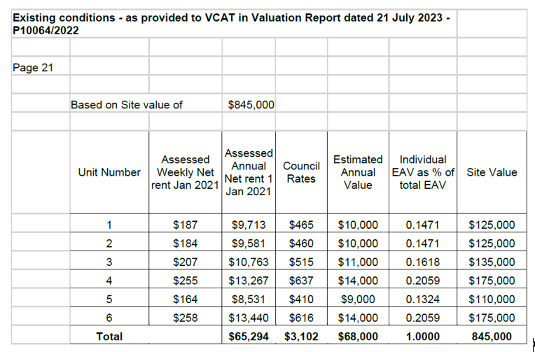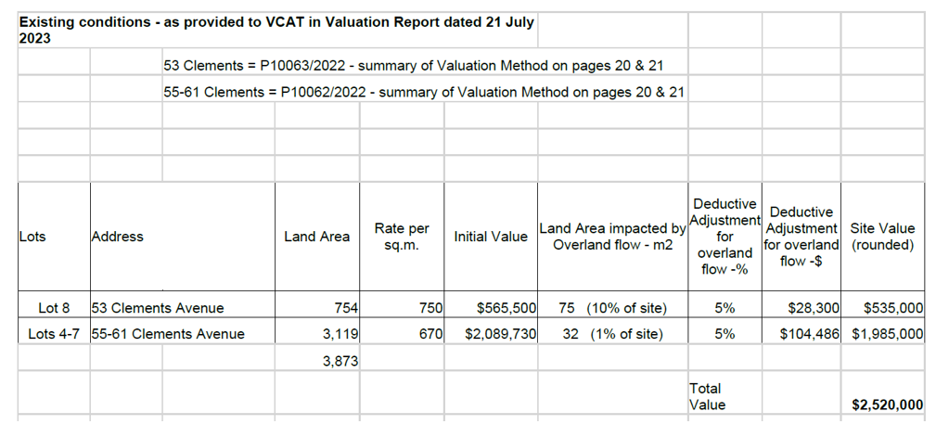

1. This means that the valuations contained in the Notices of Confirmation issued by the Valuer-General were:
   1. the same as David Archer’s revised valuation of SV for Lot 9 (i.e. $845,000), and as specified in the Notice of Recommendation; and
   2. below David Archer’s revised valuation of combined SVs for Lots 4 to 8 (i.e. $3,365.000 in accordance with the Notice of Recommendation, instead of the revised higher amount of $3,545,000).

SUMMARY OF FINDINGS

Key Issue 1

1. We are not persuaded by the Applicant that there is an overall Tavrest Larger Property as a matter of fact.
2. However, we agree with David Archer that Lot 9 is a ‘larger property’ and that the separate occupancies should be apportioned in accordance with s 2(3) of the VL Act. David Archer has carried out the application of s 2(3) of the VL Act as was required.

Key Issue 2

1. We make no specific finding on this issue of dispute between the parties. The application of a party’s methodology should be correlated to the sales evidence they rely upon. It is the comparability of the sales that is important, and, in this instance, we have found the sale relied upon by David Archer on this second key issue of dispute to be more persuasive than the Applicant’s methodology.

Key Issue 3

1. We prefer the sales evidence and analysis relied upon by David Archer. We consider the H&B Use of the subject properties is as an industrial estate and that the sales selected are comparable and support the valuations applied.
2. Whilst the Applicant point to the BR153 Overland Flow which is not an overlay control in the planning scheme, David Archer has nevertheless taken into account the impact of BR153 Overland Flow from a valuation perspective for Lots 7, 8 and 9.
3. We find the changes made to David Archer’s valuations during the hearing as described in the Amended Valuations Document, after the Notices of Recommendation to be correct. His final overall position is the addition of $845,000 (Lot 9) and $2,700,000 (Lots 4 to 8) to arrive at a total SV of $3,545,000 for the assessments in the three proceedings.

TRIBUNAL’S OVERALL DETERMINATION

1. Given this is a review of the Valuer-General’s decisions to issue Notices of Confirmation pursuant to s 21(4)(b) of the VL Act, we must apply the appropriate methodology in exercising our powers in this context.
2. The first step is to determine the correct SVs of the subject properties. Our findings on **Step 1** are as follows:

* P10062/2023 - 55-61 Clements Avenue, Bundoora (Lots 4 to 7), the SV is $2,190,000;
* P10063/2023 - 53 Clements Avenue, Bundoora (Lot 8), the SV is $535,000; and
* P10064/2023 - 49-51 Clements Avenue, Bundoora (Lots 9), the SV is $845,000.

1. **Step 2** is to consider whether discretion was enlivened to disallow any recommended adjustment because, in our opinion, when standing in the shoes of the Valuer-General, the SVs were not correct.
2. We find that:
   1. we have no discretion to vary the valuations in P10063/2023 or P10064/2023 because they are the same as the valuations in the Notices of Recommendation and therefore they must be confirmed; and
   2. discretion is enlivened with respect to the land in P10062/2023 because the SV of Lots 4 to 7 is $2,190,000 (higher) instead of the SV of $1,985,000 in the recommended adjustment which was confirmed by the Valuer-General in the Notice of Confirmation.
3. Where discretion is enlivened, **Step 3** is to consider the specific ground of review relied upon by the Applicant. In these proceedings, the Applicant contends in all cases that the valuations are ‘too high’.
4. **Step 4**, the Tribunal must next consider whether it is appropriate to exercise discretion and disallow the recommended adjustments which were confirmed in the Notices of Confirmation for P10062/2023.
5. Given our findings that the SV for Lots 4 to 7 is **higher** than the valuation contained in the Notice of Confirmation in P10062/2023, we decline to exercise discretion to disallow the Notice of Recommendation because the Notice of Confirmation contained a lower SV for Lots 4 to 7 and thus the SV is not too high.
6. The table below compares the SV confirmed by Valuer-General in the Notices of Confirmation with our findings in assessing whether they are too high:

|  |  |  |  |  |  |
| --- | --- | --- | --- | --- | --- |
| **Subject Properties** | **Notices of Confirmation**  **(SV)** | **Step 1**  **Tribunal Findings**  **(SV)** | **Step 2**  **Is there a discretion enlivened under s 21(4)(a) VL Act?** | **Step 3[59]**  **Is the Valuer-General’s confirmed valuation ‘too high’?** | **Step 4**  **Should discretion be exercised?** |
| P10062/2023  55-61 Clements Avenue, Bundoora  (1 assessment)  Lots 4 to 7 | $1,985,000 | $2,190,000[60] | Yes | No | No |
| P10063/2023  53 Clements Avenue, Bundoora  (1 assessment)  Lot 8 | $535,000 | $535,000[61] | No | N/A | N/A |
| P10064/2023  49-51 Clements Avenue, Bundoora  (6 assessments)  Lot 9 | $845,000 | $845,000 | No | N/A | N/A |

1. Having declined to exercise discretion to disallow the adjusted recommendations, this falls into the category of ‘in any other case’. Thus, **Step 5** is that we must confirm the valuation contained in the Notice of Confirmation under s 21(4)(b) of the VL Act.

CONCLUSION

1. For the reasons set out above, we determine the proceedings respectively as follows:
   1. **P10062/2022 – 55 - 61 Clements Avenue, Bundoora:**

The decision of the Valuer-General to issue a Notice of Confirmation dated 17 August 2022 confirming a recommended SV of $1,985,000 as at 1 January 2021 is confirmed.

* 1. **P10063/2022 – 53 Clements Avenue, Bundoora:**

The decision of the Valuer-General to issue a Notice of Confirmation dated 17 August 2022 confirming a recommended SV of $535,000 as at 1 January 2021 is confirmed.

* 1. **P10064/2022 – 49 - 51 Clements Avenue, Bundoora:**

The decision of the Valuer-General to issue a Notice of Confirmation dated 17 August 2022 confirming a recommended SV of $845,000 as at 1 January 2021 is confirmed.

**Carol Daicic, Deputy President Justine Jacono, Senior Member**

1. *Local Government Act 1989* (Vic), ss 154(2)(a), 155, 156(3), 156(5A).
2. We note however that at the hearing the Applicant made submissions about the valuation methodology relating to whether the landholdings owned by the Applicant were part of a ‘larger property’ for the purposes of s 2(3) of the VL Act. Given this is a specific separate ground under section 17, it would have been appropriate for the Applicant to have amended its grounds. However, this was not raised at the hearing by the Valuation Authority and we proceeded on the basis that we could hear submissions about whether there was a ‘larger property’. Given our findings, nothing turns on this.
3. VL Act, ss 17(a), 24(1).
4. Section 13H of the VL Act requires the Valuation Authority to cause a general valuation of non-rateable leviable land to be made as at 1 January in each calendar year for the purposes of the *Fire Services Property Levy Act 2012* (Vic). However, these reasons will focus on provisions for *rateable* land.
5. VL Act, s 13DC.
6. Ibid, ss 13DC(1)(a), s2(1).
7. Ibid, s 13DH.
8. Ibid, s 15.
9. Ibid, s 16(1).
10. Ibid, ss 16(2), 16(3), 16(3A), 16(3B). The ‘prescribed amount’ is defined under the *Valuation of Land Regulations 2014* (Vic) (**VL Regs**), r 14. For SV, this is $1,500,000 applicable at the relevant date.
11. VL Act, s 21(1).
12. Ibid, s 20(3).
13. Ibid, s 21(2A).
14. Ibid, s 21(2B).
15. Ibid, s 21(5). If section 20 of the VL Act applies, s 21(2B) does not require the valuer to provide a reasonable opportunity for the objector to discuss the matter with him or her unless the objector lodges a submission under s 20(3).
16. Section 23 of the VL Act provides for appeals to the Supreme Court of Victoria.
17. [2023] VCAT 246.
18. Ibid, [85] – [92].
19. Ibid, [95] – [96].
20. [2023] VCAT 246, [53].
21. Ibid, [54].
22. Ibid, [97].
23. Ibid, [106].
24. Ibid, [111], [119].
25. Ibid, [118].
26. [2023] VCAT 246, [144].
27. Ibid, [159].
28. VCAT Act, s51(2).
29. However, we did not receive any submissions on this issue and we make no findings on this point.
30. Notice of Confirmations were issued by the Valuer-General for each assessment respectively on 17 August 2022.
31. Further Information dated 20 November 2022 in each proceeding, filed on 1 December 2022.
32. The Notice of Recommendation extract is an example of the Notice of Recommendation that contained the same Valuer’s Reason for Adjustment for each of the units.
33. Tribunal Book p. 20
34. Tribunal Book p. 32.
35. Tribunal Book p. 49.
36. Tribunal Book p. 257.
37. Tribunal Book p. 287.
38. On 1 December 2022, 21 December 2022, 1 March 2023, 14 June 2023, 2 August 2023 and 9 August 2023.
39. On 30 November 2022 the Applicant filed a further Statement of Contentions.
40. Tribunal Book, 538 to 539.
41. This was raised and confirmed at the Practice Day Hearing on 10 August 2023.
42. Tribunal Book p. 259.
43. Tribunal Book p. 263.
44. Tribunal Book p. 267.
45. Tribunal Book p. 268.
46. Ibid.
47. Tribunal Book p. 20
48. Tribunal Book p. 257.
49. Tribunal Book p. 274.
50. Tribunal Book p. 270 to 273.
51. Tribunal Book p. 267 to 268.
52. Tribunal Book p. 260 to 261.
53. This case went on appeal to the Supreme Court of Appeal but Garde J’s findings about the ‘larger property’ in that case were not challenged on appeal: refer to [2017] VSCA 266, [56].
54. Ibid, [93].
55. *PTDA,* [69].
56. The Applicant filed with the Tribunal on 12 September 2023 (at the request of the Tribunal) a copy of title for all the land that the Applicant contended formed the larger property.
57. Tribunal Book, 147 to 152, 252 to 255 and 180 to 183.
58. Ibid
59. Step 3 is predicated on the ground of review(s).
60. Excluding Lot 8, Lot 4 to 7 SV’s total $2,308,810 with a 5% discount equates to $2,193,370 rounded to $2,190,000.
61. If the assessment was not combined with Lots 4 to 7, the discount would not be applied to a single lot.