VICTORIAN CIVIL AND ADMINISTRATIVE TRIBUNAL

|  |  |
| --- | --- |
| planning and environment LIST | vcat reference No. P470/2024  Permit Application no.MV/214/2018/A |
| CATCHWORDS | |
| Moonee Valley Planning Scheme; Application under Section 149(1)(a) of the Planning and Environment Act 1987; practical dispute regarding whether or not the existing open rear pergola in question should be allowed to be ‘roofed’ by way of a ‘secondary consent application’; issue arising whether the ‘minimum garden area’ requirement should be applied now in the same way that it was when the permit for the dwelling in question first received planning approval; application granted. | |

|  |  |
| --- | --- |
| **Applicant** | Timothy Tully |

|  |  |
| --- | --- |
| **Relevant Authority** | Moonee Valley City Council |

|  |  |
| --- | --- |
| SUBJECT LAND | 22 Nolan Street  NIDDRIE VIC 3042 |

|  |  |
| --- | --- |
| HEARING TYPE | Hearing |

|  |  |
| --- | --- |
| DATE OF HEARING | 30 July 2024 |

|  |  |
| --- | --- |
| DATE OF ORDER | 24 September 2024 |

|  |  |
| --- | --- |
| CITATION | Tully v Moonee Valley CC [2024] VCAT 908 |

# Order

1. In this proceeding, this Section 149(1)(a) Application is granted and in relation to the existing planning permit No. MV/214/2018/A (Permit), first, the applicant must as soon as practicable (as still applicable) provide the Responsible Authority with a further revised version of the endorsed plans which remove any reference to the subject rear pergola being unroofed. Once this issue is resolved, the Responsible Authority is directed to:
   1. Endorse (by way of secondary consent) the most current revised plans provided by the applicant, showing the rear pergola being roofed.
   2. Make same available to the applicant, in accordance with this order.

|  |  |  |
| --- | --- | --- |
| Philip Martin  **Senior Member** |  |  |

# Appearances

|  |  |
| --- | --- |
| For applicant | In person |
| For relevant authority | Ms Terri Speirs (Council planner) |

# Information

|  |  |
| --- | --- |
| Nature of proceeding | Application under section 149(1)(a) of the *Planning and Environment Act 1987* (Vic) |
| Planning scheme | Moonee Valley Planning Scheme |
| Land description | The subject land is one of two townhouse style dwellings approved at that time for the one lot by planning permit No. MV/214/2018/A. Its back yard area includes an open pergola, which sits above a hard surface area. |

# Reasons[1]

## What is this proceeding about?

1. This is an application under Section 149(1)(a) of the *Planning and Environment Act 1987* (Act), in relation to the land at 22 Nolan Street in Neddrie. To assist me with writing a succinct decision which focusses on the key issues, I have included as an Attachment to this decision the written submission of Council, which provides various background information and images.
2. The site is one of two townhouse style modern dwellings approved on the one lot at that time by planning permit No. MV/214/2018/A (Permit), where the site is zoned General Residential Zone. There has been plans endorsed pursuant to the Permit and the approved dwellings have been built. The No. 22 Nolan Street dwelling in question here is now owned and occupied by Mr Tully and he confirmed that his dwelling has been subdivided and now has its own separate title. Mr Tully confirms at [18] of his written submission that his property is now known as Lot 2 PS 843888 and he also reproduced a cadastral plan showing the separate title for No. 22.
3. He further clarified that he was not the developer of the subject dwelling but rather bought it (on its own lot) after it was built.
4. The plans which have been endorsed for the subject land show there being an open back yard pergola sitting above a hard surface area, which has been duly built as part of the No, 22 dwelling.
5. The Permit includes the usual ‘Condition 2’ which reads as follows - “The development as shown in the endorsed plans must not be altered without the written consent of the Responsible Authority”.
6. However Condition 2 needs to be seen in light of the position which has developed over time, that minor proposed changes can be made on a ‘secondary consent’ basis. That is, Council can approve minor changes to an approved building without same needing to be publicly advertised, provided the nature of the proposed changes are discrete and satisfy certain criteria.
7. I have set out further below a more detailed explanation of aspects of this dispute and see the attached copy of the Council written submission.
8. Mr Tully wishes to roof over his existing open rear pergola, so as to have better weather protection and make better use of this feature all year round. He has made a ‘secondary consent’ planning application to Council to this effect, but where Council does not support same. Mr Tully has gone on to seek the Tribunal’s review of this refusal pursuant to Section 149(1)(a) of the Act. The hearing of this matter came before me on 22 July 2024 and I heard submissions from the parties and reserved my decision.
9. For the reasons set out below, I have granted the Application.

## role of the westpoint decision

1. There was no dispute between the parties in itself about the central role of the leading *Westpoint* decision, with this type of disputed ‘secondary consent’ application. However it still seems worth briefly referring to same.
2. The leading case of *Westpoint Corporation Pty Ltd v Moreland CC* [2005] VCAT 1049 is authority that when any one Council considers a ‘secondary consent’ application, the four criteria to be considered are as follows (utilising the useful summary found at [2.8] of the Council written submission):

* The proposed changes must not result in a transformation of the proposal.
* The proposed changes must not authorise something for which primary consent is required under the planning scheme.
* The proposed changes must be of no consequence having regard to the purpose under which the permit was granted.
* The proposed changes are not contrary to a specific requirement, as distinct from an authorisation within the permit, which itself cannot be altered by consent.

## other useful background information…

1. The text in paragraph 1.2 quoted below (with my highlighting) provides some more ‘detail’ but is also important in explaining the strong link/overlap which Council sees between the proposed roofing of the existing open pergola and the role of the ‘minimum garden area requirements’ of the Planning Scheme.

1.2 The application to amend the endorsed plans through secondary consent process sought to add a solid roof over the existing 25.92 sqm pergola in 22 Nolan Street’s (Dwelling 2 on the endorsed plans) rear yard. The act of including a solid roof over the existing pergola would result in this structure now becoming a veranda and no longer meeting the definition of garden area contained in Section 73.01 (General Terms) of the Moonee Valley Planning Scheme (the Scheme). As a result, the proposed amendment reduced (sic) the garden area of the approved development from 31.06% to 27.6% of a mandatory 30% minimum garden area required pursuant to Clause 32.08-4 (General Residential Zone) of the Scheme.

1. In terms of then understanding why Council is opposing the proposal, the following paragraph 1.3 text from the Council written submission is helpful:

As the amendment proposal resulted in non-compliance with a mandatory provision of the General Residential Zone, Council resolved to refuse the application as it did not sufficiently meet the criteria set out in *Westpoint Corporation v Moreland CC* [2005] VCAT 1049 for considering applications under secondary consent. In particular, the amendment would be of material consequence having regard to the purpose of the planning control under which the permit was granted (the General Residential Zone). The amendment application otherwise met the remaining criteria of the Westpoint decision and the relevant provisions of Clause 55 (Two dwellings on a lot) of the Moonee Valley Planning Scheme. Therefore, Council would have otherwise been supportive of the amendment, if not for the garden area non-compliance.

## in the situation where each of the two approved dwellings has been subdivided, what is the ‘planning unit’ for our purposes here? …

1. One of the issues ‘floating around’ in this dispute and the hearing before me is ‘what is the planning unit for the purposes of this proceeding?’.
2. I acknowledge that the original development Permit in question here approved at that time two dwellings on a lot. However it is also critical for our purposes that both dwellings have been not only built but also subdivided, so that each one has its own separate title.
3. At a simple level then, it is straight forward (unless there is some compelling argument to the contrary) that the ‘planning unit’ here is simply the title area for this single dwelling which is owned by Mr Tully.
4. I note that at [2.2] of the Council submission there is discussion of the decision of *Clayton Gardens Pty Ltd v Monash CC (Red Dot)* [2019] VCAT 1138. However I consider this previous decision to have no role with my deliberations here, because (as was conceded by Ms Speirs during the hearing before me) the *Clayton Gardens* decision:

* involved the original planning application for development approval for the proposed development in question; rather than
* the type of situation arising here where the original development approval has already been granted, the approved buildings have been built/subdivided off and we are now dealing later-in-time with a ‘secondary consent application’.

1. In summary then, for the purposes of understanding the ‘planning unit’ in question, I find that:

* The circumstances before me of a ‘secondary consent application’ are totally different to the facts before the Tribunal in the *Clayton Gardens* decision.
* The ‘planning unit’ here is no more or less than the separate title area for this No. 22 property which is owned by Mr Tully.

## to what extent do the ‘mandatory minimum garden area’ requirements of the planning scheme still apply here?

1. I note that two paragraphs underneath the heading ‘Enduring Burden of a Planning Permit After Completion', Council’s written submission seeks to rely on/leverage off the landmark decision of *Benedetti v Moonee Valley City Council* [2005] VSC 434. That Supreme Court decision (together with *Box v Moreland CC (Red Dot)* [2014] VCAT 246) essentially stand for the proposition that where a planning permit includes the type of ‘Condition 2’ requirement as is found in the Permit here (see my explanation of this type of condition further above), then this requirement continues to apply even:

* After the approved development is built.
* If an approved dwelling is subdivided and that dwelling’s own lot is above 300 sqm in size, which would ordinarily mean that no planning permission is needed for alterations to the dwelling.

1. So on the one hand, on the facts here, I do not query Council’s position that Condition 2 of the Permit continues to operate and hence it is very appropriate that the applicant has (to comply with Condition 2) sought ‘secondary consent’ permission from Council, where the applicant wishes to roof the currently open rear pergola.
2. On the other hand, in the circumstances here, I find that it is misguided and incorrect for Council to simply assume that the GRZ ‘mandatory minimum garden area’ requirements continue to apply in a mandatory way to this ‘secondary consent’ application, in the same way that they did when the original permit applicant sought permission to develop the two dwellings on a lot.
3. That is to say, I find that the ‘mandatory minimum garden area’ requirement arising from the GRZ provisions is not an enduring requirement like the relevant planning permit conditions. Rather, the ‘mandatory minimum garden area’ requirements were simply mandatory planning scheme controls to simply be applied at the time of the original planning permit application.
4. I am unaware of any text in the relevant ‘mandatory minimum garden area’ provisions in the GRZ which give any hint or indication that such provisions in effect have a ‘mandatory indefinite life’ after the approved development is actually built. If the draftpersons of the GRZ had intended that such provisions needed to be applied in a mandatory way not just to the original planning assessment but then over the life of the as-built approved development, this could have easily been spelt out in the relevant text (but this is not the case).
5. Similarly if you only focus on previous cases which involve this type of ‘secondary consent application’, I am unaware of any previous VCAT or Supreme Court decision supporting Council’s preferred position that the ‘mandatory minimum garden area’ requirements have a mandatory on-going and indefinite operation.
6. For the removal of any doubt, I accept that when Council is exercising its discretion with this type of ‘secondary consent’ application involving a back yard area, it can still review (as one of various practical considerations) whether the proposed alteration would reduce the amount of ‘garden area’ below the relevant benchmark area. This point is that this shuld not be treated as a ‘mandatory requirement’, but rather one of potentially a variety of practical planning considerations which the Council would then weigh up.

## taking into account the tribunal’s findings set out above, should the proposed ‘secondary consent’ be granted?

1. Taking into account my findings set out above, I now turn to the conventional assessment of whether or not the proposed ‘secondary consent’ should or should not be granted.
2. The first thing that needs to be said is that the scope of the dispute here is extremely narrow. That is, commendably, Council was frank in acknowledging at its [1.3] that the proposed roofing of the existing rear veranda complies with Clause 55 and is consistent with three of the four abovementioned criteria under the *Westpoint* decision. Hence the only (quite narrow) basis on which Council opposes the requested secondary consent is Council’s belief that the roofing of the existing open rear veranda would breach the *Westpoint* criteria that the proposed alteration “…is of no consequence having regard to the purpose under which the permit was granted”.
3. I have already explained why I consider it to be misguided and wrong for Council here to refuse the proposal simply because Council sees there to still be a mandatory requirement that the garden area in question must not be allowed to shrink to below 30%. Yes, that was a mandatory requirement at the time that the original ‘two dwelling development on a lot’ was assessed, but I do not accept that it remains a mandatory requirement now. When I say ‘now’, we know that both approved dwellings have been not only built but subdivided.
4. Returning to the one contentious *Westpoint* criteria of whether the proposed alteration “…is of no consequence having regard to the purpose under which the permit was granted”, I think the key words for our purposes here are ‘of no consequence…”. That is, can it be said that when the proposed roofing of the existing open rear pergola is considered in light of the physical nature of the change proposed, the ‘30 % minimum garden area’ benchmark and the broad sweep of the relevant features of the GRZ, is it fair to say that such proposed roofing is ‘inconsequential’?
5. Answering this question involves a practical assessment of the likely implications or impacts of the proposal and hence I expect the answer will ‘turn on its own facts’ each time this type of assessment needs to be made.
6. On the facts here, my finding is that the proposed roofing of the existing open rear veranda would be inconsequential, relying on the following practical considerations:

* Compared to the whole dwelling in question, the rear veranda is a quite petite feature of it.
* The proposed works are quite discrete and limited – simply roofing an existing structure, rather than creating a new structure.
* The proposed works do not involve removing any existing vegetation/lawn and the backyard area underneath the existing open pergola is already a hard surface area.
* Because it is back yard works in question, the proposed new roofing will not be visible from the public realm, at the front of the subject land.
* The new roofing will be fairly visually low key, particularly as it is adding a new vertical rather than horizontal aspect to the existing dwelling. It is not as if it is proposed to say move an external wall closer to a boundary.
* Other than the tiny width of the presumably zinc or colourbond material itself and possibly the necessary supporting frame, the proposed roofing will not increase the height of the existing pergola.

1. It also seems fair to say that where Council has advised me that the relevant GRZ ‘minimum garden area’ benchmark here is 30%, the extent of the proposed drop in ‘garden area’ below 30% (down from 31.06 to 27.6% as calculated by Council) is measured rather than major.
2. In summary, for the reasons set out above, I am satisfied that the proposed roofing of the existing open rear pergola satisfies all four of the *Westpoint* criteria.

## Conclusion

1. For the reasons given above, I have granted this Section 149(1)(a) application and directed that the relevant revised plans be endorsed by Council and then re-issued to the applicant.
2. In closing, I note that during the hearing it was disclosed by Council that it had actually ‘along the way’ obtained written legal advice about some or all of the legal issues which I have discussed above. As I said at the time, it sees a very curious and unhelpful situation where Council goes to the trouble of getting written legal advice on contentious issues which end up being debated at a Tribunal planning hearing, yet Council has not utilised a planning lawyer at the VCAT hearing or even made a copy of the written legal advice available to the Tribunal member for the purposes of the hearing.

|  |  |  |
| --- | --- | --- |
| Philip Martin  **Senior Member** |  |  |

# attachment 1

# council written submission

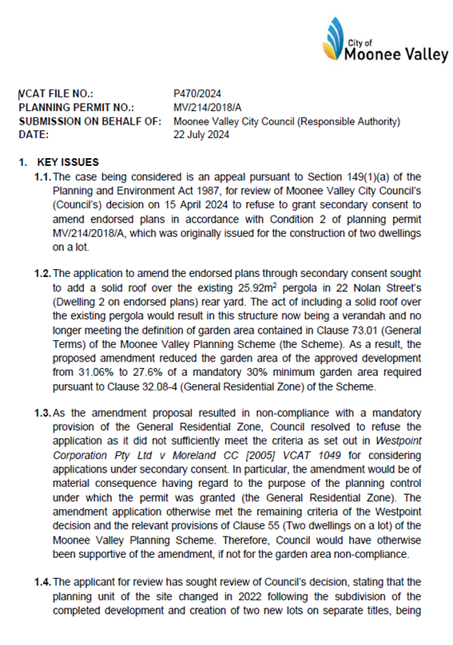

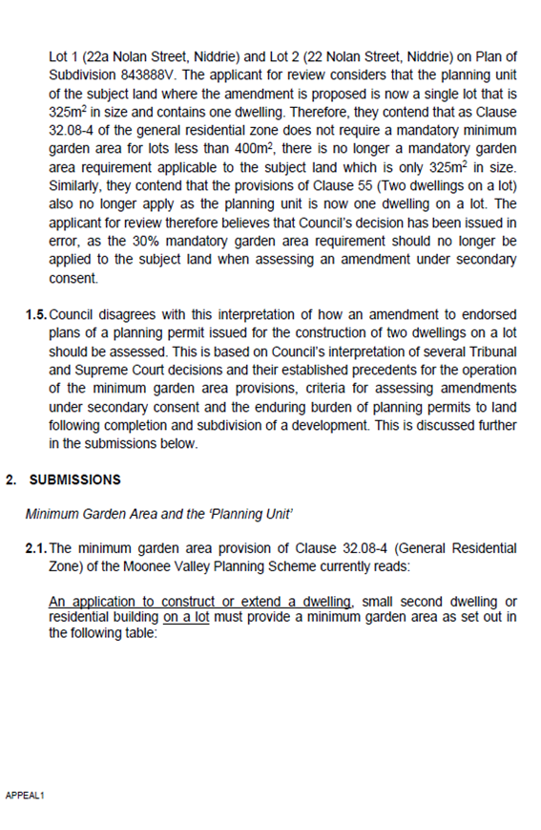

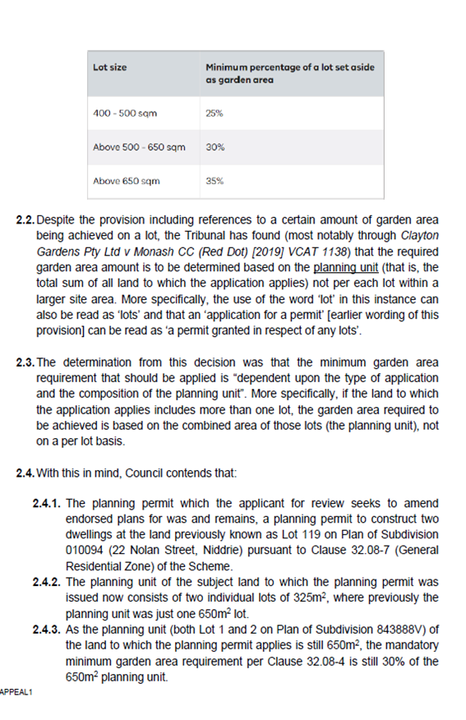

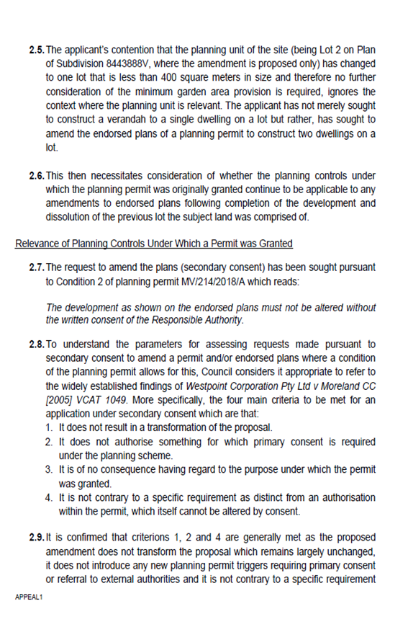

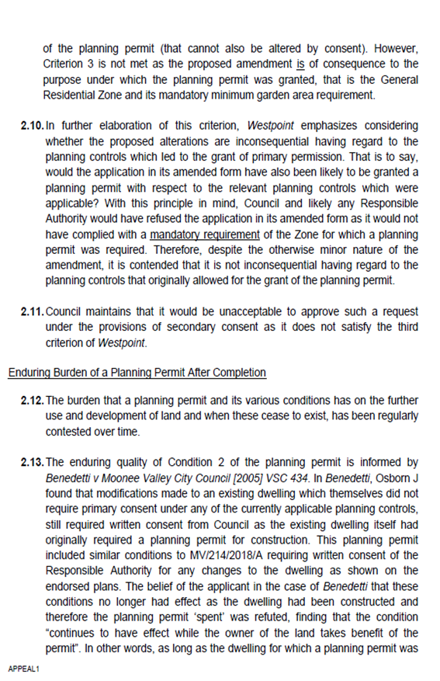

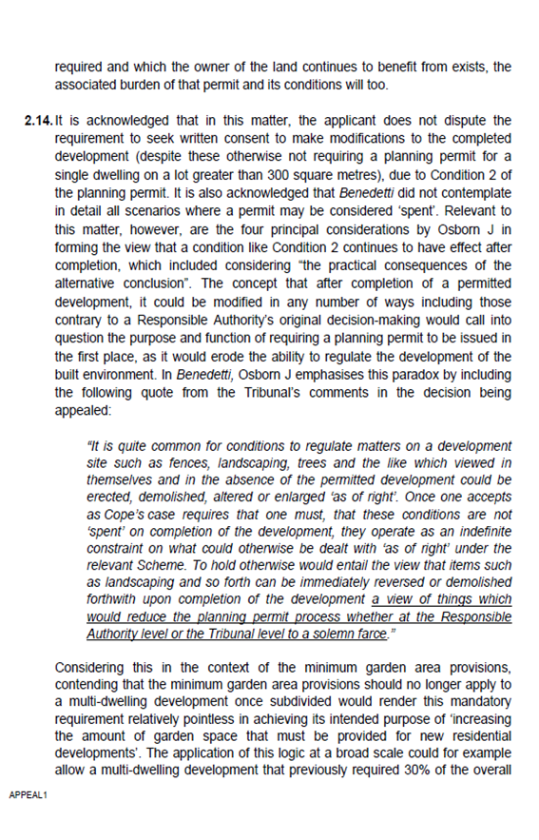

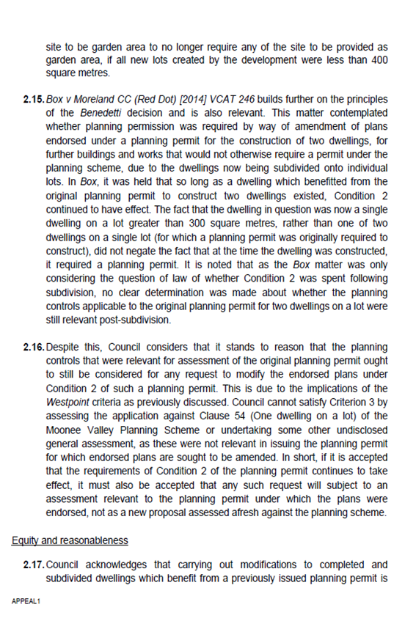

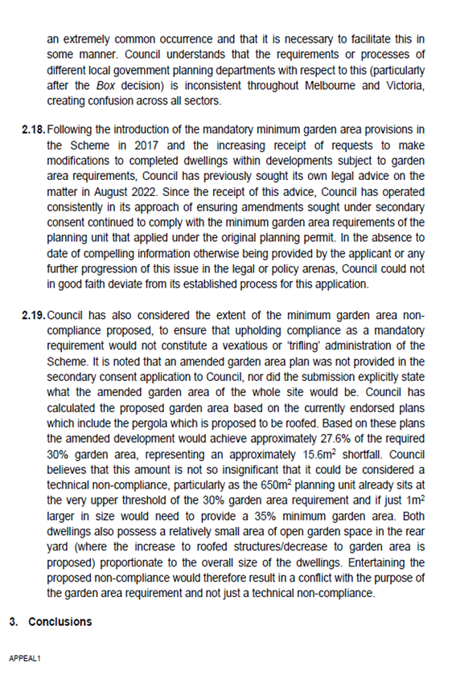

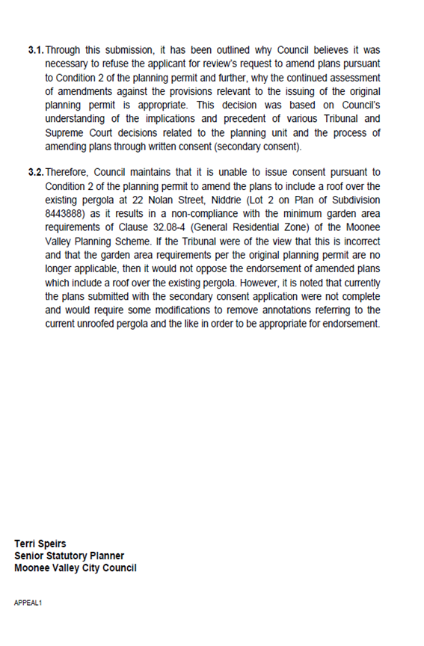

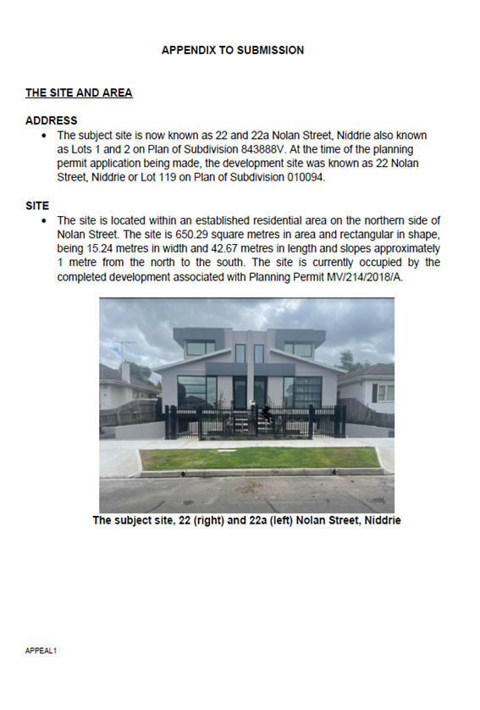

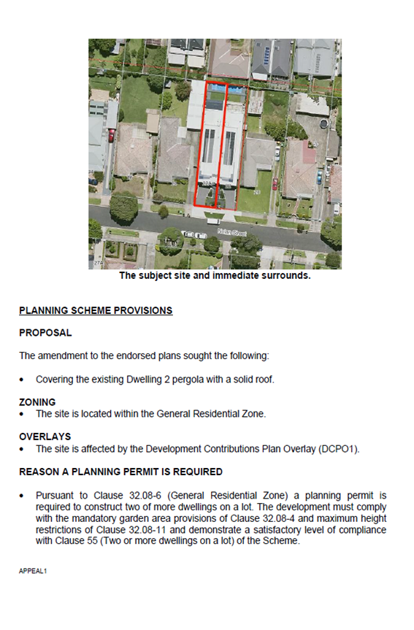

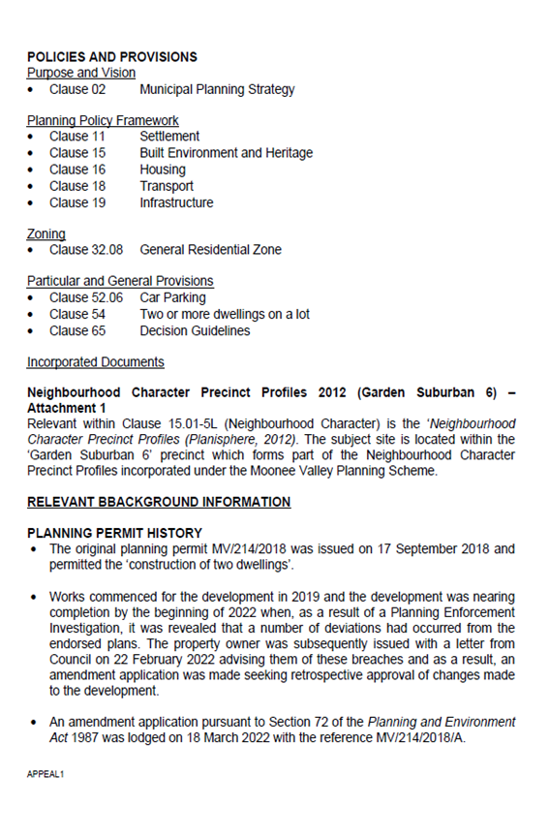

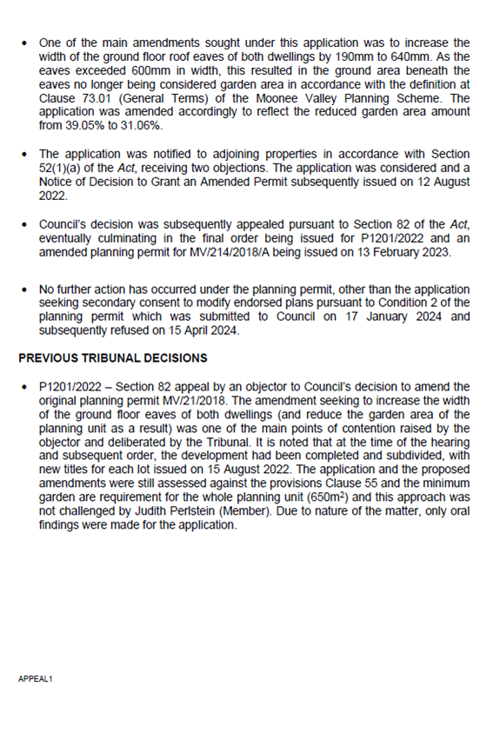

# attachment 2

# applicant written submission

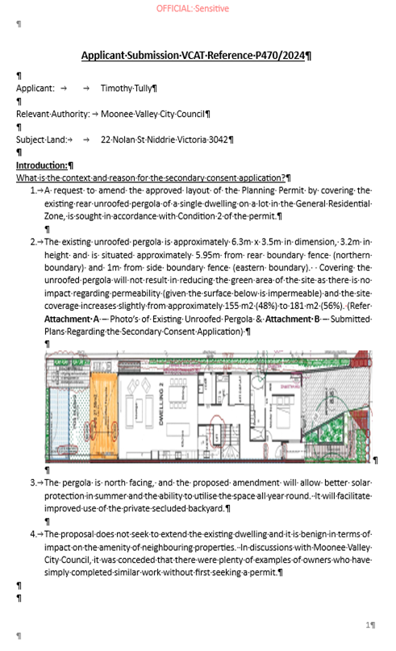

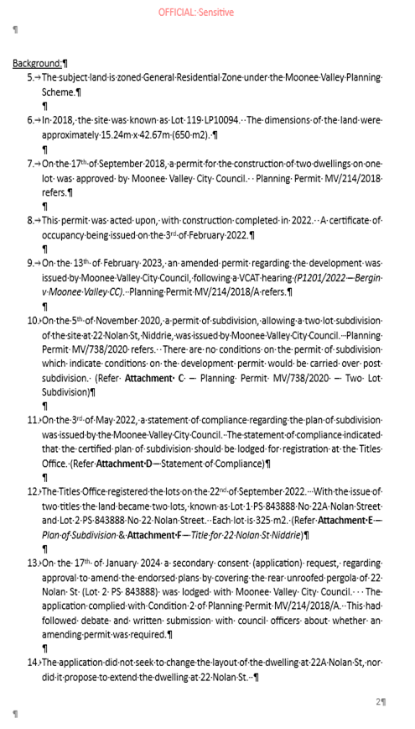

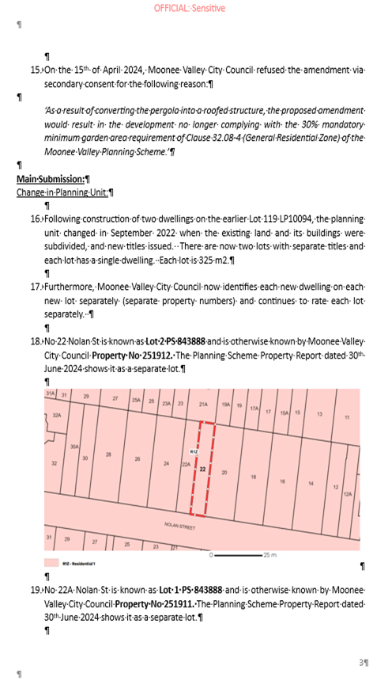

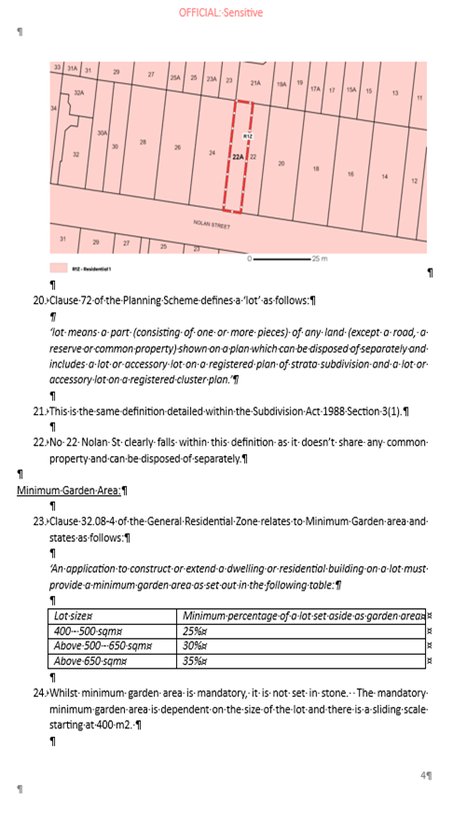

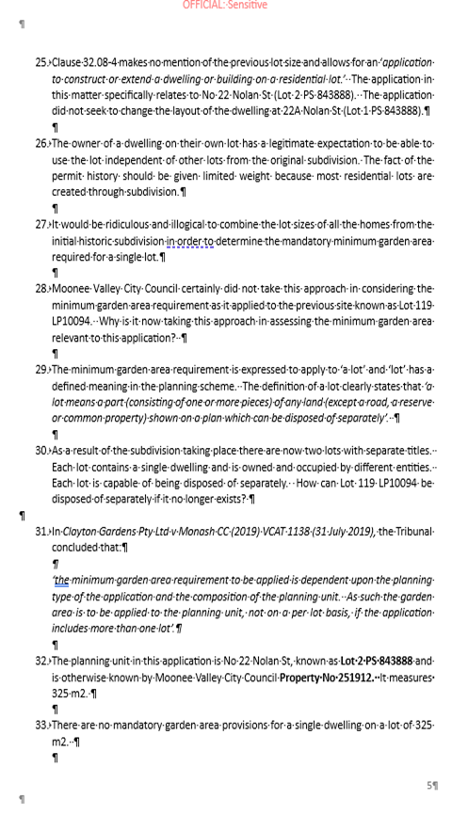

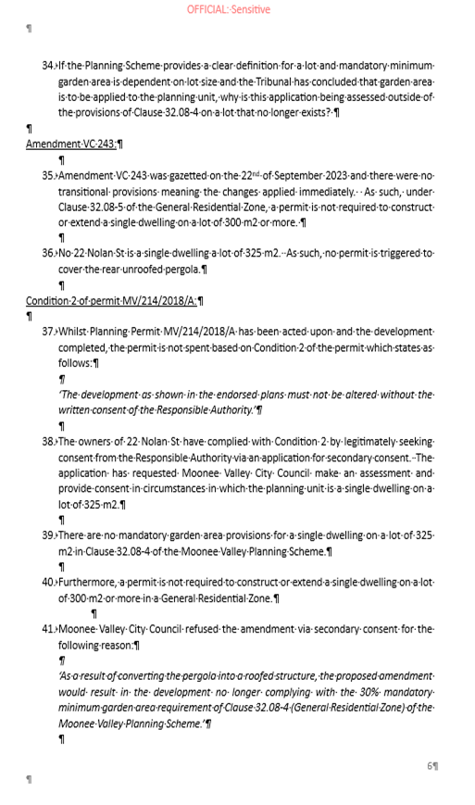

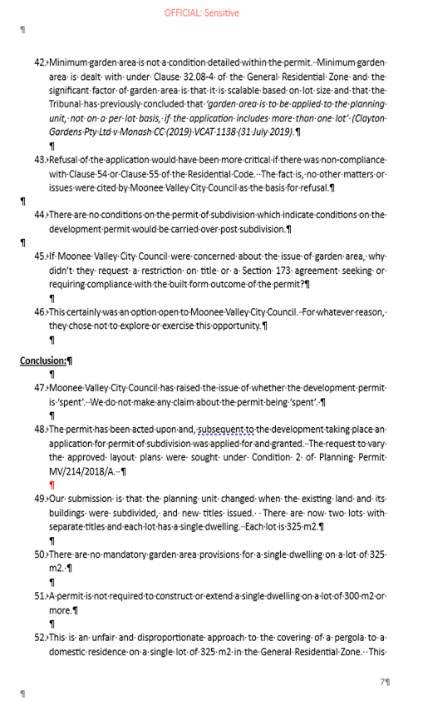

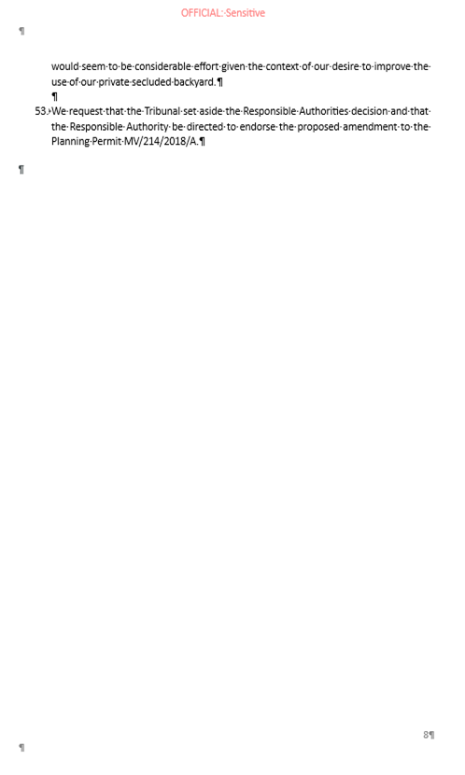

1. The submissions and evidence of the parties, any supporting exhibits given at the hearing and the statements of grounds filed have all been considered in the determination of the proceeding. In accordance with the practice of the Tribunal, not all of this material will be cited or referred to in these reasons.