VICTORIAN CIVIL AND ADMINISTRATIVE TRIBUNAL

|  |  |
| --- | --- |
| planning and environment LIST | vcat reference No. P833/2022  Permit Application no. PL21/218 |
| CATCHWORDS | |
| Section 82AAA(a) of the *Planning and Environment Act 1987* (Vic); Moyne Planning Scheme; Floodway Overlay, Land Subject to Inundation Overlay; flood risk management plan. | |

|  |  |
| --- | --- |
| APPLICANT | Glenelg Hopkins Catchment Management Authority |
| responsible authority | Moyne Shire Council |
| RESPONDENT | Donna Francis Smith |
| SUBJECT LAND | 196 Griffiths Street  PORT FAIRY VIC 3284 |
| HEARING TYPE | Hearing |
| DATE OF HEARING | 6, 7, 8 & 20 March 2023 and 11 May 2023 |
| DATE OF ORDER | 23 November 2023 |
| CITATION | Glenelg Hopkins Catchment Management Authority v Moyne SC [2023] VCAT 1245 |

# Order

### Amend permit application

1. Pursuant to clause 64 of Schedule 1 of the *Victorian Civil and Administrative Tribunal Act 1998* (Vic), the permit application is amended by substituting for the permit application plans, the following plans filed with the Tribunal:

|  |  |
| --- | --- |
| * Drawing numbers and titles: | A1 - Site (Rev) Plan  A3 - Elevations  A5 - Rev South Elevation |
| * Revision: | B |
| * Dated: | February 2022 |

### No permit granted

1. In application P833/2022 the decision of the responsible authority is set aside.
2. In planning permit application PL21/218 no permit is granted.

|  |  |  |
| --- | --- | --- |
| Claire Bennett  **Member** |  |  |

# Appearances

|  |  |
| --- | --- |
| For Glenelg Hopkins Catchment Management Authority | Mr Darren Wong, lawyer of Planology  Expert witness evidence of:   * Mr Steven Molino, flooding engineer of Water Technology Pty Ltd |
| For Moyne Shire Council | Mr Simon D’Angelo, lawyer of Marcus Lane Group |
| For Donna Francis Smith | Ms Kate Lyle, of counsel  Expert witness evidence of:   * Mr Robert Swan, flooding engineer of Hydrology and Risk Consulting Pty Ltd |

# Information

|  |  |
| --- | --- |
| Description of proposal | Construction of a single storey dwelling comprising four bedrooms, a combined lounge/kitchen/dining area and double carport/garage. |
| Nature of proceeding | Application under section 82AAA(a) of the *Planning and Environment Act 1987* (Vic) – to review a decision of the responsible authority to grant a permit, if the recommending referral authority objected to the grant of the permit. |
| Planning scheme | Moyne Planning Scheme |
| Zone and overlays | General Residential Zone – Schedule 1 (‘GRZ1’)  Environmental Significance Overlay – Schedule 1 (‘ESO1’)  Design and Development Overlay – Schedule 6 (‘DDO6’)  Floodway Overlay – Schedule 2 (‘FO2’) and  Land Subject to Inundation Overlay – Schedule 2 (‘LSIO2’) |
| Permit requirements | Clause 42.01-2 – Environmental Significance Overlay – A permit is required to construct a building or construct or carry out works.  Clause 43.02-2 – Design and Development Overlay – A permit is required to construct a building or construct or carry out works.  Clause 44.03-2 – Floodway Overlay – A permit is required to construct a building or construct or carry out works.  Clause 44.04-2 – Land Subject to Inundation – A permit is required to construct a building or construct or carry out works. |
| Land description | The subject land is on the eastern side of Griffiths Street, between Manifold Street and Connolly Street. It has a frontage to Griffiths Street of approximately 20.12 metres, a depth of approximately 50.29 metres, with a total site area of approximately 1,012 square metres. |
| Tribunal inspection | 21 June 2023 |

# Reasons[1]

## What is this proceeding about?

1. Glenelg Hopkins Catchment Management Authority (‘GHCMA’) is seeking a review of the decision by Moyne Shire Council (‘council’) to grant a permit for buildings and works to construct a dwelling at 196 Griffiths Street, Port Fairy (‘subject land’), where the GHCMA, as recommending referral authority, objected to the grant of the permit.

### The proposal

1. Donna Francis Smith (‘permit applicant’) is seeking a permit to construct a dwelling. A summary of the key elements of the proposal is provided below.

* A single-storey dwelling.
* An internal layout comprising four bedrooms, a combined lounge/kitchen/dining area and double carport/garage.
* The dwelling is set back 15 metres (‘m’) from Griffiths Street.
* The proposed floor levels, as shown in the Revision B development plans are:
  + 3.61m AHD for the main dwelling area; and
  + 2.1m AHD for the carport.
* The dwelling has a pitched roof profile with Colorbond roof sheeting, external wall finishes of vertical cladding, timber battens and masonry.
* A crossover and driveway to allow vehicular access via Griffiths Street.

### Site and description

1. The subject land, formally described as Lot 1 on TP023085X in Certificate of Title Volume 10619, Folio 451, is located on the eastern side of Griffiths Street, between Manifold Street and Connolly Street. It has a frontage to Griffiths Street of approximately 20.12m, a depth of approximately 50.29m, with a total site area of approximately 1,012 square metres (‘sqm’).
2. The subject land is currently vacant and is generally devoid of vegetation. There is no vehicular access or existing crossover and the subject land is not encumbered by any easements, restrictions or a section 173 agreement.
3. The subject land is approximately 1.5 kilometres (‘km’) from the centre of Port Fairy. Broadly, lot sizes within 100m of the subject land range in size between 135sqm to 2,050sqm and accommodate dwellings. The subject land and its interfaces are shown in the aerial image below.

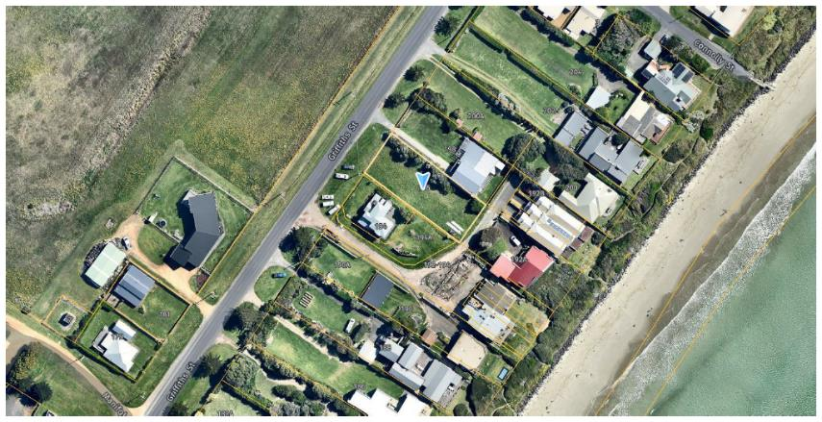

Figure Aerial image of the subject land (identified by the blue arrow) and the interfaces (Source: Council submissions, dated 27 February 2023, page 3)

1. The immediate interfaces are described as follows:

* To the west is Griffiths Street, a local road accommodating one lane of traffic in each direction. Opposite Griffiths Street is an 8 hectare (‘ha’) parcel of land in the Farming Zone. Beyond Griffiths Street to the west is the wetland estuary of Belfast Lough.
* The land to the north at 198 Griffiths Street accommodates a single storey brick dwelling.
* The land to the east at 192A Griffiths Street accommodates a double storey detached brick dwelling. Further east is East Beach.
* The land to the south at:
  + 194 Griffiths Street accommodates a double storey detached weatherboard dwelling; and
  + 194A Griffiths Street is vacant land.[2]

1. The land slopes from a height of approximately 4.5-4.75m AHD at the rear of the site to a height of approximately 1.5-1.75m AHD at the frontage to Griffiths Street.

### Background

1. There was no dispute between the parties regarding the following background of the permit application:

* On or about 2 September 2021, council received the permit application PL21/218 (‘permit application’).
* Council referred the permit application to the GHCMA under section 55 of the *Planning and Environment Act 1987* (Vic) (‘PE Act’), in its capacity as a recommending referral authority.
* In response to the GHCMA’s concerns, the permit applicant prepared amended plans for discussion, in which the dwelling’s location was modified to comply with the requirements of the Port Fairy Local Floodplain Development Plan 2013 (‘2013 LFDP’).
* In subsequent correspondence to the permit applicant dated 29 March 2022, the GHCMA advised, despite the amended plans, it still objected to a permit being granted because of non-compliance with the 2013 LFDP. Specifically, the provisions of section 6.4 of the 2013 LFDP, regarding ‘Special Area A’ and safe access criteria.
* On 7 October 2021, the GHCMA recommended that a permit not be granted on the following grounds:
  + The proposed development is likely to result in danger to the life, health, and safety of the occupants due to flooding of the site.
  + The development is likely to increase the burden on emergency services and the risk to emergency personnel.
  + The development is likely to increase the number of buildings located in a floodway area.
  + The development relies on low-level access to and from the site.
* The council considered the permit application at its meeting on 7 June 2022. The council’s planning staff recommended the refusal of the permit application on six grounds, namely:
  + The only roadway access to the property is subject to inundation up to an unsafe depth (more than 0.5 m) during the 1% Annual Exceedance Probability (‘AEP’) food event and larger floods.
  + No viable alternative exists to the sole reliance on Griffiths Street and therefore, compliance with the Port Fairy 2013 LFDP cannot be achieved.
  + The risk posed by loss of safe access to the property during large floods will also worsen, because of rising mean sea level.
  + The proposed development is likely to result in danger to the life, health, and safety of the occupants due to flooding of the site.
  + The development is likely to increase the burden on emergency services and the risk to emergency personnel.
  + The development is likely to increase the number of buildings located in a floodway area.
* At its ordinary meeting on 7 June 2022, council resolved to grant a permit, subject to 19 conditions.
* On 9 June 2021, council issued the Notice of Decision (NOD).
* By application form dated 30 June 2022, the GHCMA lodged the application for review with the Tribunal. The GHCMA relies on the following ground in support of the application for review:

The increase in risk associated with flooding resulting from this application is contrary to the objectives of the Victoria's floodplain management policy, contrary to the purposes of applicable planning controls, various provisions of the Moyne Planning Scheme (Scheme) and the Port Fairy Local Flood [sic] Development Plan 2013 (LFDP)

* On 2 February 2023, Mr Molino and Mr Swan took part in a conclave. They subsequently produced a memorandum setting out their areas of agreement and disagreement (‘Conclave Memorandum’). The Conclave Memorandum was filed and served on 10 February 2023.

## Procedural issues and rulings

### Amended plans

1. On the first day of the hearing the permit applicant made an application to amend plans pursuant to clause 64 of Schedule 1 of the *Victorian Civil and Administrative Tribunal Act 1998* (Vic) (‘VCAT Act’).
2. The permit applicant provided the following summary of the differences between the two sets of plans:

* The Revision A plans show a finished floor level of 3.31m AHD on the site plan and floor plan, as well as a 12m setback from Griffiths Street.
* The Revision B plans[3] show a finished floor level of 3.61m AHD (300mm increase) on the site plan and floor plan, as well as a 15m (3m increase) setback from Griffiths Street.

1. The Revision B plans filed with the Tribunal consisted of the following drawings:

* A1 - Site (Rev) Plan, dated February 2022;
* A3 - Elevations, dated February 2022; and
* A5 - Rev South Elevation, dated February 2022

1. During the without prejudice condition discussion the permit applicant also proposed the following condition, which included ‘updated Revision A plans A2 (floor plan) and A4 (north elevation) modified to show the finished floor levels provided in the Revisions B A1 plan’, as follows:

**Amended Plans**

3. Before the development starts, plans must be approved and endorsed by the Responsible Authority. The plans must:

a. be prepared to the satisfaction of the Responsible Authority;

b. be drawn to scale with dimensions;

c. submitted in electronic form

d. be generally in accordance with the - Revision B plans (being plans A1, A3, A5 dated February 2022) but modified to show:

i. updated Revision A plans A2 (floor plan) and A4 (north elevation) modified to show the finished floor levels provided in the Revisions B A1 plan.

ii. the carport finished floor levels above the 2% AEP flood level of 2.19m AHD;

iii. a vehicle accessway finished above the 2% AEP flood level of 2.19m AHD;

iv. a vehicle crossover finished above the 2% AEP flood level of 2.19m AHD and graded to the existing Griffiths Street surface;

v. two (2) flood height markers located at the property boundary either side of the vehicle crossover;

vi. all electrical outlets located above the 300mm above the 1% AEP flood level including a 0.8 sea level rise (SLR) (2.67m AHD); and

vii. any changes resulting from the stormwater management plan required under condition 9.

1. The permit applicant submitted that whilst the Revision A plans were the decision plans before the Tribunal, the Revision B plans had been prepared during the permit application in order to address some of the GHCMA’s concerns. Further, they submitted that the council had regard to a mix of both Revision A and Revision B in the development plans before them when making their decision, as both were referenced in and attached to the officer’s report, dated 7 June 2022.[4]
2. Council initially raised concerns relating to whether additional notice would need to be given for the Revision B plans, but council later confirmed that it was satisfied that the Revision B plans did not trigger any further notice requirements because there was no notice trigger under the zone, the Floodway Overlay (‘FO’), the Land Subject to Inundation Overlay (‘LSIO’), the Environmental Significance Overlay (‘ESO’) (because no vegetation is proposed to be removed) or the Design and Development Overlay (‘DDO’) (because the building height is well within the requirements).
3. The parties agreed that it was appropriate to amend the plans as all the required parties were present, and all the parties and their experts had prepared for the hearing based on the Revision B plans.
4. On that basis, the Tribunal agreed to amend the plans.

### Confinement of matters in dispute

1. On the first day of the hearing the parties made an application under section 84AB of the PE Act to confine the matters in dispute to those matters arising under the FO and the LSIO overlay controls. The parties all agreed to confine the matters in dispute to those matters arising under the FO and the LSIO overlay controls.
2. The application to confine the matters in dispute was made in the context of the application to amend the plans as, under both the FO and the LSIO, there are no third party rights to notice or review.
3. Council ultimately made submissions that it supported the confinement of the matters because, instead of the triggers that arise for notice under the ESO and DDO6 not being an issue, there would be no triggers that arise.
4. Given that the parties ultimately agreed that the Revision B plans did not trigger any further notice requirements, the Tribunal did not find it necessary to confine the matter.

### Amendment C69moyn

1. Amendment C69moyn (‘Amendment C69moyn’) seeks to implement the recommendations of the *Port Fairy Coastal and Structure Plan 2018* (‘PFC&SP’)[5] and the *Translation of Port Fairy Coastal Hazard Assessment*, prepared by Cardno dated 27 September 2017 (‘Cardno Assessment’)[6] through changes to local policy for Port Fairy, various zone and overlay changes, updated flooding controls planning for a 0.8m sea level rise to 2100, and changes to the operational provisions.[7]
2. The following description is provided on the website for Amendment C69moyn:

Implements the recommendations of the Port Fairy Coastal and Structure Plan 2018 and Translation of Port Fairy Coastal Hazard Assessment (Cardno, 2019) by updating local planning policy for Port Fairy; rezoning existing General Residential Zone land and land in Growth Area A to Neighbourhood Residential Zone Schedule 1; rezoning properties identified for expansion of the commercial core to Commercial 1 Zone; correcting the zoning of various land parcels; replacing 19 Design and Development Overlay Schedules with seven new Design and Development Overlay Schedules; applying the Development Plan Overlay Schedule 4 to Growth Areas A and B; extending the Erosion Management Overlay to areas along the primary coastal dune in South Beach and East Beach; updating flooding controls to identify areas subject to the combined effects of riverine flooding and coastal inundation under localised sea level rise projections; inserting the Port Fairy Local Floodplain Development Plan 2023 as an incorporated document; and making other associated changes to the Moyne Planning Scheme.

#### Amendment C69moyn timing in relation to the hearing

1. In September 2021, the amendment progressed to a Panel hearing and a Panel recommendation was provided on 9 December 2022. At the time of the hearings initial submissions from the parties on 27 February 2023, the final version of Amendment C69moyn was yet to be adopted by council.
2. The hearing was held on 6, 7, 8 & 20 March 2023 and 11 May 2023.
3. At its ordinary meeting on 28 March 2023, council resolved to adopt the amendment, incorporating the changes to the amendment recommended by the planning panel.
4. Tribunal’s order dated 20 April 2023 required the parties to provide written submissions addressing the weight to give Amendment C69moyn and any impact the amendment may have on the permit application.
5. The adopted amendment and final documents have been submitted to the Department of Transport and Planning for consideration and decision. The Minister for Planning can decide to approve the amendment with or without changes.
6. As of the date of this decision, Amendment C69moyn is currently listed as ‘Approval under consideration’.

#### Amendment C69moyn as it relates to the subject land

1. Council provided the following summary of Amendment C69moyn as it relates to the subject land:[8]

Of relevance, the Amendment as exhibited, proposed the following changes to the Scheme:

* rezoning all land in the General Residential Zone (GRZ) and the Mixed Use Zone to Schedule 1 to the Neighbourhood Residential Zone (NRZ1);
* replacing the existing 19 Design and Development Overlays, including the DDO6, with seven Design and Development Overlays to reflect areas identified in the Structure Plan;
* introducing Schedule 4 to the Land Subject to Inundation Overlay (LSIO4) and Schedule 3 to the Floodway Overlay (FO3) to the Port Fairy Township to identify areas subject to coastal inundation and a 1.2 metre sea level rise in accordance with the findings of the Cardno Assessment;
* amending clause 21.06 to reflect a 1.2 metre sea level rise (SLR) benchmark as proposed in the LSIO4 and FO3;
* amending clause 21.09 to contain new local policy;
* introducing the following background documents in clause 22.11:
  + - the PFCSP; and
    - Cardno Assessment.

In terms of controls, Amendment C69moyn, as exhibited, sought to:

* rezone the Subject Land from GRZ to the NRZ1;
* apply an amended form of the DDO6 to the Subject Land; and
* apply the FO3 to part of the Subject Land (shown below).[9]

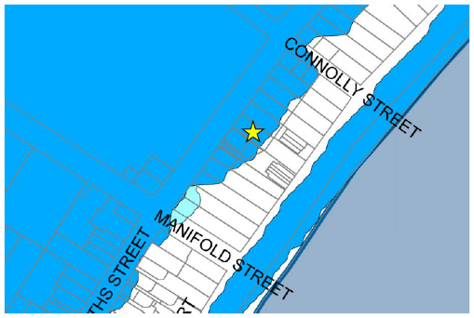

Figure FO3 with the subject land identified by the yellow star (Source: Council submissions, dated 27 April 2023, page 9)

1. The subject land is not affected by the Erosion Management Overlay (‘EMO’), nor is it proposed to be as part of Amendment C69moyn to the Scheme.
2. Amendment C69moyn also seeks to replace the existing 2013 LFDP with a revised version. A summary of the various LFDP’s referenced throughout the hearing is provided in the ‘Relevant policy documents’ section of this decision.
3. Various consequential changes are also proposed to local policy. Council made submissions that the following strategies, variously proposed under clause 21.09-3 relating to the subject land and surrounds, are of particular note (Tribunal emphasis added):

* Support only very limited new housing development in the East Beach and Griffths Street & Wharf Precincts where land is not subject to flooding or erosion risk and access is managed to the satisfaction of the responsible authority.
* …
* Recognise East Beach and Griffiths Street & Wharf Precincts and the areas around Belfast Lough as being most severely impacted by flooding.
* Do not support any increase in residential density or the introduction of sensitive uses (such as schools or aged care) in areas affected by coastal inundation.
* Do not support any mitigation measures undertaken by individual landowners or undertaken site-by-site as a basis for any development approval.
* …
* Avoid access hazards associated with flooding and provide safe access at depths of no greater than 0.3 metres.

#### Panel findings

1. Council provided the following summary of the Panel’s key findings, relevant to the proceeding:

The Panel:

* concluded the PFC&SP is ‘generally sound’ and should be included as a background document in the Scheme;
* concluded the LFDP is a ‘useful guiding document’ to assist in implementation of the Floodway Overlay and Land Subject to Inundation Overlay and is supported as an Incorporated Document;
* concluded the appropriate measure for SLR should be 0.8 metres (and not the exhibited 1.2 metres), which the Panel regarded as providing Council with ‘ample control over development of flood prone land’;
* concluded the application of the LSIO and FO as proposed are generally sound and should be supported, subject to changes in sea level measure;
* concluded the widespread application of the NRZ across all residential land in Port Fairy is not supported, but supported applying the NRZ to areas affected by the proposed Design and Development Overlay schedules 1, 2, 5, 6, and 7, including the Subject Land; and
* supported introducing the DDO Schedules 1 to 7, subject to the schedules reverting back to the exhibited discretionary built form provisions and other minor changes.

The Panel also recommended the following revisions to the Amendment material:

* revise all relevant planning scheme maps to reflect 0.8 metres SLR and undertake a ‘smoothing’ process of flood levels on affected properties;
* update all relevant documents, including but not limited to Floodway Overlay Schedule 3, Land Subject to Inundation Overlay Schedule 4, clause 21.06 and the 2021 LFDP (referred to as the ‘Day 1’ version) to substitute 1.2 metres SLR to 0.8 metres sea level rise;
* amend the 2021 LFDP as follows:
  + - insert the following definition in Section 3.0 (‘Glossary’):

Accessway: An accessway is the path or route within a property used to approach a public road or flood safe place. An accessway can be referred to as a driveway.

* + - Delete the opening statement in Section 6.3 (‘Buildings’) and replace it with:

New buildings must not be sited where the flood depth exceeds 500 millimetres or the product of velocity and depth (VxD) exceeds 0.4 metres squared per second.

#### Weight to be given to Amendment C69moyn

1. The parties agree Amendment C69moyn is seriously entertained and must be afforded weight consistent with section 84B(2)(g) of the PE Act.
2. The question is how much weight the Tribunal should place on the amendment.
3. Council made submissions that Amendment C69moyn is a seriously entertained proposal that carries great weight in determining the permit application.
4. The GHCMA agrees with the council that Amendment C69moyn is a seriously entertained planning scheme amendment. However, they say caution needs to be exercised as the adopted version of Amendment C69moyn remains subject to change through the approval process with the Minister for Planning. The GHCMA is advocating for key aspects of Amendment C69moyn to be changed before the amendment is approved.
5. The GHCMA strongly disputes that Amendment C69moyn increases support for the permit application. They say a careful and fair reading of the amendment makes clear that development in this area, including the subject land, remains strongly discouraged by the proposed FO3, policy and the adopted Port Fairy FLDP.
6. The permit applicant cautioned the Tribunal against placing any weight on GHCMA’s submissions regarding its continued advocacy on policy changes it seeks to Amendment C69moyn. They say possible changes to Amendment C69moyn outside of the amendment formally adopted by council are not relevant to the decision before the Tribunal, especially in circumstances where council has adopted the recommendations of the Panel.
7. The permit applicant submits that, whilst there is a potential policy debate to be had about sea level rise, this is not the appropriate forum for that debate. They say the Tribunal must have regard to the Scheme as it finds it and the substance of Amendment C69moyn as adopted by council.
8. The permit applicant made submissions that there is no reason stemming from the proposed policy, FO3 or the adopted LDFP for the permit application to be refused and that Amendment C69moyn can be given great weight.

### Amendment C74moyn

1. Planning Scheme Amendment C74moyn (‘Amendment C74moyn’) replaces the Local Planning Policy Framework of the Moyne Planning Scheme with a new Municipal Planning Strategy at clause 02, local policies within the Planning Policy Framework at clauses 11 to 19 and selected local schedules to overlays and operational provisions consistent with changes to the Victoria Planning Provisions introduced by Amendment VC148 and The Ministerial Direction, The Form and Content of Planning Schemes.
2. Amendment C74moyn was gazetted on 27 July 2023.
3. Council provided the following summary of Amendment C74moyn as being of relevance to this proceeding:[10]

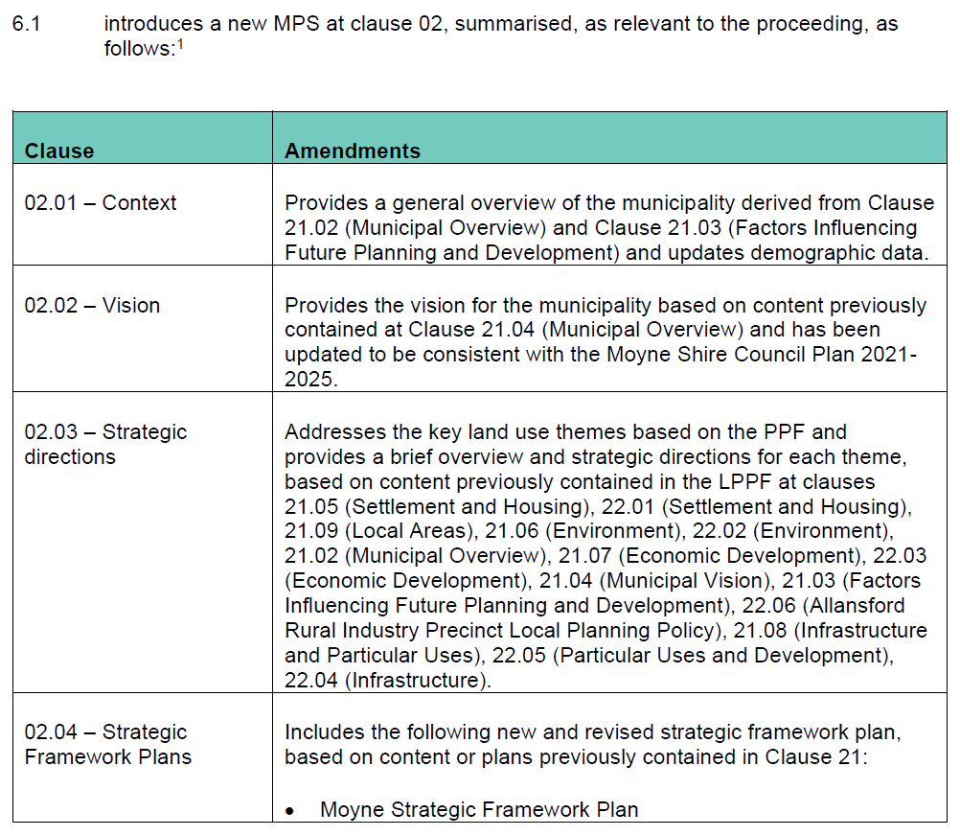



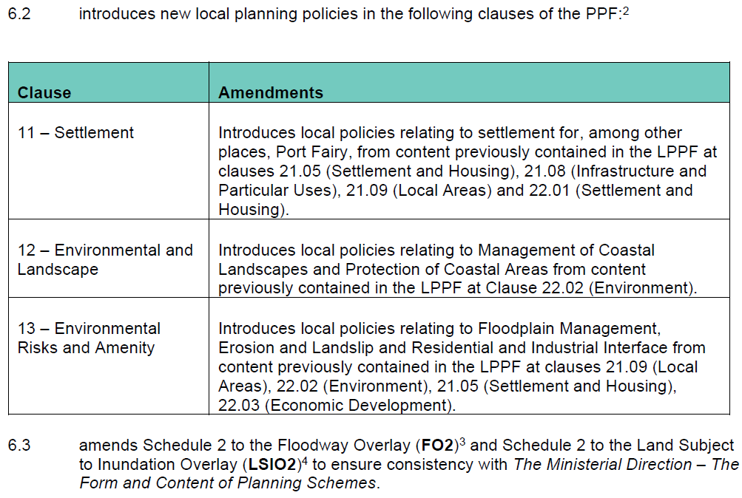

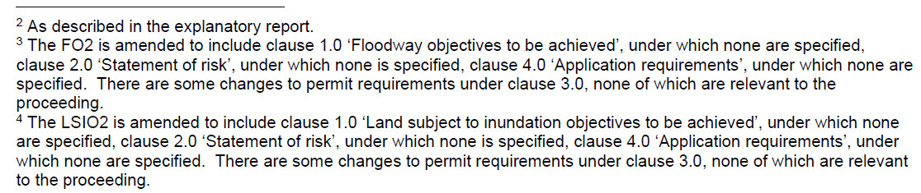

1. Amendment C74moyn introduced clause 13.03-1L – Floodplain management – Moyne, as follows:

**Policy application**

This policy applies to development on land affected by the Land Subject to Inundation Overlay or Floodway Overlay.

**Strategies**

Discourage the use of fill in areas prone to flooding.

Ensure safe access to habitable buildings in areas prone to flooding.

**Policy guidelines**

Consider as relevant:

* Achieving access to habitable buildings using flood free roads or other accessways that are subject to a depth of flooding of not more than 0.5 metres for storm events up to and including the 1 per cent Average Exceedence [sic] Probability standard.
* Implementing measures to avoid or minimise flood access risk, including emergency management and prevention plans.

1. The parties were afforded an opportunity to make further written submissions and / or submissions in response to another party’s submission with respect to Amendment C74moyn, and for completeness, any other planning scheme amendment to the Moyne Planning Scheme gazetted since the final day of the hearing on 11 May 2023.[11]
2. Post hearing submissions were received and considered by the Tribunal.

### Griffiths Street Plot

1. On 19 March 2023 the GHCMA provided document titled ‘Charts showing existing Griffiths St road surface elevation compared to road surface elevation required to bring 1% AEP flood depth over the road within safe access/egress criteria’ (‘Griffiths Street Plot’).
2. The permit applicant objected that the Griffiths Street Plot was provided by the GHCMA after the expert evidence of Mr Swan and as such Mr Swan was not able to provide evidence in relation to the plot.
3. The permit applicant made the following submissions in relation to this:

It follows that in circumstances where Tribunal has allowed the Griffiths Street Plot to be tendered and has only allowed submissions from the parties in relation to it, it should be very cautious to place weight on the document and the conclusions drawn by the CMA in relation to it in circumstances where:

a. it has been prepared by an officer the CMA, as opposed to its independent expert witness;

b. it is similar to the material filed in Mr Swan’s Addendum Statement of Evidence;

c. has not been reviewed by the independent expert witnesses, and

d. it has not been tested through cross examination. This is especially the case when the data was available at the time the relevant question was put to Mr Swan but chosen not to be produced.

1. However, GHCMA submit that the Griffiths Street Plot was provided by the GHCMA in response to two new issues raised by the permit applicant during their submissions. GHCMA stated those issues were:

* the Permit Applicant produced new documents relating to 190A Griffiths Street; and
* Mr Swan conceded in cross examination that he gave less weight to the risk associated with flood waters along Griffiths Street in the 1% AEP plus 0.8m sea level rise flood event.

1. The GHCMA submits that the Griffiths Street Plot forms part of the GHCMA’s response to both of these matters. The Griffiths Street Plot is in the same format as the plot that was prepared and filed with the Tribunal, without objection from any party, in response to new information that the council provided with respect to another nearby development that had been approved at 1 Hughes Avenue (‘Hughes Avenue Plot’).
2. Consistent with the preparation of the Hughes Avenue Plot information, the Griffiths Street Plot has been prepared by the flood engineers at the GHCMA by extracting the data from its flood model to identify flood levels and centreline levels along Griffiths Street.
3. The information provided on both the Hughes Avenue Plot and the Griffiths Street Plot is comparable for the 1 Hughes Avenue example.
4. Further, the table summarising the design flood levels and depths in Griffiths Street (refer Figure 13 below), as agreed by the experts and provided in the conclave report, is consistent with the information provided in the Griffiths Street Plots. Specifically, the design flood level and flood depth at ‘Griffiths Street Roadway’ for the 1% AEP plus 0.8m sea level rise flood event is consistent with the information provided in the Griffiths Street Plot.
5. For these reasons, I am satisfied that the Griffiths Street Plot was prepared in the same manner as the Hughes Avenue Plot, is of the same level of accuracy and can be relied upon in the same manner as the Hughes Avenue Plot, which Mr Swan had an opportunity to consider and give evidence in relation to. As such, the Tribunal considers that procedural fairness has been afforded to the permit applicant.

## Decision making context and relevant considerations

### Zoning and overlays

1. The subject land is located in the General Residential Zone – Schedule 1 (‘GRZ1’). The following overlays apply:

* Schedule 1 to the Environmental Significance Overlay (‘ESO1’);
* Schedule 6 to the Design and Development Overlay (‘DDO6’);
* Schedule 2 to the Floodway Overlay (‘FO2’); and
* Schedule 2 to the Land Subject to Inundation Overlay (‘LSIO2’).

1. The following permissions are sought:

* Clause 42.01-2 – Environmental Significance Overlay – A permit is required to construct a building or construct or carry out works.
* Clause 43.02-2 – Design and Development Overlay – A permit is required to construct a building or construct or carry out works.
* Clause 44.03-2 – Floodway Overlay – A permit is required to construct a building or construct or carry out works.
* Clause 44.04-2 – Land Subject to Inundation – A permit is required to construct a building or construct or carry out works.

1. The subject land is located in the FO2 and LSIO2. In accordance with clause 66.03, the GHCMA is a recommending referral authority under the Moyne Planning Scheme (‘scheme’) for applications in the FO and the LSIO. The GHCMA is the relevant expert authority for providing flood advice within this part of Victoria and has responsibilities for floodplain management.

#### General Residential Zone

1. No permit is required to use or develop the dwelling under the GRZ because ‘Dwelling (other than Bed and breakfast)’ is an as-of-right, section 1 use in the table of uses under clause 32.08-2.

#### Environmental Significance Overlay

1. The ESO1 concerns ‘Coastal areas and estuaries’.
2. The ‘statement of environmental significance’ is set out under clause 1.0 of the ESO1.
3. The ‘environmental objective to be achieved’ is set out under clause 2.0 of the ESO1.
4. Clause 4.0 of ESO1 requires all applications to be referred in accordance with section 55 of the PE Act to the referral authority as specified in the schedule to clause 66.04.
5. Under clause 1.0 of the Schedule to clause 66.04 the Department of Environment, Land, Water and Planning (‘DELWP’)[12] is identified as a determining referral authority and the GHCMA is identified as a recommending referral authority.
6. Council referred the permit application to the above referral authorities. DELWP did not respond.
7. The decision guidelines are set out under clause 5.0 of the ESO1 and clause 42.01-5.

#### Design and Development Overlay

1. The DDO6 concerns ‘Griffith [sic] Street North – Port Fairy Design Guidelines Character Area 2a’.
2. The design objectives are set out under clause 1.0 of the DDO6.
3. A series of built form requirements are set out under clause 2.0 of the DDO6.
4. The decision guidelines are set out under clause 5.0 of the DDO6 and clause 43.02-6.

#### Floodway Overlay

1. Part of the subject land is in an area of FO as shown below.

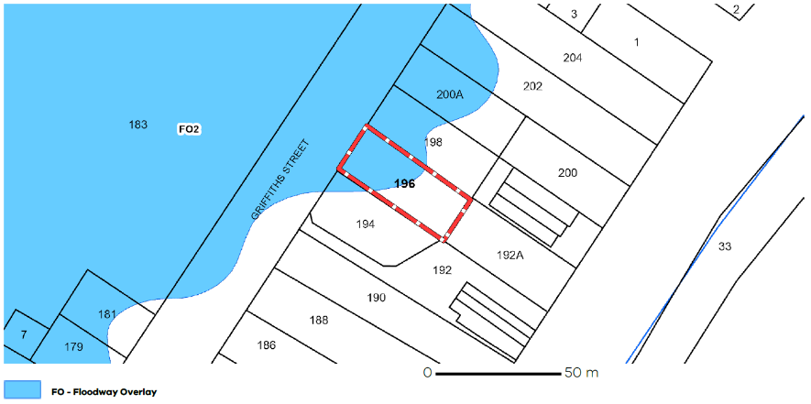

Figure FO2 with the subject land outlined in red (Source: Planning Property Report, Tribunal Book page 15)

1. The purposes of the FO are to (Tribunal emphasis added):

To implement the Municipal Planning Strategy and the Planning Policy Framework.

To identify waterways, major floodpaths, drainage depressions and high hazard areas which have the greatest risk and frequency of being affected by flooding.

To ensure that any development maintains the free passage and temporary storage of floodwater, minimises flood damage and is compatible with flood hazard, local drainage conditions and the minimisation of soil erosion, sedimentation and silting.

To reflect any declarations under Division 4 of Part 10 of the *Water Act, 1989* if a declaration has been made.

To protect water quality and waterways as natural resources by managing urban stormwater, protecting water supply catchment areas, and managing saline discharges to minimise the risks to the environmental quality of water and groundwater.

To ensure that development maintains or improves river and wetland health, waterway protection and flood plain health.

1. The relevant decision guidelines at clause 44.03-7 include (Tribunal emphasis added):

* The Municipal Planning Strategy and the Planning Policy Framework.
* The local floodplain development plan or flood risk report.
* Any comments of the relevant floodplain management authority.
* The Victorian River Health Strategy (2002) and any relevant regional river health strategy and associated wetland plan.
* Any other matters specified in a schedule to this overlay.

1. The decision guidelines in schedule 2 to clause 44.03 (i.e. clause 5 of the FO2) state:

The following decision guidelines apply to an application for a permit under Clause 44.03, in addition to those specified in Clause 44.03 and elsewhere in the scheme which must be considered, as appropriate, by the responsible authority:

* Port Fairy Local Floodplain Development Plan 2013

1. Clause 5.1 of the 2013 LFDP states that the FO2 applies to all land likely to convey active flood flows and/or store floodwaters to hazardous depths as a result of flooding of the Moyne River/Belfast Lough.

#### Land Subject to Inundation Overlay

1. Pat of the subject land is in an area of LSIO as follows.

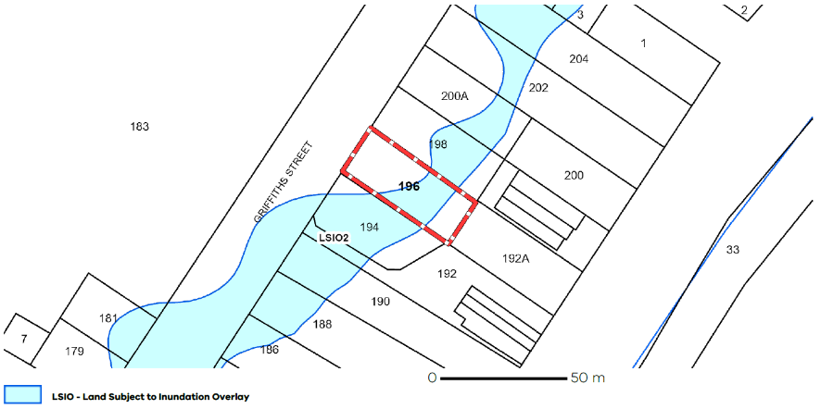

Figure LSIO2 with the subject land outlined in red (Source: Planning Property Report, Tribunal Book page 15)

1. The purposes of the LSIO are to (Tribunal emphasis added):

To implement the Municipal Planning Strategy and the Planning Policy Framework.

To identify flood prone land in a riverine or coastal area affected by the 1 in 100 (1 per cent Annual Exceedance Probability) year flood or any other area determined by the floodplain management authority.

To ensure that development maintains the free passage and temporary storage of floodwaters, minimises flood damage, responds to the flood hazard and local drainage conditions and will not cause any significant rise in flood level or flow velocity.

To minimise the potential flood risk to life, health and safety associated with development.

To reflect a declaration under Division 4 of Part 10 of the *Water Act, 1989*.

To protect water quality and waterways as natural resources by managing urban stormwater, protecting water supply catchment areas, and managing saline discharges to minimise the risks to the environmental quality of water and groundwater.

To ensure that development maintains or improves river, marine, coastal and wetland health, waterway protection and floodplain health.

1. The relevant decision guidelines include (Tribunal emphasis added):

* The Municipal Planning Strategy and the Planning Policy Framework.
* Any local floodplain development plan.
* Any comments from the relevant floodplain management authority.
* The existing use and development of the land.
* Whether the proposed use or development could be located on flood-free land or land with a lesser flood hazard outside this overlay.
* Alternative design or flood proofing responses.
* The susceptibility of the development to flooding and flood damage.
* The potential flood risk to life, health and safety associated with the development. Flood risk factors to consider include:
  + - The frequency, duration, extent, depth and velocity of flooding of the site and accessway.
    - The flood warning time available.
    - Tidal patterns.
    - Coastal inundation and erosion.
    - The danger to the occupants of the development, other floodplain residents and emergency personnel if the site or accessway is flooded.
* The effect of the development on redirecting or obstructing floodwater, stormwater or drainage water and the effect of the development on reducing flood storage and increasing flood levels and flow velocities.
* The effect of the development on river, marine and coastal health values including wetlands, natural habitat, stream stability, erosion, environmental flows, water quality, estuaries and sites of scientific significance.
* Any other matters specified in a schedule to this overlay.

1. The decision guidelines in schedule 2 to clause 44.04 (i.e. clause 5 of the LSIO2) state:

The following decision guidelines apply to an application for a permit under Clause 44.04, in addition to those specified in Clause 44.04 and elsewhere in the scheme which must be considered, as appropriate, by the responsible authority:

* Port Fairy Local Floodplain Development Plan 2013

1. Clause 5.1 of the 2013 LFDP states that the LSIO2 applies to all land on the fringe of the Moyne River/Belfast Lough floodplain subject to flooding.

### General and operational provisions

#### Clause 65 – Decision Guidelines

1. The general decision guidelines in clause 65 underpin all applications and includes the consideration of:

* Any significant effects the environment, including the contamination of land, may have on the use or development.
* The Municipal Planning Strategy and the Planning Policy Framework.
* The purpose of the zone, overlay or other provision.
* Any matter required to be considered in the zone, overlay or other provision.
* The orderly planning of the area.
* The degree of flood, erosion or fire hazard associated with the location of the land and the use, development or management of the land so as to minimise any such hazard.

#### Clause 71.02 – Operation of the Planning Policy Framework

1. Clause 71.02-3 relevantly recognises:

Victorians have various needs and expectations such as land for settlement, protection of the environment, economic wellbeing, various social needs, proper management of resources and infrastructure. Planning aims to meet these needs and expectations by addressing aspects of economic, environmental and social wellbeing affected by land use and development.

The Planning Policy Framework operates together with the remainder of the scheme to deliver integrated decision making. Planning and responsible authorities should endeavour to integrate the range of planning policies relevant to the issues to be determined and balance conflicting objectives in favour of net community benefit and sustainable development for the benefit of present and future generations. However, in bushfire affected areas, planning and responsible authorities must prioritise the protection of human life over all other policy considerations.

Planning authorities should identify the potential for regional impacts in their decision making and coordinate strategic planning with their neighbours and other public bodies to achieve sustainable development and effective and efficient use of resources.

### Policy Framework

1. Consideration must also be given to the policy framework that is relevant to the exercise of the discretion. The Tribunal has considered all of the relevant planning policies, including the provisions of: [13]

* Clause 02 – Municipal Planning Strategy*
  + Clause 02.01 – Context*
  + Clause 02.02 – Vision*
  + Clause 02.03 – Strategic Directions*
    - Clause 02.03-1 – Settlement*
    - Clause 02.03-2 – Environmental and landscape values*
    - Clause 02.03-3 – Environmental risks and amenity*
    - Clause 02.03-4 – Natural resource management*
    - Clause 02.03-5 – Built environment and heritage*
    - Clause 02.03-6 – Housing*
  + Clause 02.04 – Strategic Framework Plan*
* Clause 11 – Settlement
  + Clause 11.01 – Victoria
    - Clause 11.01-1L-01 – Settlement – Moyne*
    - Clause 11.01-1L-02 – Settlement – Port Fairy*
  + Clause 11.02 – Managing Growth
* Clause 12 – Environmental and Landscape Values
  + Clause 12.02 – Marine and Coastal Environment
    - Clause 12.02-1L-01 – Protection of coastal areas – Moyne*
    - Clause 12.02-1L-02 – Coastal landscapes*
* Clause 13 – Environmental Risks and Amenity
  + Clause 13.01 – Climate Change Impacts
    - Clause 13.01-1S – Natural hazards and climate change
    - Clause 13.01-2S – Coastal inundation and erosion
  + Clause 13.03 – Floodplains
    - Clause 13.03-1S – Floodplain management
    - Clause 13.03-1L – Floodplain management – Moyne*
* Clause 14 – Natural Resource Management
  + Clause 14.02 – Water
    - Clause 14.02-1S – Catchment planning and management
* Clause 15 – Built Environment and Heritage
  + Clause 15.01 – Built Environment
* Clause 16 – Housing
  + Clause 16.01 – Residential Development

1. A summary of some of the key objectives and strategies of these policies are set out below.

#### Clause 02.03-1 – Settlement

1. Under clause 02.03-1, Port Fairy is variously described as follows (Tribunal emphasis added):

**Port Fairy**

Port Fairy is the major business and administrative centre of the Shire and an historic coastal town that is a popular destination for tourists. Integral parts of the town’s character are the historic buildings around the town’s centre, the fishing port, Moyne River estuary, Griffith Island and its coastal setting.

It is a District Town with moderate growth capacity through infill development and some growth beyond existing urban zoned land, but within defined settlement boundaries.

Port Fairy is experiencing an increase in population driven by its attractive setting. Demand has been strong for new development, redevelopment of older properties and more intense forms of urban housing.

The population of Port Fairy increases substantially over the summer holiday period. Its tourism and recreation values include swimming and surfing beaches, recreational boating and fishing and a range of accommodation types. Due to the ongoing popularity of the Great Ocean Road region, development and tourism pressures are expected to increase.

Port Fairy has regional heritage significance because of its role in the European settlement of the area. Natural and cultural values include sites of indigenous and non-indigenous significance, scenic landscapes, wildlife viewing, and wetlands and ecosystems.

Port Fairy West is characterised by residential and tourist accommodation with rural uses in the western section.

Given Port Fairy’s proximity to the Southern Ocean, there is an increased risk of coastal inundation and erosion due to anticipated sea level rise.

1. The strategic directions of clause 13.01-1S include:

* Encourage growth within clearly established boundaries of townships and settlements to protect their character, protect adjoining farmland and ensure that the environment of the area is not compromised.

#### Clause 02.03-3 – Environmental risks and amenity

1. Clause 02.03-3 provides the following in relation to climate change impacts and floodplains:

**Climate change impacts**

The coast is under threat from the effects of climate change, including sea level rise and increased storm surges.

Rising sea levels may threaten land use and development due to eroding shorelines, increased cliff instability and landward penetration of saline water within estuaries. Development and infrastructure close to coastal and estuarine areas, including sea walls and other protective structures, may threaten the capacity of the environment to adapt to rising sea levels and increased tidal penetration.

**Floodplains**

The catchments within the municipality include areas of land prone to natural flooding. The inherent function of the floodplains to convey and store floodwater should be preserved to minimise the deterioration of environmental values, and manage flood risks to assets and communities.

1. Strategic directions under clause 02.03-3 include:

* Avoid development in coastal locations that may be affected by climate change impacts.
* Protect the function of existing flood ways.
* Minimise the potential for damage and risks to public safety and property from flooding.

#### Clause 02.03-5 – Built environment and heritage

1. Clause 02.03-5 provides the following in relation to built environment:

**Built environment**

Development occurring in coastal areas and between settlements and on highly visible sites has potential to affect landscape character. Larger, more ‘imposing’ dwellings, that are designed to maximise coastal views, often protrude above existing vegetation and natural landforms.

There is increasing pressure for substantial tourism development in coastal and non-urban locations. Other tourism-related development pressures relate to signs, car parking and viewing platforms.

1. Strategic directions under clause 02.03-5 include:

* Contain township development within defined boundaries and manage development on the fringes of townships to enhance the landscape setting.
* Provide for the reasonable sharing of views of significant landscape features, including views of the ocean, coastal shoreline, estuaries, wetlands and notable cultural features.

#### Clause 02.03-6 – Housing

1. Clause 02.03-6 provides the following in relation to housing:

**Housing**

The population of the Shire is growing, however, it is ageing and household size is declining.

The significant proportion of dwellings in the coastal towns are not permanently occupied, serving as holiday homes. This contributes to a lack of affordable worker accommodation, particularly during peak tourism periods.

Housing affordability and availability of long-term rental stock is declining in the Shire, and there is limited dwelling diversity, due to a low proportion of medium density and small dwellings in urban areas.

There is a need to provide well-located and accessible housing in the Shire to accommodate demand and attract new residents. However, housing growth is subject to infrastructure constraints, and can compromise environmental, heritage, landscape and neighbourhood character values.

The development of housing between settlements and in sensitive locations, such as areas of environmental or landscape significance, including the coastline, is an issue.

Ad hoc low density residential and rural living development has the potential to fragment productive agricultural land.

1. Strategic directions under clause 02.03-6 include:

* Encourage population growth within all areas of the Shire.
* Encourage a range of accommodation opportunities in settlements, including medium density housing, to suit the needs of the Shire’s residents.

#### Clause 02.04 – Settlement

1. The Moyne Strategic Framework Plan is provided in clause 02.04. Port Fairy is the only town within the Shire identified as having a ‘high settlement growth potential’, with Koroit, Macarthur and Mortlake identified as towns with ‘medium settlement growth potential’.

#### Clause 11.01-1L-02 – Settlement – Port Fairy

1. Clause 11.01-1L-02 provides and the Port Fairy Framework Plan, extracted below.

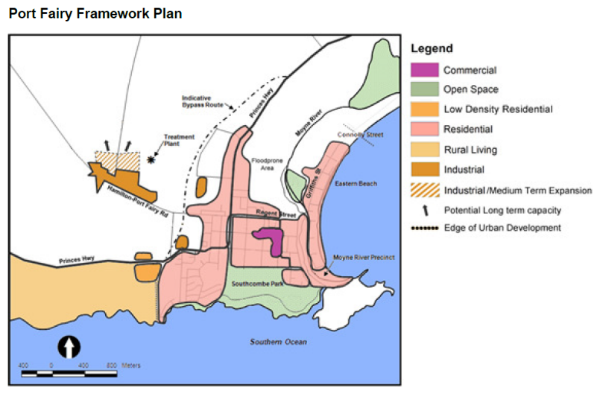

Figure Port Fairy Framework Plan (Source: Scheme, page 27 of 1062)

1. The Port Fairy Framework Plan shows residential areas in pink and has an annotation of ‘Floodplain Area’.

#### Clause 12.02-1L-01 – Protection of coastal areas – Moyne

1. Clause 12.02-1L-01 applies to land adjacent to the coastline including the area affected by the ESO1, including the subject land.
2. Strategies under 12.02-1L-01 are:

* Discourage the development or draining of limestone depressions.
* Ensure development provides substantial landscaping using environmentally suitable plant species to screen and blend development with coastal environs.
* Discourage new access roads leading to or running parallel with the coastline.
* Ensure that development minimises and clearly defines pedestrian and vehicular access through the coastal landscape to avoid potential visual and erosion impacts.
* Discourage the development of buildings and structures on sand dunes on free hold properties.
* Discourage soil removal and excavation close to the boundary of the coastal reserve.

1. Policy guidelines under clause 12.02-1L-01, to consider as relevant, are:

* Ensuring built form does not exceed 8 metres above natural ground level.
* Ensuring built form uses non-reflective exterior colours and materials.

#### Clause 13 – Environmental Risks and Amenity

1. Clause 13 is prefaced as follows (Tribunal emphasis added):

Planning should strengthen the resilience and safety of communities by adopting a best practice environmental management and risk management approach.

Planning should identify, prevent and minimise the risk of harm to the environment, human health, and amenity through:

* Land use and development compatibility.
* Effective controls to prevent or mitigate significant impacts.

Planning should identify and manage the potential for the environment and environmental changes to impact on the economic, environmental or social wellbeing of society.

Planning should ensure development and risk mitigation does not detrimentally interfere with important natural processes.

Planning should prepare for and respond to the impacts of climate change.

#### Clause 13.01-1S – Natural hazards and climate change

1. The objective of clause 13.01-1S is:

To minimise the impacts of natural hazards and adapt to the impacts of climate change through risk-based planning.

1. The strategies of clause 13.01-1S are to (Tribunal emphasis added):

* Respond to the risks associated with climate change in planning and management decision making processes.
* Identify at risk areas using the best available data and climate change science.
* Integrate strategic land use planning with emergency management decision making.
* Direct population growth and development to low risk locations.
* Develop adaptation response strategies for existing settlements in risk areas to accommodate change over time.
* Ensure planning controls allow for risk mitigation and climate change adaptation strategies to be implemented.
* Site and design development to minimise risk to life, health, property, the natural environment and community infrastructure from natural hazards.

#### Clause 13.01-2S – Coastal inundation and erosion

1. The objective of clause 13.01-2S is:

To plan for and manage coastal hazard risk and climate change impacts.

1. The strategies of clause 13.01-2S are to (Tribunal emphasis added):

Plan for sea level rise of not less than 0.8 metres by 2100 and allow for the combined effects of tides, storm surges, coastal processes and local conditions such as topography and geology when assessing risks and coastal impacts associated with climate change.

Ensure that land subject to hazards is identified and appropriately managed to ensure that future use and development is not at risk.

Avoid use and development in areas vulnerable to coastal inundation and erosion.

Respond to marine and coastal processes in the context of the coastal compartment type.

Assess the effectiveness, costs, benefits, impacts (direct, cumulative and synergistic) and path dependency of available adaptation options in the following order:

1. non-intervention

2. avoid

3. nature-based methods

4. accommodate

5. retreat

6. protect

Ensure that development or protective works that seek to respond to coastal hazard risks avoid detrimental impacts on coastal processes.

1. Clause 13.01-2S contains policy guidelines and policy documents to consider as relevant, including local coastal hazard assessments and localised projections.

#### Clause 13.03-1S – Floodplain management

1. The objective of clause 13.03-1S is (Tribunal emphasis added):

To assist the protection of:

* Life, property and community infrastructure from flood hazard, including coastal inundation, riverine and overland flows.
* The natural flood carrying capacity of rivers, streams and floodways.
* The flood storage function of floodplains and waterways.
* Floodplain areas of environmental significance or of importance to river, wetland or coastal health.

1. Relevant strategies of clause 13.03-1S include:

Identify land affected by flooding, including land inundated by the 1 in 100 year flood event (1 per cent Annual Exceedance Probability) or as determined by the floodplain management authority in planning schemes.

Avoid intensifying the impact of flooding through inappropriately located use and development.

Plan for the cumulative impacts of use and development on flood behaviour.

1. Clause 13.03-1S contains the following policy guidelines to consider as relevant:

* Regional catchment strategies and special area plans approved by the Minister for Environment or Minister for Water.
* Any floodplain management manual or guideline of policy and practice, or catchment management, river health, wetland or floodplain management strategy adopted by the relevant responsible floodplain management authority.
* Any best practice environmental management guidelines for stormwater adopted by the Environment Protection Authority.

1. Clause 13.03-1S contains the following policy documents to consider as relevant:

* Victorian Floodplain Management Strategy (Department of Environment, Land, Water and Planning, 2016)

#### Clause 13.03-1L – Floodplain management - Moyne

1. Clause 13.03-1L applies to development on land affected by the LSIO or FO, including the subject land.
2. The strategies of clause 13.03-1L are:

Discourage the use of fill in areas prone to flooding.

Ensure safe access to habitable buildings in areas prone to flooding.

1. Clause 13.03-1L contains policy guidelines to consider as relevant:

* Achieving access to habitable buildings using flood free roads or other accessways that are subject to a depth of flooding of not more than 0.5 metres for storm events up to and including the 1 per cent Average Exceedence [sic] Probability standard.
* Implementing measures to avoid or minimise flood access risk, including emergency management and prevention plans.

### Relevant policy documents

1. The following policy documents are relevant to the Tribunal considering the permit application:

* *Port Fairy Local Floodplain Development Plan 2013*;
* *Port Fairy Coastal and Structure Plan 2018*;
* *Translation of Port Fairy Coastal Hazard Assessment – Port Fairy Coastal and Structure Planning Project* (Cardno, 2019);
* *Applying for a Planning Permit under the Flood Provisions – Planning Practice Note 11* (August 2015);
* *Applying the Flood Provisions in Planning Schemes – Planning Practice Note 12* (June 2015); and
* *The Moyne Shire Flood Emergency Plan: A Sub-Plan of the Municipal Emergency Management Plan* (Version 3, March 2021).

1. Relevantsections of these documents are summarised below.

#### Port Fairy Local Floodplain Development Plan;

1. The Port Fairy Local Floodplain Development Plan 2013 (‘2013 LFDP’) is an incorporated document in the scheme under the schedule to clause 72.04 and is referenced in the decision guidelines to the FO2 and LSIO2.
2. The seriously entertained Amendment C69moyn seeks to replace the existing 2013 LFDP with a revised version. Council made substantial submissions about several versions of the LFDP which were developed during the amendment process, including:

* The Port Fairy Local Floodplain Development Plan, 2019 (‘2019 LFDP’) formed part of the original exhibited material when the Amendment was first exhibited from 14 May to 28 June 2020.
* In response to submissions, including principally the GHCMA’s submission, council prepared a further revised LFDP in December 2021 (‘2021 LFDP’). The 2021 LDFP was exhibited when the Amendment was re-exhibited from 16 December 2021 to 31 January 2022.
* The Panel’s report refers to a ‘Day 1’ version of the LFDP. This was a third iteration prepared in September 2022, accompanying council’s ‘Part A’ submission (‘2022 LFDP’).

1. Council’s description of the various versions of the LFDP are set out in Appendix A.
2. The description provided on the website for Amendment C69moyn also refers to a Port Fairy Local Floodplain Development Plan, 2023 (‘2023 LFDP’).
3. Key elements of both the current 2013 LFDP and the 2022 LFDP (which council submits forms part of the seriously entertained Amendment C69moyn) are summarised in the sections below.

##### 2013 LFDP

1. The current 2013 LFDP seeks to:

* establish minimum design and development performance criteria for buildings and works and subdivision both within and outside the township area of Port Fairy affected by the FO and LSIO; and
* provide a performance-based approach for floodplain development decisions. It seeks to implement a ‘best practice’ approach to minimising risk associated with development that is directly affected by flooding.

1. Clause 1.0 explains:

* applications for planning permits to develop land within the FO and LSIO in Port Fairy ‘must be consistent with the LFDP’; and
* the LFDP also establishes criteria that respond to specific characteristics of land within two separate areas in Port Fairy referred to as ‘Special Areas’. The subject land is identified in ‘Special Area A’, defined as an area entirely within the 1% AEP floodplain of the Moyne River and Belfast Lough as determined by the *2008 Port Fairy Regional Flood Study* (Water Technology, 2008) (‘2008 Flood Study’).

1. The flood information, including relevant studies, is set out under clause 3.0 of the LFDP. It relevantly states:

* The extent of flooding has been determined by the 2008 Flood Study and the 2010/2012 Sea Level Rise Modelling addendum reports (Water Technology, 2010 & 2012); and
* the flood levels and extents used for planning in Port Fairy are based upon 0.2m over the 100 year ARI flood.

1. Policy is set out under clause 6.0. Clause 6.2, titled ‘Exercising discretion’, relevantly states:

When a Planning Permit is required, it is policy to:

* Encourage construction of new buildings and works on land outside the LSIO and FO.
* Discourage the construction of new residential buildings within Special Area A shown on Figure 1.
* Discourage subdivision of parcels that could lead to intensification of development on land within the FO.
* With the exception of normal residential gardening activities – strongly discourage filling of the floodplain in all areas within the LSIO and FO unless it can be demonstrated that balanced cut and fill can be achieved consistent with the Glenelg Hopkins CMA Guidelines for Floodplain Cut and Fill.
* Preclude the construction of private levees.

1. ‘Performance criteria’ is set out under clause 6.3. It states (Tribunal emphasis added):

The following criteria apply to all land covered by the FO and LSIO.

New Buildings and Works including outbuildings and sheds exceeding 20m2 in floor area must:

* Be on the highest available natural ground
* Be constructed to minimise potential for disrupting flood water flow.
* Be constructed on stumps or piers and bearers unless the Glenelg Hopkins CMA has advised otherwise in writing.
* The construction of a new dwelling (excluding replacement dwellings) must be sited on land where the 100 year ARI flood depth is less than 0.5 metres above the natural surface level, and have an access way to the dwelling site from a main road that has a 100 year ARI flood depth not more than 0.5 metres
* New dwellings must not obstruct natural flood flow paths or drainage lines.
* The floor level of any new or replacement dwelling must be finished at least 0.6 metres above the 100 year ARI flood level. This level is known as the Nominal Flood Protection Level (NFPL).
* Dwellings should be aligned with their longitudinal axis parallel to the direction of flood flow.
* Dwellings must use water resistant materials up to NFPL.
* Outbuildings including sheds and garages should be:
  + - Aligned with their longitudinal axis parallel to the direction of flood flow.
    - Designed to minimise damage caused by flooding to the structure and its contents, such as by raising floor levels, using water resistant materials and raising electrical fittings above flood level.
    - Not more than 40m2 in area.

1. Clause 6.4, ‘Special Area A’, states (Tribunal emphasis added):

Special Area A shown in Figure 1 on Page 6 delineates land that is totally reliant on Griffith [sic] Street for access/egress during large floods. The majority of this land is on the Belfast Lough side of Griffiths Street, northeast of the Gipps Street Bridge. Special Area A also extends over a narrow strip of land to the south of the Gipps Street Bridge and covers portions of some lots on the ocean side of Griffiths Street.

The following design and development criteria apply to planning permit applications:

New Buildings

Buildings and works must comply with the following requirements in addition to those included under 6.3 above. While intensification of development in this area is generally discouraged, any remaining infill development opportunities that can reduce or manage access flood risk to acceptable levels will be considered.

* Dwellings proposed for land that relies on access that has a 100 year ARI flood depth greater than 0.5 metres may be approved when the risks associated with loss of road access due to flooding have been mitigated by either structural or non-structural means.

##### 2022 LFDP

1. The seriously entertained 2022 LFDP seeks to make material modifications to the performance criteria. The 2021 LFDP does not delineate the study area into precincts. The subject land is not identified in any form of special area (whereas previously the subject land was identified in ‘Special Area A’ in the 2013 LFDP) and the performance criteria are different.
2. ‘Performance criteria’ is set out under clause 6.0 and applies to all land within the FO and LSIO according to the relevant nominal flood protection level (‘NFPL’) requirements stipulated at clause 4.5.
3. All applications for development must not:

* reduce the capacity of the floodplain to store and convey floodwater;
* divert or impede the flow of floodwater; or
* adversely impact downstream or neighbouring land.

1. Specific performance criteria for ‘New or replacement buildings’ are provided at clause 6.3. It states (Tribunal emphasis added):

**New or replacement buildings**

New buildings must not be sited on land where the flood depth exceeds 500 millimetres or the product of velocity and depth (VxD) exceeds 0.4 metres squared per second; and

New or replacement buildings (excluding outbuildings and sheds) should:

* be sited on the highest available natural ground, unless it can be demonstrated to the satisfaction of the responsible authority and the Floodplain Management Authority that this is not viable;
* have an accessway to the building envelope that:
  + - does not traverse land where the flood depth is estimated to exceed 300mm during a 1% AEP flood event under the 0.8 metre sea level rise scenario; and
    - is not subject to flooding where the product of depth and velocity (VxD) exceeds 0.4 metres squared per second during the 1% AEP flood event;

be constructed to minimise potential for disrupting floodwater flow;

* be constructed on stumps (or piers) and bearers, unless the Floodplain Management Authority has advised otherwise in writing within three (3) months of lodgement of the application;
* be aligned with the longest wall parallel to the dominant direction of floodwater flow, unless:
  + - it can be demonstrated that this cannot be practically achieved, to the satisfaction of the Floodplain Management Authority and the responsible authority; or
    - the Floodplain Management Authority has advised in writing that an alternative alignment is acceptable, no more than three (3) months prior to lodgement of the application;
* be constructed of water resistant building materials up to the NFPL;
* be constructed of salt resistant building materials up to the NFPL within the area prone to storm tide flooding;
* be designed and constructed so that:
  + - the ground surface under raised building floors is sloped or mounded to ensure floodwater freely drains away from the sub floor area; and
    - any subfloor structure cladding is of an open style (such as spaced timber boards) to allow entry and exit of floodwater; and
* have building fill pads constructed in accordance with the Floodplain Management Authority Guidelines for Floodplain Cut and Fill, where deemed acceptable by the Floodplain Management Authority.

1. ‘Decision Guidelines’ are set out under clause 7.0. It states (Tribunal emphasis added):

Before deciding on an application, the responsible authority must consider (as appropriate) whether the proposed development:

* can be located on land on the property outside the FO and LSIO, to prevent to prevent creation of further legacy floodplain management challenges and increased vulnerability of persons and structures to potential flood damage;
* minimises risk of negative impacts from flooding on persons, property, and/or infrastructure, particularly in relation to existing residents or other properties (includes generating risk where none previously existed, and intensifying existing risk by exacerbating flood characteristics);
* minimises the risk of residents becoming isolated from essential services and supplies during a flood event, and the danger posed to emergency personnel in reaching such residents during large floods;
* maintains free passage and temporary storage of floodwaters, and otherwise avoids altering flood behaviour;
* is designed and uses appropriate materials and constructions methods to minimise the likelihood of damage by water (including salt water); and
* maintains a vegetated buffer to drainage corridors to minimise erosion of stream banks and verges during large floods and maintain the natural drainage function, stream habitat, and wildlife corridor and landscape values.

1. The 2022 LFDP also provides a definition for accessway as follows:

An accessway is the path or route within a property used to approach a public road or floor safe space. An accessway can be referred to as a driveway.

#### Port Fairy Coastal and Structure Plan 2018;

1. In August 2018, council adopted the Port Fairy Coastal and Structure Plan (‘PFC&SP’). The PFSCSP seeks to inform and guide sustainable and equitable growth and development in Port Fairy.
2. In the ‘Overall Structure Plan’ map shown below, the subject land (denoted by the yellow star) is identified in the ‘Coastal settlement boundary’, to the immediate south-west of the ‘Township Gateway’ (denoted by the orange circle).

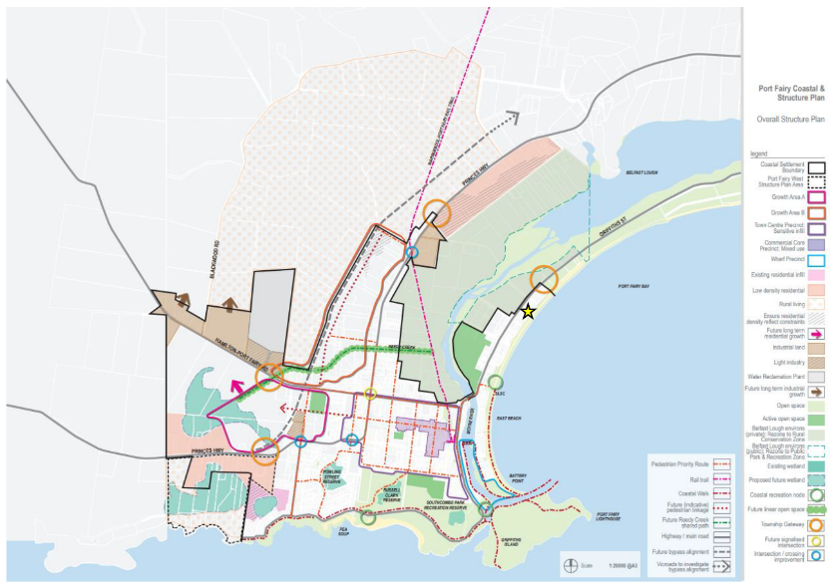

Figure PFC&SP Overall Structure Plan map with the subject land denoted by the yellow star (Source: Council Submissions dated 27 February 2023)

1. In the ‘Settlement & Housing Plan’ map shown below, the subject land (outlined in red) is in the area denoted ‘East Beach Precinct / Griffiths Street & Wharf Precinct - Restricted infill’.

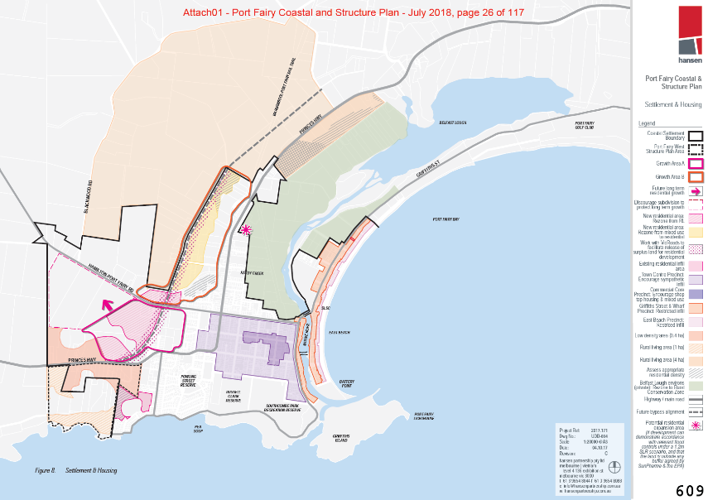

Figure PFC&SP Settlement & Housing Plan map with the subject land outlined in red (Source: Tribunal Book, page 609)

1. ‘Preferred housing outcomes’ are set out for various precincts. The section relevant to the ‘East Beach Precinct / Griffiths Street & Wharf Precinct - Restricted infill’ states:

Given the constraints caused by coastal hazards such as erosion and inundation affecting this area and the significant long term access issues associated with these, this area will not play a meaningful role in accommodating future residential growth in Port Fairy. Outside of areas affected by potential coastal hazards, the development of housing in keeping with the existing character established through the current design controls should be maintained. This is one of the more ‘sensitive’ residential areas and the quality of the design response in this area should reflect this.

1. The strip of properties between the subject site and the beach are identified in this map as an ‘Existing residential infill area’.
2. The subject land is identified within an area of ‘coastal erosion hazard’ in Figure 16 of the PFC&SP.
3. That part of East Beach behind it is identified in Figure 16 of the PFC&SP as:

Extension and upgrade of rock seawall along East Beach, prioritising those areas at extreme or high risk & implement a beach renourishment program along the southern end of East Beach, with sand sourced locally.

1. Under the heading ‘Planning Decisions: Coastal Inundation’, it states:

There are a number of planning decisions that Council may have to make in relation to planning applications in areas affected by coastal hazards. These can be categorised in two key groups as follows:

* **Category A - Rezoning**: Decisions on where to allow new opportunities for the use and / or development of land.
* **Category B - Use & Development**: Decisions on support for a use, development or works currently contemplated under existing zoning.

1. Under the heading ‘Category B – Use & Development’, it states:

There are a number of planning decisions that Council will need to make on existing zoned land which is identified as being subject to flood risk. These can be categorised as follows:

…

* New single dwellings: where there is a vacant lot with no existing dwelling and a new dwelling is proposed.

…

The appropriateness of each of approval for each of these decisions is likely to vary depending on the context of the land subject to the application and level of risk. Details of the recommended Planning Response are discussed further in Appendix Two.

1. Appendix two provides the following under the heading ‘Flood Related Overlays’ (Tribunal emphasis added):

A Floodway Overlay (FO) should be applied to areas which are identified as Hazard Class 3 or more as mapped under current scenarios for a 1.2m sea level rise. The magnitude of additional height that would be required to achieve appropriate floor levels (which would be at least a 1.1m increase) mean a ‘design’ response is unlikely to be appropriate in these areas. The depth of potential inundation these areas, which will increase further over time mean that supporting further development within these areas is problematic. Other areas identified as being affected by flooding or within a ‘swash zone’ should have a Land Subject to Inundation Overlay (LSIO) applied. While the purpose of the LSIO indicates a traditional focus on riverine flooding, the ‘purpose’ of this overlay is sufficiently broad as to make its use in managing coastal inundation appropriate in the absence of a more specific controls.

The introduction of these overlays should be supported by the introduction of a new content within the MSS of the Moyne Planning Scheme to ensure that the key components of this policy and associated decision guidelines have statutory weight.

Decision Guidelines relating to coastal hazards should also be included within the PFLFDP, having regard to the particular issues which relate to coastal inundation which is anticipated to increase in severity over time and the context of the land subject to the overlay in relation to any associated mitigation works undertaken by the Council.

However, the particular characteristics of Port Fairy mean a more nuanced approach is considered warranted as this will allow specific permit triggers and permit requirements to reflect the differences between areas of the township. The Port Fairy Local Floodplain Development Plan (PFLFDP) allows for both the broad approach to development assessment in flood affected areas to be outlined, but also for area specific approaches to be documented.

1. Various ‘Coastal Inundation Precincts’ are set out in Figure 24 of the PFC&SP. The subject land is identified within the ‘East Beach & Warf Precinct’ depicted below.

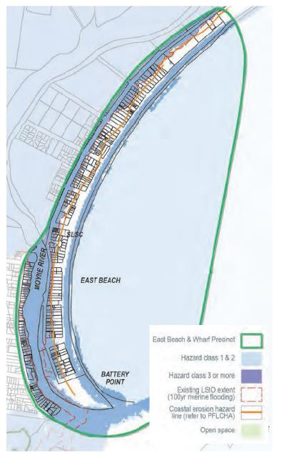

Figure PFC&SP Coastal Hazards: East Beach & Warf Precinct map (Source: Tribunal Book, page 690)

1. The section relevant to the ‘East Beach & Wharf Precinct’ states (Tribunal emphasis added):

**East Beach & Wharf Precinct**

East Beach is likely to become increasingly impacted by not only coastal inundation but also coastal erosion. While Council have adopted a position of ‘defending’ Port Fairy, in the long term it is unclear if this will be feasible or achievable in relation to the East Beach area which is impacted from both the east and west. In addition, concerns regarding access in a major flooding event have been identified given the proximity of Griffiths Street to the Lough and depth of inundation proximate to the single bridge.

The majority of land in this precinct affected by flooding is identified as being above CHC2 and as such, no further development should be approved, other than appropriate alterations and additions. The combination of these factors has led to a relatively conservative approach to support for development in this area even in areas where an LSIO is proposed. Where existing dwellings are located within the proposed LSIO extent it is considered reasonable to allow for the development of a replacement dwelling or for alterations and additions as this will not provide an increase in the density of dwellings. No sensitive non-residential uses (i.e. aged care, child care) should be supported in areas impacted by flooding.

Areas HC3 and above (Floodway Overlay):

* No subdivision.
* No medium density development.
* No approvals for new dwellings or replacement dwellings or alteration and additional greater than 20sqm.
* Permit trigger for alterations and additions of less than 20sqm subject to conditions.
* No policy support for sensitive uses.

Areas HC2 & HC1 (Land Subject to Inundation Overlay):

* No subdivision.
* No medium density development.
* No single dwellings.
* Permit trigger for replacement dwellings subject to design and appropriate access.
* Permit trigger for alterations and additions of more than 20sqm subject to design and appropriate access.
* No permit trigger for alterations and additions below 20sqm subject to conditions.
* No policy support for sensitive uses.

1. The FO presented in the PFC&SP refers to the areas which are identified as Hazard Class 3 or more as mapped under current scenarios for a 1.2m sea level rise.[14]
2. In contrast, in the 2022 LFDP, the FO is based on a combined 1% and 5% AEP riverine/ocean storm tide flood event assuming a 0.8m increase in existing sea level conditions (i.e. without incorporating any future sea level rise). The FO includes those areas inundated in such a flood event, which will experience a class 3 or above flood hazard.[15]

#### Translation of Port Fairy Coastal Hazard Assessment - Port Fairy Coastal and Structure Planning Project (Cardno, 2019)

1. The policy guidelines of clause 13.01-2S include to consider as relevant local coastal hazard assessments and localised projections.
2. The Translation of Port Fairy Coastal Hazard Assessment (‘Cardno Assessment’), dated 27 September 2017, seeks to:

* analyse expected hazards and risks associated with coastal inundation at Port Fairy;
* develop datasets to be combined to best understand and identify the coastal risks for planning purposes; and
* inform the second stage of the project, utilising a risk based approach to develop appropriate planning controls for coastal inundation and erosion.

1. The Cardo Assessment annexes mapping of various flood scenarios to illustrate probable outcomes based on the depth of water, velocity of flows and the hazard class and other factors. The scenarios ranged from present day through to 2100:

* present day maps allow 0.2 sea level rise;
* 2030 maps allow 0.4 sea level rise;
* 2050 maps allow 0.8 sea level rise; and
* 2100 maps allow 1.2 sea level rise.

1. The maps annexed to the Cardno Assessment seek to provide a comprehensive analysis of the risk of coastal inundation at Port Fairy for sea level rises of up to 1.2m, intended to provide guidance for decision makers in developing appropriate planning controls for coastal inundation and erosion.

#### Applying for a Planning Permit under the Flood Provisions – Planning Practice Note 11

1. *Applying for a Planning Permit under the Flood Provisions – Planning Practice Note 11* (‘Practice Note 11’) is a relevant matter under section 60(1A)(g) of the PE Act.[16]
2. Practice Note 11 provides guidance on making a planning permit application where flooding is evident. Practice Note 11 explains how the application is determined and what is considered in the decision making process by the relevant authorities.
3. Practice Note 11 suggests that relevant authorities should consider a list of decision guidelines when determining or commenting on an application affected by flooding which include:

* A development must be consistent with:
  + - the SPPF (clause 13.02)[17]
    - any flood-related statements made in the MSS (clause 21) and local planning policies (clause 22) of the planning scheme[18]
    - any other development guidelines agreed to by the council and the floodplain management authority.

…

* The potential impact of an extreme event larger than the 100-year ARI flood on life, health, safety and damage.

…

* The possibility of relocating that development to land which is flood-free or which has a lesser risk.
* Residential, commercial and industrial buildings are not generally an appropriate development on floodway land in view of their potential for flood hazard and for obstruction of flood flows.

…

* The incremental long-term effects of developments. While a single development may not cause a significant change, the cumulative effect of several similar developments may be substantial.
* The design of buildings should adopt flood-proofing measures that minimise the physical effects of flooding on the building structure and its contents.

1. Practice Note 11 states that a development should be refused if it is likely to cause an unacceptable increase in flood risk in the following situations:

* it is likely to result in danger to the life, health and safety of the occupants due to flooding of the site
* it relies on low-level access to and from the site
* it is likely to increase the burden on emergency services and the risk to emergency personnel
* it is likely to increase the amount of flood damage to public or private assets
* it is likely to obstruct flood flows or reduce natural flood storage. The capacity of land subject to inundation to convey and store floodwater must be maintained
* …
* if any subdivision, development or redevelopment is likely to increase the number of buildings located in a floodway area.

#### Applying the flood provisions in planning schemes – Planning Practice Note 12

1. Council considers *Applying the flood provisions in planning schemes – Planning Practice Note 12*, June 2015 (‘Practice Note 12’) a policy document relevant to the Tribunal in considering the permit application. This is a relevant matter under section 60(1A)(g) of the PE Act.
2. Planning Practice Note 12 seeks to provide guidance about applying the flood provisions in planning schemes.
3. Council provides the following summary of key statements:

* The level of planning control in each [of the Urban Floodway Zone (UFZ), Floodway Overlay (FO), Land Subject to Inundation Overlay (LSIO) and Special Building Overlay (SBO)] is commensurate with the potential flood risk.
* The UFZ is a restrictive provision that prohibits most uses and development. It is designed to be applied to urban environments where there is a high potential flood risk and only low intensity uses and development (such as recreation) are suitable. In contrast, the LSIO is used for both urban and rural environments to identify land with a lower potential flood risk or as an interim measure, areas where accurate flood mapping to identify the floodway is yet to be carried out. The LSIO only requires a permit for buildings and works and does not prohibit either use or development.
* The UFZ applies to urban areas where the potential flood risk is high and strict controls over land use are required. The three overlays (FO, LSIO and SBO) cover a range of situations in both urban and rural areas where the potential flood risk is less than in the UFZ, and where control over development (buildings, works and subdivision) and not land use, is sufficient.

#### Moyne Shire Flood Emergency Plan

1. The *Moyne Shire Flood Emergency Plan: A Sub-Plan of the Municipal Emergency Management Plan* (Version 3, March 2021) (‘MSFEP’) was prepared by council in conjunction with the Victoria State Emergency Service (‘VICSES’).
2. The Port Fairy Flood Emergency Plan forms Appendix C1 to the Emergency Plan.
3. Table 6 (‘Key assets at risk of flooding’) identifies key assets at risk of flooding, the likely consequences, mitigation actions and the relevant lead agency.
4. Two relevant ‘key assets’ are highlighted below:

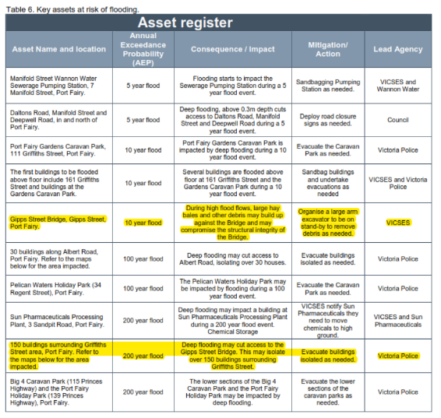

Figure Key assets at risk of flooding (Source: Council Submissions dated 27 February 2023)

1. Table 7 further explains that, in a ‘1 in 200 year AEP flood event’:

Deep flooding may cut access to the Gipps Street Bridge, this will isolate over 150 buildings for approximately 12 to 24 hours.

1. The Guidelines go on to say:

It is important to note that if flooding cuts access to the Gipps Street Bridge, this will isolate more than 150 buildings for more than 12 hours. Refer to map below showing the buildings that may be isolated. It is recommended that when there is an indication that flooding will reach a 1 in 200 year AEP flood event, the Victoria Police evacuation team may need to coordinate door knocking of residents at risk of being isolated. This will allow residents to decide to leave before the flood peak arrives, cutting access. Key messages to communicate to residents when undertaking door knocking include:

* Access to the Gipps Street Bridge will be cut, you may be isolated for 12 to 24 hours.
* Your sewerage system may be impacted by flooding and may not work.
* You must leave now if you choose to do so. Emergency Services do not have the capacity to assist everyone when access is cut.

1. Section 3.6 (‘Evacuation’) states:

…Once the decision is made VICPOL are responsible for the management of the evacuation process where possible. VICSES and other agencies will assist where practical. VICSES is responsible for the development and communication of evacuation warnings.

### Best practice manuals and guidelines

1. The policy guidelines of clause 13.03-1S include to consider as relevant:

Any floodplain management manual or guideline of policy and practice, or catchment management, river health, wetland or floodplain management strategy adopted by the relevant responsible floodplain management authority.

#### Guidelines for Development in Flood Affected Areas

1. The GHCMA and council consider the *Guidelines for Development in Flood Affected Areas*, February 2019 (‘DELWP Guidelines’) a policy document relevant to the Tribunal in considering the permit application.
2. The DELWP Guidelines provide an assessment framework and method to assist decision-makers in considering development proposals within flood affected areas. They are intended to be used with the land use planning and development system.
3. Part 3 of the DELWP Guidelines – Assessing development proposals, sets out four key objectives for floodplain managers, in this case, Melbourne Water, to assess development proposals against:

**Objective 1 – Safety:**

Protect human life and health and provide safety from flood hazard.

* Applies to all development proposals.
* Proposals that are unable to meet the safety objective will be rejected.

**Objective 2 – Flood damage:**

Minimise flood damage to property and associated infrastructure.

* Applies to building proposals
* The objective is usually satisfied by setting floor level requirements as a condition of permit.

**Objective 3 – Offsite impacts:**

Maintain free passage and temporary storage of floodwaters.

* Applies to buildings and works in flow conveyance and flood storage areas, including those associated with a subdivision.
* The objective is usually satisfied by siting the works appropriately.
* Requirements are reinforced through conditions of permit. Sometimes design modifications are necessary.

**Objective 4 – Waterway and floodplain protection:**

Protect and enhance the environmental features of waterways and floodplains.

* Applies to subdivisions, buildings and works near waterways and those parts of the floodplain that are regularly flooded.
* The objective is usually satisfied by incorporating setbacks, works to prevent harm and appropriate vegetation into site plans.
* Requirements are reinforced through conditions of permit

1. The Tribunal considers Objective 1, relating to flood safety, to be a relevant consideration in this proceeding. Objective 2, relating to flood damage, is considered to be met as the proposal is to be constructed of flood resistant materials, areas which are not required to meet freeboard requirements (carport and front deck) are not structurally connected to the main dwelling, and the floor level is set 600mm above the expected 1% AEP plus 0.8m sea level rise flood event. Objective 3 relating to offsite impacts were not considered relevant to the assessment as, whilst the proposal includes earthworks as part of the proposed flood risk management measures, the GHCMA did not raise any concerns about the potential for offsite flood impacts. None of the parties raised concerns relating to Objective 4.
2. The DELWP Guidelines draw a distinction between the development of various uses and establish different criteria for development based on those uses. Table 3 of the DELWP Guidelines provides safety criteria for development (other than subdivisions). Part of this table, relevant to the development of a single dwelling, is extracted in the figure below.

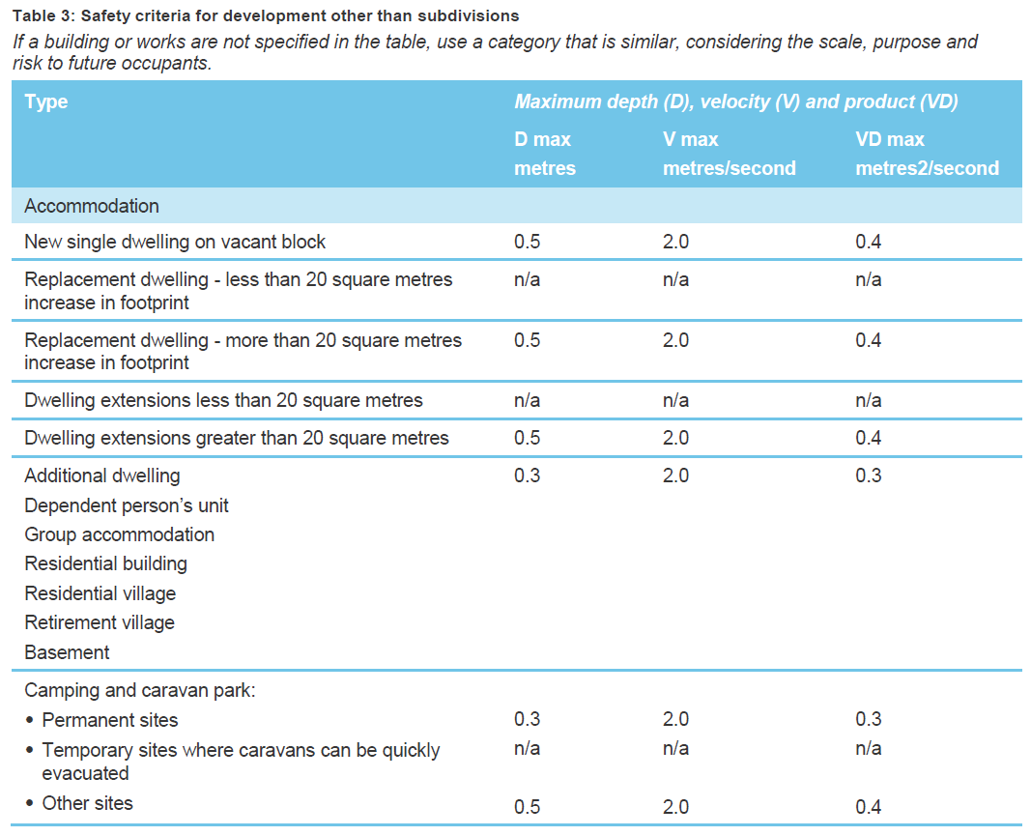

Figure DELWP Guidelines – Extract of part of Table 3: Safety Criteria for development other than subdivisions (Source: DELWP Guidelines page 33)

1. The DELWP Guidelines state that all proposed development should satisfy the safety requirements specified in Table 3, which are based on three categories:

* Building stability for residential development and other lightly constructed buildings.
* The safety of small children evacuating on foot.
* The stability of small cars being driven though floodwater.

1. The proposed development falls under the ‘Accommodation’ section of Table 3 and the ‘New single dwelling on vacant block’ type. For this type, Table 3 provides:

* maximum depth (‘D max’) of 0.5m;
* maximum velocity (‘V max’) of 2.0 metres/second (‘m/s’); and
* maximum product (‘VD max’) of 0.4 metres2/second (‘m2/s’).

1. Given the subject land is in an area of low flow velocity, with the maximum velocity no greater than 0.1m/s, the flood depth is the key factor for this site when considering flood safety.
2. In relation to isolation, the DELWP Guidelines state that (Tribunal emphasis added):

**Isolation**

How long floodwaters remain present can also be important if it leads to people being isolated. Isolation can result in people entering unsafe floodwaters to access services, employment or family members. Any situation that increases people’s need to cross floodwaters increases the likelihood of an injury or fatality.

The impacts of isolation include:

* People are cut off from transport, drinking water, medical treatment, sewerage and electricity.
* People can run out of food and drinking water.
* It diverts limited resources of emergency services away from other activities.
* Anxiety (as rescue may not be possible).

For this reason, consideration needs to be given to ensuring there are safe, external connecting routes that do not lead to isolation. They should safely connect to emergency relief services, not just to the nearest high ground.

Isolation is not an issue for short duration flooding, such as occurs when urban drainage systems are overloaded. How quickly floodwaters rise and fall does become important however, as it restricts the time available for safe evacuation, and flow velocities can often still be quite high. Judgement is still required about the exposure of people to flood debris, the length of an evacuation route through floodwater and the likelihood of being swept into deeper floodwater.

1. In relation to depth and flow of flood waters, the DELWP Guidelines state that (Tribunal emphasis added):

**Depth and flow**

People attempting to enter or leave a property during a flood should not be endangered by deep or fast-flowing water. This includes emergency response personnel, property occupants and visitors.

The areas of most interest are:

* around building envelopes
* at entrance and exit points to buildings
* along driveways and internal connecting routes to outbuildings and car parking
* along external connecting routes leading to safety.

Buildings and their foundations must also be safe from collapse or erosion.

The depth and velocity of floodwaters are key determinants of flood safety. Table 1 shows the thresholds applying for the three categories.

1. In relation to safe access for infill development, the DELWP Guidelines state that (Tribunal emphasis added):

**Safe access for infill development**

Proponents for infill development or redevelopment usually have no control over the access from the site to safe ground. This can be challenging for communities with a high flood risk. Requiring a shop floor to be built 1.5 metres above the footpath creates access issues for those unable to use stairs, for example.

Proposals that increase the population at risk should follow the requirements for safe access. For example, subdivision in a residential area should not be supported if the depth and velocities exceed the thresholds in Table 2, because it increases the population affected. Likewise, Table 3 provides restrictions to buildings in unsafe areas: replacement structures and small expansions are acceptable, but not other development.

Wherever possible, the criteria relating to floor level heights should be followed, particularly for dwellings. As can be seen from the example of a shop, there may be instances in which floodplain managers use their discretion to reduce minimal floor level requirements, after considering:

* the scale of the proposal and its purpose
* site constraints
* the amount of flood warning time
* the distance to safe ground.

Where discretion is exercised, a flood emergency plan may be required. The plan sets out appropriate actions to minimise flood damage, risk to occupants, and demands on emergency services.

#### Victorian Floodplain Management Strategy

1. Clause 13.03-1S includes a policy guideline to consider as relevant the *Victorian Floodplain Management Strategy* (‘VFMS’)[19].
2. The VFMS incorporates important lessons learnt from the 2010, 2011 and 2012 floods, and the subsequent review into the effectiveness of flood warning and response systems, and inquiry into flood mitigation infrastructure. In Chapter 5, titled ‘Aligning the Victorian and national approaches to emergency management and disaster resilience’, the VFMS states that ‘Victoria follows the national approach set out in the *Australian Emergency Management Handbook* from a flood study to on-ground action.’
3. As stated in the DELWP Guidelines, the VFMS sets the direction for floodplain management in Victoria. Part 2, ‘avoiding or minimising future risks,’ endorses the use of planning controls to manage the potential growth in risk. The DELWP Guidelines respond to Objective 3 in the VFMS: ‘not making things worse.’

#### ADR Handbook Collection

1. The *Australian Disaster Resilience Handbook Collection*[20] (‘ADR Handbook Collection’) is published by the Australian Institute for Disaster Resilience (‘AIDR’) and provides guidance on national principles and practices for disaster resilience.
2. *Handbook 7 Managing the Floodplain: A Guide to Best Practice in Flood Risk Management in Australia*[21] (‘FRM Handbook’) is relevant to the Tribunal’s consideration.
3. The GHCMA’s expert, Mr Molino, gave evidence that the FRM Handbook provides best practice guidelines for floodplain management under Australian conditions.
4. The FRM Handbook is referenced in the bibliography of both the *Victorian Floodplain Management Strategy* and the DELWP Guidelines and provides a guide to the best practice approaches to flood risk management in Australia.
5. The FRM Handbook provides the following guidance for shelter in place (Tribunal emphasis added):

There are some limited instances where an individual house or commercial development may be designed as a shelter during a flood event. This would generally only be considered appropriate in existing developed areas:

* that have no other practical management options available
* where evacuation is not possible due to lack of flood warning
* the development is outside flow conveyance areas
* it is likely to be safer to shelter in place than to try and evacuate at the wrong time.

This approach generally involves risk reduction by replacing existing flood-affected development with less vulnerable development of the same density.

The structure should be designed for flood impacts with suitable water-resistant structural materials, and be designed to have some habitable floor area above, and to withstand the forces of, the PMF. Even in the case of shelter in place, occupation during a flood may be without water, sewerage, electricity, communications and other services, and the house will be isolated (and there is no safe duration of isolation). These factors all increase the risk of a need for rescue or on-site assistance due to, for example, the need for medical attention, on-site risks such as house fire (exacerbated by lack of electricity and difficult to extinguish due to isolation) and the need for basic supplies.

These factors can impose additional loads on emergency services during floods. For these reasons, shelter in place is a last resort option, normally only appropriate for existing flash-flood environments.

1. In the absence of incorporated guidance in the planning scheme or the DELWP Guidelines, I rely on the guidance in the FRM Handbook as an indication of best practice for the application of shelter in place.

## What are the key issues?

1. Council made the following submissions:

* In strategic terms, the proposal is consistent with the purposes of the GRZ and indeed anticipated given the use is as-of-right. The proposal also accords with relevant State and local policy relating to settlement, residential development and built form expectations.
* The subject land enjoys numerous physical attributes rendering it appropriate to be developed with a dwelling. These include its substantial size, its infill location within existing residential development and convenient access to the town centre, including a range of retail, commercial, educational and public recreation uses. The subject land is also in proximity to public transport.
* The proposal responds acceptably to the design objectives and requirements of the Design and Development Overlay – Schedule 6 (‘DDO6’), so too the environmental objective to be achieved and design guidelines under the ESO1, acknowledging the subject land is vacant and devoid of any significant vegetation.

1. Council submits that the sole issue in dispute is whether the flooding risks associated with the proposal are appropriately mitigated so as to minimise those risks to an acceptable level. Council also submits that, consistent with the requirement for integrated decision making under clause 71.02-3, it is incumbent on the decision-maker to integrate the range of planning policies relevant to the issues to be determined and balance conflicting objectives in favour of net community benefit and sustainable development for the benefit of present and future generations.
2. The GHCMA does not offer a view about the permit applicant’s response to built form and character issues. The GHCMA made submissions that they do not comment on these matters as they are not relevant to the consideration of the flooding and floodplain management. GHCMA however did make submissions in relation to housing and settlement policy. This is discussed further in the section on integrated decision making below.
3. The permit applicant submits that an integrated approach is required having regard to all relevant policy in this case. They note that whilst the substance of their submissions necessarily focus on matters related to flooding, the balancing of policy relating to flood risk management is one consideration in a larger policy framework under the relevant permit triggers.
4. I agree with council’s assessment that the proposal is:

* consistent with the GRZ;
* accords with the relevant State and local policy relating to settlement, residential development and built form expectations;
* responds acceptably to the design objectives and requirements of the DDO6; and
* responds acceptably to the environmental objective to be achieved and design guidelines under the ESO1.

1. I also agree with council that the remaining issue for consideration in this matter is whether the flooding risks associated with the dwelling can be appropriately mitigated to ensure the risk is an acceptable risk. The substance of this decision will necessarily focus on matters related to flooding, but it is only one issue in the balancing of policy in a larger policy framework under the relevant permit triggers.

## Are there unacceptable flood risk impacts?

### What is the flood hazard to be considered?

1. The subject land sits within a narrow piece of land between the Moyne River and the Southern Ocean. Much of its surrounds is subject to flooding which is influenced by riverine, ocean and tidal activity. During flood events high tides reduce the rate that floodwater flows out of the Moyne River into the Southern Ocean. High tides may extend the duration of flooding in Port Fairy.
2. The subject land is currently subject to the FO2 and the LSIO2 as shown in the figure below.

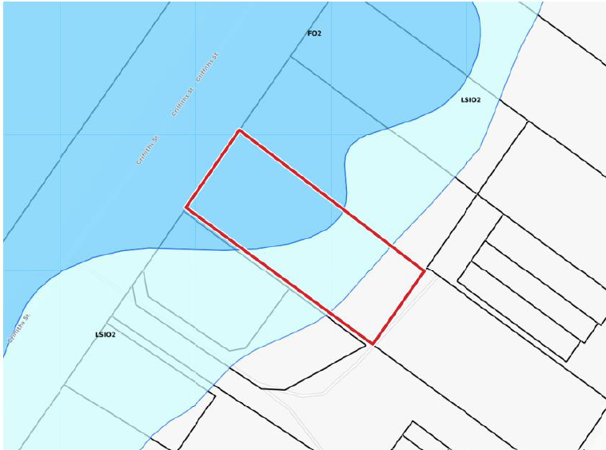

Figure Current FO2 and LSIO2 with the subject land outlined in red (Source: Expert evidence of Mr Swan dated 30 January 2023, page 6)

1. Under the seriously entertained Amendment C69moyn the subject land is subject to the proposed FO3 as shown in the figure below.

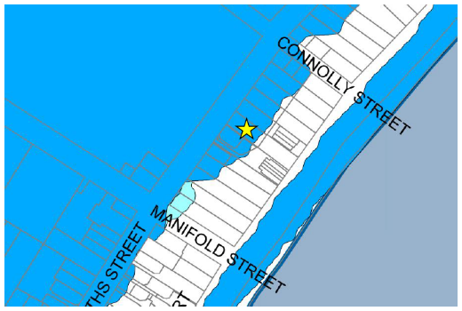

Figure Seriously entertained FO3 with the subject identified by the yellow star (Source: Council submissions, dated 27 April 2023, page 9)

1. The figure above indicates that the proposed FO3 includes flood extents along the length of East Beach.
2. The table below summarises the design flood levels and depths in Griffiths Street and within the proposed dwelling, as agreed by the experts.

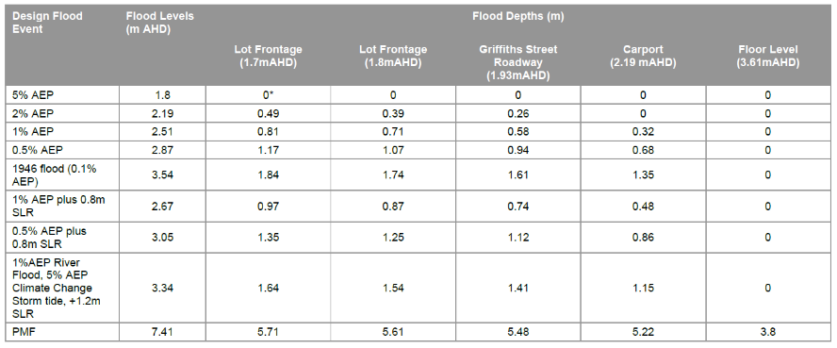

Figure Design Flood Levels and Depths for the subject land (Source: Conclave report dated 2 February 2023, page 6)

1. The table shows that the floor level is flood free in all the design flood events shown.
2. The table also shows that Griffiths Street, at 1.93m AHD, has a flood depth of 0.58m for the 1% AEP flood event and a flood depth of 0.74m for the 1% AEP plus 0.8m sea level rise flood event. This demonstrates that flood depths at the legal means of access to the subject land on Griffiths Street exceed 0.5m both currently and when a 0.8m sea level rise is accounted for during the 1% AEP flood event.
3. Further, the use of 1.93m AHD for Griffiths Street level is conservative, given that Mr Swan’s expert evidence statement stated that the approximate surface level of Griffiths Street is between 1.65 and 1.85m AHD, immediately adjacent to the subject land and the road formation of Griffiths Street is at 1.9m AHD adjacent to the subject land, sloping upwards in a southerly direction. The site topography is shown in the figure below.

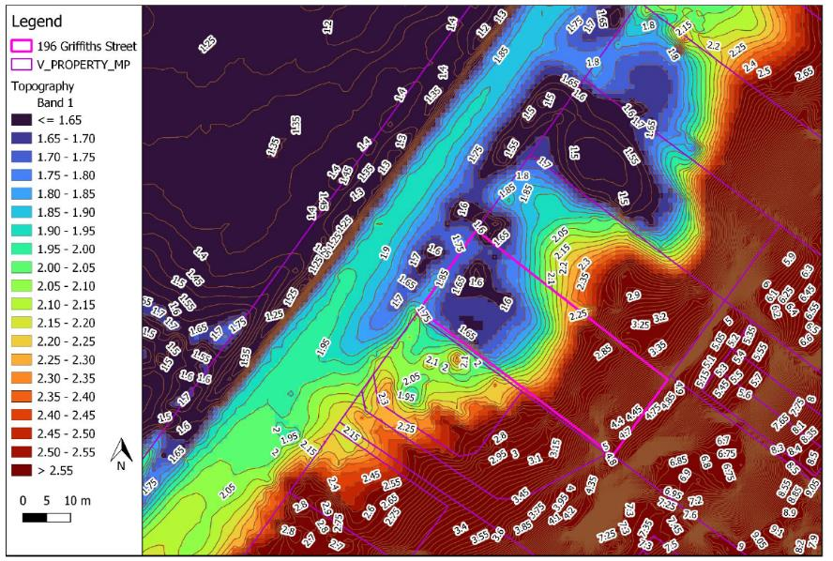

Figure Site topography (2007 Lidar) with subject land outlined in pink (Source: Conclave report, dated 2 February 2023, page 3)

1. The topography shows that in the 1% AEP flood event (i.e. a flood level of 2.51m AHD) approximately half the subject land would be subject to flood depths of 0.5m or more (i.e. approximately half the subject land has a height of 2.01m AHD or less).
2. Similarly, the topography shows that in the 1% AEP plus 0.8m sea level rise flood event (i.e. a flood level of 2.67m AHD) approximately half the subject land would be subject to flood depths of 0.5m or more (i.e. approximately half the subject land has a height of 2.17m AHD or less).
3. Given the subject land is in an area of low flow velocity, with maximum velocity no greater than 0.1m/s, the flood depth is the key factor for this site when considering flood safety.
4. The experts agree on the following summary of flood behaviour for the subject land:

* The property is in an area of low flow velocity, with maximum velocity no greater than 0.1m/s.
* There are parts of the subject land that are flood free in the 0.1% AEP flood event.
* The Port Fairy Flood Study indicates that the time to peak at Toolong in the 1% AEP flood event is in the order of 20 hours and that there is eight hours between the peak at Toolong and the peak at Port Fairy.
* The typical water level in Belfast Lough is below 1.0m AHD.
* The rate of rise between 1.6 and 1.8m from the 1% AEP flood event adopted in the Port Fairy Flood Study is two hours.
* In a repeat of the 1946 flood it would rise from between 1.5m and 1.8m in about two hours.
* In a 1% AEP flood event there would be water across the road in front of the site for at least 40 hours and it would exceed 0.3m deep for more than 22 hours and greater than 0.5m deep for more than 6 hours, assuming a road elevation of 1.9m AHD.
* A repeat of the 1946 flood would result in water across the road in front of the site for 60 hours, it would be more than 0.3m deep for more than 50 hours and more than 0.5m deep for about 48 hours. This flood event is an order of magnitude rarer than that adopted as the design standard in the LSIO overlay.

1. There is existing residential development along Griffiths Street and the surrounding streets. The MSFEP provides guidance to the VICSES and other responders in the event of a flood emergency in this area. Appendix C1 of the MSFEP details the expected flood response actions at Port Fairy and includes detail on expected travel times from upstream gauges, flood warning and evacuation arrangements, emergency messaging and trigger thresholds to initiate response activities. The MSFEP details that Victoria Police will consider evacuation of the Griffiths Street area should the Gipps Street Bridge become cut or have significantly reduced access. This isolates approximately 150 properties. Should this level be predicted, VICSES would issue evacuation orders and this is specifically stated in the MSFEP.

#### Griffiths Street Plot

1. Griffiths Street is the sole vehicular access to and from the subject land and, according to the best available information from the GHCMA, Griffiths Street is subject to inundation to depths exceeding 0.5m in both directions in the 1% AEP flood event.
2. Travelling south west on Griffiths Street provides access to the Port Fairy town centre via the Gipps Street Bridge over the Moyne River. The town centre includes the ambulance station and the Moyne Health Services Emergency Department as well as a supermarket and other commercial facilities typical of a small regional town. On the Griffiths Street side of the Moyne River development is confined principally to residential and tourist accommodation. The MSFEP indicates that, in a ‘1 in 200 year AEP flood event’, deep flooding may cut access to the Gipps Street Bridge, and this will isolate over 150 buildings for approximately 12 to 24 hours.
3. Travelling north east on Griffiths Street leads to the Princes Highway via Skenes Road and Woodbine Road. The MSFEP indicates that, during small flood events, ‘1 in 10 year AEP’ floodwater cuts access to Skenes Road.
4. GHCMA provided the following chart which shows the existing Griffiths Street road surface elevation compared to road surface elevation required to bring 1% AEP flood depth over the road within safe access and egress criteria (‘Griffiths Street Plot’).

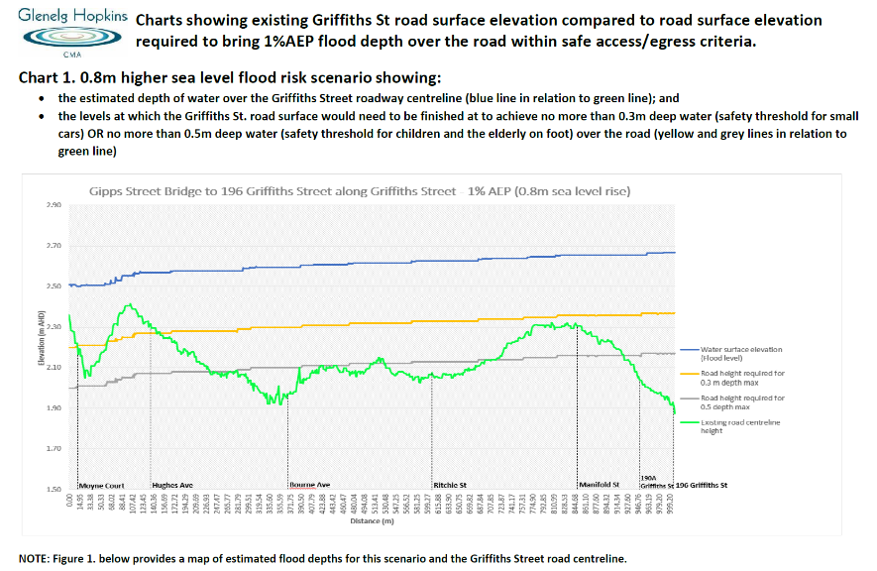

Figure Griffiths Street Plot: Griffiths Street road surface elevation compared to road surface elevation required to bring 1% AEP flood depth over the road within safe access/egress criteria (Source: Email from GHCMA dated 19 March 2023)

1. The Griffiths Street Plot demonstrates that the 1% AEP flood depth is greater than 0.5m multiple times between Griffiths Street and the Gipps Street Bridge. The areas where the 1% AEP flood depth is greater than 0.5m along Griffiths Street include the frontage to the subject land, near the intersection with Ritchie Street and near the intersection with Bourne Avenue.
2. The information in the Griffiths Street Plot also supports the table summarising the design flood levels and depths in Griffiths Street (refer Figure 13 above), that flood depths across the legal means of access to the subject land would exceed 0.5m both currently and when a 0.8m sea level rise is accounted for during the 1% AEP flood event.

### What are the proposed flood risk management measures?

1. The flood risk management measures proposed by the permit applicant include:

* The dwelling is proposed to be located on higher land, towards the rear of the property.
* The dwellings finished floor levels are elevated 600mm above the expected 1% AEP plus 0.8m sea level rise flood level.
* The proposed development also seeks to respond to possible future increased flood levels from climate change, as the proposed finished floor levels are well above the 1% AEP plus 1.2m sea level rise flood level, as sought by council and the CMA through Amendment C69moyn.
* The building is proposed to be constructed of flood resistant materials.
* Areas which are not required to meet freeboard requirements (carport and front deck) are not structurally connected to the main dwelling.
* External doors do not open directly into flood waters and there is always a structural buffer provided via a deck or stairs.
* Whilst the proposal includes earthworks as part of the proposed flood risk management measures, the GHCMA did not raise any concerns about the potential for offsite flood impacts.
* The proposed development provides a shelter in place option for occupants that is flood free under both existing and future climate conditions.
* Occupants can retreat to a flood free area at the rear of the site as there is high ground (that can be accessed from the north facing deck and the deck outside Bedroom 1).
* The proposed development provides access and egress via Griffiths Street either:
  + whilst the road is passable; or
  + through flood waters exceeding 0.5m, which the permit applicant’s expert, Mr Swan, gave evidence is acceptable because the flood depth during the 1% AEP flood event is only greater than 0.5m for a relatively short distance along Griffiths Street, when travelling in a southerly direction towards Gipps Street Bridge.
* A proposed alternative route for access and egress, via the existing driveway for neighbouring properties to the rear of the subject land, then either East Beach or the ‘goat track’ along the sand dunes of East Beach.
* The proposed installation of a flood marker at the property boundary where access from Griffiths Street to the subject land is proposed.
* The inclusion of a Flood Risk Management Plan (‘FRMP’) to formalise the risk management at the site, including:
  + Maintain awareness of Flood Warnings for the Moyne;
  + Follow the instructions of Emergency Managers to evacuate or evacuate early.
  + If flooding inundates Griffiths Street, do not drive through floodwaters. Maintain sheltering in the property until waters recede.
  + Should the flood approach the floor level (noting that this is well above a 1000 year flood event), then evacuate to the rear of the site on dry land.
  + Should a major emergency occur while sheltering, contact emergency services and follow their instructions.

1. The permit applicant’s expert, Mr Swan, notes that the adoption of an FRMP for a single dwelling has limited effect, as there is no organisational structure that will support and manage the plan. However, he considers that, if the property was to be used as rental accommodation, a FRMP could be of use to inform renters of the potential risk and actions.
2. Council submits that the proposal ensures safe access to habitable buildings via Griffiths Street itself, or, depending on what stage access is necessitated, retreating by foot to a flood-free area from the rear of the subject land.
3. Council submits that common sense will dictate the manner in which an occupant exits from the subject land before or during a flood event (if at all, given that they consider shelter in place is a safe and viable option).
4. This option of retreating by foot to a flood-free area from the rear of the subject land is referred to by the permit applicant as safe access by ‘other accessways’ on foot along the ‘goat track’ at the top of the beach. This option is considered further in the section on the alternative route for access and egress, below.

### Are the proposed flood risk management measures acceptable?

1. There is no dispute between the parties that the East Beach and Griffiths Street & Wharf Precincts and the areas around Belfast Lough are impacted by flooding and that coastal and riverine flooding creates hazardous conditions for the subject land.
2. The proposed dwelling leads to an increase in population in this area.
3. The permit applicant submits that one of the ways the application appropriately manages the risk is through the modest scale of the proposed development, comprising a single storey home (as opposed to a more intensive use such as a Bed and breakfast which is also as of right use in the GRZ).
4. The permit applicant’s expert, Mr Swan, gave evidence that the addition of a single property, or a small number of additional properties in this area that already has a detailed planned response is unlikely to cause any additional burden on emergency personnel.
5. The GHCMA agrees that some properties within the East Beach and Griffiths Street & Wharf Precinct can be acceptable for infill development under the current scheme. The approved development at 1 Hughes Avenue was presented as an example of infill development in this precinct that the GHCMA considers to be acceptable. The GHCMA submit that the difference between 1 Hughes Avenue and the subject land is simply one of safe access.
6. GHCMA made submissions that 1 Hughes Avenue was an acceptable development because, based on the existing road centreline height, the 1% AEP flood depth was never greater than 0.5m over the road. In contrast, the same assessment for the subject land shows that the 1% AEP flood depth is greater than 0.5m multiple times between Griffiths Street and the Gipps Street Bridge. The issue of access is considered in more detail below.
7. This level of analysis for individual properties demonstrates that GHCMA is thoroughly considering all proposals for infill development in the East Beach and Griffiths Street & Wharf Precincts and recommending approval only for those applications which meet the requirements for, amongst other flood safety requirements, safe access and egress to and from the habitable buildings using flood free roads or other accessways that are subject to a depth of flooding of not more than 0.5m for storm events up to and including the 1 % AEP flood event.
8. The multiple background documents relevant to flooding in Port Fairy, and the multiple amendments relevant to flooding that have arisen during and after the hearing for this case, demonstrate that policy relevant to flooding in Port Fairy is clearly an area of changing policy.
9. The permit applicant and council submit that, whether assessed under the current planning scheme or with the inclusions of the seriously entertained Amendment C69moyn, the scheme supports the development.
10. The GHCMA submits that, whether assessed under the current planning scheme or with the inclusions of the seriously entertained Amendment C69moyn, the scheme does not provide support for the application.
11. Having regard to the proposed provisions under Amendment C69moyn, the GHCMA submits:

* The FO3 identifies areas where inundation (coastal and riverine) poses a significant risk being areas with a hazard risk of between Classes 3-5 (these are the hydrological risk classes discussed by the experts) and this includes the subject land and Griffiths Street.
* Policy recognises that the Griffiths Street & Wharf Precinct, which includes the subject land, is one of the precincts most severely impacted by flooding within Port Fairy.
* Both policy and the 2022 LFDP expressly seek to avoid new development on land within FO3. In particular:
  + The floodway objective to be achieved on FO3 includes ‘to avoid new development in areas at high risks of coastal inundation’.
  + Clause 21.09-3 states to:
    - ‘support only very limited new housing development in the East Beach and Griffths Street & Wharf Precincts where land is not subject to flooding or erosion risk and access is managed to the satisfaction of the responsible authority’.
    - ‘not support any increase in residential density or the introduction of sensitive uses (such as schools or aged care) in areas affected by coastal inundation’ and 'do not support the intensification of housing in locations where there is coastal erosion and flooding above 0.3 metre is projected.’ The Permit Application does increase the residential density in the area and intensifies the number of houses within Griffiths Street.
  + The 2022 LFDP states ‘new buildings must not be sited on land where the flood depth exceeds 500 millimetres’.

1. For these reasons, the Tribunal finds that the seriously entertained Amendment C69moyn does not provide support for the application.
2. Whether assessed under the current planning scheme or with the inclusions of the seriously entertained Amendment C69moyn, the Tribunal finds the proposal to be unacceptable for flood safety reasons.
3. Similarly, the Tribunal recognises that, whilst Amendment C74moyn has changed flood policy in the scheme, it has not changed the broad thrust of planning policy, namely that there remain areas within the municipality that are constrained and impacted by flooding which need careful management.
4. The Tribunal finds that, whilst the proposal meets many of the scheme’s requirements for properties in flood affected areas and the proposal meets many of the DELWP Guidelines’ key objectives for assessing development proposals – for example through the use of flood resistant materials and floor level set 600mm above the expected 1% AEP plus 0.8m sea level rise flood level – the proposal ultimately fails to meet the requirements for flood safety. Specifically, the proposal proposes a shelter in place strategy and does not achieve access to habitable buildings using flood free roads or other accessways. Each of these issues is considered in turn below.

#### Shelter in place to manage risk to human life and safety

1. The permit applicant submits that the dwelling provides a safe shelter in place option for residents as the finished floor levels are elevated 600mm above the expected 1% AEP plus 0.8m sea level rise flood level. The shelter in place strategy is proposed to be included in the FRMP for the subject land.
2. The planning scheme and DELWP Guidelines are silent on shelter in place. In the absence of incorporated guidance about shelter in place as a flood risk management strategy, I rely on the guidance in the FRM Handbook as an indication of best practice for the application of shelter in place. The FRM handbook acknowledges that there are some limited instances where an individual house may be designed as a shelter during a flood event. However, it provides the caveat that shelter in place is a last resort option, normally only appropriate for existing flash-flood environments. Further it specifies that this approach generally involves risk reduction by replacing existing flood affected development with less vulnerable development of the same density. The FRM Handbook sets out that the use of shelter in place is entirely appropriate in situations where people are already on site, but it is not appropriate to justify an increase in density for a site through a planning permit.
3. While I accept that a shelter in place strategy may be a viable alternative to evacuation during flash floods (for existing buildings or where there is also safe access to and egress from the building), the best practice information in the FRM Handbook is that the shelter in place strategy should not be used to justify a new development which increases density in the floodplain.
4. Given that this proposal is for a new building which increases density in the floodplain and does not have safe access to and egress from the dwelling, I am not satisfied that shelter in place is an acceptable strategy for the proposal before me.

#### Access to habitable buildings using flood free roads or other accessways

1. Clause 13.03-1L (Floodplain management – Moyne) contains the strategy to ‘ensure safe access to habitable buildings in areas prone to flooding’. Clause 13.03-1L also provides the policy guidelines to consider as relevant ‘achieving access to habitable buildings using flood free roads or other accessways that are subject to a depth of flooding of not more than 0.5 metres for storm events up to and including the 1 per cent Average Exceedence [sic] Probability standard’ and ‘implementing measures to avoid or minimise flood access risk, including emergency management and prevention plans’.
2. The seriously entertained Amendment C69moyn includes a strategy at clause 21.09-3 to ‘support only very limited new housing development in the East Beach and Griffths Street & Wharf Precincts where land is not subject to flooding or erosion risk and access is managed to the satisfaction of the responsible authority.’
3. The current 2013 LFDP states that ‘while intensification of development in this area is generally discouraged, any remaining infill development opportunities that can reduce or manage access flood risk to acceptable levels will be considered’ and that ‘dwellings proposed for land that relies on access that has a 100 year ARI flood depth greater than 0.5 metres may be approved when the risks associated with loss of road access due to flooding have been mitigated by either structural or non-structural means.’
4. The proposed 2022 LFDP, as part of the seriously entertained Amendment C69moyn, states that new buildings should ‘have an accessway to the building envelope that: does not traverse land where the flood depth is estimated to exceed 300mm during a 1% AEP flood event under the 0.8 metre sea level rise scenario; and is not subject to flooding where the product of depth and velocity (VxD) exceeds 0.4 metres squared per second during the 1% AEP flood event’.
5. To avoid access being subject to water depths that exceed 0.5m, is also consistent with the DELWP Guidelines. In relation to depth and flow of flood waters, the DELWP Guidelines also state that ‘people attempting to enter or leave a property during a flood should not be endangered by deep or fast-flowing water. This includes emergency response personnel, property occupants and visitors.’ The guidelines include ‘external connecting routes leading to safety’ in the areas of most interest to this. Further, the DELWP Guidelines provide guidance that ‘consideration needs to be given to ensuring there are safe, external connecting routes that do not lead to isolation. They should safely connect to emergency relief services, not just to the nearest high ground.’
6. The permit applicant submits that local policy at clause 13.03-1L does not call for consideration of access with a sea level rise. However, State policy does require proponents to plan for sea level rise of not less than 0.8m sea level rise by 2100. The permit applicant submits that, cognizant of this policy, the proposal has planned for a 0.8m sea level rise by elevating the finished floor levels, elevating the garage floor and proposing an alternative access via the rear of the property in the event of 0.8m sea level rise. The permit applicant submits that through these measures, the objectives of both the local and State policies are met.
7. Flood depths across Griffiths Street, the legal means of access to the subject land, would exceed 0.5m both currently and when a 0.8m sea level rise is accounted for during the 1% AEP flood event.
8. The parties agree that safe access is a relevant policy strategy in the scheme.
9. The two options for access and egress put forward by the permit applicant – Griffiths Street and an alternative access route – are considered in turn below.

##### Griffiths Street access and egress

1. Flood depths at the legal means of access to the subject land on Griffiths Street exceed 0.5m both currently and when a 0.8m sea level rise is accounted for during the 1% AEP flood event.
2. The experts agreed in the conclave minutes that, in a 1% AEP flood event there would be water across the road in front of the site for at least 40 hours and it would exceed 0.3m deep for more than 22 hours and greater than 0.5m deep for more than 6 hours, assuming a road elevation of 1.9m AHD.
3. Both experts accepted that flood depths over 0.5m would be unsafe for all vehicles. Both experts referenced the combined flood hazard curves, which set hazard thresholds that relate to the vulnerability of the community when interacting with floodwaters. The combined flood hazard curves from *Australian Rainfall and Runoff: A Guide to Flood Estimation, Book 6 – Flood Hydraulics* (‘ARR’) are presented in the figure below.

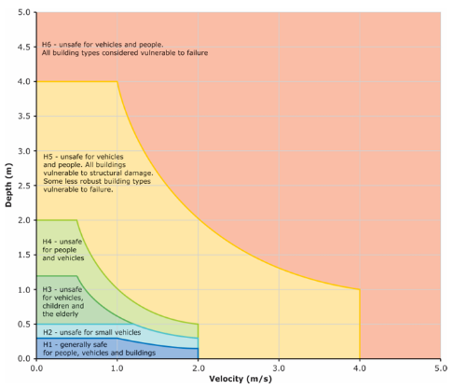

Figure Combined flood hazard curves (Source: Australian Rainfall and Runoff: A Guide to Flood Estimation, Book 6 – Flood Hydraulics, page 260)

1. The permit applicants expert, Mr Swan, gave evidence that there would be no requirement for an owner to evacuate via vehicle through floodwaters, with the MSFEP indicating that evacuation orders would be issued well in advance of the flood peak. He also gave evidence that travelling through flood waters exceeding 0.5m was acceptable in this instance because it was only for a relatively short distance. His expert evidence states:

…the flood depth immediately adjacent to the property on Griffiths Street is around 0.6m at the peak of the flood event and decreases to below the 0.5m threshold after approximately 40m towards the township (at the access driveway to 190-192 Griffiths Street) The depth of flooding is below the GHCMA threshold until Bourne Avenue, although it does approach the threshold value near Ritchie Street.

The deep flooding at Bourne Avenue can be avoided via a detour at Ritchie Street, with cars driving along Beach Street and Hughes Avenue until re-joining Griffiths Street. Even at the peak of the flood, there is the ability to avoid the deepest parts of the flooding via the road network. There is an accessway easement on the adjoining property to the east (190-192 Griffths) that is adjacent to the eastern boundary of the subject land. This access could be used by emergency services in the event a road evacuation was required and would provide a path for emergency services that would be below the 0.5 metre threshold if required. There is no requirement for an owner to evacuate via vehicle through floodwaters, with the MFEP indicating that evacuation orders would be issued well in advance of the flood peak.

1. The Tribunal questioned Mr Swan about why he considered it safe to traverse approximately 40m of flood water deeper than 0.5m, a depth recognised as unsafe for vehicles, children and the elderly. When asked at what point the distance would be too great, Mr Swan gave a distance of approximately 100m, though he added ‘to be fair, that is a very arbitrary number’.
2. I note that the hazard thresholds set out in ARR and the safety criteria set out in the DELWP Guidelines only consider depth, velocity and depth/velocity product. Distance is not taken into consideration.
3. Mr Molino’s evidence was that 0.5m deep flood waters are unsafe for vehicles, children and the elderly and should not be traversed at all.
4. Mr Molino also gave evidence that:

A further hazard in Griffiths Street, particularly if travelling northeast from the site, is that there are no guide posts on the side of the road and the road is raised above the surrounding landscape, particularly heading northeast. Even if there is shallow flooding on the road it would be very easy to drive off the road and into higher hazard water on either side of the road.

1. In relation to evacuating before the flood peak, Mr Molino also gave evidence that gauge levels at Willatook and Toolong would not themselves be sufficient indication of impending flood levels at the site because flood levels at the site are influenced by both sea level and the total volume of water reaching Belfast Lough rather than there being a direct relationship between instantaneous flood levels at these upstream gauges and future flood levels at the site. Therefore, in the absence of a forecasting model, it would be difficult for any site occupant to use observations of upstream river levels to make informed decisions about flood emergency response actions, including evacuation.
2. Ultimately it was Mr Molino’s evidence that the proposed development poses an unacceptable risk to life because the subject land will be impacted by high hazard flooding and will be isolated in the 1% AEP flood event. Further, if a more conservative flood depth of 0.3m is considered (i.e. the depth unsafe for small vehicles), the site is isolated more often.
3. Mr Molino gave evidence that evacuation would be the most appropriate flood emergency response for the site, but it is not a viable option because:
   * + - 1. There is no flood forecasting and warning service available for the Moyne River.
         2. The reliance on observed flood levels to trigger evacuation and the potential rates of rise mean that a flood trigger in the order of a 10% AEP flood level would need to be adopted. This could lead to many false alarms and response complacency.
         3. The potential rates of rise and lack of flood forecasts could mean that the opportunity to evacuate is lost if flooding occurs during the night.
4. The Tribunal prefers the evidence on Mr Molino, as it is consistent with best practice floodplain management, that 0.5m deep flood waters are unsafe for vehicles, children and the elderly and should not be traversed.
5. The Tribunal finds that access to the subject land via Griffiths Street does not meet the hazard thresholds set out in ARR, or the safety criteria set out in the DELWP Guidelines in relation to depth of flood waters.
6. Based on the best practice guidance for floodplain management, the Tribunal finds that access to the subject land via Griffiths Street does not ensure safe access to habitable buildings in areas prone to flooding under clause 13.03-1L.

##### Alternative route for access and egress

1. The permit applicant submits that neither State nor local policy prescribes that access must be from the front of the dwelling. Nor does the State or local policy prescribe that access must be from a public road. Rather, it merely asks the decision maker to ensure there is safe access to habitable buildings.
2. As such, the permit applicant submits that, if the occupants have not yet evacuated the building whilst the road is passable, there is a ‘second option’ for access and egress via the rear of the site. They propose that the occupants can retreat to a flood free area at the rear of the site as there is high ground (that can be accessed from the north facing deck and the deck outside Bedroom 1) and an existing driveway for neighbouring properties to the rear of the subject land that connects to Griffiths Street and provides footway access to the beach. From there, they propose the access would be via the beach itself or the ‘goat track’ next to the beach, for approximately 350m to reach the Hanley Court beach access point. At this point, near the intersection of Griffiths Street and Richie Street, the flood waters along Griffiths Street meet the CMA’s requirements for access.
3. The permit applicant submits that, in the case of an emergency, common sense will prevail, and the rear access will be utilised as it provides safe and flood free egress. They say they have sought to:
4. ensure safe access via the rear driveway with the consent of the owner’s corporation, and
   * + - 1. achieve access via the other accessway being the ‘goat track’ next to the beach or the beach itself.
5. The GHCMA does not agree that the access to the rear of the subject land via the existing driveway is an acceptable option.
6. As such, the GHCMA does not consider the proposal to be consistent with clause 13.03-1L. They say that Amendment C74moyn has reinforced consideration of access and that such access should not be subject to flood depths exceeding 0.5m. Further, the GHCMA submit that, unlike the former policy, the current policy does not contemplate circumstances where flood depths exceeding 0.5m will be acceptable.
7. The GHCMA does not agree that the access to the rear of the subject land via the existing driveway is an acceptable option. The GHCMA submit that reliance on the ‘goat track’ is illusionary as there is no legal access to the ‘goat track’ and flood depths across the legal means of accessing the ‘goat track’ would exceed 0.5m both currently and when a 0.8m sea level rise is accounted for during the 1% AEP flood event, as shown in the Griffiths Street Plot.
8. Further, while the proposed EMO does not affect the subject land, the proposed EMO applies to the full length of the ‘goat track’ that the permit applicant seeks to rely on. There is no understanding of the EMO’s implications on this access over the medium or long term. Therefore, even if the above matters can be addressed (in terms of legal and safe access to the ‘goat track’), the ‘goat track’ remains unsuitable as an alternative means of access given the underlying risks which have justified the EMO being proposed over this land.
9. I agree with the GHCMA that the ‘other accessway’ options proposed by the permit applicant are unacceptable for the reasons set out below.
10. The first section of the proposed alternative route for access and egress, via the existing driveway for neighbouring properties to the rear of the subject land, is unacceptable because there is no assurance that this private access will always be available to the occupants and/or visitors of the subject land.
11. The second section of the proposed alternative route for access and egress, being via either East Beach or the ‘goat track’ along the sand dunes of East Beach, is also unacceptable.
12. Given that most of East Beach is subject to the FO as part of the seriously entertained Amendment C69moyn, and given the high tide information provided by the GHCMA, I do not consider walking along East Beach is to be an acceptable ‘other accessway’ for the purposes of clause 13.03-1L.
13. The ‘goat track’ is a very narrow path suitable only for the single file foot traffic of an able-bodied person through dense coastal dune shrubland. Further, it is not clear who has the right to, or is responsible for, the maintenance of this track, which, when the Tribunal conducted their site visit, was impassable on one of the neighbouring properties due to overgrown shrubs blocking the ‘goat track’. As such, I do not consider walking along the ‘goat track’ to be an acceptable ‘other accessway’ for the purposes of clause 13.03-1L.
14. The second policy guideline at clause 13.03-1L states to consider as relevant ‘implementing measures to avoid or minimise flood access risk, including emergency management and prevention plans’.
15. In this case there is a relevant emergency management plan, namely the Council’s MSFEP which is a sub-plan of the Municipal Emergency Management Plan. The parties agree that this plan is a relevant consideration. However, I agree with the GHCMA that MSFEP makes no recommendations to avoid or minimise the underlying flood risk. The MSFEP is focussed on identifying the procedures and responsibilities of organisations when responding to an emergency. In ‘1 in 200 year AEP flood event’, it recommends the evacuation of Port Fairy residents at risk of being isolated.
16. With respect to a prevention plan, the GHCMA made submissions that there is no such relevant plan for the purposes of this proposal. They say that, for the purposes of flood management, prevention (sometimes referred to as mitigation) plans identify actions or works that are to be undertaken in advance of an emergency. This can include constructing sea walls to protect property and infrastructure from tidal waves.
17. I accept GHCMA’s interpretation of a prevention plan as widely accepted terminology in the emergency management industry. The PFC&SP includes reference to the Port Fairy Local Coastal Hazard Assessment and the associated draft Coastal Climate Change Adaptation Plan,[22] including the ‘extension and upgrade of rock seawall along East Beach, prioritising those areas at extreme or high risk & implement a beach renourishment program along the southern end of East Beach, with sand sourced locally’.[23] There is no reference to whether these plans are intended to improve flooding for the subject land and as such are not relevant to our consideration for this proposal.
18. There was mention in the evidence and during the hearing of a potential upgrade to Griffiths Street, to raise it such that safe access conditions are met. I agree with Mr Swan that it is beyond the scope of this development and therefore not relevant to our consideration for this proposal.
19. The raising of Griffiths Street was also identified by Mr Molino as a preventative or mitigation measure that would likely reduce the flood risk associated with accessing the subject land in a flood event. However, the council who is responsible for the care and management of this asset, has no current prevention plan for Port Fairy that proposes this as a possible project and there was no evidence that this is likely to occur. [24]
20. The permit applicant submits that the proposed FRMP for the subject land is also relevant to this consideration under 13.03-1L. The FRMP is proposed to include evacuation and shelter in place as flood risk management strategies. The issues related to evacuation access and shelter in place are considered in detail in this decision.
21. In accordance with clause 13.03-1L, the Tribunal has considered all the relevant measures to avoid or minimise flood access risk, including the identified emergency management plans. Whilst emergency management plans are useful and important documents, they do not reduce or remove the underlying risk for this property, which is that there is no safe access or egress.
22. The Tribunal does not consider the access to the rear of the subject land, via the existing driveway for neighbouring properties to the rear of the subject land, to be an acceptable option under clause 13.03-1L for achieving access to habitable buildings using flood free roads or other accessways that are subject to a depth of flooding of not more than 0.5m for storm events up to and including the 1% AEP flood event.

## Integrated decision making

1. Clause 71.02-3 states that the Planning Policy Framework operates together with the remainder of the scheme to deliver integrated decision making. It requires planning and responsible authorities to ‘endeavour to integrate the range of planning policies relevant to the issues to be determined and balance conflicting objectives in favour of net community benefit and sustainable development for the benefit of present and future generations.’
2. There is no dispute arising from the council or the GHCMA’s submission in relation to housing, urban design and environmental significance. There is dispute in relation to the interpretation of the flooding policy. It follows, the substance of this decision has necessarily focused on matters related to flooding, but it is not lost that the balancing of policy relating to flood risk management is one consideration in a larger policy framework under the relevant permit triggers.
3. An integrated approach is required having regard to all relevant policy in this case.
4. GHCMA submit that housing and settlement policy does not unconditionally support new housing within township boundaries and within residential zones. They cite clause 02.03-1 which expressly recognises that parts of Port Fairy are subject to an ‘increased risk of coastal inundation … due to anticipated sea level rise’ and clause 2.03-3 expressly seeks to ‘avoid development in coastal locations that may be affected by climate change impacts’.
5. The permit applicant submits that the weight to be afforded to each policy turns on the facts and circumstances of each proposal. For example, the permit applicant submits that it would be appropriate to give council’s strategic direction to ‘avoid development in coastal locations that may be affected by climate change impacts’ more weight in circumstances where a Planning Panel is considering a large scale subdivision that will create a new community than in circumstances where a single dwelling is being sought on land in an already well-developed area that is zoned general residential and has a purpose to ‘encourage a diversity of housing types and housing growth particularly in locations offering good access to services and transport’.
6. The CHGCMA submits that the Tribunal should place weight on flooding policy at clause 13.03-1L to justify refusing the permit application.
7. Council submits the degree of weight to accord to the policy guidance in clause 13.03-IL depends on the nature of the proposal and relevant circumstances. In this regard, council submits it is necessary to distinguish the subject proposal (a single dwelling proposed on a vacant, residentially zoned parcel in an existing infill location) from a rezoning application or a large-scale residential development or subdivision, for example.
8. Whether assessed under the current planning scheme or with the inclusions of the seriously entertained Amendment C69moyn, the Tribunal finds the proposal to be unacceptable for flood safety reasons.
9. The proposed use and development of a dwelling on the subject land would create an unacceptable risk to life and safety of occupants of the dwelling during a flood event, as defined by the planning scheme and the DELWP Guidelines.
10. The seriously entertained Amendment C69moyn includes a strategy at clause 21.09-3 to ‘support only very limited new housing development in the East Beach and Griffths Street & Wharf Precincts where land is not subject to flooding or erosion risk and access is managed to the satisfaction of the responsible authority.’ In this case, access is not managed to the satisfaction of the GHCMA, the recommending referral authority under the scheme for applications in the FO.
11. The application comprises an unacceptable outcome with respect to flood risk because the access to the property along Griffiths Street does not meet the safety criteria for depth. Further, the proposed alternative route for access and egress via the ‘goat track’ does not provide legal or reliable access and egress. Safe access and egress requires safe, external connecting routes that do not lead to isolation. They should safely connect to emergency relief services, not just to the nearest high ground. The proposal does not have safe access to and egress from the subject land.
12. This permit application seeks to introduce a new dwelling onto vacant land with a flood hazard. It intensifies the population residing in a hazardous situation and is contrary to the objectives, purposes, strategies policy guidelines and decision guidelines of the planning scheme, including those for clause 13.03-1S (Floodplain management), clause 13.03-1L (Floodplain management – Moyne) and clause 44.03 (Floodway Overlay).
13. I am not satisfied that the proposed development is consistent with the LSIO objective to minimise the potential flood risk to life, health and safety. Nor am I satisfied that the proposed development is consistent with:

* clause 13.03-1L;
* the seriously entertained Amendment C69moyn strategy at clause 21.09-3;
* the current 2013 LFDP; or
* the proposed 2022 LFDP, as part of the seriously entertained Amendment C69moyn.

1. This development is not acceptable due to the flood hazard associated with this location and the increased population at risk resulting from the development.
2. The Tribunal has considered all relevant policy for the application, including those relating to settlement, housing, urban design, the environment and flooding.
3. Council submits that the newly introduced strategic directions and policies resulting from Amendment C74moyn reinforce the subject land as a suitable candidate for residential development, in settlement terms. They say the proposal for a single dwelling in an infill location within the defined settlement boundaries is consistent with these ambitions.
4. I recognise that one of the strategic directions for the scheme is to ‘encourage growth within clearly established boundaries of townships’, and that Port Fairy is recognised as ‘a District Town with moderate growth capacity through infill development and some growth beyond existing urban zoned land, but within defined settlement boundaries’. I also recognise the strategic direction to ‘contain township development within defined boundaries’.
5. However, the housing and settlement policy requires it to be read in the context of further policy directions that provide express directions to avoid development within certain areas and that there are various constraints that need to be considered.
6. Ultimately, the Tribunal needs to be satisfied that a permit should be granted under the FO and LSIO having regard to the present and future flood risks associated with the subject land. Within this context, and having regard to the relevant permit triggers, to the extent there is any tension between settlement and housing policy and flood policy, the Tribunal finds that the flood policy provisions in this case outweigh the more general policy references arising from the residential zoning of the subject land, particularly given the marginal contribution the proposal makes to new housing.

## Conclusion

1. For the reasons given above, the decision of the responsible authority is set aside. No permit is granted.

|  |  |  |
| --- | --- | --- |
| Claire Bennett  **Member** |  |  |

# Appendix A - Port Fairy Local Floodplain Development Plan Submissions by Council on Other Versions

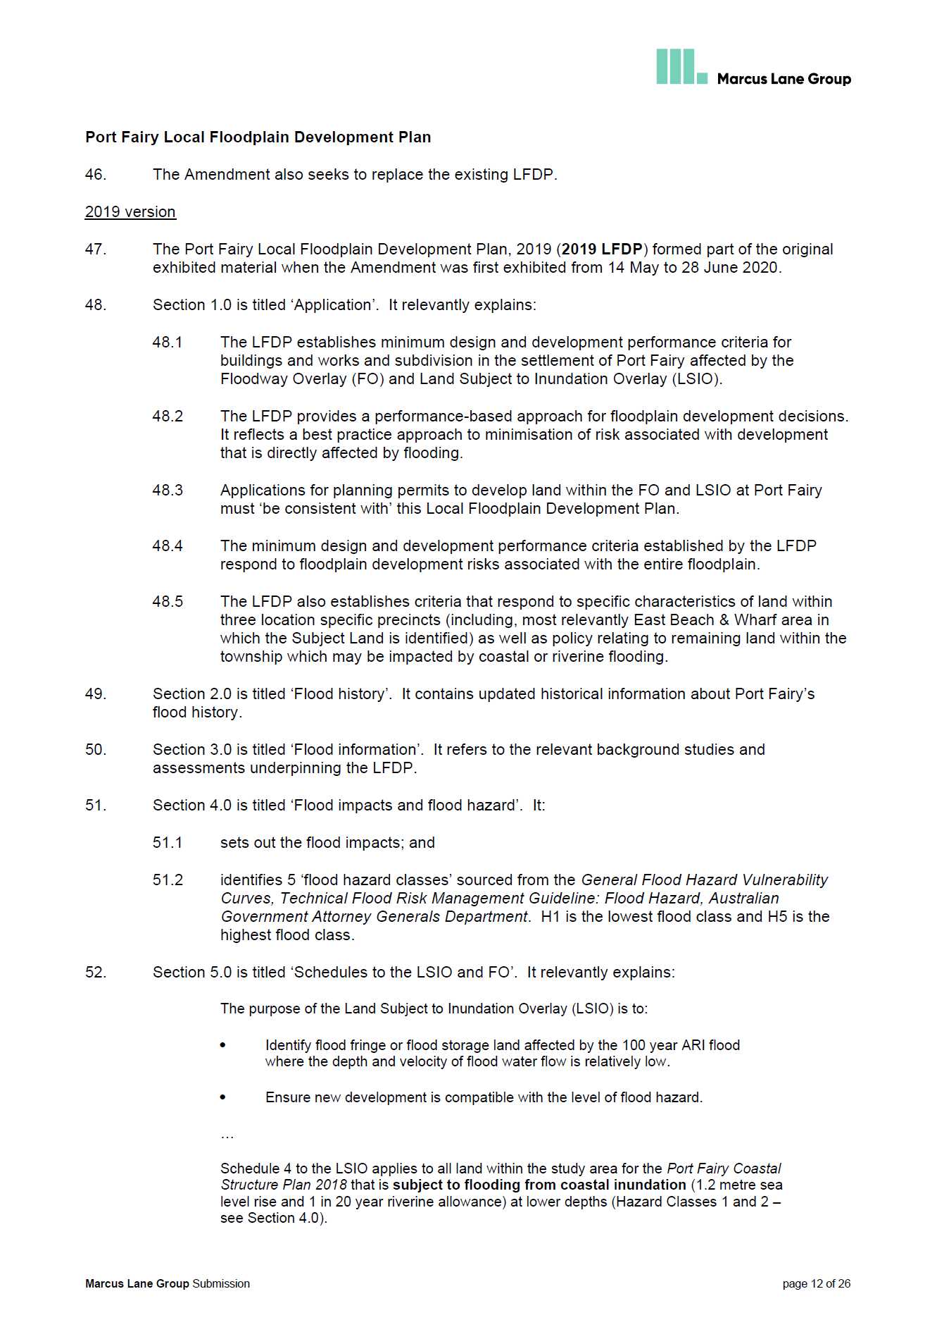

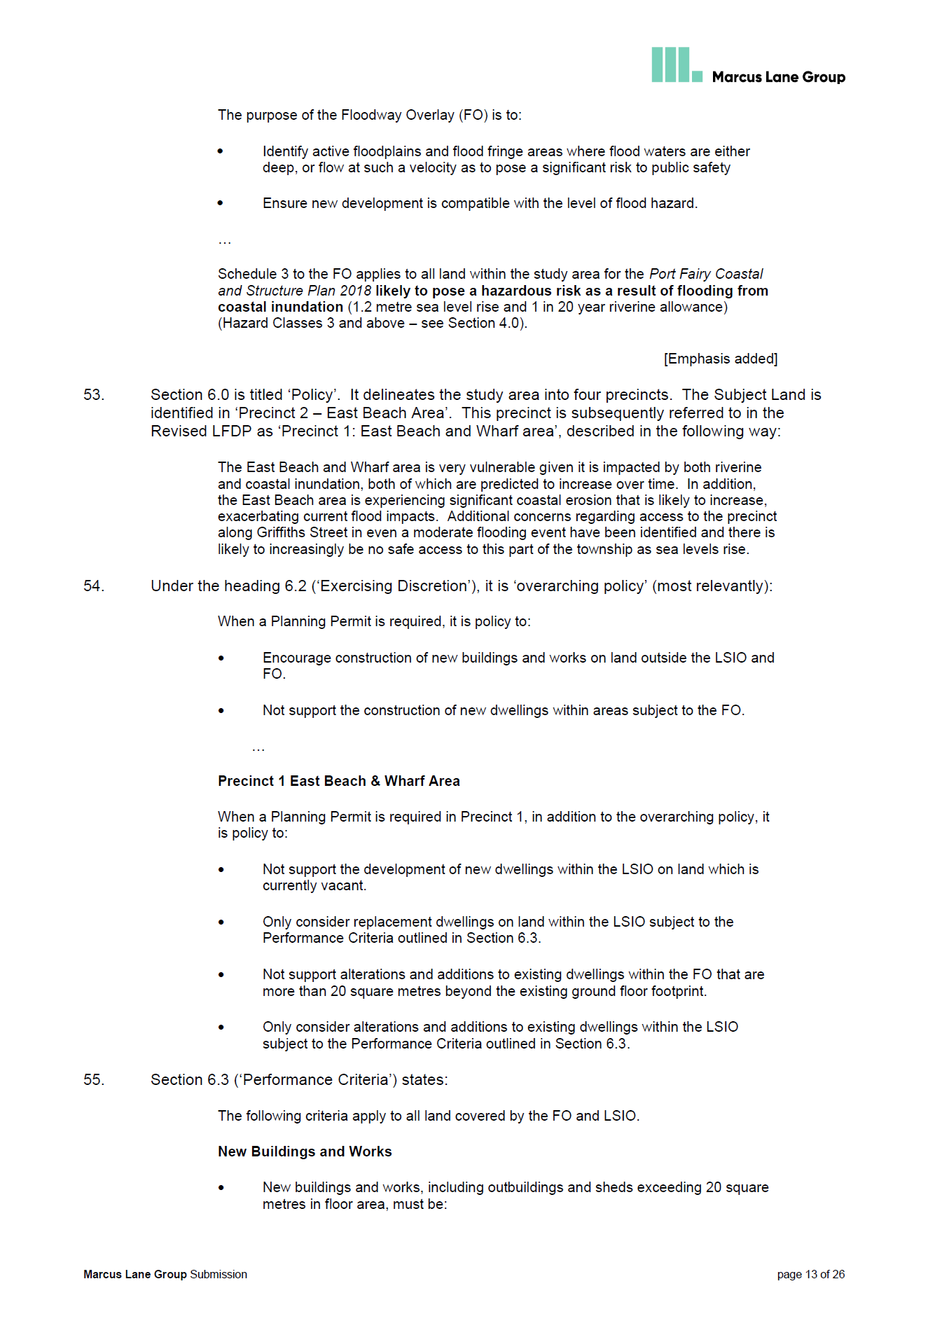

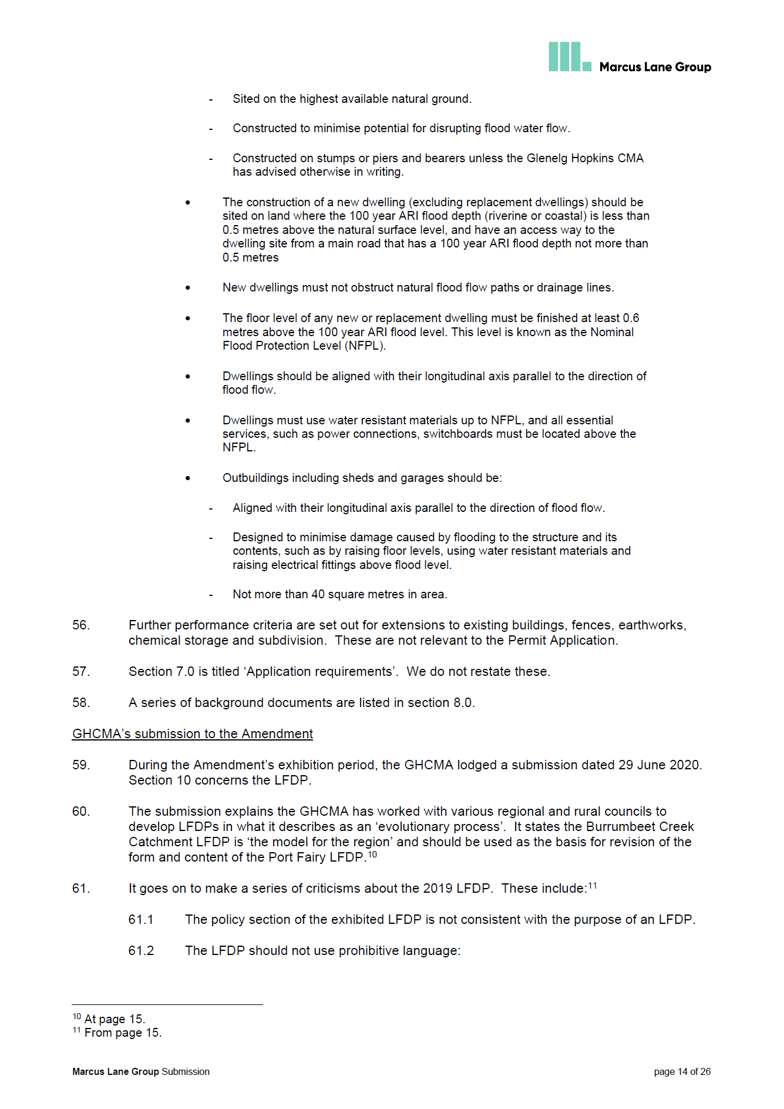

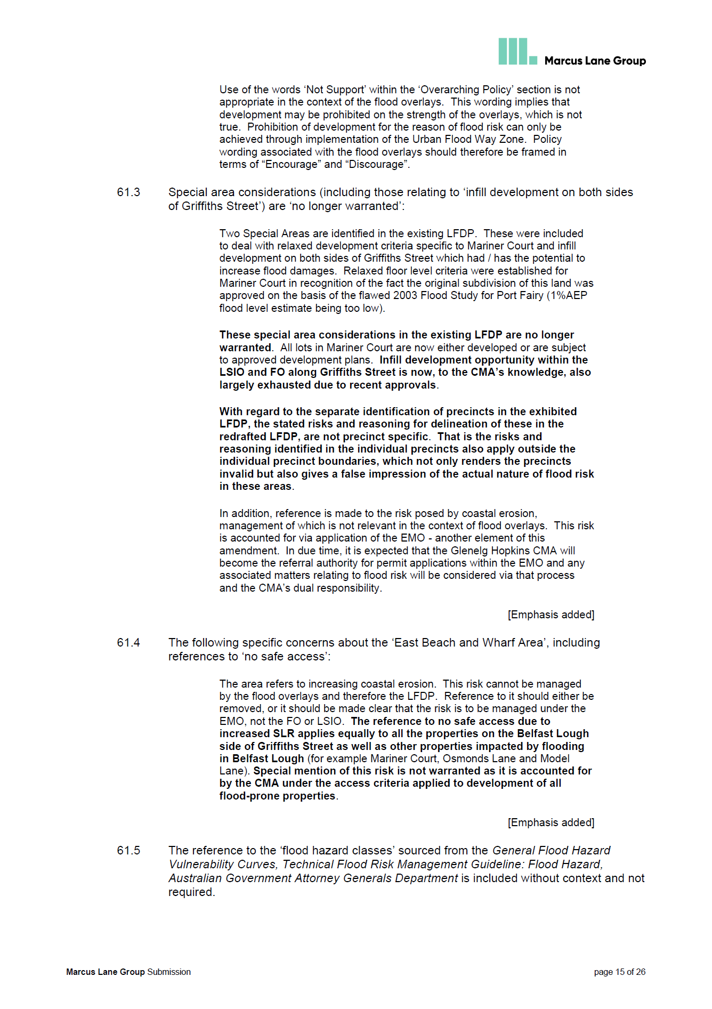

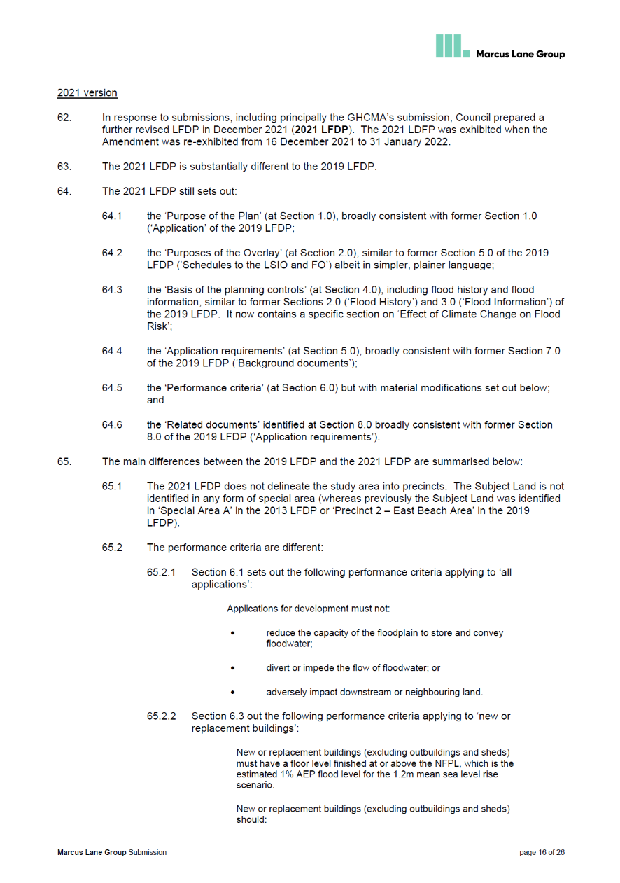

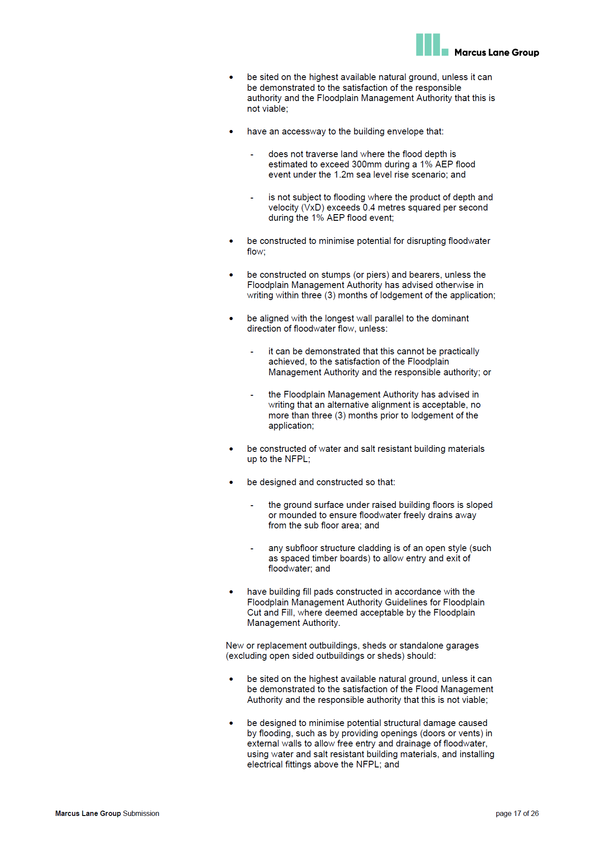

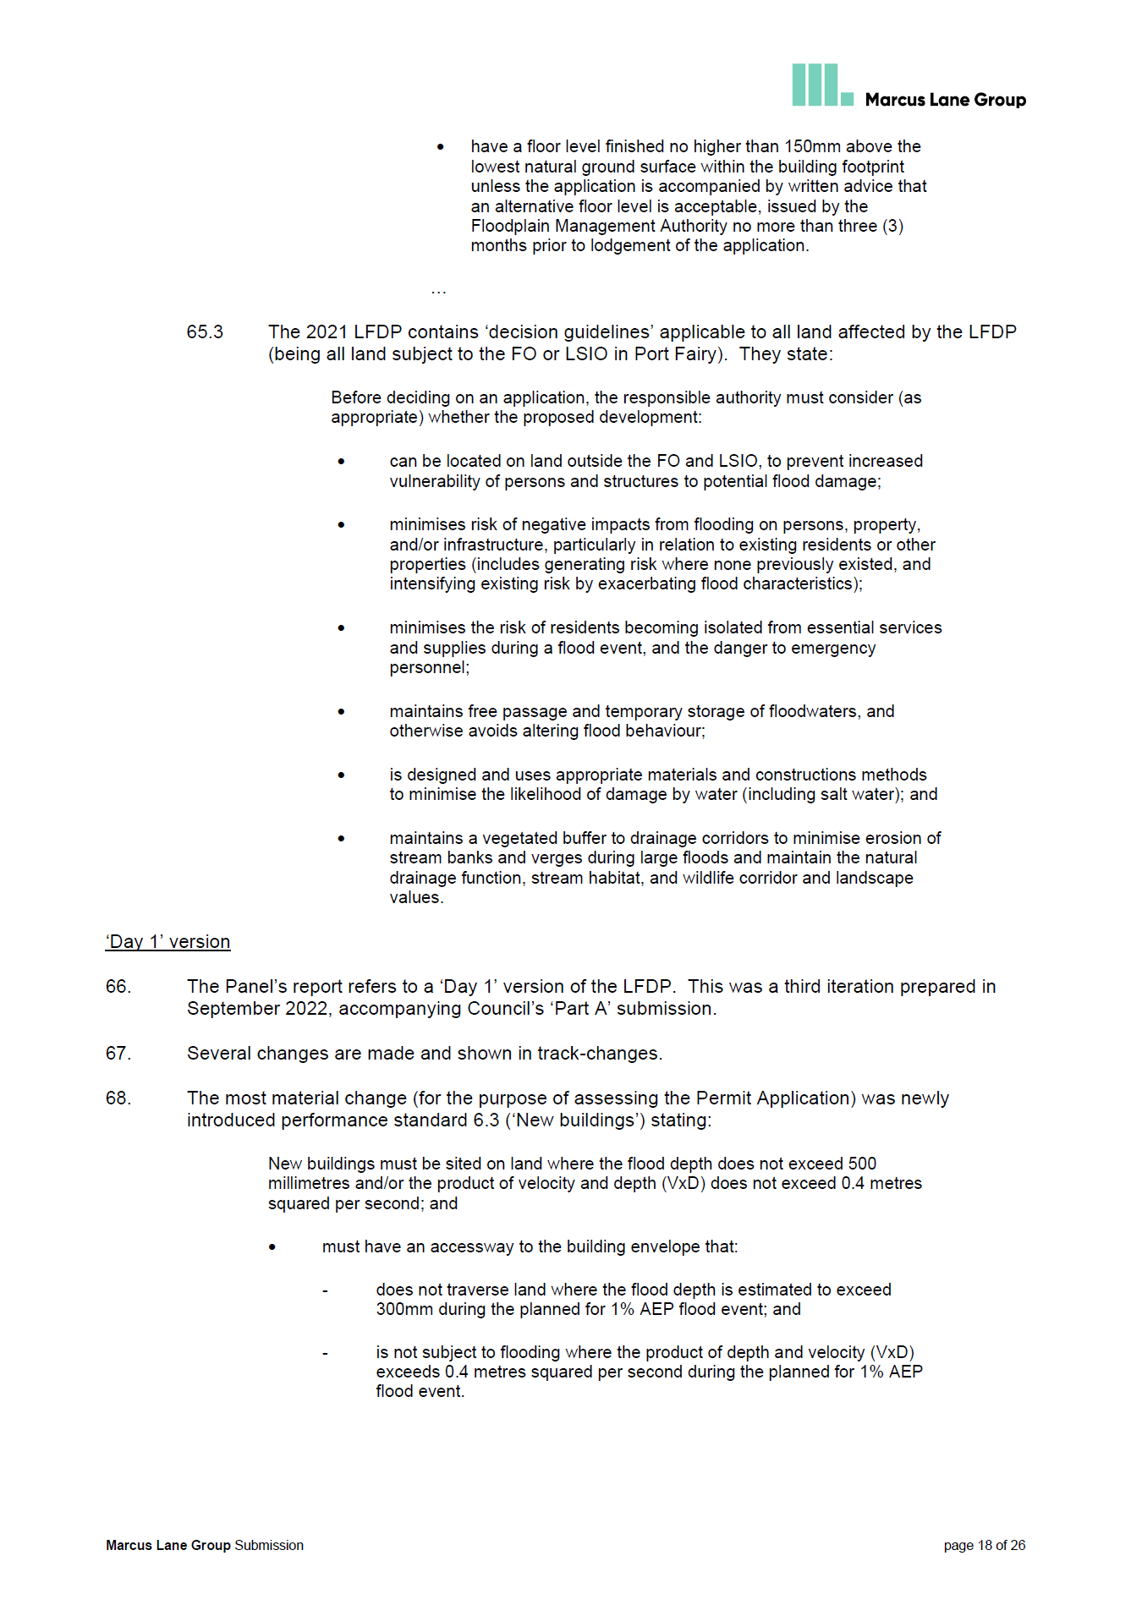

1. The submissions and evidence of the parties, any supporting exhibits given at the hearing and the statements of grounds filed have all been considered in the determination of the proceeding. In accordance with the practice of the Tribunal, not all of this material will be cited or referred to in these reasons.
2. Council made the following submissions in relation to the neighbouring property, 194A Griffiths Street: ‘On 9 June 2022, council issued a notice of decision to grant a permit for application no. PL22/045, allowing buildings and works to construct a dwelling on the land at 194 Griffiths Street, Port Fairy. The GHCMA subsequently lodged an application to review council’s decision under s 82AAA of the Act. On 13 February 2023, the Tribunal ordered (by consent) to set aside council’s decision and for no permit to issue.’
3. Tribunal Book, page 292.
4. Tribunal Book, page 238.
5. A summary of the PFC&SP is provided in the ‘Relevant policy documents’ section of this decision.
6. A summary of the Cardno Assessment is provided in the ‘Relevant policy documents’ section of this decision.
7. In its exhibited form, Amendment C69moyn proposed to update flooding controls planning for a 1.2m sea level rise to 2100. In accordance with the Panel’s recommendation, council purposes a 0.8m sea level rise only.
8. Council submissions, dated 27 April 2023.
9. This extract is the updated mapping prepared in late 2021 in response to additional flood modelling. Initially, when the Amendment was exhibited from 14 May to 28 June 2020, the LSIO4 was also proposed to be applied to part of the Subject Land but it was later removed when the Amendment was re-exhibited between 16 December 2021 to 31 January 2022.
10. Council submissions, dated 8 September 2023.
11. Since the receipt of these further written submissions, there have been several other amendments to the Moyne Planning Scheme. One of these amendments, Amendment C70moyn, makes changes to clause 2.03-1 Settlement. The changes to clause 2.03-1 are not in relation to the ‘Port Fairy’ section, which is referenced in this decision.
12. Now known as the Department of Energy, Environment and Climate Action (‘DEECA’).
13. Clauses marked with an * are relevant to Amendment C74moyn, refer earlier discussion.
14. PFC&SP, page 60, Tribunal Book, page 642.
15. 2022 LFDP, page 2.
16. Practice Note 11 is dated August 2025 and the website notes ‘This practice note is being reviewed. This version may not reflect planning system changes made since the publish date.’
17. Since the update of the Victoria Planning Provisions (‘VPP’), the relevant clause is now 13.03 Floodplains.
18. Amendment C69moyn replaces the Municipal Strategic Statement (‘MSS’) at clause 21 and Local Planning Policies at clause 22 of the Moyne Planning Scheme with a Municipal Planning Strategy (‘MPS’), local policies within the Planning Policy Framework (‘PPF’) and selected local schedules to overlays and operational provisions. The bulk of content from the LPPF has been edited and moved to the new MPS at clause 2 and local planning policies at clauses 11 to 19.
19. Department of Environment, Land, Water and Planning, 2016.
20. Also sometimes referred to as the ‘*Australian Emergency Management Handbook Collection’*.
21. *Australian Disaster Resilience Handbook 7 Managing the Floodplain: A Guide to Best Practice in*

    *Flood Risk Management in Australia* (AIDR 2017).
22. PFC&SP, page 67, Tribunal Book, page 649.
23. PFC&SP, page 62, Tribunal Book, page 644.
24. In the GHCMA submission dated 8 September 2023 they note that GHCMA has had some initial discussions with officers from council regarding possible mitigation works in this area, however GHCMA note that nothing has come to fruition to date.